Practical Information

*9th International ERNOP Conference*

Please contact [info@ernop.eu](mailto:info@ernop.eu) for any queries.

**Dates**

Pre-conference get-together: July 3rd 2019

Main conference: July 4th and 5th 2019

Philanthropic walking-tour: July 5th 2019, after conference ends

**Venue**

Main conference: University of Basel, Kollegienhaus, Petersgraben 50, 4051 Basel

Pre-conference get-together: Verso, University of Basel, Kollegienhaus, Petersgraben 50, 4051 Basel

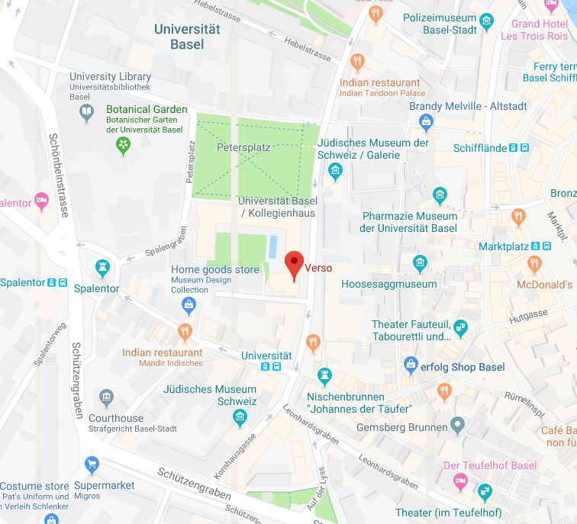

**Getting there**

*Public transportation*

The University of Basel is very easy to get to by public transportation. From Basel SBB (main train station) and Badischer Bahnhof train stations it takes around ten minutes on **bus 30** to reach the bus stop «Universität» (location: see red arrow on map above).

*Plane*

Take the airport shuttle bus (number 50) from Basel EuroAirport to SBB train station and then change to bus 30, which will take you to the bus stop “Universität”. Alternatively, there are taxis waiting outside the airport (taxi fee from airport to conference venue: approx. 50 Swiss Francs / bus fee (2 zones): 4.70 Swiss Francs).

*Car*

When traveling from the A2/A3, follow signs to Basel-Süd/City, Ausfahrt Basel-Süd/West Universitätsspital, Universitätsspital and City-Parking. Finding parking is difficult, so we recommend using public transport.

**Getting around / fares**

*Basel Card*

All guests booking overnight stays in hotels in Basel are provided with a complimentary [Basel Card](http://www.basel.com/en/BaselCard) when they check in. It can be used to travel free of charge on public transport, to access the free guest WiFi at particular hotspots within the city and to benefit from attractive cultural and leisure activities. For transfer from Basel airport to the hotel, some hotels annotate reservation confirmations with the words «Mobility-Ticket», which is valid for travel upon arrival at the airport.

*Other ticket options*

There are also various other ticket options available, such as short journey, single journey, day passes or multi-day passes. Further information regarding ticket fares and availability can be found on the website of Basler Verkehrsbetriebe, [here](http://www.bvb.ch/en/billette-tarife/informationen-zu-den-tarifen/). Tickets can be bought at the green vending machines at every bus/tram stop.

Consult [www.bvb.ch](https://www.efa-bw.de/bvb3/XSLT_TRIP_REQUEST2?language=en) or [www.sbb.ch](https://www.sbb.ch/en/) for current transport schedules.

**Accommodation (some recommendations)**

|  |  |  |  |  |
| --- | --- | --- | --- | --- |
| **Name** | **Address** | **Category** | **Rate\*** | **Distance** |
| Hotel D | Blumenrain 19 | **** | 210 CHF | 6min (on foot) |
| Hotel Der Teufelhof | Leonhardsgraben 47 | **** | 180 CHF** | 6min (on foot) |
| Hotel Krafft | Rheingasse 12 | *** | 170 CHF | 11min (on foot) |
| Basel Motel One | Barfüssergasse 16 | *** | 160 CHF | 10min (on foot) |
| Rochat | Petersgraben 23 | *** | 109 CHF | 2min (on foot) |
| * Rates are approx.per night, per person and include breakfast and wifi and BaselCard (public transport)  ** Special ERNOP conference rate until March 30. Mention ‘ERNOP Conference’ in the booking process to make use of this rate. | | | | |

**Taking a look around Basel**

Thanks to its manageable size and excellent public transport, it is quick and easy to get around Basel. The city is known as the culture capital of Switzerland. And not without reason: art can be seen wherever you go, whether strolling through the beautiful Old Town or when visiting one of the almost 40 museums. Visit [www.basel.com](http://www.basel.com) for more information. As aforementioned, with the Basel Card you can benefit from attractive cultural and leisure activities. Of course, we are always glad to offer you first-hand information on places to visit during your stay, and on restaurants and bars – just visit us at the conference office or join us during the cultural tour on Friday afternoon!

**Conference dinner**

The conference dinner will take place at restaurant [Schmatz](https://www.schmatzbasel.ch/).

*Address*

Frankfurt Strasse 36, 4142 Münchenstein

*How to get there*

From the city center or from Basel SBB take tram number 10 (direction: Dornach, Bahnhof) or number 11 (direction: Aesch, BL, Dorf) and get off at the tram stop «Dreispitz». Cross the road and follow Leimgrubenweg until you reach the BP petrol station. Turn left onto Frankfurt-Strasse and continue straight on, until you reach the restaurant (it will be clearly signposted). We will also offer the possibility of travelling to the restaurant as a group – just visit us at the conference office.

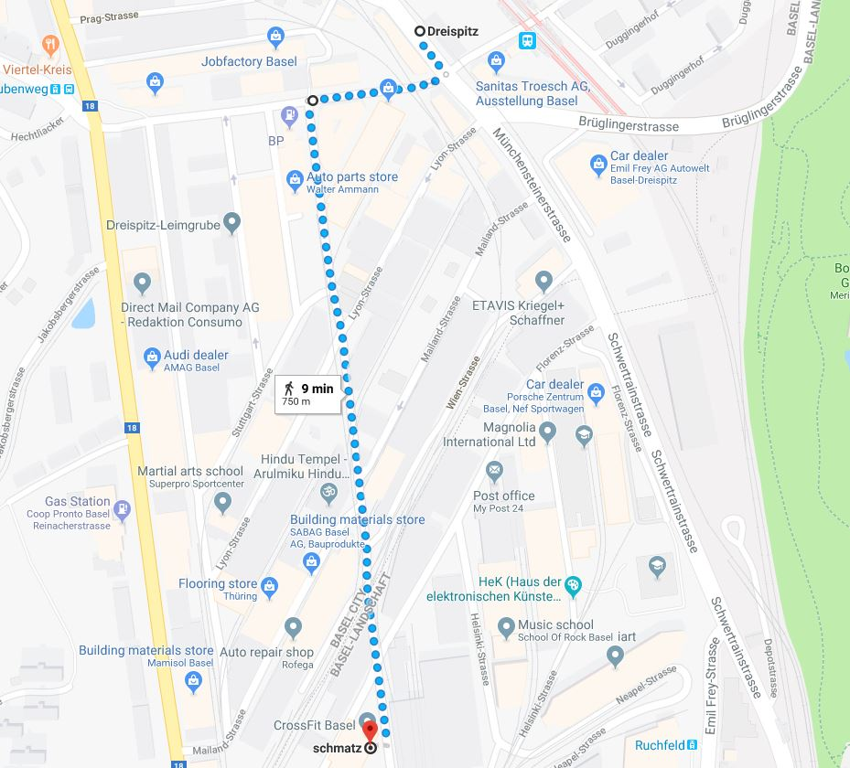

**Philanthropic city-tour**

After the conference ends on Friday, July 5th 2019, members of the Center for Philanthropy Studies (CEPS) will offer a walking tour through the historic old-town of Basel. This will allow interested participants to discover what role Philanthropy played in shaping the city – after all, with 45.3 foundations per 10,000 inhabitants, Basel has one of the highest densities of foundations in Europe and you will find a foundation for nearly every cause. We’ll be walking around the center of the city for approx. 1.5 hours. More information concerning meeting point and time will be made available in the conference program.

**Additional information**

*WiFi*

At the conference venue, WiFi access will be available using «eduroam».

Alternatively, conference participants can connect their device to the WiFi network and choose the option «unibas-events». Once you’ve done this, just go to your browser and open any page. You will be guided to a login-site, where you can input following login-credentials on the left-hand side: 1) user (Benutzername): ernop2019; 2) password (Passwort): @TwoSites.

*Currency*

All prices are indicated in Swiss Francs (CHF), which is the official currency of Switzerland. All major credit cards are accepted in most hotels, restaurants, and shops. Many places accept cash payments in Euros, will return any change in Swiss Francs. Exchange rate (approx.): 1 Euro = 1.15 CHF.

*Language*

The official language of Basel is Swiss German, but French and English are widely spoken.

*Electricity sockets*

The electrical current in Switzerland is 230V, 50Hz. Swiss sockets are incompatible with many plugs from abroad. They usually, however, take the standard European two-pronged plug.