**The evolution of SDG-related third sector and public administration literature:**

**An analysis and call for more SDG-related research**

Dominik S. Meier

Center for Philanthropy Studies (CEPS)

University of Basel, Switzerland

# Abstract

The Sustainable Development Goals (SDGs) were adopted in 2015 and achieving the seventeen goals by 2030 is crucial for human development. However, progress on the goals currently remains behind the requirements. As the third and public sectors play a crucial role in achieving the goals, this study analyses how the SDG-related third sector and public administration literature evolved over the last 30 years. I use a state-of-the-art method to map articles to the SDGs. In contrast to previous studies that found an increase in articles that directly mention the SDGs, I find a decline in the proportion of articles that relate to the SDGs without necessarily mentioning them directly. I also analyze how the SDG-relatedness of a paper relates to its citation count. While I find mixed results across SDGs and data sources, the relationship between SDG-relatedness and citation count is significantly more positive for articles published after the adoption of the SDGs. While the association between SDG-relatedness and citation count is now positive for the third sector literature published after 2015, it is still negative for the public administration literature.

*Keywords:* Sustainable Development Goals (SDGs), third sector, public sector, public administration, nonprofit studies, bibliometric analysis

# Introduction

In 2015, the United Nations General Assembly adopted the “Sustainable Development Goals (SDGs)”. The seventeen goals aim to steer humanity towards sustainable development, with the aim to achieve the goals by 2030. We are now midway through the timeline of achieving these goals, and while some progress has been achieved, it remains far behind the requirements (Gehringer, 2020), with the last two years even showing no progress (Sachs et al., 2022). To achieve the goals, collaboration between the public-, private-, and third sector is crucial (Hecht et al., 2012; Saxena et al., 2021). Next to directly contributing to the SDGs via service provision, the third sector plays a key role in achieving the SDGs by serving as a broker between sectors and representing the voice of civil society (Arhin, 2016). So although the third- and public sector play a crucial role in achieving the SDGs, studies on how these sectors contribute to the SDGs are lacking (Pizzi et al., 2020). This study aims to examine how and to what extent research about the thirdand public sector addresses the SDGs. Specifically, I want to test whether research about the SDGs increased or decreased over the years and which SDGs are researched the most. I use query systems that have been developed to detect SDGs in text and a novel state-of-the-art ensemble model developed by Wulff et al. (2023) to analyze thousands of research papers published in the nonprofit studies literature and the public administration literature. The results show a decrease in SDG-related research across both streams of literature. While this is worrying, the analyses also show that the degree of SDG relatedness of an article published since the adoption of the SDGs is positively associated with its number of citations for the nonprofit studies literature.

# The role of the third and public sector in achieving the SDGs

Because the SDGs are global goals, they require global action (Sachs et al., 2019).

As development challenges are increasingly interlinked, persistent, and complex, robust partnerships across the private, public, and third sector are needed to achieve the SDGs

(Saxena et al., 2021). This is also recognized through SDG 17 (Partnership for the Goals) (von Schnurbein, 2020). According to Saxena et al. (2021), partnerships between the third sector and the other two sectors are the least established. This is concerning, as one of the third sector’s roles in achieving the SDGs is to represent the diverse range of organizational and civic interests (Hassan et al., 2020). According to Saxena et al. (2021), the public sector’s role is to ensure that the SDGs are considered at the implementation level as well as to set up initiatives to monitor progress on the SDGs. These roles are also highlighted by Callmer and Bradley (2021) and Hess and Gentry (2019). The private sector’s efforts to contribute to the SDGs have largely been operationalized through Corporate Social Responsibility (CSR) practices (Saxena et al., 2021). But greater integration with the other two sectors’ actions is needed since CSR alone will likely not be sufficient (Mintzberg, 2019).

While the third sector acts as a partnership broker (Arhin, 2016; Gehringer, 2020), there are also more direct ways it contributes to the SDGs. For example, with activities such as mass protests and campaigning, civil society actors in general and NGOs specifically can directly influence intergovernmental policy-making by pressuring governments (Rietig, 2011). However, Sénit (2020) found the influence of civil society on global SDG-related policymaking only to be moderate. Third sector organizations also play a prominent role in developmental aid (Appe, 2022) and in the area of climate change (Johnson et al., 2023). More generally, as third sector organizations offer a wide range of services that the private and public sector cannot or do not provide to the community, they play a crucial role in achieving the SDGs by providing services that benefit society (Nordin et al., 2022). The ways third sector organizations can contribute to the SDGs are nicely summarized by Kagan and Dodge (2022). Although they focus on climate change, the statement can be expanded to the SDGs more broadly. Kagan and Dodge (2022) note that third sector organizations “play a critical role in the climate crisis by advocating for policy change, influencing corporate and individual behavior, and supporting vulnerable communities (Bies et al., 2013; Hall & Taplin, 2010)” (p. 2). Similarly, Hege and Demailly (2017) identified four roles for NGOs in the context of SDG implementation. Namely, holding the government accountable, holding the private sector accountable, communicating the SDGs, and implementing projects. So, although the third sector has great promise in contributing to the SDGs, the scholarly literature on how the third sector can contribute to the SDGs might be lacking behind. This is exemplified by the study of Kagan and Dodge (2022) that found that the response to the climate crisis by the third sector scholarly field has been slow. According to Kagan and Dodge (2022), only a limited body of literature examined the relationship between the third sector and the climate crisis. This study aims to test whether this slow scholarly response expands to the broader scope of the SDGs.

# Bibliometric studies about the SDGs

A series of bibliometric analyses and expert surveys have shed light on how the SDGs are represented in the current body of literature. Most closely related to this article’s field of study, Pizzi et al. (2020) and Mio et al. (2020) investigated the representation of SDGs in business and management research. Mio et al. (2020) found that the most frequently mentioned SDGs in business-related papers were SDG 9 (Industry, Innovation and Infrastructure), SDG 3 (Good Health and Well-being), and SDG 6 (Clean Water and Sanitation), alongside SDG 12 (Responsible Consumption and Production) and SDG 13 (Climate Action). In contrast, SDGs 5 (Gender Equality), 10 (Reduced Inequalities), and 14-17 were the least mentioned, appearing in only 14% of articles. Pizzi et al. (2020), while not directly mapping articles to specific SDGs, identified four major research themes: technological innovation, firms’ contributions in developing countries, non-financial reporting, and education for SDGs. Broadening the scope, several studies found that SDG 3 (Good Health and Well-being), SDG 13 (Climate Action), and SDG 6 (Clean Water and Sanitation) are recurrently among the most represented SDGs in the literature (Londoño-Pineda & Cano, 2022; Meschede, 2020; Sweileh, 2020; Yamaguchi et al., 2023; Yeh et al., 2022). SDG 7 (Affordable and Clean Energy) and SDG 2 (Zero Hunger) also frequently occur, especially in the bibliometric analyses of Yamaguchi et al. (2023) and Londoño-Pineda and Cano (2022). Contrarily, research on SDG 5 (Gender Equality), SDG 10 (Reduced Inequalities), SDG 14 (Life Below Water), and SDG 16 (Peace, Justice and Strong Institutions) were found to be underrepresented across the board (Londoño-Pineda & Cano, 2022; Meschede, 2020; Mio et al., 2020; Sweileh, 2020; Yamaguchi et al., 2023; Yeh et al., 2022). This scarcity of literature is particularly notable in business and management research where these SDGs are mentioned in only 14% of articles (Mio et al., 2020). While these studies are quite consistent in their findings, discrepancies appear when contrasting more global research with specific geographic contexts. For example, Trane et al. (2023) found that in the EU context, environmental-related SDGs were studied more frequently than social issues, which contradicts the findings of Körfgen et al. (2018) for articles published by Austrian universities. Expert opinions collected by Salvia et al. (2019) also offer an interesting contrast to the results that are based on bibliometric data, identifying SDGs 8 (Decent work and economic growth), 14 (Life below water), and 16 (Peace, Justice, and Strong Institutions) as least represented among the surveyed experts. In general, studies observed an exponential growth in the volume of SDG-related publications over time (Pizzi et al., 2020; Sweileh, 2020; Yeh et al., 2022), indicating a rising global interest in SDG-related research.

The current study differs from the above-mentioned bibliometric studies in two important ways. First, all of the above-mentioned bibliometric studies base their sample on studies that directly mention the SDGs in the title, abstract or keywords. For example, the sample of Pizzi et al. (2020) is based on management-related articles whose titles, abstracts, or keywords contained the words "sustainable development goal*" or "sdg*". One limitation of this search strategy is that it only identifies a fraction of the articles that are actually related to the SDGs, since articles can be related to the SDGs without explicitly referring to the SDGs (e.g., research on poverty reduction or climate change). The current study avoids this limitation by analyzing whether articles are related to the SDGs even if they do not explicitly mention the SDGs. This drastically broadens the scope of the study, since only a small fraction of the scientific literature directly mentions the SDGs. This study is therefore able to paint a more complete picture of how the (nonprofit- and public administration related) literature relates to the SDGs.

Second, the current study differs from the above-mentioned studies in the way that articles were mapped to the SDGs. While I also rely on an automated method to map the studies to SDGs, in contrast to most previous studies I use a validated state-of-the-art method to do so. This contrasts with studies that developed their own method to map the studies to the SDGs (e.g., Körfgen et al., 2018; Londoño-Pineda & Cano, 2022). This is problematic because the analysis of Wulff et al. (2023) showed that these methods can produce biased results. For example, Sweileh (2020) used the Aurora queries (Vanderfeesten et al., 2020) to map the studies to the SDGs. While this method was validated, a comparison of different methods to map text to SDGs carried out by Wulff et al. (2023) found that it doesn’t perform well with the kind of text it was used in the study by Sweileh (2020) (i.e., abstracts). The results of Wulff et al. (2023) also revealed that the Aurora system underestimates SDGs 2, 6, 7, 8, 9, and 10 but overestimates SDG 13. Other systems that can be used to map text to SDGs face similar issues (Wulff et al., 2023). I therefore use the state-of-the-art ensemble model developed by Wulff et al. (2023) to map the articles to the SDGs (see methods section for more details).

**Methods**

# Data

Articles published between 1990 and 2022 form the basis of my analysis. To identify articles from the nonprofit studies literature, I followed LePere-Schloop and Nesbit (2022) and used the query they developed to identify third sector-related literature (see online appendix[1]). Also following LePere-Schloop and Nesbit (2022), I used the Web of Science “public administration” subject category filter to identify and download public administration articles. For all of these downloaded records, I only kept articles with neither a missing title nor a missing abstract. Table 1 displays the number of articles that were available with title and abstract. This data formed the basis for the analyses described in the next section. Because the subject category “public administration” only contained three articles in 1990 I excluded articles from this year from the analysis for this data source. Similarly, there were no articles left for the year 1990 in the nonprofit studies literature data after excluding data that either had a missing title or a missing abstract.

# Table 1

*Number of articles per source*

|  |  |  |
| --- | --- | --- |
| Data | Nonprofit Studies Literature | Public Administration Literature |
| Number of articles | 27,286 | 58,155 |

# Analyses

To detect SDGs in the titles and abstracts of the analyzed papers, I used the text2sdg R package developed by Meier et al. (2021). This package implements query systems and ensemble models that have been developed to detect SDGs in text. A total of six query systems are available through text2sdg. These query systems assign SDGs to a text if a given query produces a hit. Much like a query that can be used to query databases like Scopus, these queries use a combination of keywords. For example, the query system developed by Elsevier (Jayabalasingham et al., 2019) contains a query that assigns SDG 01 (No poverty) to text that contains the word combination “extreme poverty”. Most of these queries were designed by domain experts and gradually refined to make them more accurate (e.g., Vanderfeesten et al., 2020). Although these queries can be used to detect SDGs in any kind of text, most of the queries were designed to detect SDGs in academic publications (i.e., abstracts). These queries are already being used in policy-relevant publications. For example, the Elsevier queries are used to rank the SDG-related research output of universities in the Times Higher Education Impact Rankings.

Wulff et al. (2023) tested how accurately these queries detect SDGs in text and found that the systems vary in their sensitivity (i.e., true-positive rate) and specificity (i.e., true-negative rate). The analysis of Wulff et al. (2023) also showed that these labeling systems are sensitive to the length of the input text, with longer input text generating more hits (erroneously). The results also revealed that the query systems show biases for specific SDGs (i.e., some query systems systematically over- or underestimate certain SDGs) (Wulff et al., 2023). To alleviate these shortcomings, Wulff et al. (2023) developed an ensemble model that leverages the predictions from all six labeling systems and takes the text length into account. This model exceeds the labeling performance of all the other labeling systems and achieves both a high accuracy and a low false positive rate. That the ensemble model takes text length into account is crucial for this study, as abstracts became longer over the years (reported in the appendix). Next to expert-labeled data, the ensemble model was also trained on synthetic data sets to reduce the false positive rate. The text2sdg R package allows the user to choose ensemble models that vary in the amount of synthetic data that was used to train the model. The higher the amount of synthetic data, the lower the false positive rate (Wulff et al., 2023). As the ensemble model that was not trained on any synthetic data suffers from a very high false positive rate, I do not use this model in the analysis. Due to the shortcomings of the individual query-based systems, I only used the ensemble models for the analysis. I use models that used a third, equal, or triple the amount of synthetic data relative to the expert-labeled data.

To answer how the amount of research that is related to the SDGs evolved over the years, I calculated the share of articles that relate to at least one SDG for each year between 1991 and 2022. Additionally, I determined the average number of SDGs that articles were assigned during that time frame. These results are visualized for all ensemble models. I also compute the prevalence of each SDG over the years and the overall prevalence combined over all years. I used the ensemble model that was trained on an equal amount of synthetic and expert-labeled data for these two tasks because this model has both a low false positive rate and a high accuracy. It is also the default model in the text2sdg package. To assess whether certain SDGs are likely to occur together in the published articles, I calculated the correlation between the detected SDGs.

To make trends better visible, I plot the smoothed instead of the raw values for figures that include a temporal dimension (Figures 1 & 2). I used the function “geom_smooth” to do this with the ggplot2 R package (Wickham, 2011). This function fits a local polynomial regression of degree two to model the relationship between x and y.

To assess whether the adoption of the SDGs in 2015 led to an increase in the number of published SDG-related articles, I used the Causalimpact R package (Brodersen et al., 2015). This package fits a Bayesian structural time-series model to the data prior to the intervention (i.e., prior to the adoption of the SDGs). This model is then used to predict the counterfactual after the intervention, i.e., how the dependent variable would have evolved after the intervention if the intervention had never occurred. This counterfactual is then used to test whether the intervention had a significant effect. More details can be found in Brodersen et al. (2015) and in the detailed description of the results of these models in the appendix.

I use Poisson regression models to test whether articles that are related to SDGs were cited more often. I used the results of the ensemble equal model for these analyses. In all of these models, the number of citations an article received as of 2022 is the dependent variable. All models also control for a linear and a quadratic time trend (year of publication). The independent variables in the first model are dummy variables that specify for each SDG whether a given article relates to this SDG or not. I also use a model to test whether the adoption of the SDGs led to an increase in citations for articles that relate to the SDGs. I used the number of SDGs an article relates to as the independent variable for this model and interacted this variable with a dummy that indicates whether an article was published after 2015. The coefficient of this interaction will tell us whether the association between an article’s degree of SDG relatedness and its citation count is stronger for articles published after 2015. Finally, I also fit a model only for articles published after 2015 with the number of SDGs a given article relates to as the independent variable to see how strong the association is for articles published after the adoption of the SDGs. The formulas of these three Poisson regression models can be found in the appendix. I only plotted the coefficients of interest in the results section but included the regression tables in the appendix.

# Results

Figure 1 A shows the percentage of articles with at least one SDG in the nonprofit studies literature over time. The ensemble equal model shows a minimal decline in articles with at least one SDG over the years, with less than 50% of the articles being related to at least one SDG. Figure 1 B reports the mean number of SDGs per article over time. The patterns are very similar to those reported in Figure 1 A, indicating that not many articles relate to more than one SDG. Figure 1 C shows the percentage of articles with a given SDG over time. The prevalence of the individual SDGs remained relatively stable over the years. Quite a few SDGs reached their highest prevalence in 2022, indicating a recent growth in articles covering these SDGs. Among these are SDG 4 (Quality Education), SDG 5 (Gender Equality), and SDG 17 (Partnership for the Goals).

As the third sector, the public sector plays a crucial role in achieving the SDGs. Figure 2 shows the evolution of SDG-related research in this literature. While the amount of SDG-related research is relatively steady until 2010, 2010 marks the beginning of a slow decline in SDG-related research both in the percentage of articles with at least one SDG (Figure 2 A) and in the mean number of SDGs per article (Figure 2 B). Compared to the nonprofit studies data, the mean number of SDGs per article is slightly higher (around 1, ensemble equal model) until 2010. From then on, it slowly converges to about the same number as for the nonprofit studies literature data set. Looking at the evolution of individual SDGs in Figure 2 C, we see that SDG 3 (Good Health and Well-being), SDG 13 (Climate Action), and SDG 17 (Partnerships for the Goals) reached their highest prevalence in 2022. SDG 8 (Decent Work and Economic Growth) is the most prevalent SDG over all years but shows an almost steady decline.

In the appendix, I report the results of the causal impact analysis that tests whether the adoption of the SDGs in 2015 led to a significant increase in the amount of published SDG-related articles. This method indicated a significant decrease in the mean number of SDGs per article for the public administration literature. A significant negative effect was also found for the number of articles with at least one SDG for articles published after 2015 in the public administration literature. Unsurprisingly given the already reported results, none of the tests indicated an increase in SDG-related research after 2015.

This is in stark contrast to the percentage of articles that directly mention the

SDGs ("sdg", "sdgs", or "sustainable development goals") in the title, abstract, or keywords.

There was an exponential increase in these articles over the years for both the Public Adminstration literature and the Nonprofit Studies literature (Fig. 3). This shows that while there was a decrease in the share of articles that (indirectly) relate to the SDGs, the share of articles that directly mention/study the SDGs increased over time.

Figure 4 shows the prevalence of SDGs for the two data sources aggregated over all years. SDG 08 (Decent Work and Economic Growth) is the most prevalent SDG overall. This is followed by SDG 10 (Reduced Inequalities) for the nonprofit studies literature data and SDG 16 (Peace, Justice and Strong Institutions) for the public administration literature. These SDGs are the most prevalent overall in both datasets. SDGs 14 (Life Below Water) and 15 (Life on Land) belong to the least prevalent SDGs. Looking at the differences in the prevalence of specific SDGs, SDG 3 (good health and well-being) is a bit more prevalent in the nonprofit studies literature than in the public administration literature, and SDG 13 (Climate Action) and SDG 16 (Peace, Justice and Strong Institutions) are more prevalent in the public administration literature.

Finally, we can also look at the correlation of SDGs, i.e., whether certain SDGs are more likely to occur together in the articles. Figure 5 shows the SDG correlation matrix for the public administration literature data, ordered according to a hierarchical cluster analysis. The dendrogram of the cluster analysis is shown on top of the figure. The figure shows that SDG 7 (Affordable and Clean Energy) and SDG 13 (Climate Action) are most likely to co-occur within a given article, with a correlation of .38. This is followed by SDG 6 (Clean Water and Sanitation) and SDG 11 (Sustainable Cities and Communities) (.32) and SDG 1 (No Poverty) and SDG 10 (Reduced Inequalities) (.26).

Figure 6 shows the same analysis for the Nonprofit Studies literature. In these articles, SDG 8 (Decent Work and Economic Growth) and SDG 9 (Industry, Innovation and Infrastructure) show the highest correlation (.27), followed by SDG 6 (Clean Water and Sanitation) and SDG 11 (Sustainable Cities and Communities) which are again relatively highly correlated (.26), and SDG 8 (Decent Work and Economic Growth) and SDG 10 (Reduced Inequalities), which are slightly more correlated in the Nonprofit Studies literature than in the Public Administration literature (.21 vs. .19).

Comparing the clusters that are formed by specifying five clusters, we see that three clusters are stable across the two pieces of literature. Namely, in both pieces of literature SDG 7 (Affordable and Clean Energy) and SDG 13 (Climate Action) form one cluster, SDG 2 (Zero Hunger), 14 (Life Below Water), and 15 (Life on Land) form one cluster, and SDG 6 (Clean Water and Sanitation), 11 (Sustainable Cities and Communities), and 12 (Responsible Consumption and Production) form one cluster. Indeed, the only difference in the clusters across the two pieces of literature is that SDG 8 (Decent Work and Economic Growth), 9 (Industry, Innovation and Infrastructure), and 17 (Partnerships for the Goals) form one cluster in the public administration literature while this cluster additionally contains SDGs 4 (Quality Education) and 16 (Peace, Justice and Strong Institutions) in the Nonprofit Studies literature.

**Do SDG-related articles get cited more often?**

The results so far show a decrease in the amount of SDG-related research in the nonprofit and public administration literature over the years. However, maybe SDG-related articles received more attention in the form of being cited more often than their non-SDG-related counterparts. As described in the methods section, I therefore also analyzed whether articles that are related to (specific) SDGs are cited more often than their counterparts. Figure 7 A shows the coefficients of a Poisson model that has the number of times an article has been cited as the dependent variable and whether a given article relates to a given SDG as independent variables. The model also controls for a linear and quadratic time trend (year of publication). Figure 7 A shows that for most SDGs, articles related to the specific SDG were cited less. This is confirmed by an analysis reported in the appendix, where I used the number of SDGs an article is related to as the independent variable in the Poisson models instead of the individual SDGs. However, some SDGs are associated with an article being cited more often. This positive association is more pronounced in the nonprofit studies data, where this is the case for seven SDGs. SDGs 17 (Partnerships for the Goals), 7 (Affordable and Clean Energy), 12 (Responsible Consumption and Production), 9 (Industry, Innovation and Infrastructure), and 13

(Climate Action) show the strongest positive association among these. SDGs 13 and 17 are positively associated with the number of citations for both data sets, whereas SDG 15 (Life on Land), SDG 11 (Sustainable Cities and Communities), SDG 6 (Clean Water and

Sanitation), SDG 4 (Quality Education), SDG 3 (Good Health and Well-being), and SDG 1 (No Poverty) are negatively associated with citations across both data sets. It could be that the adoption of the SDGs in 2015 led to an increase in the number of citations of SDG-related articles. I tested this by interacting the number of SDGs an article is related to with a dummy that indicates whether the article was published after 2015 in the Poisson regression. The interaction is significantly positive for both data sources, indicating that the association between the number of SDGs an article is related to and the number of times it is cited is significantly more positive for articles published after 2015 (see Figure 7 B). Indeed, there is now a significant positive association between the number of SDGs an article relates to and the number of times the article has been cited for articles published after 2015 in the nonprofit studies literature (Figure 7 C). It would be interesting to test whether SDG-related articles published before 2015 also experienced an increase in citations after 2015, but since I do not have yearly citation data, I unfortunately cannot test that.

# Discussion and Conclusion

Because the third sector and the public sector play an important role in achieving the SDGs, this study set out to examine the prevalence and evolution of SDG-related research in the nonprofit studies and public administration literature. The results of the analyses show that third sector and public administration research that is related to the SDGs remains scarce and even declined over the past few years. While it might be surprising or even worrying that such research remains scarce despite the importance of the SDGs, it is in line with recent reviews which found that very few top business journals published articles about the SDGs (Mio et al., 2020; Pizzi et al., 2020). The results are also in line with a recent review that found limited third sector research that addresses climate change (Kagan & Dodge, 2022).

The results showed that SDG 8 (Decent Work and Economic Growth) is most prevalent in this literature, followed by SDG 10 (Reduced Inequalities) for the nonprofit studies literature and SDG 16 (Peace, Justice and Strong Institutions) for the public administration literature. The high prevalence of SDG 8 aligns with the findings of Mio et al. (2020) and Yamaguchi et al. (2023), who also found this SDG to be highly represented in the literature. The strong prevalence of SDG 3 (Good Health and Well-being) is also in line with previous literature (Londoño-Pineda & Cano, 2022; Meschede, 2020; Sweileh, 2020; Yamaguchi et al., 2023; Yeh et al., 2022). Although these same studies also found SDG 6 (Clean Water and Sanitation) and SDG 13 (Climate Action) to be among the most represented SDGs, which is not the case in this study. That SDGs 14 (Life Below Water) and 15 (Life on Land) were found to be among the least prevalent SDGs is consistent with previous studies indicating that especially SDG 14 is underrepresented in the literature (Londoño-Pineda & Cano, 2022; Meschede, 2020; Mio et al., 2020; Sweileh, 2020; Yamaguchi et al., 2023; Yeh et al., 2022). While the strong presence of SDG 8 contradicts previous studies to some extent (Salvia et al., 2019), it is in line with the findings of Yamaguchi et al. (2023) who showed that keywords relating to SDG 8 (Decent Work and Economic Growth) and SDG 9 (Industry, Innovation and Infrastructure) had the greatest relevance among the analyzed keywords and were present in multiple clusters. Previous studies found that SDG 5 (Gender Equality), 10 (Reduced Inequalities), and 16 (Peace, Justice and Strong Institutions) are underrepresented (Londoño-Pineda & Cano, 2022; Meschede, 2020; Mio et al., 2020; Sweileh, 2020; Yamaguchi et al., 2023; Yeh et al., 2022). This is in contrast to the results of this study, where these SDGs are among the most prevalent ones.

The correlation between the SDGs revealed that some SDGs are more likely to co-occur in the articles than others. In fact, the clusters revealed by the correlation matrix were highly similar across the two pieces of literature. The correlation of SDGs corresponds to the literature on synergies between the SDGs (i.e., positive correlations between pairs of SDG indicators) (Kroll et al., 2019; Pradhan et al., 2017). For example, SDGs 1 (No Poverty) and 10 (Reduced Inequalities) belong to the SDGs with the strongest synergies in the study by Pradhan et al. (2017), which is in line with the positive correlation of these SDGs in the current study.

While some of this study’s results are in line with the results of previous studies, there also are some notable differences. Two factors can explain these differing results. First, in contrast to previous bibliometric studies about the SDGs, I analyzed all articles in the population of interest, and not only those that directly refer to the SDGs. This paints a more comprehensive picture of SDG-related research, as articles can relate to the SDGs without directly mentioning the SDGs. Indeed, this is the case for about half of the articles analyzed in this study (Fig. 1A & 2A), while only a fraction of them directly mention the SDGs (Fig. 3). Second, the difference in results probably relates to the subject area of the analyzed articles. For someone who is familiar with the Nonprofit Studies and Public Administration literature, it is not surprising to see that SDGs 8 (Decent Work and Economic Growth), 10 (Reduced Inequalities), and 16 (Peace, Justice and Strong Institutions) are the most represented SDGs, given that these are central themes in this literature (Ma & Konrath, 2018). Indeed, SDG 8 also belonged to the three most represented SDGs in a bibliometric study about supply chain practices and business strategies (Agrawal et al., 2022).

This study also revealed an important difference between the publication trend of research that directly mentions the SDGs and research that is related to the SDGs but does not mention the SDGs explicitly. While the exponential increase in the former articles is in line with the findings of past studies (Pizzi et al., 2020; Sweileh, 2020; Yeh et al., 2022), the relative decline in the latter contradicts this pattern. Thus, while there seems to be an increase in research that directly mentions the SDGs, there seems to be a decrease in the share of published articles that relate to the SDGs without directly mentioning them. This is worrying because it is these articles that build a broad knowledge source on how we can achieve the SDGs. Of course, articles that directly mention the SDGs and therefore likely have the SDGs as their main focus of study are at least as important. By e.g., synthesizing the results of studies that relate to the SDGs without explicitly mentioning them, these articles provide important contributions. However, without the former articles, there is not a lot that these articles can build on.

While the volume of literature related to Sustainable Development Goals doesn’t necessarily reflect the progress made towards these goals, it may act as an early signal of future progress on the Goals. This is because science plays a critical part in promoting evidence-based strategies and in conducting research that supports the attainment of the SDGs (Allen et al., 2021; Messerli et al., 2019). In light of this, the high prevalence of Nonprofit Studies and Public Administration articles that are related to SDG 8 (Decent Work and Economic Growth), 10 (Reduced Inequalities), and 16 (Peace, Justice and Strong Institutions) is a promising result. Especially when considering that the current progress on these goals is moderate at best, with a trend that doesn’t look promising either (United Nations, 2022). On the other hand, the reported decrease in the share of SDG-related articles might be an early warning sign of future stagnation on the SDGs, especially in civil society and public sector related areas.

An overly optimistic interpretation would be to attribute the decline in SDG-related research to a saturation of research on this topic. However, both my results and results from the literature show that more research is urgently needed in this area (Kagan & Dodge, 2022; Pizzi et al., 2020). I therefore hope that my results serve as a call for researchers to produce more research that relates to the SDGs. Science being inherently slow might be another explanation for why we haven’t (yet) witnessed an increase in SDG-related research. However, the myriad of published Covid related research over the last three years casts doubt on this explanation. We are therefore left with a more sobering but probable explanation, namely that the SDGs are not yet important enough for researchers in these fields. It will probably take institutional changes and incentives to change that. Popular University rankings such as the times higher education rankings now ranking universities on their SDG-related research are an example of such incentives. These incentives can also come from the research community itself. For example, my results show that for the nonprofit studies data, the degree of SDG relatedness is positively related to an article’s citation success for articles published after the adoption of the SDGs. This result is a silver lining showing that while SDG-related research production remains scarce, at least scholars increasingly cite such existing research. I invite researchers to capitalize on this by producing more SDG-related research. I hope this study inspires researchers to take a more in-depth look at how third sector and public administration research addresses the SDGs, as has been done for research published in business journals (Mio et al., 2020; Pizzi et al., 2020).

One of the limitations of my results is that the automated method of detecting SDGs in the articles might have produced false positives or false negatives. While I cannot rule this out, I safeguarded against it by using the state-of-the-art tool to label the articles. Another limitation is that I did not analyze the ways in which the identified articles study/relate to the SDGs. As proven by the article by Kagan and Dodge (2022), there is great merit in doing this, and I hope that future research will expand on such SDG-specific literature reviews. Finally, the relative decrease in SDG-related research is associated with a relative increase in other topics. For example, as mentioned by a reviewer, climate change has been replaced by biodiversity risks in policy agendas (*The Global Risks Report*, 2023). Although the method I used also contains biodiversity-related queries, it might not have detected newly emerging SDG-related topics. Future research could also use unsupervised machine learning methods to uncover common themes among SDG-related articles. A recent example of such an approach is the study by Ligorio et al. (2022), where latent Dirichlet allocation (LDA) revealed eight different trends in sustainable cities research which the authors then connected to the targets of SDG 11. As such, I hope that the results of this study and the new methods to detect SDGs in text (Meier et al., 2021; Wulff et al., 2023) inspire many researchers to study the SDGs and its related literature more intensively.

# Figure 1

*Evolution of SDG prevalence in the nonprofit studies literature.*

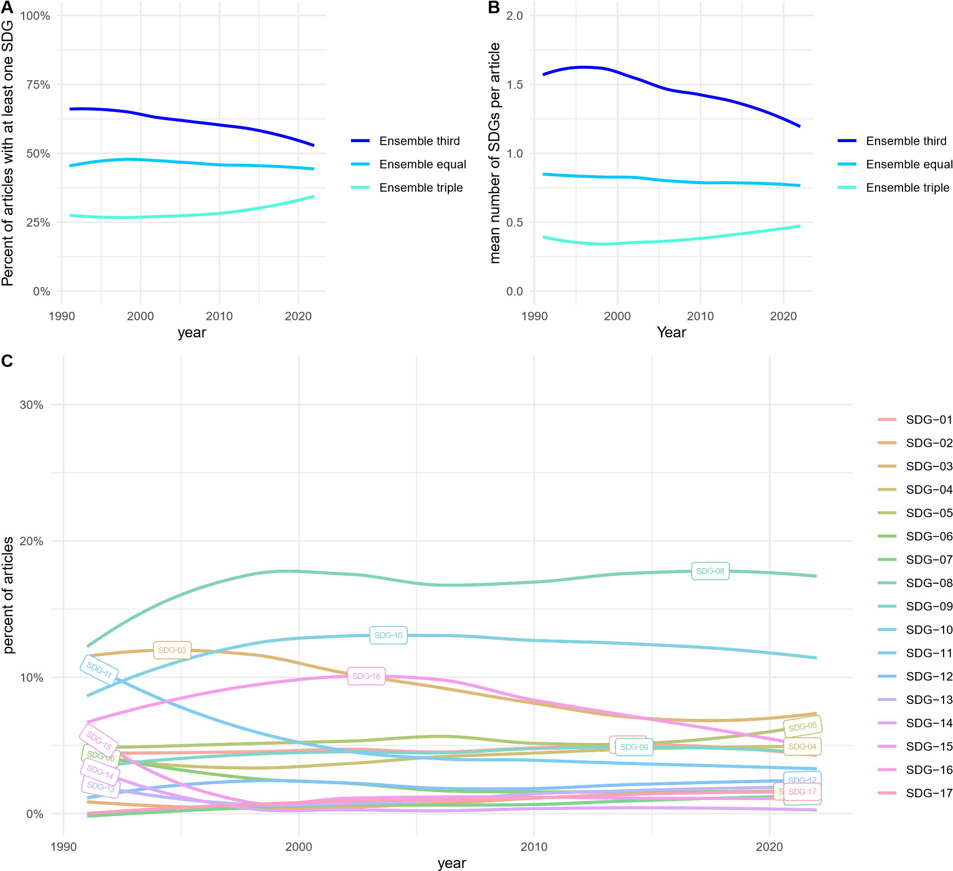

# Figure 2

*Evolution of SDG prevalence in the public administration literature.*

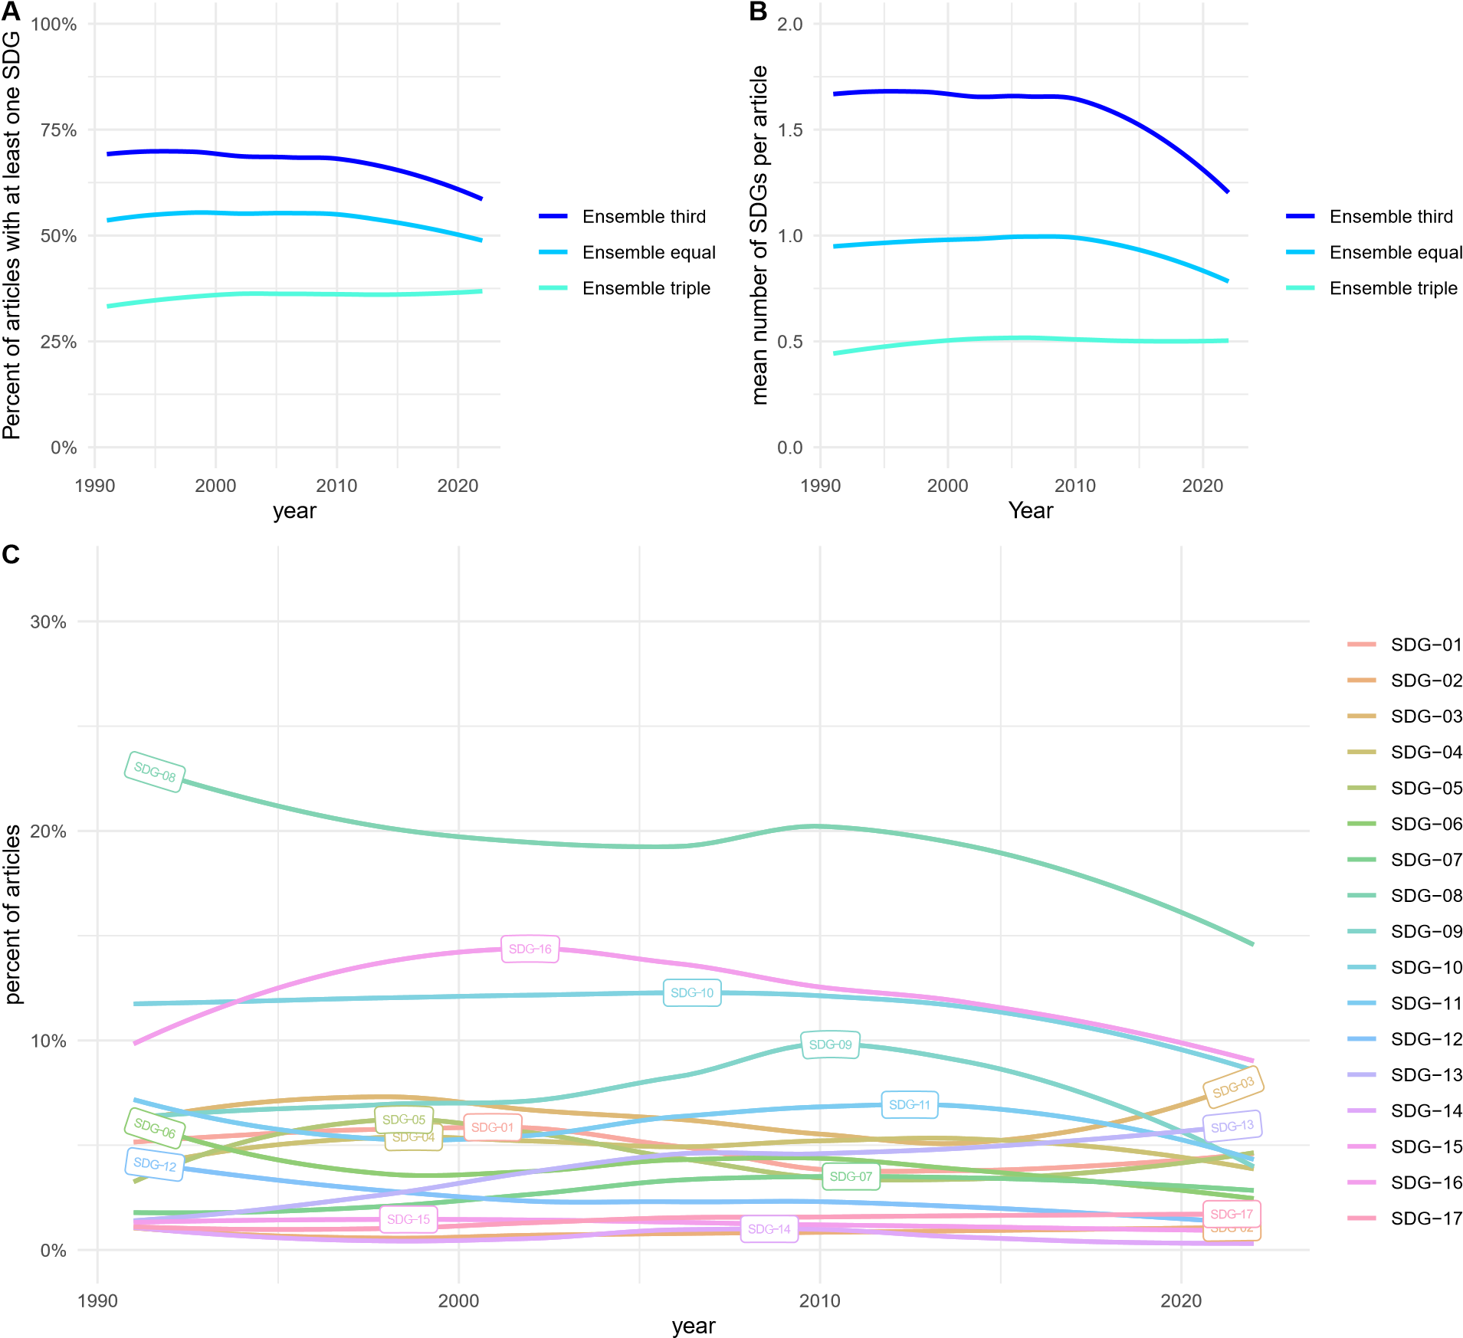

# Figure 3

*Percentage of articles published between 2010 and 2021 that directly mention the*

*Sustainable Development Goals in the title, abstract or keywords.*

0.0

%

1.0

%

2.0

%

2010

2013

2016

2019

Year

Percent of articles

data

Nonprofit Studies Literature

Public Administration Literature

# Figure 4

*Overall prevalence of SDGs. The highest and lowest ranks per data source are indicated with numbers on the bars.*

3

5

16

1

2

17

15

4

16

5

1

4

3

17

15

2

%

0.0

5.0

%

10.0

%

%

15.0

20.0

%

SDG−01

SDG−02

SDG−03

SDG−04

SDG−05

SDG−06

SDG−07

SDG−08

SDG−09

SDG−10

SDG−11

SDG−12

SDG−13

SDG−14

SDG−15

SDG−16

SDG−17

Percent of articles that relate to given SDG

data

onprofit

Studies

e

N

Literatur

P

ublic Ad

ministrat

ion Liter

ature

# Figure 5

*Correlation of SDGs within public administration articles, ordered according to a hierarchical cluster analysis.*

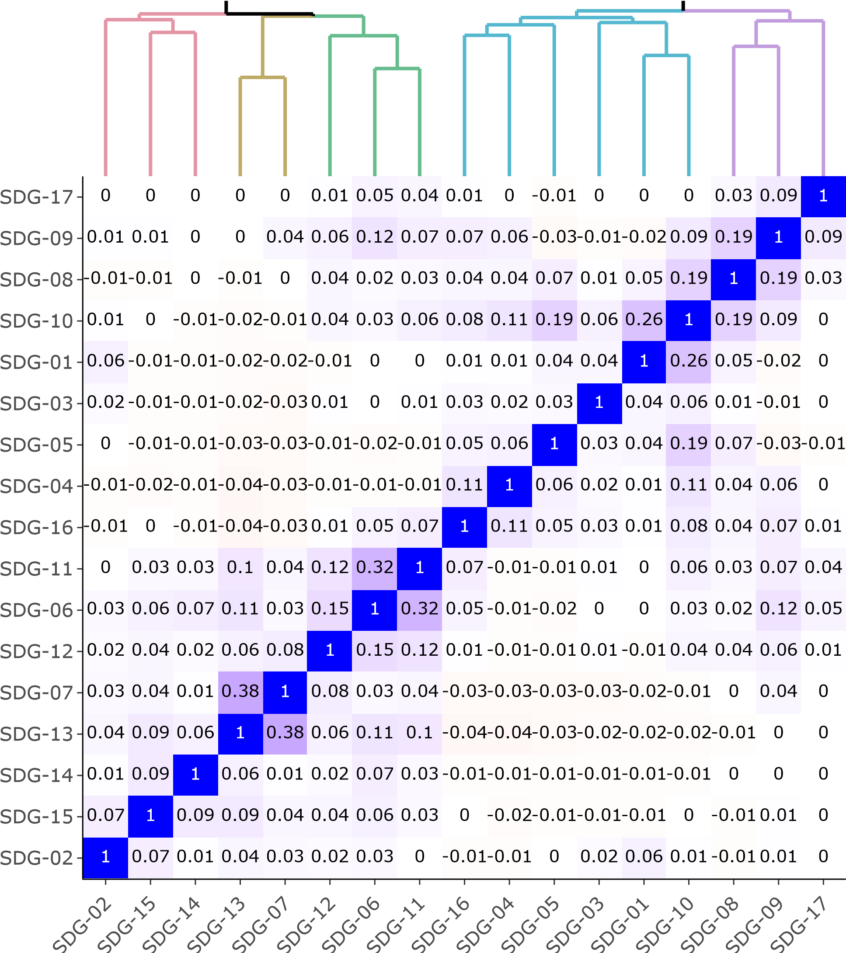

# Figure 6

*Correlation of SDGs within nonprofit studies articles, ordered according to a hierarchical cluster analysis.*

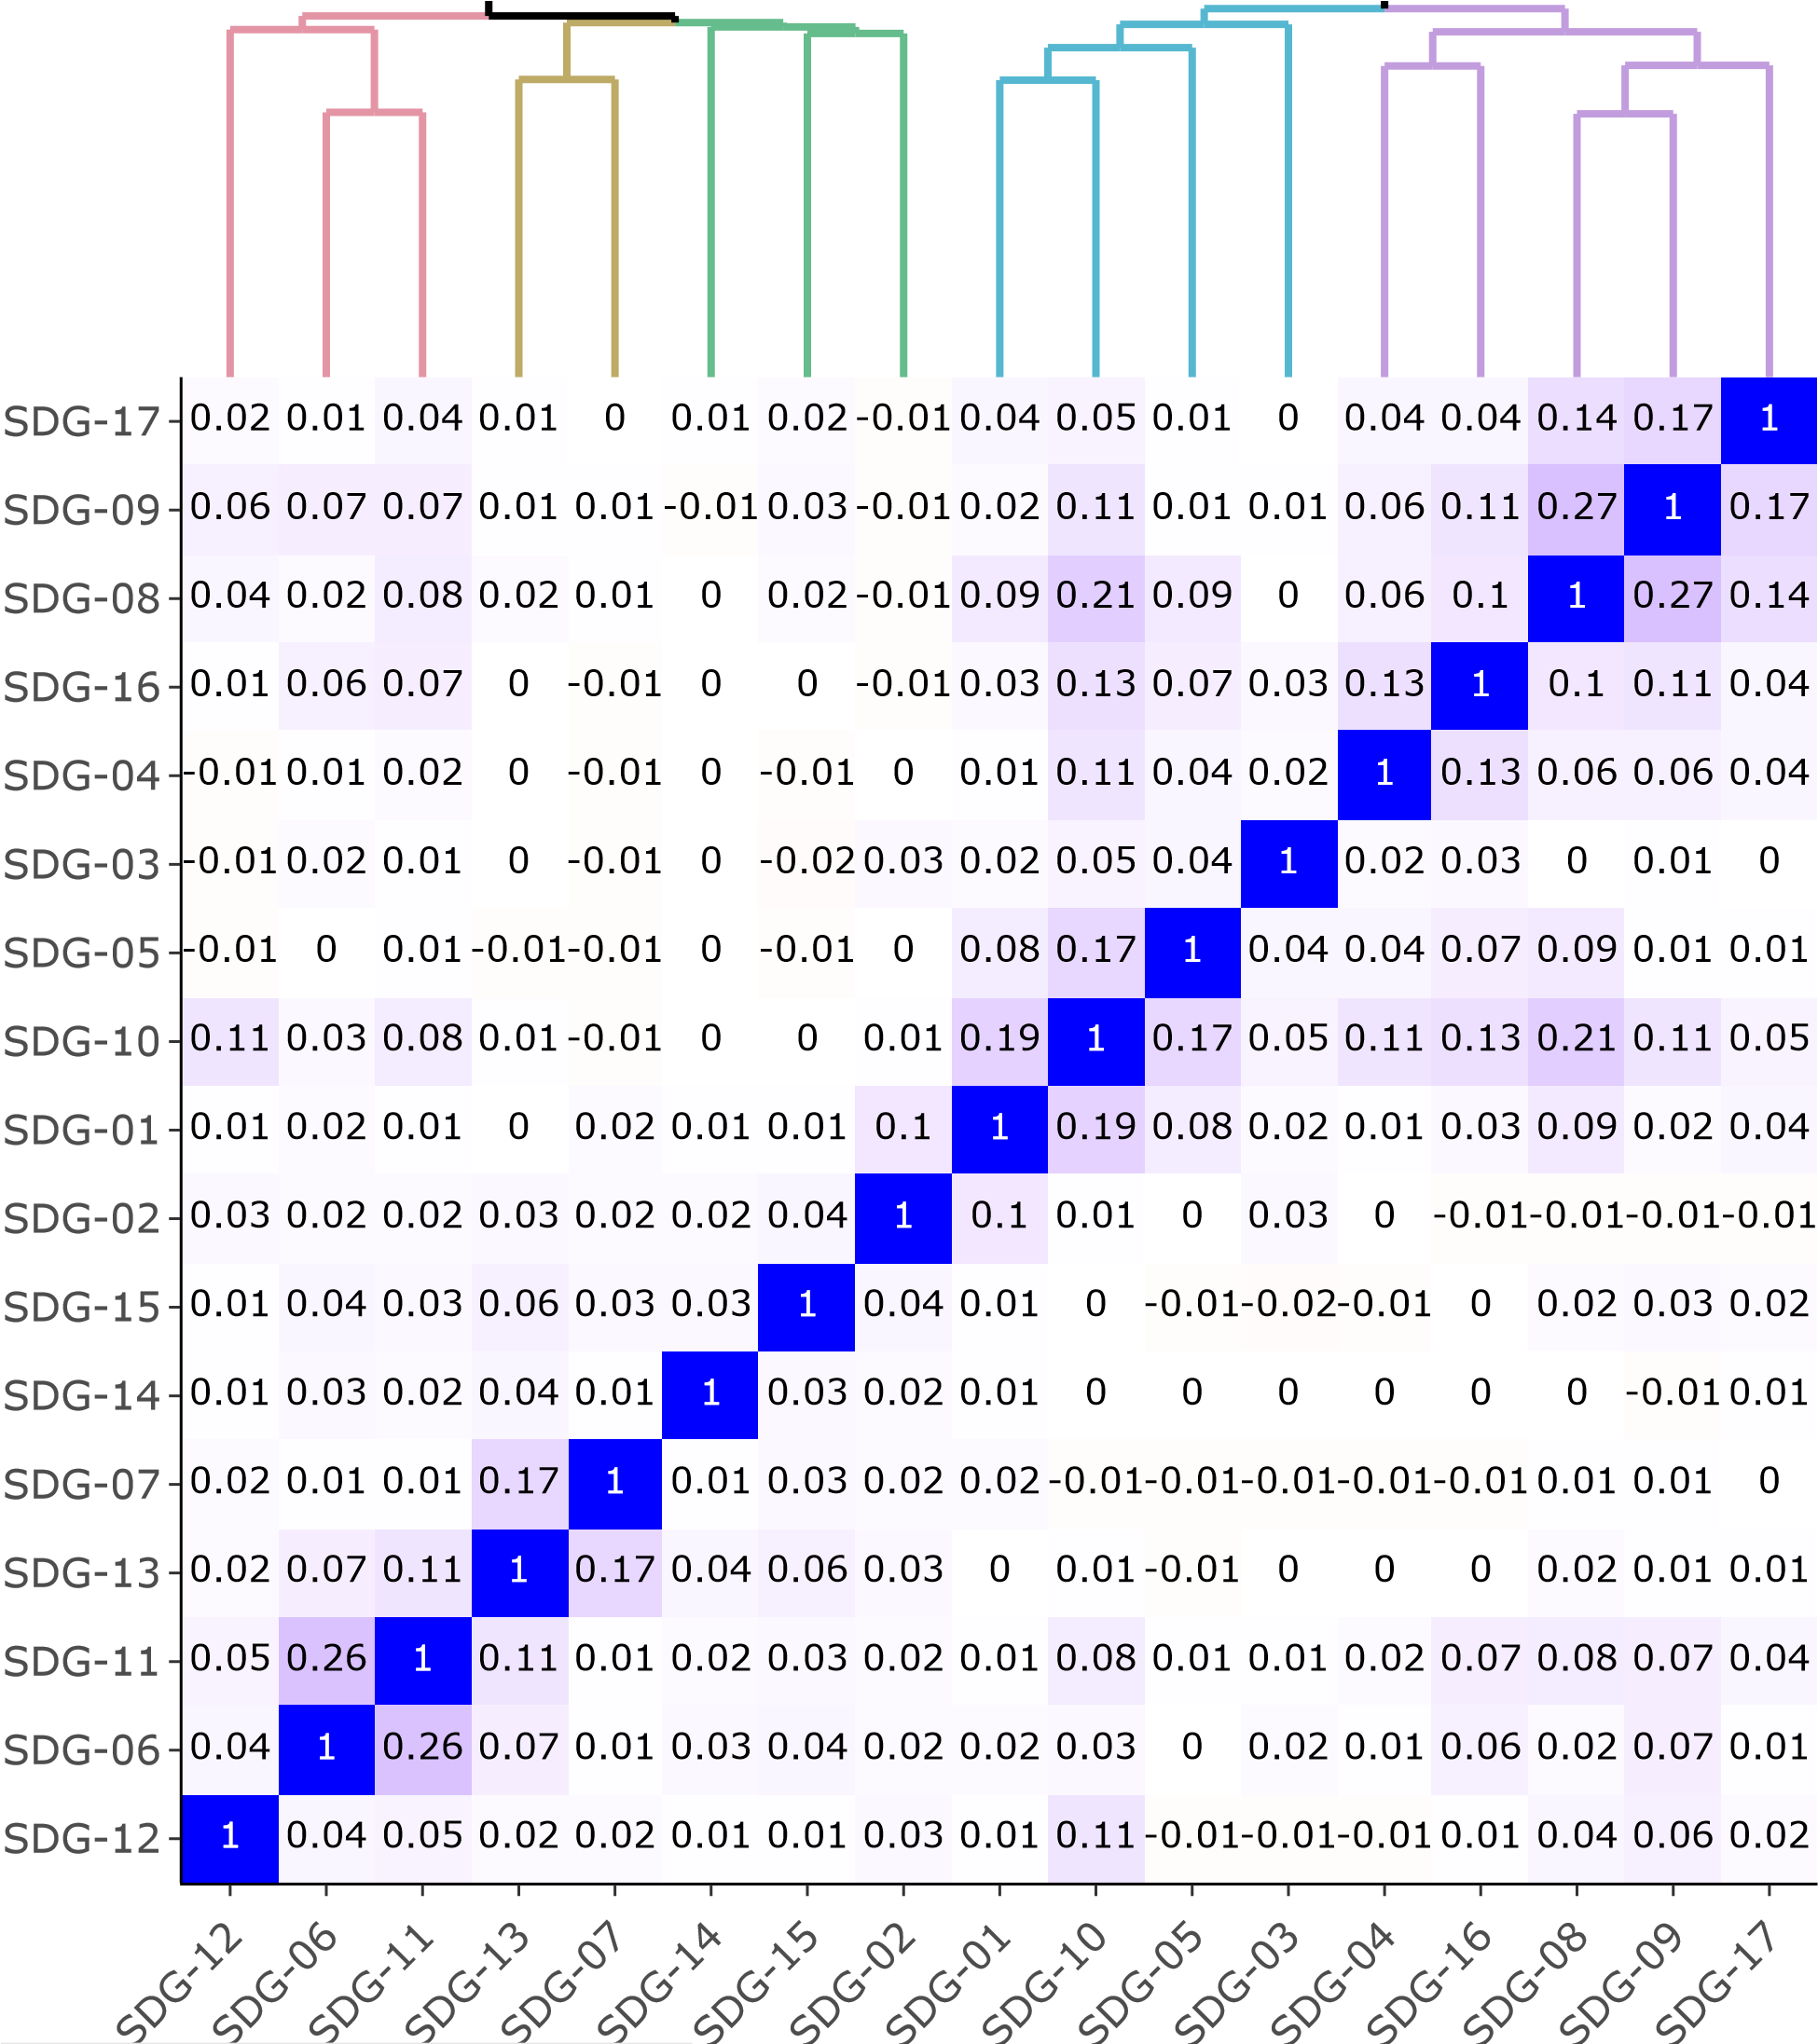

# Figure 7

*A) effect of an article being related to a specific SDG on citation count. X-axis truncated for visibility, regression tables shown in the appendix. B) effect of SDG relatedness of an article on citation count. C) effect of SDG relatedness of an article on citation count for articles published after 2015.*



# References

Agrawal, R., Majumdar, A., Majumdar, K., Raut, R. D., & Narkhede, B. E. (2022). Attaining sustainable development goals (sdgs) through supply chain practices and business strategies: A systematic review with bibliometric and network analyses.

*Business Strategy and the Environment*, *31*(7), 3669–3687.

<https://doi.org/https://doi.org/10.1002/bse.3057>

Allen, C., Metternicht, G., & Wiedmann, T. (2021). Priorities for science to support national implementation of the sustainable development goals: A review of progress and gaps. *Sustainable Development*, *29*(4), 635–652.

<https://doi.org/https://doi.org/10.1002/sd.2164>

Appe, S. (2022). Grassroots ingos in africa: Perspectives on what they are (and are not?)

*Nonprofit and Voluntary Sector Quarterly*, *51*(1), 125–147. <https://doi.org/https://doi.org/10.1177/0899764021991672>

Arhin, A. (2016). Advancing post-2015 sustainable development goals in a changing development landscape: Challenges of ngos in ghana. *Development in Practice*,

*26*(5), 555–568. <https://doi.org/10.1080/09614524.2016.1189513>

Bies, A. L., Lee, D. G., Lindsey, C., Stoutenborough, J. W., & Vedlitz, A. (2013).

*Nonprofit Policy Forum*, *4*(1), 5–28. <https://doi.org/doi:10.1515/npf-2012-0001>

Brodersen, K. H., Gallusser, F., Koehler, J., Remy, N., & Scott, S. L. (2015). Inferring causal impact using bayesian structural time-series models. *The Annals of Applied Statistics*, *9*(1), 247–274. Retrieved March 4, 2023, from <http://www.jstor.org/stable/24522418>

Callmer, Å., & Bradley, K. (2021). In search of sufficiency politics: The case of sweden.

*Sustainability: Science, Practice and Policy*, *17*(1), 194–208.

<https://doi.org/10.1080/15487733.2021.1926684>

Gehringer, T. (2020). Corporate foundations as partnership brokers in supporting the united nations’ sustainable development goals (sdgs). *Sustainability*, *12*(18). <https://doi.org/10.3390/su12187820>

Hall, N. L., & Taplin, R. (2010). Environmental nonprofit campaigns and state competition: Influences on climate policy in california. *Voluntas: International Journal of Voluntary and Nonprofit Organizations*, *21*, 62–81.

Hassan, M. M., Lee, K. E., & Mokhtar, M. (2020). Mainstreaming, institutionalizing and translating sustainable development goals into non-governmental organization’s programs. In K. E. Lee (Ed.), *Concepts and approaches for sustainability management* (pp. 93–118). Springer International Publishing.

<https://doi.org/10.1007/978-3-030-34568-6_6>

Hecht, A. D., Fiksel, J., Fulton, S. C., Yosie, T. F., Hawkins, N. C., Leuenberger, H., Golden, J. S., & Lovejoy, T. E. (2012). Creating the future we want. *Sustainability:*

*Science, Practice and Policy*, *8*(2), 62–75.

<https://doi.org/10.1080/15487733.2012.11908098>

Hege, E., & Demailly, D. (2017). How do ngos mobilize around the sdgs and what are the ways forward: A french-german comparison. *IDDRI Working Paper*, 8.

Hess, D. J., & Gentry, H. (2019). 100% renewable energy policies in u.s. cities: Strategies, recommendations, and implementation challenges. *Sustainability: Science, Practice and Policy*, *15*(1), 45–61. <https://doi.org/10.1080/15487733.2019.1665841>

Jayabalasingham, B., Boverhof, R., Agnew, K., & Klein, L. (2019). Identifying research supporting the united nations sustainable development goals. *Mendeley Data*, *1*.

<https://doi.org/10.17632/87txkw7khs.1>

Johnson, E. W., Coma, A., & Castonguay, S. (2023). Characteristics of large environmental nonprofits that identify climate change and social justice as focal concerns. *Nonprofit and Voluntary Sector Quarterly*, *Online first*, 08997640221138264. <https://doi.org/10.1177/08997640221138264>

Kagan, J. A., & Dodge, J. (2022). The third sector and climate change: A literature review and agenda for future research and action. *Nonprofit and Voluntary Sector*

*Quarterly*, *Online First*, 08997640221123587. <https://doi.org/10.1177/08997640221123587>

Körfgen, A., Förster, K., Glatz, I., Maier, S., Becsi, B., Meyer, A., Kromp-Kolb, H., & Stötter, J. (2018). It’s a hit! mapping austrian research contributions to the sustainable development goals. *Sustainability*, *10*(9).

<https://doi.org/10.3390/su10093295>

Kroll, C., Warchold, A., & Pradhan, P. (2019). Sustainable development goals (sdgs): Are we successful in turning trade-offs into synergies? *Palgrave Communications*, *5*(1),

140. <https://doi.org/10.1057/s41599-019-0335-5>

LePere-Schloop, M., & Nesbit, R. (2022). Disciplinary contributions to nonprofit studies: A 20-year empirical mapping of journals publishing nonprofit research and journal citations by nonprofit scholars. *Nonprofit and Voluntary Sector Quarterly*,

08997640221119728. <https://doi.org/https://doi.org/10.1177/08997640221119728>

Ligorio, L., Venturelli, A., & Caputo, F. (2022). Tracing the boundaries between sustainable cities and cities for sustainable development. an lda analysis of management studies. *Technological Forecasting and Social Change*, *176*, 121447. <https://doi.org/https://doi.org/10.1016/j.techfore.2021.121447>

Londoño-Pineda, A. A., & Cano, J. A. (2022). Assessments under the united nations sustainable development goals: A bibliometric analysis. *Environmental and Climate*

*Technologies*, *26*(1), 166–181. <https://doi.org/doi:10.2478/rtuect-2022-0014>

Ma, J., & Konrath, S. (2018). A century of nonprofit studies: Scaling the knowledge of the field. *VOLUNTAS: International Journal of Voluntary and Nonprofit Organizations*,

*29*(6), 1139–1158. <https://doi.org/10.1007/s11266-018-00057-5>

Meier, D. S., Mata, R., & Wulff, D. U. (2021). Text2sdg: An open-source solution to monitoring sustainable development goals from text. *arXiv preprint arXiv:2110.05856*.

Meschede, C. (2020). The sustainable development goals in scientific literature: A bibliometric overview at the meta-level. *Sustainability*, *12*(11).

<https://doi.org/10.3390/su12114461>

Messerli, P., Kim, E. M., Lutz, W., Moatti, J.-P., Richardson, K., Saidam, M., Smith, D.,

Eloundou-Enyegue, P., Foli, E., Glassman, A., Licona, G. H., Murniningtyas, E., Staniškis, J. K., van Ypersele, J.-P., & Furman, E. (2019). Expansion of sustainability science needed for the sdgs. *Nature Sustainability*, *2*(10), 892–894. <https://doi.org/10.1038/s41893-019-0394-z>

Mintzberg, H. (2019). Please welcome csr 2.0. In T. Wunder (Ed.), *Rethinking strategic management: Sustainable strategizing for positive impact* (pp. 43–46). Springer

International Publishing. <https://doi.org/10.1007/978-3-030-06014-5_2>

Mio, C., Panfilo, S., & Blundo, B. (2020). Sustainable development goals and the strategic role of business: A systematic literature review. *Business Strategy and the*

*Environment*, *29*(8), 3220–3245. <https://doi.org/https://doi.org/10.1002/bse.2568>

Nordin, N., Khatibi, A., & Azam, S. F. (2022). Nonprofit capacity and social performance:

Mapping the field and future directions. *Management Review Quarterly*, 1–55.

<https://doi.org/https://doi.org/10.1007/s11301-022-00297-2>

Pizzi, S., Caputo, A., Corvino, A., & Venturelli, A. (2020). Management research and the un sustainable development goals (sdgs): A bibliometric investigation and systematic review. *Journal of Cleaner Production*, *276*, 124033. <https://doi.org/https://doi.org/10.1016/j.jclepro.2020.124033>

Pradhan, P., Costa, L., Rybski, D., Lucht, W., & Kropp, J. P. (2017). A systematic study of sustainable development goal (sdg) interactions. *Earth’s Future*, *5*(11),

1169–1179. <https://doi.org/https://doi.org/10.1002/2017EF000632>

Rietig, K. (2011). Public pressure versus lobbying-how do environmental ngos matter most in climate negotiations? *Grantham Research Institute on Climate Change and the*

*Environment Working Paper No. 70*.

Sachs, J. D., Kroll, C., Lafortune, G., Fuller, G., & Woelm, F. (2022). *Sustainable development report 2022*. Cambridge University Press.

Sachs, J. D., Schmidt-Traub, G., Mazzucato, M., Messner, D., Nakicenovic, N., & Rockström, J. (2019). Six transformations to achieve the sustainable development goals. *Nature sustainability*, *2*(9), 805–814.

<https://doi.org/https://doi.org/10.1038/s41893-019-0352-9>

Salvia, A. L., Leal Filho, W., Brandli, L. L., & Griebeler, J. S. (2019). Assessing research trends related to sustainable development goals: Local and global issues. *Journal of*

*Cleaner Production*, *208*, 841–849.

<https://doi.org/https://doi.org/10.1016/j.jclepro.2018.09.242>

Saxena, A., Ramaswamy, M., Beale, J., Marciniuk, D., & Smith, P. (2021). Striving for the united nations (un) sustainable development goals (sdgs): What will it take?

*Discover Sustainability*, *2*, 1–14.

<https://doi.org/https://doi.org/10.1007/s43621-021-00029-8>

Sénit, C.-A. (2020). Leaving no one behind? the influence of civil society participation on the sustainable development goals. *Environment and Planning C: Politics and*

*Space*, *38*(4), 693–712. <https://doi.org/http://dx.doi.org/10.1177/2399654419884330>

Sweileh, W. M. (2020). Bibliometric analysis of scientific publications on “sustainable development goals” with emphasis on “good health and well-being” goal

(2015–2019). *Globalization and Health*, *16*(1), 68.

<https://doi.org/10.1186/s12992-020-00602-2>

*The Global Risks Report* (tech. rep. No. 18). (2023). World Economic Forum.

Trane, M., Marelli, L., Siragusa, A., Pollo, R., & Lombardi, P. (2023). Progress by research to achieve the sustainable development goals in the eu: A systematic literature review. *Sustainability*, *15*(9). <https://doi.org/10.3390/su15097055>

United Nations. (2022). *Progress chart*. Retrieved May 18, 2023, from <https://unstats.un.org/sdgs/report/2022/progress-chart/>

Vanderfeesten, M., Otten, R., & Spielberg, E. (2020). *Search Queries for "Mapping*

*Research Output to the Sustainable Development Goals (SDGs)" v5.0* (Version 5.0).

Zenodo. <https://doi.org/10.5281/zenodo.3817445>von Schnurbein, G. (2020). One for all—sdg 17 as a driver to achieve the sustainable development goals. In G. von Schnurbein (Ed.), *Transitioning to strong partnerships for the sustainable development goals* (pp. 1–10). MDPI.

Wickham, H. (2011). Ggplot2. *WIREs Computational Statistics*, *3*(2), 180–185.

<https://doi.org/https://doi.org/10.1002/wics.147>

Wulff, D. U., Meier, D. S., & Mata, R. (2023). Using novel data and ensemble models to improve automated labeling of sustainable development goals. *arXiv preprint arXiv:2301.11353*.

Yamaguchi, N. U., Bernardino, E. G., Ferreira, M. E. C., de Lima, B. P., Pascotini, M. R., & Yamaguchi, M. U. (2023). Sustainable development goals: A bibliometric analysis of literature reviews. *Environmental Science and Pollution Research*, *30*(3),

5502–5515. <https://doi.org/10.1007/s11356-022-24379-6>

Yeh, S.-C., Hsieh, Y.-L., Yu, H.-C., & Tseng, Y.-H. (2022). The trends and content of research related to the sustainable development goals: A systemic review. *Applied*

*Sciences*, *12*(13). <https://doi.org/10.3390/app12136820>

1. <https://osf.io/xk4t6/?view_only=2a14d3e8211a4007abfb626217525fa9>