#STOP ASKING ME TO DONATE: UNDERSTANDING CAUSES OF FUNDRAISERS PERCEIVED ILLEGITIMACY FROM A CLASSIFICATION OF RESISTANT DONORS’ TWEETS.

Elodie Manthé (USMB)[1], Alexandre Morel (USMB)

# Abstract

While resistance to charity appeals is a diffuse phenomenon, some of its stronger manifestations are becoming observable online, thanks to social networks. This paper aims to explore what are the main causes for not giving expressed online by resistant donors. Using the Charity Triad Theory and attribution theory, a focus is made on the role of fundraiser on charity resistance.

Based on a coding of tweets with hashtag “stop asking me to donate” (n=706 tweets) and a correspondence analysis, we propose a 3-classes classification of resistant donors according to the type of fundraisers they were in contact with (disappointed citizens, upset consumers, annoyed donors). Then, thanks to an experimental design (n=190 respondents), we study the effect of donation request on the attribution of motives to the fundraiser, and on the consequences for charitable attitudes and behavior.

Theoretically, the study offers new insights for the comprehension and enrichment of the Charity Triad (donor-beneficiary-fundraisers, defined by Chapman et al., 2022) by showing that the fundraiser-donor dyad can lead to charity resistance through a perceived illegitimacy of fundraisers, which is affected by its the type of organization asking for donation. We also find that potential donors attribute mainly strategic-driven motives to the fundraiser requesting for donation. Yet, the mere fact that there is a request for a donation negatively affects potential donors' belief that the fundraiser is doing this for strategic reasons (e.g. to keep customers when the fundraiser is a company), probably because they don't believe that this action could be a win-win for the organization. the fundraiser donation implication on the sides of donor could have positive attitudinal outcomes.

From a managerial perspective, this study shows the importance of motives attribution to fundraisers by resistant donors which can help fundraisers to carefully design their philanthropic strategy. For charitable organizations, efforts should be done to avoid spamming donors; for companies fundraising for charities, there is a call for matching donation with donors; for political organizations, philanthropic appeals will not turn electors into donors if their expectations are unfulfilled; finally, for Universities, indebtedness of their alumni should be considered before asking them for money.

Key words: donation ; charitable resistance ; charity triad theory ; motive attribution

# Main text

## Introduction

“Would you like to round up the value of your purchases to the nearest euro, to support a charity?” In the past few years, a growing number of shoppers have had to respond yes or no to this question at check-out, whether in aid of Ukrainians, to support victims of the earthquake in Eastern Turkey/Syria, or for a huge variety of local and international charitable causes. The sums – a few cents when you are at check-out – may seem derisory. However, the act of microdonation (or rounding up your bill, or gifts to ‘check-out charities’) is becoming increasingly common among retail brands who see it as a way to boost their reputation. This phenomenon is of a great interest for charities – and brands who associate their image to virtuous organizations – but led to a dramatic increase in number of donation solicitations undergone by individuals on a daily basis. Some customers find this an easy and painless way to support a charity (Hwang et al., 2021). However, asking people to donate on each journey to check out can end up aggravating.

Indeed, statistical evidence points out the emergence of a backlash due to the over-solicitation of potential donors. Precisely, charitable giving by individuals in the U.S totaled $326 billion in 2021 (The Giving Environment, 2021). However, in the meantime, the giving is being done by a smaller percentage of the American population (The Giving Environment, 2021). Declining US Donor Participation is echoing the extensive use of marketing tools and practices by charitable organizations and fundraisers. Instead of an opportunity to show generosity, it can become a cause for embarrassment and anxiety (Hepworth et al., 2021), nourishing what the medias named “donation fatigue”. Practitioners too suggest that the commercial transformation of the nonprofit sector can lead to donor fatigue, defined as “a reluctance to commit to voluntary donations of resources or altruistic behavior […]” (Oxford Dictionary of Politics).

While resistance to charity appeals is a diffuse phenomenon, some of its stronger manifestations are becoming observable online thanks to social networks. The purpose of this article to go deep further to (a) explore what are the main reasons for not giving expressed online by resistant donors and (b) what type of motives are attributed to the fundraiser which can mediate charitable attitude and behaviors.

In brief, based on the Charity Triad Theory (Chapman and al., 2022), we stand that the donor-fundraiser dyad is of a great interest to explain resistant donors’ resentment. Rather than focusing on donors’ personal characteristics effect on donation behavior, we suggest that perceived fundraiser illegitimacy by the donor can be an antecedent for negative feelings and resistance behaviors (such as avoiding donation and bad online word-of-mouth). We will show that the misfit lies in the perceived motivations for solicitating donation that the donor allocates to the fundraiser. In other words, the two studies conducted for this research suggest that resistant donors assign different motives to the fundraiser, depending on its nature. Moreover, we qualify this result by showing that the motive attribution is partially dependent on the merry fact of soliciting a donation but can be moderated by the fact that the fundraiser associates is financially involved in the donation alongside the donors.

The current article contributes to the literature on fundraising, charitable giving and nonprofit marketing in three ways. First, by using an original netnographic method (n=706 tweets), we contribute to fill the gap on understanding resistant behaviors which are often hard to observe and measure. The analysis of online tweets allows us to capture verbatims of resistant donors that are otherwise difficult to obtain without a risk of biases when respondents are interviewed afterwards. Second, we put forward the importance of motive attribution from donors to fundraisers and the almost systematic attribution of egoist motives to fundraisers by resistant donors. Third, we deepen these findings with a test of an empirical model (n=190) to fine-tune the understanding of which dimensions of motives attribution by donors to fundraisers play a role in the construction of attitude towards the fundraiser and the donor’s willingness to donate.

The structure of the article is as follows. First, we present our conceptual framework build on the Charity Triad Theory (Chapman et al., 2022) and the Motive Attribution Theory (Thomas, Kureshi, and Vatavwala, 2020). We precise the interest of mobilizing such a literature to study donation resistance behaviors. Then, we present methods and main findings for Study 1 which relies on a netnography of the #StopAskingMeToDonate on twitter. This study results in a classification of resistant donors. After spotlighting the role of fundraiser perceived legitimacy among these classes, we elaborate an experimental model in Study 2 to test for the effect of a donation request on three types of motives that can be attributed to fundraisers (values-driven, egoistic, strategic). Then, we present results for the test of an experimental model for a donation request within a store (i.e. with the fundraiser being a non-professional fundraising organization). Finally, we generally discuss Study 1 and Study 2 findings before suggesting future research avenue based on identified limitations.

## Conceptual framework

*Charity triad theory*

The Charity Triad Theory proposes a holistic framework to understand how donors, charitable organizations, and beneficiaries interact, as well as the underlying mechanisms explaining each stakeholder's behavior. Conducting an extensive systematic review of philanthropic literature, Chapman et al. (2022) posit that charitable giving is a triadic phenomenon involving donors, beneficiaries, and fundraisers. Defined as “the ones asking for money” (p.1835), the latter can be individual or organizational. The authors highlight that literature on philanthropy usually focuses on one of the stakeholders, the donors, overpassing the role and interaction with the two others actors in the triad – the fundraiser and the charitable cause. This shared bias led research to simplify underlying mechanisms of charitable behavior. Thus, they propose to reintroduce complexity, and accuracy, in the literature research by introducing the study of interactions within the Charity Triad. Among many research avenues, the authors propose that perceived legitimacy - defined as perceived validity and appropriateness of a fundraiser to be representative of a cause (Suchman 1995)– can influence donation responses in a dyadic relationship with donors.

*Fundraiser perceived legitimacy and behavioral outputs*

In philanthropy, Heydemann and Toepler (2006) distinguishes between procedural legitimacy – fitting to legal requirements – and normative legitimacy – a normative and subjective understanding of what is appropriate. In this research we take up this second approach to legitimacy.

Fundraiser perceived legitimacy influences donation behavior. Despite inconsistent findings among research, some studies have demonstrated that fundraiser legitimacy may promote giving but its effect may vary across donors (Karlan & Wood, 2017). A fundraiser is perceived as legitimate if it is seen as a valid and appropriate representative of the cause (Chapman et al., 2022; Suchman, 1995). For organizational fundraisers, legitimacy lies in their track-record, reputation, trustworthiness (Chapman et al., 2022). In this research, we assume that fundraiser’s legitimacy is also elicit by the motives (egoistic or altruistic) attributed to the fundraiser by the potential donors. Legitimacy has been associated to date with fundraisers dedicated to charitable causes (Bodem‐Schrotgens & Becker,2020; Gneezy et al., 2014) but less frequently with other types of fundraisers, such as political organizations, Universities or companies using donation campaigns as a tool to implement their corporate social responsibility (CSR).

*Charity resistance and attribution theory*

As motives attribution has been shown to influence fundraiser credibility, a closed concept from legitimacy (del Mar Garcia de los Salmones, et al.,2013), we mobilize motive attribution theory to study fundraiser’s legitimacy issues in a non-profit context. The attribution theory describes how individuals make causal inferences about others’ behaviors whether it is perceived as egoist and self-interest or altruistic and others-oriented. The underlying precept of attribution theory in the context of cause-related marketing, and more generally of CSR is that “people care less about what others do than about why they do it’’ (Gilbert and Malone, 1995, p. 21). Certain attributions can influence consumers’ behavioral intentions and attitudes, such as, purchase intent or recommendation intentions (Ellen et al., 2006). In the meantime, attributing motives to an organization can be a complex task for consumers. In a climate of mistrust, entities' actions are scrutinized, analyzed and interpreted, encouraging individuals to “entertain multiple, plausible rival hypotheses about the motives or genuineness” of an organization’ behavior. Individuals perceive altruistic motives if they consider that the organization is supporting a cause for benefiting the society. On the other hand, potential donors will perceive egoistic motives if they think that the fundraiser is seeking to support its own interests (Becker-Olsen et al., 2006). In the second case, people can react badly because they assume that they are being manipulated or because they are deceived that the fundraiser adopt such a behavior (Foreh and Grier, 2003). In cause-related marketing, the motive attribution perspective is the most popular theory (Thomas, Kureshi, and Vatavwala, 2020) and can help to study consumer resistance mechanisms (Folkes, 1984). Considering the importance of these attributions as attitudinal response mechanisms, the current research sought to identify if the attributed motives a potential donor assigns to donation request mediate the relationship between the donation request (i.e., absence vs. presence) and two outcomes (i.e., attitude toward the fundraiser and willingness to donate).

Building against this literature, we hypothesize that fundraiser type plays an important role in the appearance of charity resistance and that egoist motives are often attributed to fundraisers by resistant donors. We therefore present Study 1 which is an exploratory online study aiming to understand reasons for not giving expressed by resistant donors and to identify a potential issue with the fundraiser's legitimacy before developing Study 2 which posit various hypotheses to build and test a conceptual model around motive attribution concept.

## Study 1 – exploratory netnography

## Procedure

An automated tweet-scrapping via octoparse is performed to collect the data of 828 tweets mentioning hashtag “stop asking me to donate” (until 07/15/2022). After cleaning data (withdrawing tweets without text or out-of-scope), 706 tweets were retained. Considering some specificities of the content obtained (low variety of words employed, lot of familiar expressions and abbreviations, use of irony), a classification procedure following Weber (1990) method is conducted, preferred over classic text analysis procedure, to extract information on who are resistant donors, why do they tweet about their resistance, what do they say, what are the feelings expressed. A manual coding based on a thematic analytic grid is realized ensuring all the methodological precautions (open and axial coding, dual-coding, intercoder reliability check). Then, a Correspondence Analysis is run to analyze the interactions of the qualitative variables identified.

## Results

Fundraisers’ type is particularly discriminant in clustering charity resistance manifestations. There are significative differences among type of fundraisers in motives attributed, type of claim (individual/collective) and cause for their perceived illegitimacy. Indeed, although perceived illegitimacy is mentioned systematically among tweets with #stopaskingmetodonate, the main reason leading to this perception differs from an organization to another (see Table 1 for Khi2 analyses). Interestingly, when the fundraiser is a charitable organization, donation appeals are mainly perceived as illegitimate due to lack of efficiency in targeting (verbatims mention too many requests and no consideration of last donation recency). When the organization is political, resistant donors express unfulfilled expectations that should be addressed before any donation appeals (“*why would I donate to you when you are completely ineffective while having complete control of the govt?”*). Considering businesses, retailers and companies in general, charity resistance manifestations seem to be generated by a lack of reciprocity in donation and are associated with egoist motives (*“Businesses need to stop asking me to round up. How about YOU round down and donate THAT part? You make the first move to help out*”). Finally, donation requests from Universities and College are associated with egoist motives (61% for companies’ vs 11.8% for charitable organizations, *x*2=120.2, see Table 1). It leads to more individual claims, mainly about the indebtedness of alumni and their inability to give, considering the bad financial situation generated by the scholarship fees.

Table 1 – Khi2 analyses results

|  |  |  |  |  |
| --- | --- | --- | --- | --- |
| **Type of fundraiser** | **N** | **Main cause for perceived illegitimacy** | **Egoist motive attributed to fundraiser** | **Collective claim expressed** |
| Charitable organizations | 256 | Too many requests (45%) | 11.8% | 15.9% |
| Political organizations | 205 | Unfulfilled expectations (52%) | 7.1% | 50% |
| Companies | 164 | Absence of reciprocity (in donation) (38%) | 35% | 14.3% |
| Universities | 81 | Absence of reciprocity (in relationship) (41%) | 61% | 9.5% |
| **Total** | **706** |  |  |  |
| X2 statistics |  | 307.3 | 120.2 | 93.8 |
| Risk alpha |  | 1.35E-58 | 6.98E-26 | 3.4E-20 |

## Proposition of classification of charity resistance manifestations

Correspondence analysis reveals three main configurations of charity resistance manifestations (see Figure 1 for a graphic representation of correspondence analysis).

The first class gathers “*disappointed citizens*”, resisting to donation appeals from political organizations. Mentioning being able to give money they decide to not donate to manifest their displeasure with politicians. Their claims are more frequently collective (“*need to stop asking everyday people to donate”*).

The second class observed represents “*upset consumers*” which are reluctant to give money at companies, businesses, stores, websites while they are shopping. By fundraising for charities, companies are perceived as egoists, doing it for social washing. They are perceived as illegitimate to ask for money mainly because they do not match donation with their clients nor they give money themselves to the supported charity. Fed-up donors pan the lack of reciprocity in the arrangement: why should we give, when the store doesn’t? Businesses which ask for charity donations are accused of acting selfishly in 61% of cases, compared to just 11.8% when it’s the charity itself asking for money (Table 1). Customers can sometimes find it hard to tell the difference between a brand’s sincere support for a cause, and reputation laundering. Often this leads them to want to know where the donated money is going. This class is shared with “*upset alumni*” in bad financial situation outraged that their University insists on the need for donation.

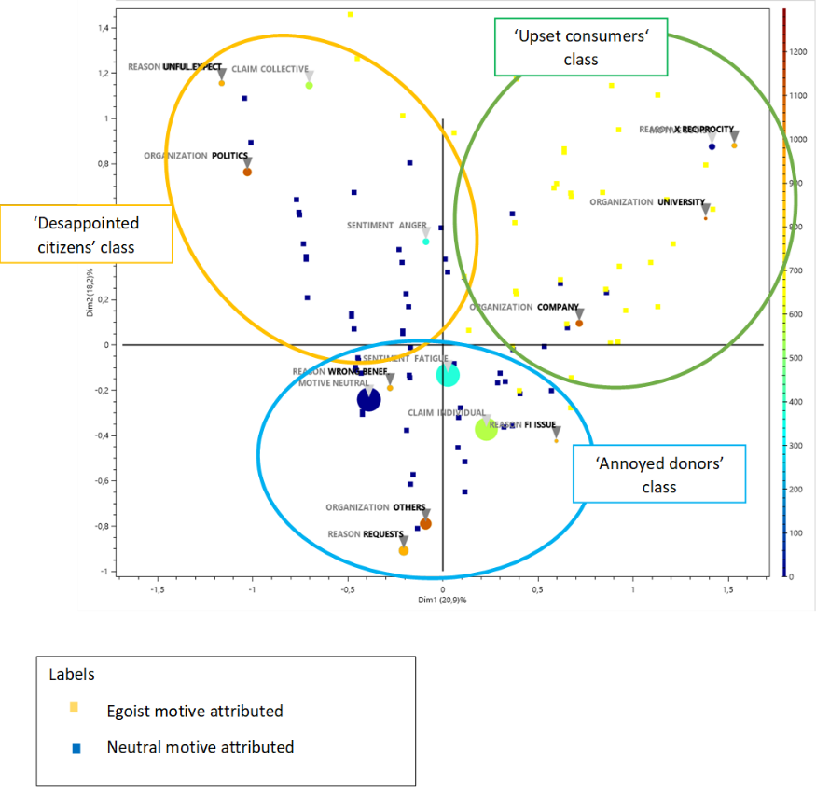Figure 1 – Graphical representation of Correspondence Analysis results

Finally, “*annoyed donors*” are irritated by the multiplication of donation appeals, the cross-canal communication and a poor targeting. Due to the multiple channels through which people are asked to give – over e-mail, by phone, in person, by mail, at the check-out etc – and places where they are asked (in the street, through their letterbox, at work, while they’re shopping, etc.) potential donors suffer from a lack of tailoring.

## Effect of individual financial situation

A correspondence analysis is run on tweets mentioning people financial ability to donate money (n=191).

Noticeably, totality of tweets mentioning a donation request by a University also mention the inability to give for the resistant donor. In the meantime, resistant donors to political donation appeals are more often able to give but choose to resist (inability to give according type of organization: politics =39%, charitable organizations=68%, companies=72%; universities=100%, x2=29.5, a =1.75E-06). Furthermore, attribution of egoist motives to fundraiser is more frequent when resistant donors declare not being able to give (31% of egoist motive attributed among people enable to give vs 3% among people able to give, x2 = 18.8, a = 1.452E-05).

## Discussion on Study 1

This previous exploratory study permits to have a better overview on how charity resistance is expressed and what are the causes resistant donors put forward for not giving. From the variety of situations encountered by potential donors we were however able to bring to light three main configurations of factors leading to strong reactance behaviors. While the proposed classes may seem very intuitive, the coding we carried out showed the importance of the fundraiser's role in charitable behavior.

In other words, the fact that the illegitimacy of the organization requesting the donation is so frequently cited should give us pause. From previous research, we know that the legitimacy of the fundraiser plays an important role in the charity triad (Chapman et al., 2022). Yet, although some antecedents to legitimacy and consequences have been studied, it's interesting to see that attribution of motivation appears very little in the literature, whereas it particularly stands out in the coding of tweets as being intricate with legitimacy. This observation does not allow us to conclude on the nature of the relationship between these two constructs. On the other hand, it does allow us to show that the attribution of motivation, like the perceived legitimacy of the fundraiser, seems to have attitudinal and behavioral consequences.

In addition, all the tweets studied had as their starting point a donation request. This simple request systematically provoked a strong negative reaction online for all these potential donors. We therefore propose to continue studying the effect of this request on the attribution of motivations to the fundraiser, and on the consequences for charitable attitudes and behavior in study 2.

## Study 2 – Effect of motive attribution on willingness to donate

The main objectives of study 2 are three-fold. First, we attempt to test for the effects of requesting donation on four types of motives that can be attributed to fundraisers (*values-driven, egoistic, strategic, stakeholders-driven*). Second, study 2 tests the existence of a mediating effect (total or partial) of motives attributed to fundraiser between the solicitation and behavioral outputs (attitude and willingness to donate). Last but not least, we test for a moderation effect for the presence/absence of a matching donation from the fundraiser. As mentioned in some verbatims analyzed in study 1, the absence of reciprocity in supporting a charitable cause from the fundraiser leads to attribution of egoistic motives by many resistant donors. We therefore test for a moderating effect on the donation request - motive attribution relationship through the presence of a matching donation by the fundraiser.

Study 1 shows that the resistant donors face a wide variety of fundraising association, not only professional fundraisers for non-profit causes. As a consequence, we decide to test the experimental model for a donation request within a store. This choice allows us to study the case where the fundraiser in a non-professional fundraising organization.

This choice is also supported by the plausibility of a store matching donation of its clients, rather than a University or a political organization. Lastly, attribution of egoist motives was particularly predominant within the ‘upset consumers’ class in study 1 findings which suggests that the effect of requesting for donation in a consumption context could lead to stronger effects than in others contexts.

Bryant et al. (2003) demonstrated that donors rarely give to charities without being asked to do so and Chapman et al. (2022) add that charities generally do not ask for themselves. Donation solicitation predicts the likelihood of charitable donation (Andreoni et al., 2017). Thus, we hypothesis that:

*H1: donation request has a positive effect on willingness to donate.*

On one hand, past research has shown the importance of fundraiser’s characteristics on charitable behavior, such as effectiveness (Bodem-Schrotgens & Becker, 2020), reputation based on size, brand image, trustworthiness (Bennett & Gabriel, 2000 ; Hornsey et al., 2021).

On another hand, the way fundraisers and beneficiaries interact to influence giving has been overpassed (Chapman et al., 2022). To answer the call for further research by these authors, we assume that motives attributed to the fundraiser asking for donation can influence both the willingness to donate and the attitude towards the fundraiser. As exposed in the literature section, this hypothesis stands on the fact that good deeds like asking people to support a cause may draw suspicion or on the contrary be perceived as a high commitment to the cause (Groza et al., 2011). Relying on motive attribution theory presented above, we suggest the following hypothesis:

*H2: The attributions will (at least partially) mediate the relationship between the donation request and attitudes toward the fundraiser (H2a) and willingness to donate (H2b).*

In the field of charitable action and CSR, previous research finds that the attribution of motivations to an organization is multidimensional. Ellen et al. (2006) and later Groza et al., (2011) posited that consumers attribute various motives to CSR engagement ranging from strategic-driven (e.g., the firm wants to increase sales), stake-holders-driven (e.g., engagement in CSR in adopted due to stakeholders’ pressure), egoistic (e.g. taking advantage of the firm) and values-driven motives (e.g., the firm sincerely believe CSR is good for society). According these authors CSR effort – which can take the form of supporting a charitable cause through a donation campaign – will have a positive effect on attribution of values-driven and strategic-driven motives but negative on egoistic and stakeholder-driven motives. In other words, a CSR action is more likely to be perceived as being for the good of society and the organization's long-term survival.

However, with study 1 we show that this type of solicitation for donations can provoke very negative reactions. Moreover, the multiplication of requests, sometimes on a daily basis, combined with the perceived illegitimacy of some fundraisers, accentuates this effect. Thus, unlike previous studies, we do not assume of direction of effects, but formulate the hypothesis as follows:

*H3: A donation request will have an effect on attribution of motives, whether they are (H3a) values-driven motives, (H3b) egoistic, (H3c) strategic, (H3d) stakeholders-driven motives.*

However, as the consequences of assigning motives have already been studied, we rely on Ellen et al. (2006) and Groza et al. (2011)'s work to put forward the following hypotheses.

*H4: A higher attribution of values-driven motives will have a positive effect on attitude towards the fundraiser (H4a) and on willingness to donate (H4b).*

*H5: A higher attribution of egoistic motives will have a positive effect on attitude towards the fundraiser (H5a) and on willingness to donate (H5b).*

*H6: A higher attribution of strategic-driven motives will have a positive effect on attitude towards the fundraiser (H63a) and on willingness to donate (H6b).*

*H7: A higher attribution of stakeholders-driven motives will have a positive effect on attitude towards the fundraiser (H7a) and on willingness to donate (H7b).*

The hypotheses are presented in a conceptual model hereafter (Figure 1).

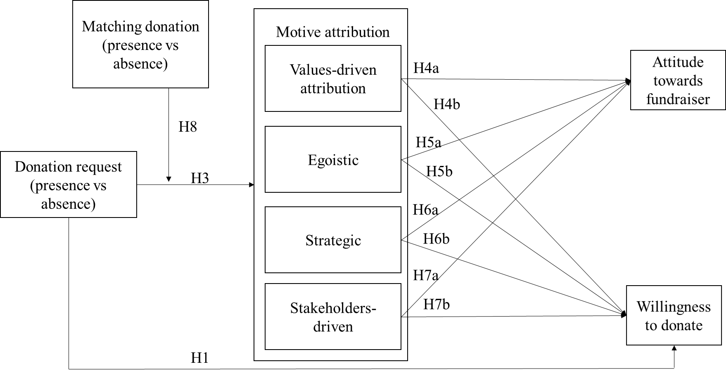Figure 1. Conceptual model

## Procedure

Study 3 employs a 2 (donation request: presence versus absence) x 2 (matching donation: presence versus absence) between-subjects design in which participants were randomly assigned to one of three conditions (the condition absence of request and absence of matching donation made no sense and was withdrawn). We recruited 190 participants (Mage=, 35% female) from a convenience panel. After answering socio-demographic questions, participants were randomly assigned to one of three scenarios. They were asked to read carefully a scenario with the same structure in every condition. For the condition presence of request/presence of matching donation, the message was as follows (see Appendix 1 for all scenarios details): “*You've finished shopping in a store and are about to check out. When it's time to pay, the cashier asks you if you'd like to round up your purchases to the nearest euro. This money will be donated to a cause supported by the store. He/she also informs you that the store doubles the donation made by its customers.”*

Motive attribution is three-dimensional with a total of seven items. It is adapted from Groza et al. (2011) and Ellen et al. (2006). After conducting factorial analysis with SPSS software and test for reliability, we withdrawn items related to stakeholders-driven motives from the original scale. Attitude towards the store is measured with three items from Kinard and Pardo (2017) on a 5-point Likert’s scale. Items for motive attribution which were measured with a 7-point Likert’s scale. Willingness to donate is measured with one item. Two control questions were added about past donation experience (Have you ever donated? Yes/No; If yes, how often do you give?). All the constructs are proved to be reliable with Cronbach’s α > .70) except from dimension 1 and attitude which are slightly above. Considering the exploratory nature of this study we deal with it and keep the constructs. A complete listing of the items and reliability indices is provided in Table 2.

Table 2. Constructs reliability and viability.

|  |  |  |  |
| --- | --- | --- | --- |
|  | Cronbach's alpha | Composite reliability (rho_a) | AVE |
| **ATTITUDE** | **0.639** | **0.643** | **0.734** |
| **DIM1 - values-driven** | **0.676** | **0.712** | **0.605** |
| *Their owners or employees believe in this cause.*  *They want to make it easier for consumers who care about the cause to support it.*  *They are trying to give something back to the community.* |  |  |  |
|  |  |  |  |
| **DIM2 - egoistic** | **0.882** | **0.920** | **0.893** |
| *They are taking advantage of the nonprofit organization to help their own business.*  *They are taking advantage of the cause to help their own business.* |  |  |  |
|  |  |  |  |
| **DIM3 - strategic** | **0.852** | **0.861** | **0.871** |
| *They will get more customers by making this offer.* |  |  |  |
| *They will keep more of their customers by making this offer.* |  |  |  |

## Results and discussion

**Main model**. A first phase of tests (ANOVA) led us to exclude the existence of direct relationships between matching donation and both attitude and willingness to donate (p=.693; p=.606). Similarly, there is no significant relationship between donation request and both attitude or willingness to donate (p=.277; p=.139).

With these initial results supporting a more complex effect, we conducted tests of mediating effects to test the proposed model. We tested a mediation model in which motives attributed to fundraiser mediate the relationship between donation request both willingness to donate and attitude towards the fundraiser. We used Hayes' (2013) PROCESS macro with 5,000 bootstraps provided but SmartPLS 4.0 software (see Figure 2).

Donation request has a strong significant and negative effect on dimension 3 “attribution of strategic-driven motives” (a3= **-** .535; p=.012). Relationships between donation request and Dimension 1 “attribution of values-driven motives” and Dimension 2 “attribution of stakeholders-driven motives” are insignificant (a1=--.040; p=.846; a2=-.271; p=.310).

Controlling for the presence or absence of request, we observe different effects of motives attribution on willingness to donate and attitude towards the fundraiser, depending on the dimension analyzed. Dimension 1 and Dimension 3 have a significant and positive effect on attitude (b1 ATT=.245, p=.000; b3 ATT=.129, p=.046) and on willingness to donate (b1 WTD=.288, p=.000; b3 WTD=.135, p=.038). Dimension 2 has an insignificant effect on willingness to donate and on attitude (see Figure 1 for detailed results).

Considering willingness to donate as output, the direct effect of donation request on willingness to donate is insignificant at a 95% confidence threshold (CI=[-.09 to .628]). The indirect effect of donation request on willingness to donate through the mediation of dimension 3 in significant but very weak (coeff= -.08) with a 95% confidence interval excluding 0 (CI=[-.207 to -.002]). This result supports the existence of a weak indirect mediation (Zhao et al., 2010).

Considering attitude as model output, the direct effect of donation request on willingness to donate is insignificant at a 95% confidence threshold (CI=[-309 to .153]). Th150e indirect effect of donation through the mediation of dimension 3 in significant but very weak (coeff= -.06) with a 95% confidence interval excluding 0 (CI=[-.152 to -.0032]). This result supports the existence of a weak indirect mediation (Zhao et al., 2010). Hypothesis 3 is therefore partially validated for one dimension of motive attribution (strategic-driven motives) with a lot of caution concerning the weight of the coefficient. Please refer to Table 3 for an overview of the hypothesis tests.

Table 3. overview of hypotheses

|  |  |
| --- | --- |
| Hypotheses | Results |
| H1: donation request has a positive effect on willingness to donate. | Not supported |
| H2: The attributions will (at least partially) mediate the relationship between the donation request and attitudes toward the fundraiser (H2a) and willingness to donate (H2b). | **Supported** |
| H3: A donation request will have an effect on attribution of motives, whether they are (H3a) values-driven motives, (H3b) egoistic, (H3c) strategic, (H3d) stakeholders-driven motives. | **Partially supported for H3c** |
| H4: A higher attribution of values-driven motives will have a positive effect on attitude towards the fundraiser (H4a) and on willingness to donate (H4b). | **Supported** |
| H5: A higher attribution of egoistic motives will have a positive effect on attitude towards the fundraiser (H5a) and on willingness to donate (H5b). | Not supported |
| H6: A higher attribution of strategic-driven motives will have a positive effect on attitude towards the fundraiser (H63a) and on willingness to donate (H6b). | **Supported** |
| H7: A higher attribution of stakeholder-driven motives will have a positive effect on attitude towards the fundraiser (H7a) and on willingness to donate (H7b). | Not supported |
| H8: Matching donation has a moderating effect on the relationship between motives attributed and attitude and willingness to donate. | **Supported** |

**Controlling for gender and past donation.** We controlled the model for differences between genders and between donors (at least one donation made in the past) and non-donors (who never have donated). None of these two variables have influence on the attribution of motives to fundraiser but do have an effect on outputs variables. In this case, there is a standard deviation of .122 between males and females on attitude measure (p=.000) and a standard deviation of .158 between people with a past experience of donation and those who never donated on their willingness to donate (p=.000).

**Moderation test**. Considering the weakness of the indirect path between request and model outputs, we also tested a moderated mediation model. We tested for the moderation effect of the presence of a matching donation from the fundraiser on the relationship between each dimensions of motive attribution on WTD. The analysis was conducted using Hayes' (2013) PROCESS macro (Models 14), with 5000 bootstraps on SPSS.

There is a significant negative effect of interaction between dimension 3 and matching donation on WTD (αDIM3 x MATCHING =-.296, p=.049). All the loadings and their significance are presented on Figure 2. To go further, we conducted a multigroup analysis by recoding experimental data. Condition “presence of donation request x no matching donation” was coded as “donation from donor” for supporting the cause (group 1). Condition “presence of donation request x matching donation” was coded as “shared donation” (group 2). Condition “no donation request x matching donation” was coded as “donation from fundraiser” (group 3). We then run ANOVA analysis on SPSS and MGA Bootstrapping on SmartPLS 4.0 (5,000 iterations).

Table 4. Paths coefficient- bootstrapping results for MGA with donation origin.

|  |  |  |  |  |  |  |
| --- | --- | --- | --- | --- | --- | --- |
|  | Mean (Group1) | Mean (Group_2) | Mean (Group_3) | p value (Group_1) | p value (Group_2) | p value (Group_3) |
| DIM1 -> ATT | 0.205 | 0.375 | 0.418 | 0.153 | **0.000** | 0.073 |
| DIM1 -> WTD | 0.362 | 0.362 | 0.243 | **0.002** | **0.001** | 0.258 |
| DIM2 -> ATT | -0.082 | -0.101 | 0.039 | 0.496 | 0.466 | 0.916 |
| DIM2 -> WTD | -0.152 | -0.118 | 0.138 | 0.177 | 0.264 | 0.302 |
| DIM3 -> ATT | 0.316 | 0.027 | 0.329 | **0.038** | 0.826 | 0.077 |
| DIM3 -> WTD | 0.251 | 0.102 | 0.102 | **0.019** | 0.211 | 0.563 |

By doing so, we found that there are no significative differences in motive attributions according the group. Same observation for paths differences between groups. But what is intriguing is that this non-significance comes from the fact that some paths coefficients are not consistently significant among groups. Referring to table 4, we observe that if the donation is handled by fundraiser. When the donation effort is requested from the donor (group1), there is a positive effect of attributing altruistic motives to fundraiser (DIM1) on willingness to donate but not on attitude. In contrast, a shared donation with donor through matching donation (Group 2) leads to a positive effect of altruistic motives attribution on attitude. In the same vein, strategic motives (DIM3) attributed has a significative effect on both attitude and donation only for the group1.

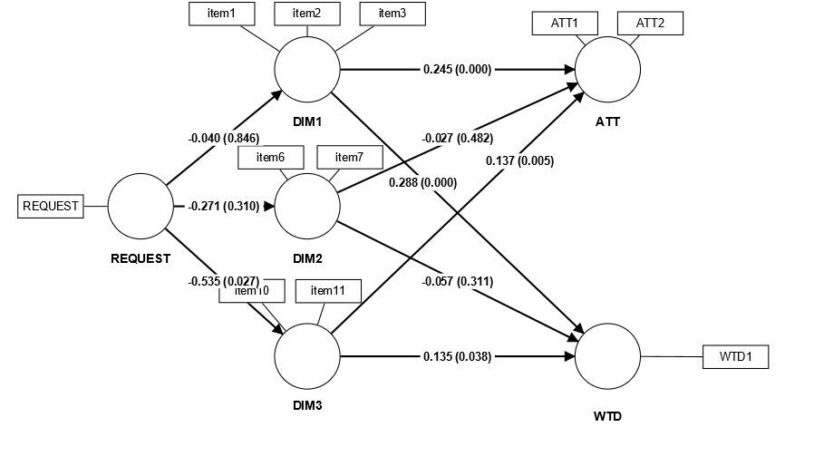Figure 2. Graphical output for PROCESS model test (paths coefficients and p-values)

## Main discussion

The methodologies and objectives of studies 1 and 2 are complementary in that they enable us to answer our research questions, which are as follows: what are the main reasons for not giving expressed online by resistant donors and (b) what type of motives are attributed to the fundraiser which can mediate charitable attitude and behaviors.

Study 1 highlights the importance of motive attribution and perceived legitimacy for fundraisers depending on their organizational nature. In addition to contributing to the philanthropic marketing literature, the findings contribute both in cause-related marketing and checkout charity literature by showing that when the fundraiser is a company, the cause of perceived illegitimacy is mainly the absence of reciprocity in donation. On the one hand, “irritated customers” sense a kind of illegitimacy in a chain associating itself with their gift, which could damage the brand’s image in their eyes and their desire to go back there. On the other, “annoyed donors,” tired of being solicited to give money wherever they go, by multiple means, without a message tailored to them, might just give up on charity appeals.

Thanks to study 2, we are able to conclude that simply requesting donation can lead to attribution of strategic-driven motivations but not to attribution of altruistic nor egoistic ones. In other words, the attribution of selfish motives does not come from the simple fact of asking for a donation as we might have expected from the analysis of the tweets in study 1. Likewise, the attribution of altruistic motives does not depend either more of this solicitation. On the other hand, we show that when some altruistic motives are attributed (for factors that are not captured here), reciprocity in giving (multigroup analyzes of study 2 for matching donation) will make it possible to improve the attitude AND willingness to donate. On the other hand, if donating to the cause is offered to the donor without reciprocity from the fundraiser, the effect on the attitude towards the fundraiser disappears.

If we focus on the strong, negative effect of donation solicitation on the attribution of strategic motives highlighted in Study 2, it differs from Ellen et al. (2006) results which is intriguing. This result indicates that soliciting a donation, for a fundraiser, reduces potential donors' belief that the fundraiser is doing so for strategic motives. This may seem counter-intuitive without rereading the wording of the items in the "strategic-driven" dimension: *They will get more customers by making this offer / They will keep more of their customers by making this offe*r. It seems, therefore, that potential donors perceive a negative effect of soliciting donations on the organization's long-term strategy, in particular its ability to retain customers. Soliciting potential donors thus reduces the attribution of strategic motivations, as they seem to evaluate that the organization cannot do so to keep or win customers. In the light of the two studies, we propose to interpret this result as meaning that they assess a risk of detrimental outcomes for the organization soliciting donations, notably losing customers.

Theoretically, the study offers new insights for the comprehension of the Charity Triad (donor-beneficiary-fundraisers, defined by Chapman et al., 2022) by showing that the fundraiser-donor dyad can lead to charity resistance through a perceived illegitimacy of fundraisers, which is affected by its the type of organization asking for donation. In addition, we are enriching this theory by studying the effects of interaction between the donor and the fundraiser, by experimentally testing the latter's involvement in the donation, alongside the donor. We are also helping to enrich our understanding of donation behavior by demonstrating the existence of a (weak but significant) mediation between donation demand and willingness to donate through a dimension of motives attribution. Finally, our exploratory study (study 1) suggests the existence of a correlation between the attribution of motives and the perceived legitimacy of the fundraiser.

In addition to contributing to the philanthropic marketing literature, the findings contribute both in cause-related marketing and checkout charity literature.

From a managerial perspective, this study shows the importance of motives attribution to fundraisers by resistant donors which can help fundraisers to carefully design their philanthropic strategy. By examining the downsides of asking for money donations, it allows us to better understand how to adapt charity gift campaigns to avoid wearing out donors’ generosity. In fact, chains and charities should take into consideration customers who don’t see rounding up the value of purchases for charity donations in a positive light.

For charitable organizations, efforts should be done to avoid spamming donors; for companies fundraising for charities, there is a call for matching donation with donors; for political organizations, philanthropic appeals will not turn electors into donors if their expectations are unfulfilled; finally, for Universities, indebtedness of their alumni should be considered before asking them for money.

## Limitations and research avenue

Despite our rigorous efforts, this research is not without its limitations, which are just as many avenues of research opened.

First, our work is limited to explain direction and loads of relationships between attribution of motives and perceived (il)legitimacy as antecedents of charity resistance manifestations. Even if some evidences plea

Furthermore, external validity of the results can be limited considering that tweets analyzed may be context-dependent. argues for a correlation between motivation attribution and perceived legitimacy of the fundraiser, the legitimacy construct was not included in our model as we were focusing on the motivation attribution that was mentioned within each class of resistant donors. testing a model linking these two constructs would be of great interest.

Secondly, we have justified the choice of studying a charity checkout context for the experiment in study 2. This choice is also a limitation in terms of the external validity of the results. We encourage future research to explore other contexts.

Finally, we have controlled the results for the gender and age of potential donors but other individual characteristics that may interact with those of the fundraiser should be integrated.

**References**

Andreoni, J., Rao, J. M., & Trachtman, H. (2017). Avoiding the ask: A field experiment on altruism, empathy, and charitable giving. Journal of Political Economy, 125(3), 625–653. https://doi.org/10.1086/ 691703

Becker-Olsen, K. L., Cudmore, B. A., & Hill, R. P. (2006). The impact of perceived corporate social responsibility on consumer behavior. *Journal of business research*, *59*(1), 46-53.

Bennett, R., & Gabriel, H. (2000). Image building for charitable organizations. Social Marketing Quarterly, 6(3), 77–80. https://doi.org/10. 1080/15245004.2000.9961124

Bryant, W., Jeon‐Slaughter, H., Kang, H., & Tax, A. (2003). Participation in philanthropic activities: Donating money and time. Journal of Consumer Policy, 26(1), 43–47.

Bodem‐Schrotgens, J., & Becker, A. (2020). Do you like what you see? How nonprofit campaigns with output, outcome, and impact effectiveness indicators influence charitable behavior. Nonprofit and Voluntary Sector Quarterly, 49(2), 316–335. [https://doi.org/10. 1177/0899764019868843](https://doi.org/10.%201177/0899764019868843)

Chapman, Cassandra M., Winnifred R. Louis, Barbara M. Masser, et Emma F. Thomas. « Charitable Triad Theory: How Donors, Beneficiaries, and Fundraisers Influence Charitable Giving ». *Psychology & Marketing* 39, no 9 (2022): 1826‑48. <https://doi.org/10.1002/mar.21701>.

Chapman, C. M., Louis, W. R., Masser, B. M., & Thomas, E. F. (2022). Charitable Triad Theory: How donors, beneficiaries, and fundraisers influence charitable giving. *Psychology & Marketing*, *39*(9), 1826-1848.

del Mar Garcia de los Salmones, M., Dominguez, R., & Herrero, A. (2013). Communication using celebrities in the non-profit sector: Determinants of its effectiveness. *International Journal of Advertising*, *32*(1), 101-119.

Ellen, P. S., Webb, D. J., & Mohr, L. A. (2006). Building corporate associations: Consumer attributions for corporate socially responsible programs. *Journal of the academy of Marketing Science*, *34*(2), 147-157.

Folkes, V. S. (1984). Consumer reactions to product failure: An attributional approach. *Journal of consumer research*, *10*(4), 398-409.

Foreh, M. R., & Grier, S. (2003). When is honesty the best policy? The effect of stated company intent on consumer skepticism. *Journal of consumer psychology*, *13*(3), 349-356.

Gilbert, D. T., & Malone, P. S. (1995). The correspondence bias. *Psychological bulletin*, *117*(1), 21.

Gneezy, U., Keenan, E. A., & Gneezy, A. (2014). Avoiding overhead aversion in charity. *Science*, *346*(6209), 632-635.

Groza, M. D., Pronschinske, M. R., & Walker, M. (2011). Perceived organizational motives and consumer responses to proactive and reactive CSR. *Journal of business ethics*, *102*, 639-652.

Heydemann, S., & Toepler, S. (2006). Foundations and the challenge of legitimacy in comparative perspective. *The legitimacy of philanthropic foundations: United States and European perspectives*, 3-26.

Hornsey, M. J., Chapman, C. M., Mangan, H., La Macchia, S., & Gillespie, N. (2021). The moral disillusionment model of organizational transgressions: Ethical transgressions trigger more negative reactions from consumers when committed by nonprofits. Journal of Business Ethics, 172, 653–671. <https://doi.org/10.1007/s10551-020-04492-7>

Hwang, Yoo Hee, Sungwoo Choi, et Anna S. Mattila. « Rounding up for a Cause: The Joint Effect of Donation Type and Crowding on Donation Likelihood ». *International Journal of Hospitality Management* 93 (février 2021): 102779. https://doi.org/10.1016/j.ijhm.2020.102779.

Karlan, D., & Wood, D. H. (2017). The effect of effectiveness: Donor response to aid effectiveness in a direct mail fundraising experiment. *Journal of Behavioral and Experimental Economics*, *66*, 1-8.

Kinard, B. R., & Pardo, M. L. (2017). Cause-related marketing: The effect of checkout charity requests on consumer donation behavior. *Atlantic Marketing Journal*, *6*(2), 6.

Suchman, M. C. (1995). Managing legitimacy: Strategic and institutional approaches. *Academy of management review*, *20*(3), 571-610.

Thomas, S., Kureshi, S., & Vatavwala, S. (2020). Cause-related marketing research (1988–2016): An academic review and classification. *Journal of Nonprofit & Public Sector Marketing*, *32*(5), 488-516.

Weber, Robert Philip. *Basic Content Analysis*. Sage Publications. Vol. 49, 1990.

Zhao, X., Lynch Jr, J. G., & Chen, Q. (2010). Reconsidering Baron and Kenny: Myths and truths about mediation analysis. *Journal of consumer research*, *37*(2), 197-206.

1. Corresponding author: [elodie.manthe@univ-smb.fr](mailto:elodie.manthe@univ-smb.fr), 9, rue de l’Arc-En-Ciel – 74940 Annecy-le-Vieux – France.