Big Data-driven predictive framework for Charitable Giving

Da Mata Carneiro, P.*, Gomez, L.*, Ugazio, G.

Geneva Finance Research Institute, University of Geneva

* These authors contributed equally

**1. Abstract**

Philanthropic behavior, the ensemble of generous actions for promoting social good, plays a critical and fundamental role in providing support and resources in times of crisis. Charity foundations appeal to this behavior when they seek to raise funds to help those in need. One of the primary means by which foundations achieve this is by collecting individual donations and strategically planning their distribution in high-priority campaigns. Donations are thus a huge factor in whether or not a campaign will be successful. Therefore, understanding the patterns in donor contributions can prove crucial to inform charitable organizations’ strategies thus improving their ability to raise more funds to support their activities. Here, we brought together the power of Big Data and Machine Learning to gather insights on the patterns and diversity underlying donor behavior. Using historical donations data from Swiss Solidarity, we found that donor behavior can be modeled and predicted accurately. In addition, we discovered donor-specific and campaign-specific characteristics underlying the diversity of donation-related philanthropic engagement. Specifically, while we found that women participate more than men in charitable campaigns, men are the ones who donate the most significant amount of money. Parallelly, we compared the amount of money that COVID-19 and Ukraine’s campaigns were able to raise, and we found that Ukraine raised more funds than the COVID-19 campaign. This outcome is not specific to Switzerland, but it extends worldwide. Finally, we reported that the Swiss population is more concerned about conflict matters regardless of the amount given. In sum, these results constitute a step further in the understanding of Swiss donors’ charitable behavior. However, given the complexities underlying philanthropic behavior, more studies need to be done to characterize and predict the complexities of Swiss population’s philanthropic behavior. Altogether, this research effort illustrates the power of data mining for understanding donor behavior and sets the ground for innovative fundraising optimization methods.

**2. Introduction**

Philanthropic behavior, the ensemble of voluntary private actions for promoting the well-being of others and the common good, is characterized by a value-driven genuine concern for the welfare of others and a desire to make a positive impact on individuals, communities, or society (Batson, 2014; Bekkers & Wiepking, 2010; Ranganathan & Henley, 2008). Across the multiple shapes philanthropy takes: charitable giving of resources, time, expertise or acts of kindness or support, it is primarily an individual decision and the power of the collective confers its massive strength (Eikenberry & Breeze, 2018).

Philanthropy outcomes are much more than the sum of its parts, and proof of it is the performance achieved in crisis relief made by organizations such as Swiss Solidarity (www.swiss-solidarity.org), which base their efficiency for fundraising partially on engaging media for launching calls for action. In times of crisis, philanthropic humanitarian aid is instrumental for providing immediate action and support to affected communities, addressing urgent needs, and fostering resilience and recovery (Haaland & Wallevik, 2019; United Nations, 2022). Protracted support for recovery after such emergencies is as well important (Carrasco & O’Brien, 2018), making donation management and distribution a critical role to be played by actors such as Swiss Solidarity.

Swiss Solidarity foundation is a pioneer charitable donation-based crowdfunding (CDBC) organization for humanitarian aid based in Switzerland. Stablished as an independent foundation in 1983, it counts with a long-established reputation and currently constitutes one of the most influential Swiss organizations of its kind, collaborating with numerous NGOs such as Caritas or Swiss Red Cross for exerting impactful humanitarian relief and support.

Despite the vast amount of knowledge available on the motivations underlying charitable behavior (Anik et al., 2009), much remains to be explored to understand how donation dynamics are shaped and evolve over time. Two main reasons for this are the scarcity in rich data sources accounting for historical donations and the lack of application of Big Data methods to find transcendent patterns across the existent data sources (Leliveld & Risselada, 2017; Sisco & Weber, 2019).

In the present study, we combined the power of Big Data and Machine Learning to shed light into the temporal patterns of individual charitable behavior in recent years while considering their association with broad donor intrinsic characteristics. After constructing this Charitable Behavior Atlas, we ought to develop a predictive framework for charitable behavior that further reveal what is predictable and what is circumstantial. Through this work on historical donation data from Swiss Solidarity, we revealed novel insights at the intersection of donor and temporal profiling.

Altogether, the results here presented constitute a valuable contribution to the comprehension of the temporal evolution of charitable behavior and its predictability, how crisis shape individuals’ behavior and which donor profiles are characteristic for each donation response.

**3. Results**

*3.1. Donor profiling*

Aiming at obtaining an ensemble Big-Data supported view of Swiss Solidarity donor population profiles (n=766’578), we first explored donor diversity both in terms of their donation behavior and the distribution of donor intrinsic profiles on historical donations’ data covering the time-period from 10/1905 to 07/2022.

**Figure 1. Donor diversity profiling. A.** Bar plot depicting the number of donations made by occasional versus recurrent donors (donor supporting profiles). Boxplot illustrating the amount donated by the member of these donation groups (log). **B.** Bar plot depicting the number of donations made by each donor engagement profile (suscribed or unsuscribed to Swiss Solidarity). Boxplot illustrating the amount donated by the member of these donation groups (log). **C.** Bar plot depicting the number of donations made by each donor type (family donors, females and males). Boxplot illustrating the amount donated by the member of these donation groups (log). **D.** Bar plot depicting the number of donations made by each donor residence profile (cantons in Switzerland). Boxplot illustrating the amount donated by the member of these donation groups (log). Switzerland maps with canton divisions filled by percentage population donations.

Two main types of donors were found with differential representations in the data (p<0.001, permutation proportion (pp) = 0.52): recurrent and occasional (Fig 1A). The firsts, recurrent donors, constitute the minority of the total donor population (33.75%) and are long term engaged with Swiss Solidarity mission. Their contributions, making up 168065 total donations, result in the biggest monetary source supporting Swiss Solidarity charitable campaigns. Occasional donors', on the other hand, register most of the donation events to Swiss Solidarity (66.24%, 329900 total donations) but altogether contribute with a much lesser amount of CHF across the years.

Among occasional and recurrent donors, we found two orthogonal differential profiles with statistical significancy and englobed them in the so called “donor engagement profiles” (Fig 1B) and reflecting whether donors are or not registered in Swiss Solidarity newsletter. Interestingly, unsubscribed donors constitute the vast majority among both occasional and recurrent populations. This observation suggests that recurrency in the second and therefore their charitable behavior through time is not necessarily linked to the reception of newsletter communications. Nevertheless, although subscribed donors constitute the minority in number, their monetary contributions to Swiss Solidarity is significantly higher.

Next, we explored the gender/family grouping distribution and their overall donation contributions (Fig 1C). Results indicated that females compose the largest donation population type, but this group is the one donating the less money despite its abundance. Conversely, while families are the least represented population by frequency, are the ones contributing with bigger charitable gifts.

Finally, we explored the regional distribution of Swiss donors (Fig. 1D). Results again enforced the view that amount of donations and amount donated are mostly unlinked realities. Indeed, the geographical component most suggestive of frequency is city versus countryside residence, largely explained by differences in population density. If this is substracted from donation amounts, we observe that individual contributions are rather normally distributed across Swiss cantons.

Altogether, these results constitute a Big-Data supported information view towards understanding donor diversity profiles in Switzerland. A standing out observation across the different profiling variables collected is the inverse relationship between donation frequency and amount. Interestingly, the population groups more often driven to contribute to Swiss Solidarity are the ones that overall register a smaller monetary contribution.

*3.2. Charitable behavior temporal atlas*

Next, we aimed at reconstructing the ensemble of donor profiling characteristics in the frame of their charitable giving behavior to Swiss Solidarity over time. To do so, we performed population clustering on donation behavior over time and recovered the population segments explaining each temporal profile on a charitable behavior temporal atlas.

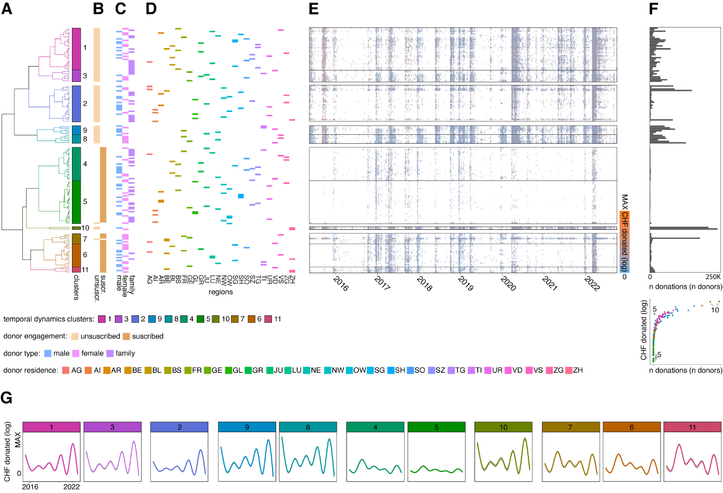

**Figure 2. Atlas of charitable behavior temporal dynamics diversity of occasional donors. A.** Dendrogram detailing the hierarchical clustering results on time-series (05/2015 – 10/2023) donations amount data from occasional donors. Dendrogram color-coding highlights the distribution of the 11 clusters identified. Inset bar plots in dendrogram end-leaves indicate cluster size. **B.** Bar plot indicating newsletter subscription status of donor groups belonging populating each cluster. Color-coding: light-beige (unsubscribed), beige (subscribed). **C.** Bar plot showing donor type groups populating each cluster. Color-coding: blue (male), pink (female), purple (family). **D.** Bar plot detailing canton of residence of donor groups populating each cluster. Color-coding: rainbow color scale for Switzerland canton abbreviations alphabetically ordered. **E.** Time series heatmap illustrating donation amount (CHF, log scaled) per donor group by day and ordered following clustering results. Color-scale: gradient blue (low) – orange (high). **F.** Bar plot illustrating total number of donations performed across the analyzed time span for each donor group (equivalent to the number of people assigned to each donor group). **G.** Loess fitting line plots detailing donation temporal dynamics per donor group. Color – coding corresponds to clustering colors (see A).

To provide an accurate view of the complete donation history of donors, we restricted the atlas construction to those donors for which the data accounted all their actions, occasional donors (a next study will cover recurrent donor profiling and frame its differences with occasional ones).

Clustering analysis splitting on optimal Elbow partitioning revealed the presence of 11 temporal donation profiles (Fig 2A) (due to outlier removal preprocessing, the time span here consider ranged from 05/2015 to 10/2022). These donation-through-time profiles highlighted a gradient of giving characterized by, on one hand, early-enriched donors (clusters 4, 5, 7, 6 and 11), and on the other hand, late-enriched donors (clusters 1, 2, 3, 9, 8 and 10). To note, cluster 5 population groups, while most active during early years, present a rather flat donation behavior. Cluster 10, interestingly, congregated donors with an outlier late profile of donation, constituting the population groups that gave the most historically to Swiss Solidarity (Fig 2F).

The donor characteristic better explaining clustering splitting turned out to be newsletter subscription (Fig 2B). Indeed, early-enriched donors correspond to subscribed population groups while late-enriched donors are mainly unsubscribed. Donor gender/family type was also segregated through clusters although not so consistently: while early-enriched donors are mostly individuals, either female or male, late-enriched donors capture a relatively bigger contribution of families (Fig 2C).

Donor regionalization was rather evenly distributed although some differential patters were observed (Fig 2D): outlier donators (those that gave the most historically) reside in Zurich. Cluster 5 donors, those donating the less overall and with a flatter profile, are also the more regionally distributed population. Among the early-enriched profiles, Bern residing donors constituted a highly donating outlier located in cluster 9.

Taken together, these results constitute a Big-Data supported valuable reference resource to understand at a global level (atlas) the donation diversity in Switzerland. This source provides a first view that, more importantly, sets the ground for integrating further donor dimensions, regional components or events through time.

*3.3. Predictive framework for Charitable Giving*

Finally, we ought to develop a machine learning pipeline for reconstructing donation history, understand its predictable and unpredictable temporal components and comprehend their donor profile belongings.

We observed two main timepoints in which donation behavior registered unprecedented mass engagement (Fig 3A): march-june 2020 and february-may 2022. The number of donations registered in the three months acute period around them constitute a clear outstanding trend when compared to all years prior. Time series donation fitting further confirmed the outlier status of these periods as random forest regression modeling registered the biggest error differences on those spans (Fig 3C). The best performing fitting model for donation history, thus was achieved when only events prior 03/2020 were considered (Fig 3D).

Using the time series span showcasing better performance, we built a random forest classifier to unveil the predictable and randomly distributed donor profiles (Fig 3E). Results turned consistent with unsupervised learning conclusions (clustering), indicating that subscription status can be accurately predicted with almost no error margin. Here, we discovered what about gender/family donor type is indeed the most predictable: families. The time evolution of family donation profiles its outstandingly salient, thus predictable to a 73%. Other donor characteristics, however, are more subtly encoded in temporal patterns and those present predictive powers around chance levels. Understanding which profiles are non-temporally patterned donors is equally essential as patterned ones, since stable donators constitute the basis working force for charitable actions.

Finally, we aim at addressing the power of mass engagement upon Swiss Solidarity calls for action (crisis appeals) (Fig 3F). This analysis was restricted to the most recent years with complete data (2019-2021). We observed that appeal periods, through years, are not necessarily the points in which a maximum peak donation behavior is observed except for outstanding global crisis events such as COVID-19. However, appeal periods do consistently elicit a stronger charitable giving as compared to non-appeal periods apart from December.

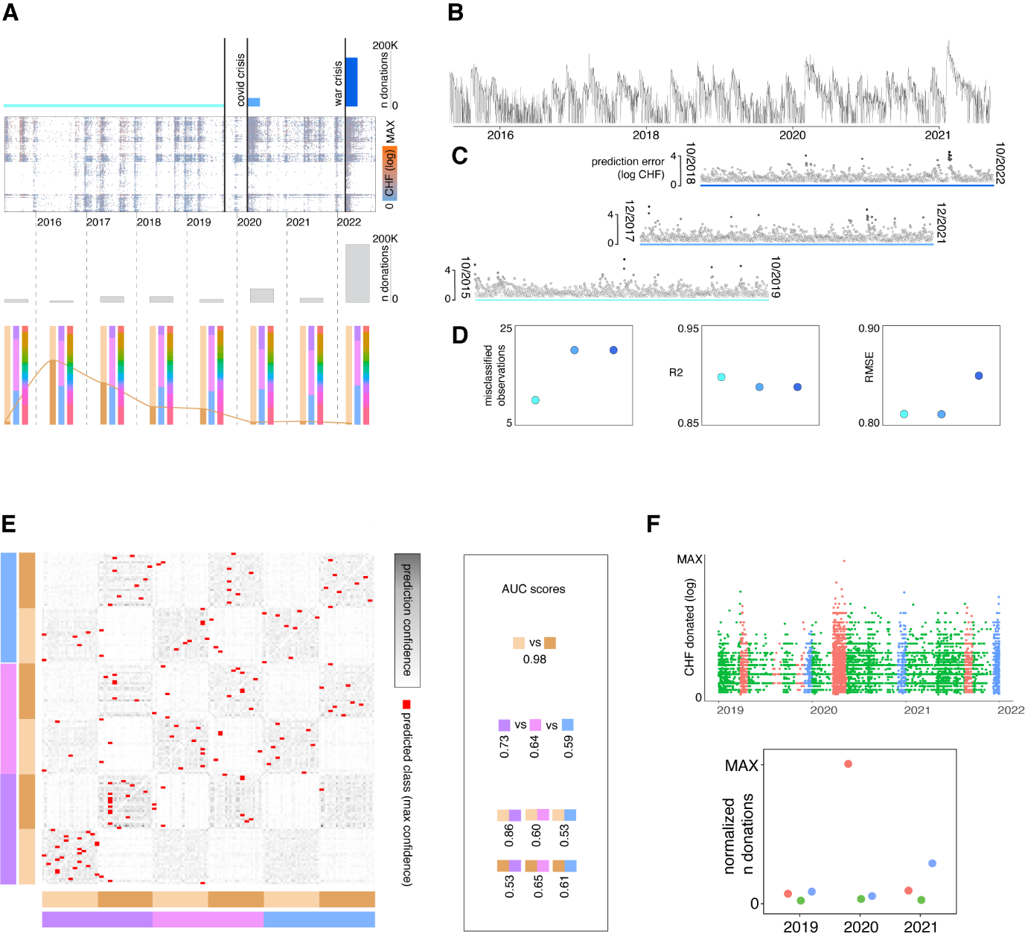

**Figure 3. Predictive Framework of Charitable Giving. A.** Bar plot depicting the number of donations made in the years before the COVID pandemic onset (light blue), during the first 3 years of the COVID pandemic (middle blue) and during the first 3 months of the russie-ukraine war (dark blue). Heatmap depicting donations over time (columns) by population profiles (rows) and color coded by the amount donated (CHF log). Bar plot showing the number of donations made per year. Barplots indicating the percentage of total donations per year made by each subtype of population profiling variables (engagement profile, donor type and residence profile). **B.** Time series plot illustrating donated amount in log CHF for each day during the analyzed time period. **C.** Scatter plots illustrating the distance between the real and predicted time-series using random forest regression (y axis illustrates prediction error as a metric of distance) (light blue – donation time series regression on 4 yeas before the onset of the covid crisis, middle blue – donation time series regression on 4 years before the onset of the acute russia-ukraine war, dark blue – donation time series regression on 4 years before the last donation registered in the dataset). **E.** Heatmap depicting random forest classification decision values (scale of greys) and maximum predicted classes (red). Colum and row side color bars indicate the heatmap location of population groups by their demographic profiling variables. AUC scores for each classification combination. **F.** Scatter plot depicting CHF log amounts for donations made from the beginning of 2019 to the end of 2021. Color coding indicates time period type: orange (appeal period), green (inter appeal interval) and blue (december). Bottom scatter plot summarizes the normalized number of donations for each time period type for each of the analyzed years.

In sum, these findings highlighted the existence of two remarkably different timepoints of high mass engagement, corresponding to the onset of COVID-19 and Ukraine acute conflict. In addition, we developed a predictive framework that allowed to identify consistent donation patterns through time and link them with population profiling. Finally, we explored the impact of crisis appeals on donation behavior was explored, showing higher giving during appeal periods and December, Christmas and taxation coinciding month. Overall, this research provides insights into donation behavior, emphasizing the importance of temporal analysis and early engagement for effective donation campaigns.

**4. Methods**

*4.1. Donor Profiling*

The core material analysed in the present manuscript was provided by Swiss Solidarity.  Composed of 766’578 observations after base preprocessing (missing or duplicated observations), it details individual monetary donations made in Switzerland to the organisation from 1905 to October 2022.

To address the presence of outlier observations in the donation’s amount data, we employed a logarithmic transformation on them using the formula: $ln(amount+1)$ .

To understand the different intrinsic characteristics of donors (supporting, engagement, type and region) and determine if they significantly differ, we conducted permutation tests on group medians (results not shown). This method allows us to assess statistical robustness by calculating the permutation proportion score, which measures the frequency of observing a result more extreme or unusual compared to randomly generated permutations.

*4.2. Charitable behavior temporal atlas*

The available data did not include information for every timestamp of donors' donations. To account for this, we restricted our analysis to donor supporting profiles characterized by point contributions (occasional) (Fig 1.A). In this categorization process, 10% of the sample was excluded due to missing data (39’274). Then, 34% disregarded due to their belonging to a recurrent donor profile (168’065).

Given the large sparsity of donation records in the earlier timepoints of the dataset, we removed from the donations and time the last 0.05 quantile. This resulted in the filtering of donations made before 2015-05-19, leading to the removal of an additional 16’593 observations. Moreover, to account for extreme values in the lower end of donation amounts, we applied and additional outlier detection and removal resulting in the filtration of donations below 20.5 CHF (16’028 observations).

The resulting time series data for constructing the atlas of occasional donors consisted of 304’735 observations. This atlas was built on a donation amount time-series matrix consolidating data from donors sharing identical intrinsic characteristic profiles (156 user profiles and 2150 timestamps with daily resolution) and populated with the cumulative sum of daily donations corresponding to each group combination (Fig 2E,F).

We sought to uncover inherent donation temporal patterns within population groups and assemble them into the so called “charitable behaviour temporal atlas”. To achieve this, we applied linear dimensionality reduction (PCA) on time and employed ward.D2-based hierarchical clustering following the criteria for optimal grouping indicated by the Elbow method. As a result, donors with similar temporal dynamics resulted assigned to a given data group (Fig 2A-D). To illustrate the characteristic pattern of each temporal cluster, we constructed a loess fitted line over their donation history (Fig 2G).

To further understand the basis for the grouping of the identified clusters, we examined the relationship between the groups and various demographic attributes of the donors. To do so, we analysed their associative coefficients, quantifying the relationship strength between variables (each cluster and donor profiling level). We employed Cramer's V (φc) as a measure of association, while the significance of the associations was determined using the χ2 test (result not shown).

*4.3. Predictive framework for Charitable Giving*

The subsequent stage of the project involved exploring whether the donation dynamics over time encode predictive power. To facilitate this analysis, we needed to prepare the matrix. Initially, we addressed the issue of missing dates in our dataset. Although our filtered data spanned from "2015-05-19" to "2022-10-02," we encountered a total of 682 missing days. To overcome this challenge, we decided to generate artificial data to ensure a complete sequence of dates. To preserve the integrity of our analysis, we created a new matrix frame based on the original matrix, with dimensions of 2150 rows and 2 columns. Each row represented an observation, with the first column denoting the date and the second column representing the sum of daily donations.

Subsequently, we created a separate data frame named “all_dates” encompassing a continuous sequence of days starting from "2015-01-01" up until the last available date in our matrix, which was "2022-10-02." We decided to start at "2015-01-01" to have the whole year of 2015. By merging the “all_dates” data frame with the existing data frame, we obtained an expanded matrix with dimensions of 2832 rows and 2 columns. Each row in this matrix represented an observation, where the first column indicated the date and the second column denoted the sum of daily donations.

Using the expanded matrix, we proceeded to create a time series object to conduct a comprehensive time series analysis. For this analysis, we employed a random forest (RF) which is an ensemble learning algorithm that combines decision trees to improve prediction accuracy and generalization in classification and regression tasks (Richard A. Davis & Mikkel S. Nielsen, 2020). We used an RF regression technique to explore the time series. The objective behind employing RF regression was to assess the potential for developing a robust model capable of accurately fitting the data. By doing so, we aimed to determine the model's accuracy in predicting donation amounts through time.

In addition to RF regression, we also performed RF classification. The purpose of using RF classification was to identify the specific group combination to which each donor belonged. By leveraging the RF classifier, we sought to effectively assign donors to their respective groups, based on their donation patterns and characteristics.

To evaluate the accuracy of each model, we employed multiple metrics including Root Mean Squared Error (RMSE), R2, and the distance between the predicted and validation values. The distance measure allowed us to dynamically identify mispredicted observations with a high time resolution.

RMSE, a widely adopted evaluation metric, measures the average magnitude of errors between validation values and actual values, providing a comprehensive assessment of prediction accuracy. A model can be considered accurate if the RMSE value falls between 0.2 and 0.5.

In addition to RMSE, we utilized R2, a statistical metric that quantifies the proportion of variance in the dependent variable explained by the independent variables. R2 serves as an indicator of the goodness of fit for a regression model. R2 values range between 0 and 1, and a model is considered good if the R2 value is greater than or equal to 0.8.

To classify the observations based on demographic profiles, we utilized an RF Classifier. Initially, we created a normalized and transposed data frame from the original matrix. This new data frame had dimensions of 156 rows and 2150 columns. Each row represented a unique group combination, while each column denoted a specific day over time. The matrix cells contained the cumulative logarithmic sum of daily donation amounts corresponding to each group combination. To evaluate the accuracy of the classifier, we utilized the Area Under the Curve (AUC) method, a commonly used metric in machine learning for assessing binary classification model performance.

*4.4. The Impactful Appeal by Swiss Solidarity*

We conducted an evaluation to determine if the appeal made by Swiss Solidarity resulted in a greater number of donations compared to the inter-appeal interval or the month of December. This month holds significance for several reasons: it is a time when Christmas fosters solidarity motivations, it represents the last opportunity for impactful tax deductions through donations, and the second portion of the 13th salary is often received during this month. For our analysis, we defined the appeal period as the first month of the campaign, the inter-appeal interval covered the months with no appeals, and we considered December as a special donation period (control) due to the aforementioned factors.

Next, we performed a subsetting operation on the original data frame, specifically from the date range "2019-01-01" to "2021-12-31". This selection was made to include only campaigns that did not start in December and belonged to Collection Level 3 or 4, indicating a higher level of campaign importance. Each observation in the data frame was then assigned to one of these three periods. The total number of donations made within each period was calculated and normalized by the number of months in the interval.

**5. Conclusions and Discussion**

In this study, significant results were obtained regarding philanthropic behavior and its outcomes in the context of Swiss Solidarity, a charitable donation-based crowdfunding organization for humanitarian aid in Switzerland.

The analysis of historical donation data using Big Data and Machine Learning techniques revealed several key findings. Firstly, characteristic donor profiles associated with different donation responses were identified, with certain population groups demonstrating a higher frequency of contribution but with smaller monetary amounts. Secondly, two distinct time points of high mass engagement were identified, coinciding with the onset of the COVID-19 pandemic and the acute conflict in Ukraine, highlighting the impact of crises on donation behavior. Additionally, a predictive framework was developed, successfully uncovering consistent donation patterns over time and providing insights into the factors influencing charitable behavior. Thirdly, the study explored the influence of crisis appeals, revealing heightened giving during appeal periods and in December, aligning with the Christmas season and taxation periods.

In conclusion, these results underscore the importance of temporal analysis for understanding the nuances of charitable behavior and donor differential profiles. Overall, this research contributes valuable insights constituting a Big-Data-supported view of charitable behavior.

Our analysis revealed that prior to the COVID pandemic, a majority of donations originated from subscribed donors while after COVID, and likely due to an increase of digitalized services for fundraising, the biggest charitable contributions were made by spontaneous non subscribed donors. This result indicates that a large potential for donor engagement remains untapped by fundraising organisations such as Swiss Solidarity and research as the one here presented could provide key insights on how the success those user engagement efforts could be enhanced. Additionally, being part of a family in Switzerland was found to positively influence donation behavior. Surprisingly, family donor behavior resulted better predicted when those families weren’t subscribed to the organisation newsletter. Moreover, our results indicated that the Swiss population displayed heightened sensitivity during global crises compared to local crises. In these lines, charitable response to large-scale crisis such as the ones witnessed in the last 2 years constituted a never seen before charitable enhancement in Switzerland changing the panorama of philanthropy.

Although the models implemented in this study were not able to capture all instances of donation surges, they demonstrated good performance overall. These results contribute valuable insights into understanding charitable behavior over the past seven years, as there is a scarcity of studies examining philanthropic patterns over time. However, further research is necessary to comprehensively explore the larger amount of dimensions of philanthropic behavior over time.

These findings shed light on the complex dynamics of philanthropy and provide a foundation for future investigations in this domain. Understanding the evolving nature of charitable contributions is crucial for designing effective strategies and interventions to encourage and optimize philanthropic behavior in the future.

**6. References**

Anik, L., Aknin, L. B., Norton, M. I., & Dunn, E. W. (2009). Feeling Good About Giving: The Benefits (and Costs) of Self-Interested Charitable Behavior. *SSRN Electronic Journal*. https://doi.org/10.2139/ssrn.1444831

Batson, D. (2014). *The Altruism Question: Toward A Social-psychological Answer*. Psychology Press.

Bekkers, R. e, & Wiepking, P. (2010). A Literature Review of Empirical Studies of Philanthropy. *Nonprofit and Voluntary Sector Quarterly*, *40*(5), 924–973. https://doi.org/10.1177/0899764010380927

Carrasco, S., & O’Brien, D. (2018). The Role of Humanitarian Agencies in Reconstruction and Development of Disaster Affected Communities in Japan and the Philippines. *Procedia Engineering*, *212*, 606–613. https://doi.org/10.1016/j.proeng.2018.01.078

Eikenberry, A. M., & Breeze, B. (2018). Growing Philanthropy through Giving Circles: Collective Giving and the Logic of Charity. *Social Policy and Society*, *17*(3), 349–364. https://doi.org/10.1017/S1474746417000124

Haaland, H., & Wallevik, H. (2019). Beyond crisis management? The role of Citizen Initiatives for Global Solidarity in humanitarian aid: the case of Lesvos. *Third World Quarterly*, *40*(10), 1869–1883. https://doi.org/10.1080/01436597.2019.1656060

Leliveld, M. C., & Risselada, H. (2017). Dynamics in charity donation decisions: Insights from a large longitudinal data set. *Science Advances*, *3*(9), e1700077. https://doi.org/10.1126/sciadv.1700077

Ranganathan, S. K., & Henley, W. H. (2008). Determinants of charitable donation intentions: A structural equation model. *International Journal of Nonprofit and Voluntary Sector Marketing*, *13*(1), 1–11. https://doi.org/10.1002/nvsm.297

Sisco, M. R., & Weber, E. U. (2019). Examining charitable giving in real-world online donations. *Nature Communications*, *10*(1), 3968. https://doi.org/10.1038/s41467-019-11852-z

United Nations. (2022). *Global Humanitarian Overview 2022*.