Evolution of Philanthropy Ecosystem(s) in the Western Balkans

Marko Galjak (Institute of Social Sciences),

1. **Abstract (please do not exceed 250 words)**

This study takes an innovative approach in investigating the evolution of philanthropic ecosystems in the Western Balkans from 2015 to 2022. The research employs social network analysis (SNA) to dissect and understand the intricate relationships among donors and beneficiaries, applying graph theory metrics like centralization, density, and homophily to examine network evolution. The study utilizes a comprehensive data set from the Giving Balkans philanthropy database, which includes more than 90,313 instances of giving among over 35,779 unique entities, accounting for more than half a billion euros in donations. The data, meticulously collected and classified based on factors such as donor type, beneficiary type, and the purpose of giving, aids in creating an encompassing network of philanthropy in the region. This network comprises seven countries in the Western Balkans: Serbia, Croatia, Bosnia and Herzegovina, Albania, Macedonia, Kosovo, and Montenegro. Findings reveal considerable differences in the development trajectories of each country's philanthropic ecosystem, indicating specific strengths and potential vulnerabilities. The research contributes a unique, data-driven approach to compare different philanthropy ecosystems by scrutinizing the collected data holistically and across various giving categories. The insights derived from this study provide valuable information about the evolving philanthropy networks in the Western Balkans, ultimately enhancing our broader understanding of regional philanthropy.pt.

1. **Introduction**

All The examination of philanthropy is undeniably a complex endeavor. Understanding the dynamics of giving, the motivations of donors, the needs of beneficiaries, and the factors influencing these interactions often seems like trying to chart a course through a labyrinthine landscape. Furthermore, this complexity is magnified when trying to draw comparisons across different nations, each with its unique cultural, socio-economic, and political realities (Bekkers 2016). These realities shape the patterns and practices of philanthropy, often defying simple one-size-fits-all models or comparisons. Yet, the importance of understanding these complex ecosystems cannot be understated; this knowledge can help foster philanthropic culture, formulate effective policy and strategy, and direct efforts where they can have the greatest impact.

Building upon a previous paper that charted a snapshot of the philanthropic landscape in the Western Balkans region (Galjak 2020), this study ventures into uncharted territory. It aims to enrich our understanding of these ecosystems by exploring not only the spatial dimension, the 'who gives to whom', but also the temporal one – how these networks of giving evolve over time. This longitudinal approach allows us to capture the dynamism of these philanthropic ecosystems, acknowledging that they are not static entities, but evolving systems shaped by a myriad of factors.

Our data source is the Giving Balkans philanthropy database, which records philanthropy across seven Western Balkan countries: Serbia, Croatia, Bosnia and Herzegovina, Albania, Macedonia, Kosovo, and Montenegro. It aggregates a massive collection of over 90,313 instances of giving between more than 35,779 unique entities, totaling over half a billion euros, during the period from 2015 to 2022. This extensive dataset provides a rich foundation for our exploration, enabling us to uncover intricate patterns and connections that would otherwise remain hidden.

To navigate this wealth of data, we utilize the powerful lens of social network analysis (SNA). This tool, grounded in graph theory, enables us to visualize and quantify the relationships and interactions in our dataset. By examining metrics such as centralization, density, and homophily, we can begin to uncover the underlying structures of these philanthropy ecosystems, their strengths, and potential vulnerabilities. This paper presents an innovative approach to understanding and comparing philanthropy ecosystems. It leverages the power of data and the insights of SNA to provide a multi-dimensional view of these complex networks. By delving into both the spatial and temporal dimensions, we hope to contribute to a richer, more nuanced understanding of philanthropy in the Western Balkans. As such, our findings not only provide valuable insights into the evolution of these ecosystems but also contribute to the broader discourse on philanthropy in the region.

1. **Unpacking Philanthropy through Social Network Analysis**

Concurrently, the Social Exchange Theory (Cook and Rice 2006, p. 200) introduces the idea of reciprocity in giving, suggesting that philanthropy can also serve as a mechanism for social exchange. This theory might be especially pertinent in exploring interactions between donors and beneficiaries and networks they form.

This study also anchors its approach in the theories and principles of Social Network Analysis (SNA), which provide essential tools to understand and illustrate the patterns and structures in the philanthropic ecosystem of the Western Balkans. Key to our analysis are the theories around network structures, such as Granovetter's (1973) "Strength of Weak Ties" theory, which posits that less-intense connections in a network can often provide the most value, due to their potential to bridge diverse groups. This theory might help us better understand how resources and influence spread in the philanthropic network. We will also draw on the work of Barabási and Albert (1999), who proposed the theory of "Scale-Free Networks", suggesting that in many large networks, including social networks, a few highly connected nodes (hubs) dominate the network structure. This could have implications for the roles of certain actors in the philanthropic landscape. By grounding our analysis in these SNA theories, we will gain insights into the patterns, dynamics, and evolution of the Western Balkans' philanthropy networks.

This paper is also theoretically grounded in Resource Dependency Theory (RDT), a perspective that holds significant potential for understanding the behaviors and strategies of entities within the philanthropic ecosystems. Originally developed by Pfeffer and Salancik (1978), RDT posits that organizations are dependent on their environment for resources, and this dependency influences their strategies and behaviors. In the context of our study, RDT could illuminate how philanthropic organizations in the Western Balkans manage relationships with donors and beneficiaries to secure necessary resources. This might involve strategies to reduce dependencies, such as diversifying funding sources, or to manage dependencies, such as cultivating relationships with key donors. RDT might also provide insights into the power dynamics within the philanthropic network, as entities that control key resources often wield significant power. By applying RDT to our analysis, we can better understand how resources flow within the philanthropic ecosystem and how this shapes the ecosystem's structure and evolution.

Our analysis is further informed by the theoretical understanding of philanthropic behavior, a critical aspect when exploring the philanthropy landscape in the Western Balkans.

In this paper we use a novel data driven approach, based on graphs and network analysis, to shed some light on the philanthropy circumstance in 7 countries of the Western Balkans. The data used in this paper doesn’t rely on surveys or government statistics but is collected by a philanthropy support organization that operates in all the 7 countries called Catalyst Balkans. They record locally sourced donations instances that appear in media and curate the GivingBalkans database where all such donations that appear in the newspapers, broadcast and internet media are recorded. This recorded philanthropy data represents only the visible philanthropy and doesn’t cover all those instances of giving that aren’t publicized. This approach gives us much more detail and reliability as donations can be verified. The major advantage of tracking philanthropy in this way is that the coding is done by the professional analysts who code and classify instances of giving from media, while in surveys self-reporting is ubiquitous and leaves a lot of room for bias and wrong classification. Where surveys are based on samples, recorded philanthropy data-set employed in this paper is more similar to census data-set, since it encompasses every single instance of giving that appears in media.

The detailed census type data-set enables us to look at more than just averages and estimates. It enables us to actually explore the connections between entities–donors and beneficiaries. To look into these connections (and the wider network they form) we use social network analysis tools and way of thinking. At the macro level this enables us to truly see the entire philanthropy ecosystem of a country if not in a single number, then in a single image.

1. **Understanding the Western and the importance of locally sourced philanthropy**

The seven nations investigated in this study share a post-socialist, middle-income status, despite distinct cultural nuances. Most were components of the former Yugoslavia, with the exception of Albania. Moreover, Montenegro, Bosnia and Herzegovina, Croatia, and Serbia, are united by language, differing slightly from Macedonia's language which is also in the South Slavic group. Kosovo and Albania, that share Albanian language, both present unique cases but maintain several shared characteristics. Particularly, Kosovo, a part of the former Yugoslavia, wasn't isolated like Albania during the Hoxha regime. The shared communist history of the region translates to an overreliance on the government to take care things (Grødeland 2006; Wiepking and Handy 2015).

Political contexts in the Western Balkans, characterized by varying levels of democracy, occasional political instability, and challenges with corruption, create a complex landscape that can both hinder and potentially catalyze philanthropic efforts (EWB 2023; Freedom House 2016; Transparency International 2020).

The legal framework regulating philanthropy and non-profit operations in the Western Balkans presents both challenges and opportunities for the sector, with certain restrictions potentially limiting the growth and efficacy of these organizations (USAID 2023).

The economic conditions in the Western Balkans, marked by a range of mid-income statuses, uneven development, and the lingering impacts of the transition from socialism, significantly shape the capacity for philanthropic activities and the allocation of resources within the region (Bartlett and Prica 2011).

A strong reliance on state welfare is observed in these nations. A survey identified the state as the primary entity responsible for the common good, indicating potential barriers to local philanthropy such as distrust in the appropriate use of donated funds (Trag Foundation 2019). Consequently, foreign donors exert significant influence in the region, causing accountability issues and adverse impacts on public perception of civil society organizations (CSOs)(Daly 2011; Puljek-Shank 2018). This dominance also marginalizes smaller, local organizations, instigating competitive behavior and discouraging collaboration (Wunsch 2015).

Dependence on foreign aid is ubiquitous but most evident in Bosnia and Herzegovina, a nation deeply scarred by the Yugoslav wars (Selimović 2011). Simultaneously, government funding poses an analogous issue, potentially displacing local philanthropy (Sokolowski 2013). The emergence of government-organized non-governmental organizations (GONGOs) further complicates the situation (Meyer et al. 2019). Consequently, future development of the non-profit sector depends largely on local resource mobilization (Mikuš 2015).

Diaspora populations represent such resources, their cultural and geographic proximity presenting them as strong potential contributors to the socioeconomic advancement of their countries of origin (Flanigan 2017). While some countries of the region are more reliant on remittances from their diasporas (Bosnia and Herzegovina, Albania and Kosovo)(Bajra 2021), diaspora plays an important role in all the economies of the region. Particularly relevant to the Western Balkans, the large diaspora shaped the evolution of philanthropy in the region. Shedding light on locally sourced philanthropy in the Western Balkans represents not only an interesting research topic but also serves a very practical purpose. As foreign donors are pulling away from the region, a healthy philanthropy ecosystem that yet needs to be developed is of paramount importance for the future of the nonprofits and the democracy in the region.

1. **Hypotheses**

H1 (Network Density Hypothesis): The philanthropic network will become increasingly interconnected over time, with more donors and beneficiaries forming connections and contributing to the overall philanthropic impact in the Western Balkans.

H2 (Transitivity Hypothesis): As the philanthropic network evolves, actors within the network will tend to form groups or clusters, with a growing number of connections between actors who share common donors or beneficiaries.

H3 (Degree Centralization Hypothesis): Certain actors within the philanthropic network will emerge as key players, with a higher number of connections than others, indicating a concentration of philanthropic activity around these influential actors.

H4 (Betweenness Centralization Hypothesis): A few critical actors within the philanthropic network will play pivotal roles in facilitating connections and information flow between different parts of the network, thereby exerting significant influence on its structure.

H5 (Assortativity by Donation Amount Hypothesis): Actors who contribute or receive larger sums of money will exhibit a tendency to connect and interact with others who have also received or contributed significant amounts, resulting in a network structure that reflects financial homophily.

H6 (Leaves Percentage Hypothesis): The percentage of leaves (actors with only one connection) within the philanthropic network will decrease over time, indicating a greater level of connectivity and reduced fragmentation within the network as it evolves in the Western Balkans.

1. **Data and methodology**
   1. *Data*

The parameters of this study are delineated by data availability, specifically from the Giving Balkans philanthropy database. This database chronicles philanthropic endeavors in seven Western Balkan countries: Serbia, Croatia, Bosnia and Herzegovina, Albania, Macedonia, Kosovo, and Montenegro (Catalyst Balkans 2023). Giving Balkans focuses exclusively on locally sourced philanthropy. This includes the contributions from foreign enterprises operating within these countries and the diaspora of each nation. However, donations from foreign sources outside of these categories are not tracked. This decision is not reflective of their insignificance; in fact, large foreign donations often overshadow local philanthropy, potentially skewing the ecosystem's dynamics. Such external influences are not viewed as consistent or dependable sources of philanthropy that non-profit organizations in the Western Balkans can, or should, depend upon. Consequently, Giving Balkans excludes data from foreign donors. The exception to this rule is the diaspora, which is considered a local resource and therefore included in the database.

*Figure 1 The process of data collection for Giving Balkans database curated by Catalyst Balkans*

The data are collected from print, broadcast, and electronic media, coded and classified in the database, and then verified (Figure 1). The database includes recorded donations gleaned from press clippings, thus representing visible philanthropy. Catalyst Balkans, the regional philanthropy support organization that curates the database, verifies the collected data by directly contacting donors and beneficiaries. However, the dataset is neither perfect nor comprehensive. For instance, there are many cases where a donor prefers anonymity or where the donated sum was never disclosed to the media and neither party is willing to confirm it. The database also records in-kind donations, tracking their estimated worth. For the purposes of this research, only cash donations were considered, to ensure comparability with other research that typically focuses solely on cash donations.

* 1. *First Layer of the Graph Abstraction*

To transform the raw data into a meaningful network graph, we first represent the entities from the data-set as vertices (nodes), connected by edges signifying donation instances. The abstraction process omits donations where only one party is identifiable, often beneficiaries of anonymous donations. Our graph comprises three vertex types: donors, beneficiaries, and intermediaries. Donors exclusively provide donations, beneficiaries receive, and intermediaries can both contribute and receive funds. This creates a nuanced directed graph, with bipartite characteristics (Jackson 2008), further complexified by the presence of intermediary organizations. To enrich our graph, additional data attributes are assigned to vertices and edges. For vertices, these include: (a) the beneficiary type (e.g., individuals/families, institutions, local/national governments, nonprofits, and others); (b) the geographical region (based on NUTS3 district classification), with diaspora donors being the exception; and (c) the total donations a donor has made, a beneficiary has received, or an intermediary has given and received. Edges, on the other hand, are weighted by the number of donations made, further enhancing the depth of our analysis.

* 1. *Second Layer of the Graph Abstraction*

Our initial abstraction culminated in a graph with near-bipartite properties, i.e., a network consisting of two discrete node types that exclusively interconnect, preventing us from analyzing the network with some useful metrics like transitivity that measure. By omitting the intermediary vertices, we realized a genuine bipartite graph, ready for further projection into two discrete graphs (Figure 2). The first graph comprises solely donor entities, and the second, exclusively beneficiary entities. In the donor-only projection, an edge between two donors signifies that they have both made donations to the same beneficiary. Conversely, in the beneficiary-only graph, an edge between two beneficiaries represents their mutual receipt of donations from a single donor. This second-level abstraction sharpens our focus on the distinct relationships within each group.

Figure 2 Projection of bipartite network into two distinct donor and beneficiary networks.

* 1. *Metrics in Network Analysis: Comprehending the Abstracted Network*

In network analysis, a plethora of metrics exist. However, for meaningful interpretation, one must consider the type of network abstracted. For metrics exclusive to undirected networks, the graph was accordingly adapted to an undirected format. A detailed breakdown of the computed metrics and their definitions can be found in Table 1. The metrics computed fall into three categories. First, descriptive metrics, which provide straightforward network insights. Second, centralization metrics, which gauge the network's inclination towards centralization by degree (Diestel 2006) and betweenness (Diestel 2006). Finally, we utilized assortativity coefficients (Newman 2002, 2003) to explore homophily, specifically degree assortativity and nominal assortativity coefficients.

*Table 1. Network metrics defined in the context of philanthropy network. The formal names of the network metrics used is presented, along with a suggested common name*

|  |  |  |
| --- | --- | --- |
| Network metric | Common name | Definition |
| Vertex count | Donor or beneficiaries | Number of donors or beneficiaries within the philanthropic ecosystem. |
| Edge count | Shared Donation/Beneficiary Relationships | Quantity of connections between donors or beneficiaries based on shared donation/beneficiary interactions. |
| Edge density | Relationships density | The ratio of actual shared donation/beneficiary relationships to the maximum possible. (range: 0,1) |
| Transitivity | Cliquishness | The measure of the network's tendency to form mutually connected triplets or 'closed triads.' This metric reflects the propensity for integrative and robust relational structures. (range: 0,1) |
| Leaves percentage | Singular Connectors | Proportion of donors or beneficiaries connected to only one other donor or beneficiary, irrespective of donation repetition. (range: 0%, 100%) |
| Degree centralization | Relationship Disparity | Reflects network centralization based on each actor’s degree centrality, a measure of the proportion of actual to potential relationships. (range: 0,1) |
| Betweenness centralization | Structural Importance Disparity | Centralization measure based on each actor’s betweenness centrality, the frequency of an actor appearing on the shortest paths between all actor pairs. High betweenness centrality signifies important actors whose removal would severely disrupt network connectivity. High betweenness centralization indicates few highly critical actors. (range: 0,1) |
| Assortativity by degree | Relationship Homophily | Measure of a tendency for donors with many beneficiaries or beneficiaries with many donors to connect. It's computed as the Pearson correlation coefficient of degree between pairs of connected actors. (range: -1,1) |
| Associativity by sum | Financial Homophily | Tendency for high-donating donors or high-receiving beneficiaries (categorized by quartiles) to connect. For this metric, isolated actors from the main component are excluded. (range: -1,1) |

* 1. *Trends*

In addition to leveraging social network analysis, our study incorporated a robust time series analysis to scrutinize the evolution of philanthropic donations from 2015 to 2022. We employed an Autoregressive Integrated Moving Average (ARIMA) model, a statistical analysis model that is capable of capturing a suite of different stationary temporal structures in time series data. Our goal was to identify any significant temporal trends in the volume of donations. In this model, we used each SNA metric (Table 1) as dependent variable, and the year of donation as the explanatory variable, signifying the potential trend over time. To formally assess whether the volume of philanthropy had experienced a statistically significant increase or decrease during the observed period, we tested the null hypothesis, which posited that the coefficient associated with the temporal trend was zero. The alternative hypothesis was that the coefficient deviated significantly from zero, signaling a significant trend. The determination of whether a statistically significant trend existed was based on the p-value linked to the coefficient of the trend term. A p-value of less than 0.05 would reject the null hypothesis, hence affirming the existence of a significant trend. The results of this hypothesis testing, combined with the social network analysis, aimed to offer a comprehensive understanding of the changes in the philanthropy landscape in the Western Balkans over the study period.

References should be added at the end of the paper, and its corresponding citation will be added in the order of their appearance in the text. Authors should ensure that every reference in the text appears in the list of references and vice versa. Indicate references by Clark et al., 1962 or Deal and Grove, 2009 or Fachinger, 2006 in the text. The actual authors can be referred to, but the reference citation(s) must always be given.

* 1. *Graph visualizations*

One of the great aspects of network analysis is the ability to visualize graphs and to intuitively comprehend them. However, there is a problem when visualizing big networks and retaining the ability to see distinct features. For the visualization representing the entire network force directed, distributed recursive layout was used (Martin et al. 2008). For visualizing individual graphs of each country the Fruchterman–Reingold algorithm was used (Fruchterman and Reingold 1991).

* 1. Code and reproducibility

The data-set used in this paper and all the code used to generate graphs, compute metrics and create visualizations is available in the supplementary materials (https://osf.io/2g798/). R programing language (Ihaka and Gentleman 1996), and igraph package (Csardi and Nepusz 2006) were used for network analysis.

1. **Results**

The cumulative visualization of the philanthropic ecosystems in the Western Balkans over the eight-year period (Figure 3) provides insights into their evolution. The visualization reveals that each country has its distinct philanthropy ecosystem, although there are some connections between these separate ecosystems. Furthermore, the visualization highlights a significant number of leaves, representing vertices that are connected to only one other vertex. Some of these leaves form isolated components, representing one-time donor-beneficiary interactions without further engagement with other entities. In large network visualizations, individual vertices can be challenging to distinguish.

H1 (Network Density Hypothesis)

Our hypothesis, proposing an increase in interconnectedness within the philanthropic networks in the Western Balkans, finds mixed support (Appendix 1). The regional trend reveals a marginal decline in networks’ density, suggesting fewer connections among donors relative to the number of philanthropic entities. Nevertheless, Bosnia presents an interesting deviation, with a substantial surge in donor density within the donor-only projection of the bipartite network. This means that fewer unique beneficiary organizations are receiving donations from an increasing number of donors, suggesting that the philanthropic focus in Bosnia is consolidating towards certain beneficiary organizations. These results underscore the varied evolution of philanthropic networks, stressing the importance of considering local contexts when examining philanthropy dynamics in the region.

H2 (Transitivity Hypothesis)

We proposed that as the philanthropic network evolved, it would demonstrate an increasing propensity for actors to form clusters or groups, with connections developing among actors sharing common donors or beneficiaries (Appendix 2). Our analysis shows that this hypothesis finds partial support. In the beneficiary-only projection of the bipartite network, there is a clear trend of increasing transitivity. This indicates that beneficiaries tend to form more cohesive clusters over time, sharing common donors. This suggests the growth of interconnected beneficiary groups, which could signify a consolidation of donor focus towards certain sectors or causes. Conversely, the donor-only graph presents a contrasting trend with decreasing transitivity. This suggests that donors are less likely to form clusters around shared beneficiaries over time, indicating a diversification in their giving patterns. Interestingly, these trends are consistent across all countries in the Western Balkans. The divergence between donor and beneficiary transitivity patterns offers a nuanced understanding of the evolving philanthropic landscape in the region, demonstrating different dynamics of clustering among donors and beneficiaries.

*Figure 3. The evolution of Western Balkans philanthropy network (2015-2022)*

H3 (Degree Centralization Hypothesis)

Our hypothesis posited that as the philanthropic network develops, certain actors would emerge as central figures, accruing more connections and indicating a concentration of philanthropic activity around them. Our findings lend strong support to this hypothesis (Appendix 3). The analysis reveals an increasing trend in degree centralization for both donors and beneficiaries across all countries in the Western Balkans. This suggests that the philanthropic network is evolving towards a structure where certain donors and beneficiaries are becoming increasingly influential, demonstrating a higher number of connections than others. However, interesting exceptions to this trend are found among the beneficiaries in Kosovo and Croatia, where a trend of decentralization is evident. These findings offer valuable insights into the changing dynamics of the philanthropic network, suggesting a shift towards a structure centered around key actors, while also highlighting distinct country-specific trends.

H4 (Betweenness Centralization Hypothesis)

Our hypothesis postulated that certain pivotal actors within the philanthropic network would facilitate connections and information flow, thereby significantly influencing the network's structure. Our findings corroborate this hypothesis, as betweenness centralization is on the rise for both donors and beneficiaries across all countries (Appendix 4). This indicates the emergence of disparate actors who are critical in bridging different parts of the network, facilitating philanthropic exchange and information flow. An exception is found in Kosovo, where the increasing trend in betweenness centralization is not statistically significant, indicating a more evenly distributed network with no single actors dominating as bridges. Although an increase is noticeable, the betweenness centralization values for all graphs remain below 0.2. This indicates that while certain actors are becoming pivotal in connecting various segments of the network, the structure of the philanthropic network continues to be fairly decentralized. The findings reflect the evolving complexity of the philanthropic landscape in the Western Balkans, with the simultaneous emergence of key facilitators and the preservation of a diverse, distributed network structure.

H5 (Assortativity by Donation Amount Hypothesis)

Our hypothesis suggested that actors contributing or receiving larger sums would likely interact with others doing the same, resulting in a network structure reflecting financial homophily. Our data shows mixed support for this hypothesis (Appendix 5). There's a discernible increase in assortativity by donation amount among donors, suggesting that donors contributing larger sums are increasingly likely to connect with each other (via the same beneficiaries). This denotes a financial homophily among high-donating entities. However, among beneficiaries, we observe a decreasing trend in assortativity by donation amount, indicating that high-receiving beneficiaries are less likely to be connected to each other over time. Country-specific trends vary significantly, emphasizing the influence of local contexts on philanthropic behaviors. Nonetheless, all countries show positive assortativity by donation amount in both types of graphs, though the assortativity coefficients hover around 0.25, indicating moderate financial homophily. These findings reveal a nuanced picture of the evolving philanthropic network in the Western Balkans, with financial homophily manifesting differently among donors and beneficiaries and varying across different countries.

H6 (Leaves Percentage Hypothesis)

Our sixth hypothesis predicted that the percentage of leaves (actors with only one connection) within the philanthropic network would decline over time, indicative of enhanced connectivity and decreased fragmentation within the network. Our analysis indeed demonstrates a general decreasing trend in the percentage of leaves across all countries and both types of actors (donors and beneficiaries) (Appendix 6). This finding aligns with our hypothesis, suggesting that the philanthropic network in the Western Balkans is evolving towards a higher level of interconnectedness and lesser fragmentation A notable exception to this trend is Albania, where the data does not reflect a decrease in the percentage of leaves. Nonetheless, the overall leaves percentage for all countries and actor types hovers around 10%, suggesting that the majority of actors in the network have multiple connections, reinforcing the view of an increasingly interconnected philanthropic ecosystem in the region.

1. **Discussion**

The yearly reports from Catalyst Balkans on the state of philanthropy in each country of the region tell a story about growing philanthropy in each country. However, descriptive statistics can tell us only so much about the strengths and weakness and the development of the philanthropy ecosystem in the region.

Within the frame of Social Exchange Theory (Cook and Rice, 2006), the nuanced reciprocity observed in our study indicates the complexity of social exchange in the philanthropic ecosystem. For instance, our findings around network density and transitivity suggest a certain reciprocity at play between donors and beneficiaries, though this interaction is marked by a diversification in giving patterns among donors and a consolidation of beneficiary focus.

Our analysis for betweenness supports the assumption that certain pivotal actors are important in bridging different parts of the philanthropic network. Such key facilitators are likely to significantly influence the philanthropic network's structure and evolution, reflecting the principles of Granovetter's "Strength of Weak Ties" theory.

Furthermore, our study resonates with the concept of "Scale-Free Networks" proposed by Barabási and Albert (1999). The evidence of certain actors accruing more connections is indicative of a few highly connected nodes dominating the network structure, thereby shaping the philanthropic landscape. In the lens of Resource Dependency Theory (RDT; Pfeffer and Salancik, 1978), our findings reflect the strategies organizations employ to secure resources. The trend towards a more interconnected ecosystem might suggest efforts to manage dependencies, such as cultivating relationships with key donors. However, the divergence in behavior between donors and beneficiaries in financial homophily possibly indicates attempts to reduce dependencies, particularly by beneficiaries seeking to diversify their funding sources.

The findings of this study provide valuable insights into the evolving nature of the philanthropic networks in the Western Balkans. The mixed support for our hypotheses suggests that the evolution of these networks is shaped by a multitude of factors that can result in different dynamics in different contexts. This highlights the importance of a nuanced and comprehensive approach to understanding philanthropy in the region.

Our findings show that while there is an overall marginal decrease in network density at the country level, some countries like Bosnia and Herzegovina present an interesting pattern of increased donor density. This could potentially be attributed to the consolidation of philanthropic efforts towards certain beneficiary organizations. This suggests that while the region's philanthropy landscape is marked by decreasing density, the local contexts and specific dynamics within individual countries significantly shape the density of the philanthropic networks. These findings underscore the importance of understanding the specificities of the local contexts in shaping the philanthropic landscape.

Overall, our study elucidates the complex, evolving nature of the philanthropic networks in the Western Balkans. Our findings have important implications for policy-makers, practitioners, and researchers in the field of philanthropy. For policy-makers and practitioners, our findings can provide insights for strategic planning, decision-making, and resource allocation. For researchers, our findings can open up new avenues for further research, deepening our understanding of philanthropy in the region.

The implications of this study go beyond the Western Balkans. The approach and methodologies used in this study can be applied to other contexts and regions to understand their specific philanthropic landscapes. As philanthropy continues to play a vital role in addressing global challenges, studies like this are critical for enhancing our understanding of the intricate dynamics of philanthropic networks. This will, in turn, enable us to leverage philanthropy more effectively in creating a more equitable and sustainable world.

* 1. Conclusion

In observing the evolution of philanthropic ecosystems within the Western Balkans, we uncover an intricate and dynamic landscape. The increasing interconnectedness, as observed through the decline in network fragmentation, signals a maturing ecosystem. However, this growth isn't uniform, with distinct regional variations like Bosnia's surge in donor density and beneficiary-focused decentralization in Kosovo and Croatia. Trends in transitivity suggest an intriguing divergence, with donors broadening their giving patterns while beneficiaries consolidate around shared donors. Both degree and betweenness centralization reveal the emergence of influential actors, suggesting a shift towards key actors steering the philanthropic direction. Yet, this centralization is balanced by a resilient diversity and a generally decentralized network structure. Finally, the exploration of financial homophily unveils complex dynamics among donors and beneficiaries, highlighting the multifaceted factors shaping philanthropic behaviors. Collectively, these findings illuminate the fascinating complexity of the philanthropic landscape in the Western Balkans, emphasizing the importance of context-specific strategies to navigate and leverage these networks effectively for societal benefit.

**Acknowledgements**

The work by this author was supported by Catalyst Balkans.

**References**

Bajra, U. Q. (2021). THE INTERACTIVE EFFECTS OF REMITTANCES ON ECONOMIC GROWTH AND INEQUALITY IN WESTERN BALKAN COUNTRIES. Journal of Business Economics and Management, 22(3), 757–775. https://doi.org/10.3846/jbem.2021.14587

Barabási, A.-L., & Albert, R. (1999). Emergence of Scaling in Random Networks. Science, 286(5439), 509–512. https://doi.org/10.1126/science.286.5439.509

Bartlett, W., & Prica, I. (2011). The variable impact of the global economic crisis in South East Europe. Economic Annals, 56(191), 7–34. https://doi.org/10.2298/EKA1191007B

Bekkers, R. (2016). Regional Differences in Philanthropy. In T. Jung, S. Phillips, & J. Harrow (Eds.), The Routledge companion to philanthropy (pp. 124–138). London ; New York: Routledge, Taylor & Francis Group.

Catalyst Balkans. (2023, June 4). Giving Balkans database on philanthropy in the Western Balkans. https://givingbalkans.org/. Accessed 23 May 2019

Cook, K. S., & Rice, E. (2006). Social Exchange Theory. In J. Delamater (Ed.), Handbook of Social Psychology (pp. 53–76). Springer US. https://doi.org/10.1007/0-387-36921-X_3

Csardi, G., & Nepusz, T. (2006). The igraph software package for complex network research. InterJournal, Complex Systems, 1695.

Daly, S. (2011). Philanthropy, the Big Society and Emerging Philanthropic Relationships in the UK. Public Management Review, 13(8), 1077–1094. https://doi.org/10.1080/14719037.2011.619063

Diestel, R. (2006). Graph theory (3. ed.). Berlin: Springer.

EWB. (2023, May 24). Freedom House: Democratic institutions in the Western Balkans continued to falter in 2022. European Western Balkans. https://europeanwesternbalkans.com/2023/05/24/freedom-house-democratic-institutions-in-the-western-balkans-continued-to-falter-in-2022/. Accessed 4 June 2023

Flanigan, S. T. (2017). Crowdfunding and Diaspora Philanthropy: An Integration of the Literature and Major Concepts. VOLUNTAS: International Journal of Voluntary and Nonprofit Organizations, 28(2), 492–509. https://doi.org/10.1007/s11266-016-9755-7

Freedom House. (2016). Back Where We Started in the Balkans. Freedom House. https://freedomhouse.org/article/back-where-we-started-balkans. Accessed 4 June 2023

Fruchterman, T. M. J., & Reingold, E. M. (1991). Graph drawing by force-directed placement. Software: Practice and Experience, 21(11), 1129–1164. https://doi.org/10.1002/spe.4380211102

Galjak, M. (2020). Philanthropy in the Western Balkans: A Network Analysis Report on Giving in the Region. In B. Hoolwerf (Ed.), Philanthropy in the Spotlight? Resources, Reputation and Achievements (pp. 74–88). Presented at the European Research Network on Philanthropy (ERNOP) 9th International Conference, Basel: Center for Philanthropy Studies University of Basel. https://doi.org/10.17605/OSF.IO/SA72D

Granovetter, M. S. (1973). The Strength of Weak Ties. American Journal of Sociology, 78(6), 1360–1380.

Grødeland, Å. B. (2006). Public perceptions of non-governmental organisations in Serbia, Bosnia & Herzegovina, and Macedonia. Communist and Post-Communist Studies, 39(2), 221–246. https://doi.org/10.1016/j.postcomstud.2006.03.002

Ihaka, R., & Gentleman, R. (1996). R: A Language for Data Analysis and Graphics. Journal of Computational and Graphical Statistics, 5(3), 299. https://doi.org/10.2307/1390807

Jackson, M. O. (2008). Social and economic networks. Princeton, NJ: Princeton Univ. Press.

Martin, S. B., Brown, W. M., Klavans, R., & Boyack, K. W. (2008). DrL: Distributed Recursive (Graph) Layout. Journal of Graph Algorithms and Applications.

Meyer, M., Moder, C., Neumayr, M., & Vandor, P. (2019). Civil Society and Its Institutional Context in CEE. VOLUNTAS: International Journal of Voluntary and Nonprofit Organizations. https://doi.org/10.1007/s11266-019-00106-7

Mikuš, M. (2015). Indigenizing “civil society” in Serbia What local fund-raising reveals about class and trust. Focaal, 2015(71). https://doi.org/10.3167/fcl.2015.710105

Newman, M. E. J. (2002). Assortative Mixing in Networks. Physical Review Letters, 89(20). https://doi.org/10.1103/PhysRevLett.89.208701

Newman, M. E. J. (2003). Mixing patterns in networks. Physical Review E, 67(2). https://doi.org/10.1103/PhysRevE.67.026126

Pfeffer, J., & Salancik, G. R. (1978). The External Control of Organizations: A Resource Dependence Perspective. SSRN Scholarly Paper, Rochester, NY. https://papers.ssrn.com/abstract=1496213. Accessed 4 June 2023

Puljek-Shank, R. (2018). Civic Agency in Governance: The Role of Legitimacy with Citizens vs. Donors. VOLUNTAS: International Journal of Voluntary and Nonprofit Organizations, 29(4), 870–883. https://doi.org/10.1007/s11266-018-0020-0

Selimović, I. (2011). A Note from Bosnia and Herzegovina: Leading a Displaced Life. Human Rights Quarterly, 33(2), 397–201. https://doi.org/10.1353/hrq.2011.0014

Sokolowski, S. W. (2013). Effects of Government Support of Nonprofit Institutions on Aggregate Private Philanthropy: Evidence from 40 Countries. VOLUNTAS: International Journal of Voluntary and Nonprofit Organizations, 24(2), 359–381. https://doi.org/10.1007/s11266-011-9258-5

Trag Foundation. (2019). Survey on philanthropy in Bosnia and Herzegovina, Kosovo, Macedonia, Montenegro and Serbia (Unpublished Raw Data). Belgrade: Ipsos Public Affairs.

Transparency International. (2020, December 11). Captured states in the Western Balkans and Turkey - News. Transparency.org. https://www.transparency.org/en/news/captured-states-western-balkans-turkey. Accessed 4 June 2023

USAID. (2023). Civil Society Organization Sustainability Index (reports). FHI 360. https://www.fhi360.org/sites/default/files/media/documents/csosi-europe-eurasia-2021-report.pdf. Accessed 4 June 2023

Wiepking, P., & Handy, F. (Eds.). (2015). The Palgrave Handbook of Global Philanthropy. London: Palgrave Macmillan UK. https://doi.org/10.1057/9781137341532

Wunsch, N. (2015). Beyond instrumentalisation: NGO monitoring coalitions in Croatia, Montenegro, and Serbia. East European Politics, 31(4), 452–467. https://doi.org/10.1080/21599165.2015.1085859

1. **Density of networks in the Western Balkans**

+ and – signs denote a positive or a negative trend *** p<0.0001, ** p<0.001, * p<0.01, . p<0.05

Appendix 2. Transitivity of networks in the Western Balkans 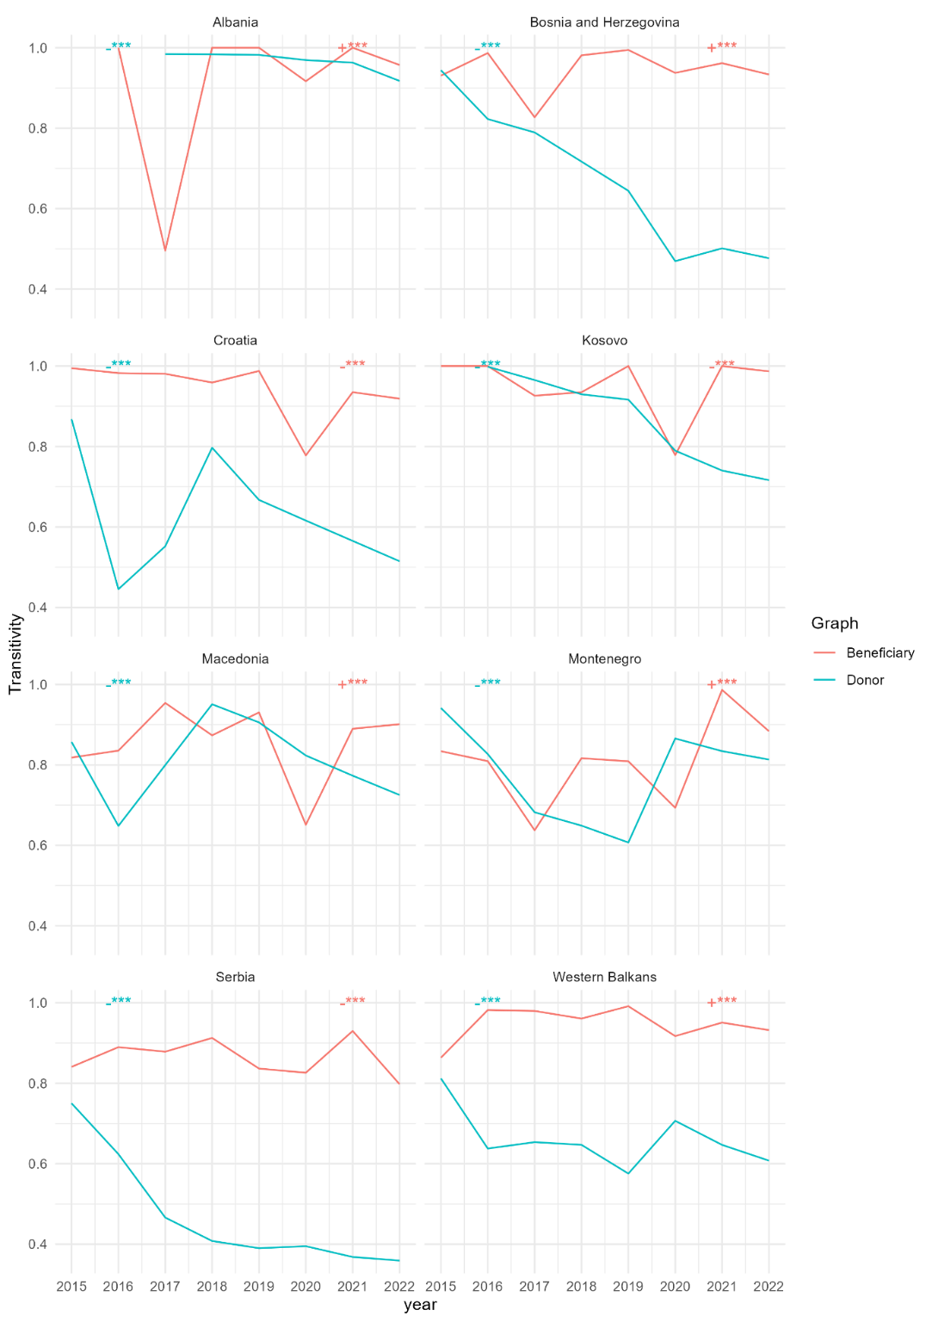

+ and – signs denote a positive or a negative trend *** p<0.0001, ** p<0.001, * p<0.01, . p<0.05

Appendix 3. Degree centralization of networks in the Western Balkans

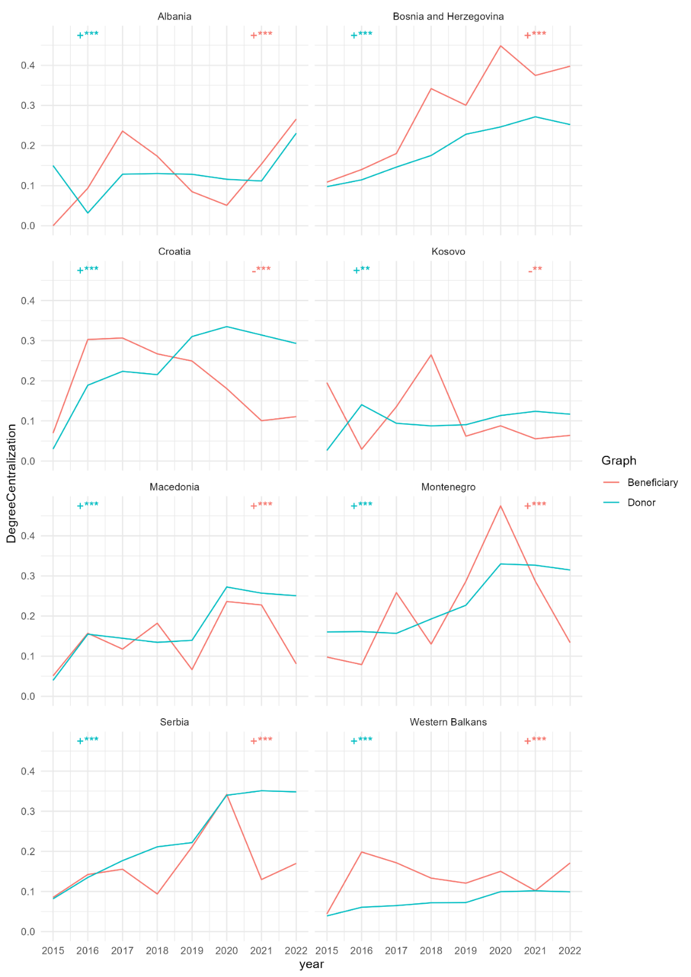

+ and – signs denote a positive or a negative trend *** p<0.0001, ** p<0.001, * p<0.01, . p<0.05

Appendix 4. Betweenness Centralization of networks in the Western Balkans

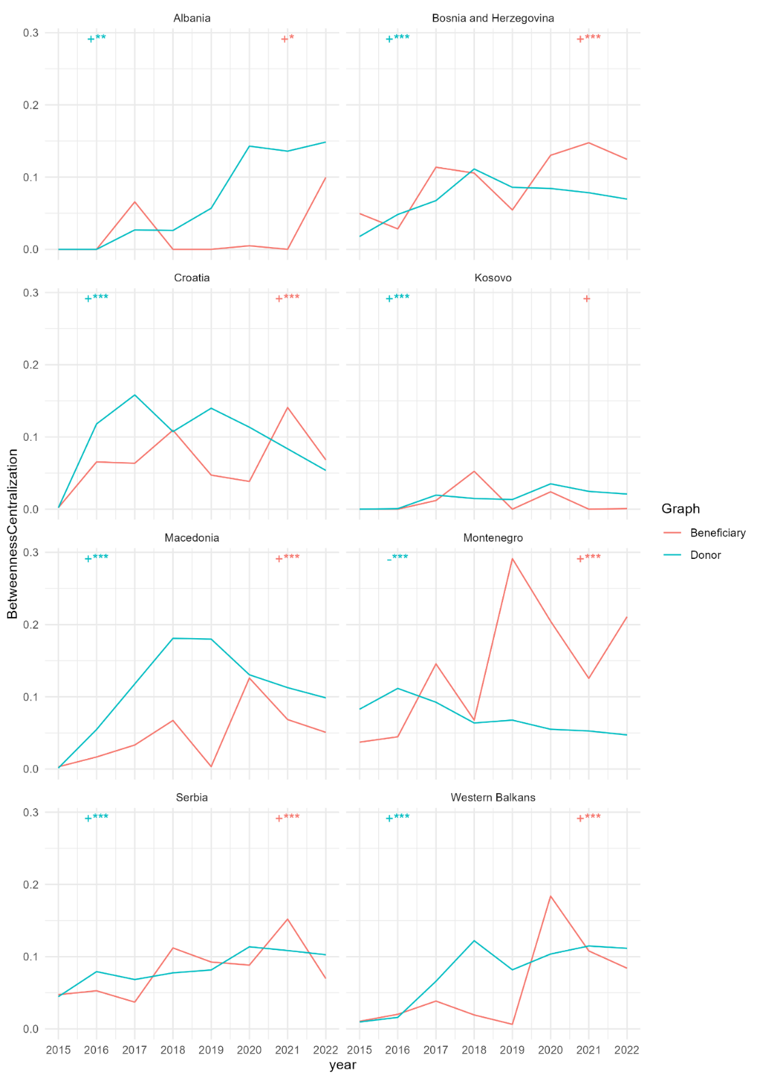

+ and – signs denote a positive or negative trend *** p<0.0001, ** p<0.001, * p<0.01, . p<0.05

Appendix 5. Assortativity by donation amount graphs in the Western Balkans

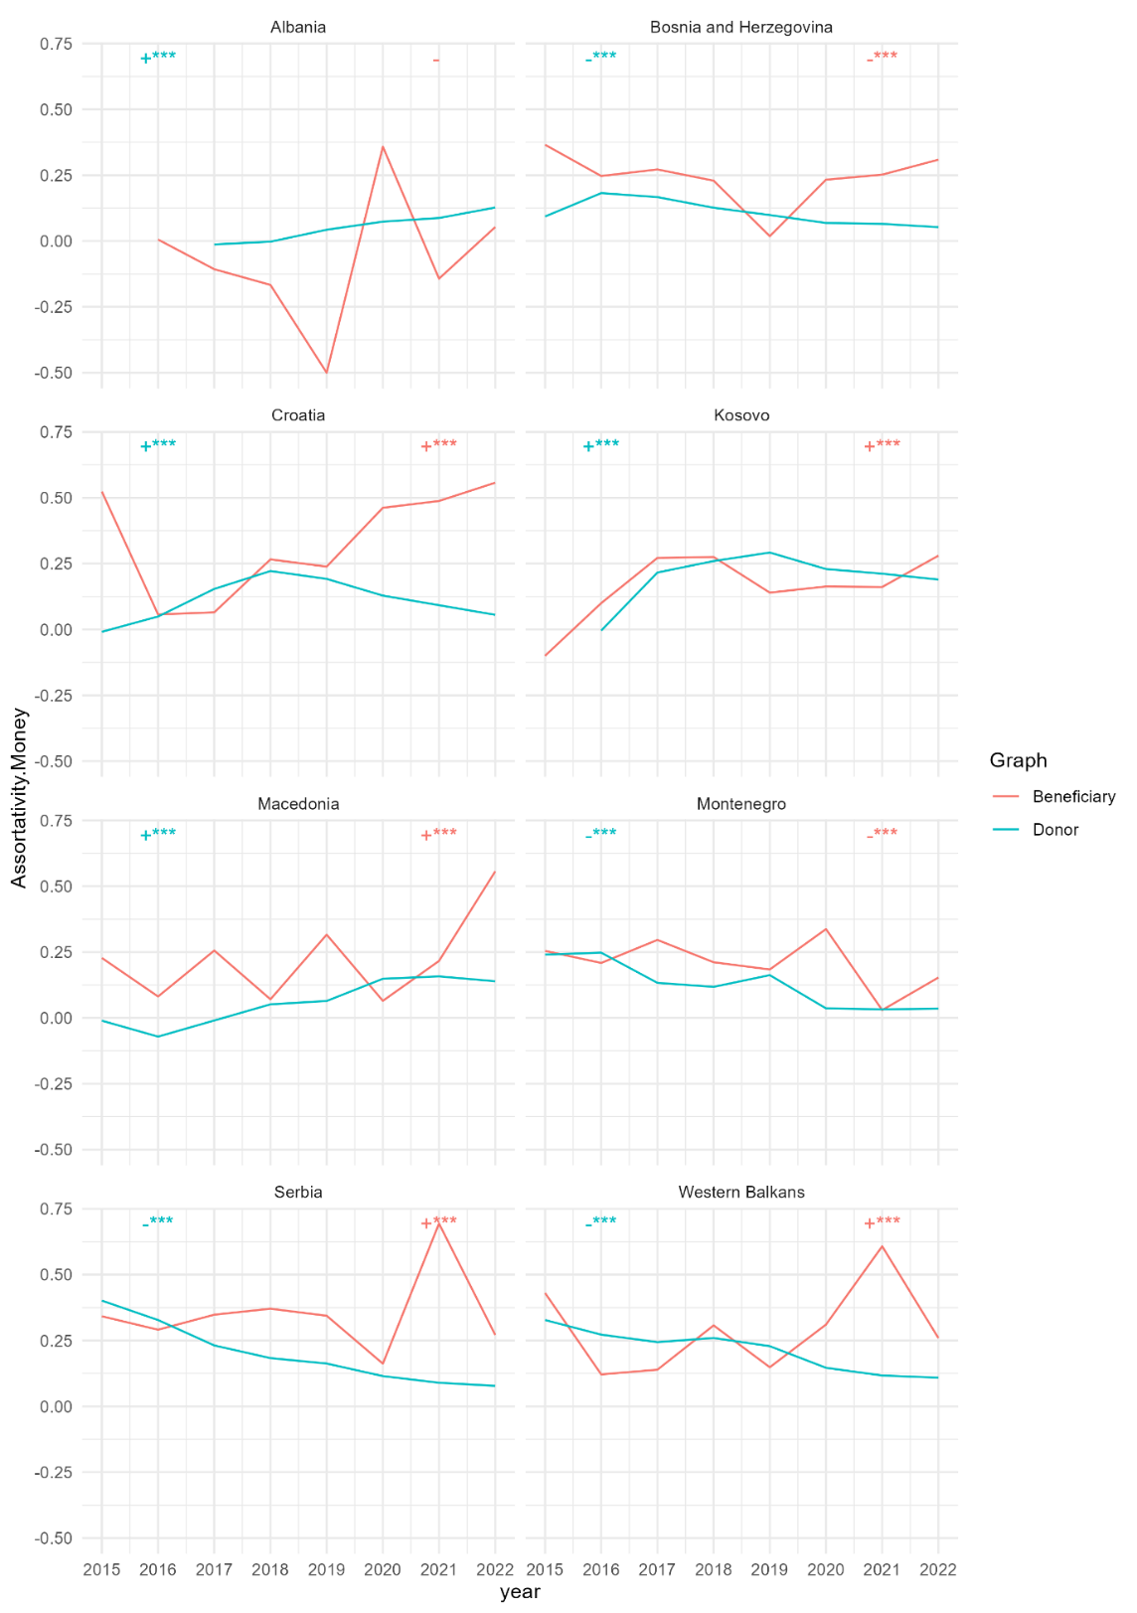

+ and – signs denote a positive or a negative trend *** p<0.0001, ** p<0.001, * p<0.01, . p<0.05

Appendix 6. Leaves percentage of the graphs in the Western Balkans

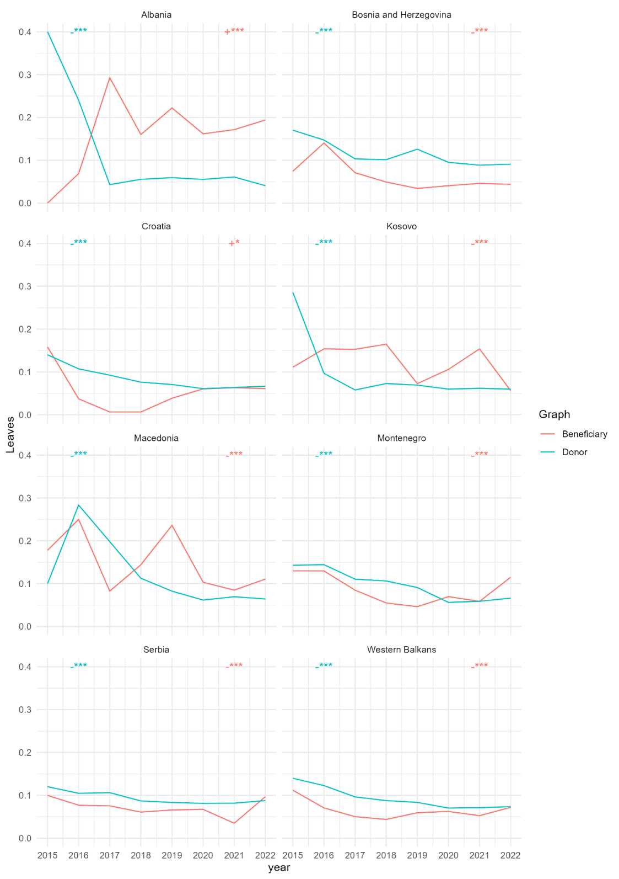

+ and – signs denote a positive or a negative trend *** p<0.0001, ** p<0.001, * p<0.01, . p<0.05