**Leverage effect and multiplication of resources.**

The results of a pilot research on the Next Generation WE project of the Compagnia di San Paolo Foundation.

Renato Roda, PhD (*Compagnia di San Paolo Foundation*), Michele Osella, PhD (*Compagnia di San Paolo Foundation*), Claudia Traina (*Compagnia di San Paolo Foundation*)

1. **Abstract**

Many scholars of the evolution of welfare systems have stressed how in recent years to private philanthropy - which, in Italy mainly takes the form of the so-called Foundations of Banking Origin (FOB)- a special role of integration and support of the basic public welfare state has been reserved. Exceptional events such as the Covid-19 epidemic created the conditions for organized philanthropy to expand its action according to new different directives and also to cooperate in filling some fundamental shortcomings of public social policies. This is the case of a series of projects linked to the National Recovery and Resilience Plan (PNRR - Italian expression of the package of extraordinary European funding Next Generation EU) proposed by the Compagnia di San Paolo Foundation, the largest Italian philanthropic foundation. Often compared to a new Marshall Plan, the support package approved by the European Commission after the 2020 crisis is indeed a unique intervention both in terms of the amount of economic aid made accessible, and the constraints of responsibility that the initiative imposes on the various institutional levels involved. It is no secret that in Italy the PNRR still suffers from a lack of competent human capital -especially within the local municipalities small and medium- able to meet professionally in terms of design and management the demands of the European Commission. This is precisely the problem that the Foundation wanted to address for the North-West of Italy, through interventions that stimulate beneficiary organizations to activate a variety of training paths in the sense of social innovation, strengthening their applications to PNRR and similar calls. In this document we will focus on Next Generation WE project, in which FCSP allocates six million euros to support the project capabilities of local institutions ranging from metropolitan cities to mountain communities. A particular and very important feature of the project is to rely on leverage mechanisms to ensure that the capital initially invested by the Company enjoys a multiplier effect that significantly increases the resources available to the individual entities involved. The evaluation of the effectiveness of the project and in particular of its unique characteristics (leverage effect in the first place) is carried out through the quantitative analysis of the data obtained by the Foundation itself. It should also be noted that the entire action undertaken by the FCSP is inspired by an innovative philanthropic strategy that sees an increasingly supplementary role, on the one hand, and the ability to multiply through aggregations and cooperation its resources on the other, its characteristic points.

1. **Main text**

*Introduction*

Immediately after the pandemic crisis of 2020, the European Commission, as is known, carried out an extraordinary financial intervention, that in Italy was adapted and implemented under the name of the National Recovery and Resilience Plan (PNRR). Often compared to a new Marshall Plan, such support package is in fact a unique initiative, both in terms of the scale of the economic aid made available and in terms of the constraints of responsibility imposed at the various institutional levels involved. At the time of the implementation of the plan, it was quickly realized that, paradoxically, the main beneficiaries of the 191,5 billion euros of the PNRR (that become 220 billions thanks to other national interventions) too often and for different reasons were not able to express the skills necessary to obtain the funds that had been intended for them. The greatest risk was a dramatic waste of resources at national and European level. Our research follows in particular an experimental and innovative project, with a budget of about 6 million euros, funded by the main Italian Foundation of banking origin, Compagnia di San Paolo. This project, called Next Generation WE (NGWE), has the main objective of supporting public entities/municipalities or aggregations of municipalities - interested in the resources of the PNRR but with diminished and poorly equipped personnel and a lack of skills in the design field. Our research, conducted mainly with quantitative methodologies, referred to the whole population of 88 involved beneficiaries, located within the reference territory of the Compagnia di San Paolo Foundation (i.e., Piedmont, Liguria and Valle d'Aosta). Alongside the more explicit objective of supporting the beneficiaries' skills, NGWE was intended from the very beginning to play in a completely innovative way its role as a philanthropic project, giving rise to what was defined as a "leverage effect" multiplier. The aim was to act only if there were the conditions under which resources directly spent by the Foundation would be added subsequently to other different sources, always to the benefit of the recipients. The Foundation would therefore act as a catalyst for other, increasingly substantial resources, in some kind of virtuous circle. The study of the effectiveness of the project and its specific characteristics (complementarity, leverage effect, capacity building) is carried out through the quantitative analysis of the data obtained by the Foundation itself, through the continuous monitoring of project applications. Once the research work is now starting to give enough exhaustive information, we have a considerable amount of quantitative data that confirm the basic theory on the effectiveness of specific approaches in determining leverage effects that can multiply the resources initially invested by a charity: in our case the multiplier effect covers a range that goes surprisingly up to 27,7 times the initial figure.

The results of the research also contribute substantially to defining new developments and new approaches regarding the philanthropic potential of the Private Social and also its subsidiary role in the balance of contemporary welfare.

*The PNRR*

In the complex, uncertain period of pandemic, whose boundaries were less than certain, Republican Italy has experienced one of its greatest crises, not only being overwhelmed by the fury of the Corona Virus and counting several tens of thousands of the deceased (for accuracy, 190,517 deaths at the 2nd of june 2023), but exacerbating in economic terms a lasting crisis whose origins can be traced back to the subprime mortgage scandal of 2008. To these very serious structural problems was added the difficulty encountered by decision-makers in implementing procedures which were not popular with a particularly active and aggressive minority of citizens, contrary in principle to the restrictions necessary to fight the spread of the infection and the use of the vaccine as the main means of preventing the disease. Both from the point of view of the number of victims and the seriousness of the economic damage, Italy was among the Western countries that found itself paying the highest price: it is therefore not surprising that at the time of the allocation of the special funds for recovery and of the overcoming of at least the most immediate consequences of the crisis times, Europe has decreed that it favours Italy with by far the highest share (€222,1 billions, that almost equals to the 30% of the total amount) among those attributed to individual states with the Next Generation EU funding programme, the €750 billion temporary financial instrument agreed by the European Commission, the European Parliament and EU leaders in July 2020. In Italy, the National Recovery and Resilience Plan, commonly known as PNRR, was born as an immediate reaction to the establishment of the Next Generation EU. This complex design apparatus that has a duration of 6 years -from 2021 to 2026 is mainly designed to achieve three fundamental purposes:

* + To identify the objectives, reforms, and investments that the country considers priority from the point of view of implementation using the funds made available by the European Community through NextGenEU
  + To limit the negative economic and social effects of the pandemic
  + To accelerate the transition of Italy to a more equitable, sustainable and inclusive country, with a more competitive, dynamic and innovative economy (www.agenziacoesione.gov.it)

On 5 May 2021 the official website of the Presidency of the Council of Ministers made public in its entirety the text of the National Recovery and Resilience Plan -sent by the Italian government to the European Commission entitled "Italy Tomorrow"- including European and partly national funds totalling EUR 222,1 billion (191,5 billions of the Next Generation Eu plus other national and international funds). Within a few weeks the PNRR was finally approved by an executive decision of the Council of Ministers, on a proposal from the European Commission. A large series of addenda are attached to the basic text, stating clearly defined and specifically timed objectives and targets for each investment and reform. The allocation of resources, which is checked every six months, depends on the achievement of these objectives.

The PNRR is formally divided into 6 macro sections, called "Missions", which represent the structural "thematic" areas of intervention. The Missions are in turn divided into 16 sub-sections, called "Components". The PNRR is finally defined by a third sub-level consisting of 134 "investments" and 63 "reforms".

* + *Digitalisation, innovation, competitiveness, culture and tourism*: Mission 1 aims to promote and support the so-called digital transition in both the private and public sectors (e.g. in the Public Administration) supporting innovation in the industrial and production system and investing in the two key sectors of tourism and culture.
  + *Green revolution and ecological transition*: Mission 2 deals with the important issues of sustainability in agriculture, circular economy, energy transition, sustainable mobility, energy efficiency of buildings, water resources, pollution, with the aim of improving the overall sustainability of the economic system and ensuring a fair and inclusive transition toward the realization of a zero environmental impact society.
  + *Infrastructure for sustainable mobility*: Mission 3 makes a series of investments with the aim of creating a modern, digital, sustainable and interconnected transport network that can encourage the electrification and digitalisation of transport, and improve the overall competitiveness of the country, in particular in the *Mezzogiorno*.
  + *Education and research*: Mission 4 proposes an economic model focused on knowledge, and on strengthening the educational system in all levels of education. It is also proposed to encourage research, also in relation to the production system.
  + *Inclusion and cohesion*: Mission 5 was born as a barrier both to the emergence of new forms of inequality from the current economic-health crisis and to the channelling of existing gaps in our society, with the aim of protecting the country’s social fabric. The mission aims to make participation in the labour market more permeable by providing training, proposing new active policies, and promoting social inclusion as much as possible.
  + *Health*: Mission 6 is completely dedicated to health. Its main objectives are two: to improve the prevention and care potential of the national health system for the benefit of all citizens, and to promote research and innovation in medicine.

**Table1- The division of the PNRR into 6 main elements, known as Missions (shortened M1, M2, etc). The figures written before the percentage in brackets represents the number of billions of euros invested by the European Union in the respective Mission.** 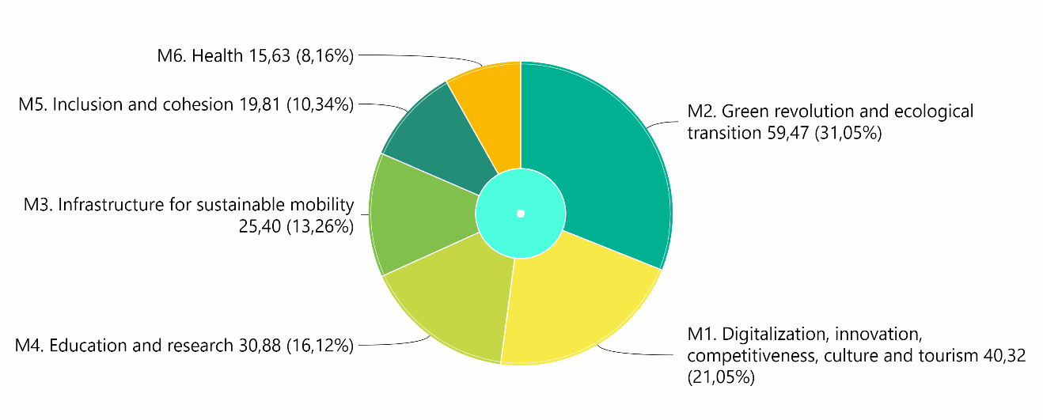

*Lacking skills*

However, the richness and complexity of the Plan came up against a difficulty whose gravity went beyond the predictions of the most pessimistic of industry analysts: we are talking about the considerable lack of specific skills, especially in the context of professional planning, that can be dramatically found both in the setting of public administration and in that of private initiative. It is such a lack of qualified professional resources - especially regarding the management of complex projects - to put at great risk the very implementation of the interventions required by the PNRR (Contissa, 2022). In addition to the mere lack of competence, there is also the question of the inadequate allocation of competent personnel in the roles best suited to the exercise of their skills, in particular in relation to the objectives of the *Piano Nazionale di Ripresa e Resilienza* itself.

In the area of local public administrations that will manage (and in part is already facing the challenge of) 90 billion of total resources -sum of PNRR and Complementary Fund- it is estimated that something like 14.000 competent professionals are needed, when at the state of the art are only available only a little more than 1.000 figures selected to this end.

The shortage is particularly marked for Mission 2 ("green revolution and ecological transition") and Mission 1 ("digitisation, innovation, competitiveness, culture and tourism"), with respect to which approximately 3.500 and 2.900 profiles are required respectively. If one considers with greater detail the professional deficiencies that weigh on the public sector, it will be possible to note in particular a lack of curricula regarding project and program management, whose fundamental importance for the management and coordination of the complexity of the Plan are evident. Administrative technical expertise would also be needed in relation to the management, monitoring, reporting and control of investments. Unfortunately, is similarly reported a deep lack of knowledge of EU and national procurement and contract law.

In the field of infrastructures, the competences regarding the procedures of selection of the more innovative contractors and the competences of project financing are lacking above all. From the point of view of the vertical skills required in the individual measures, there are, for example, IT experts, engineers, architects, geologists, surveyors, and physicists. More specifically, in mission 1, there is urgency of data scientist, social media expert, enterprise architect, IT solution and software developer architect, always from the point of view of direct examples. In mission 2 there is a need for hydraulic, civil, environmental and management engineers. In mission 5 -dedicated to inclusion and cohesion- there is a need for impact assessment experts and ecosystem managers.

There are territorial issues too. In the South of Italy, where the PNRR incidentally allocates 40% of the total resources, the same competences are required as the rest of the country despite Southern Italy shows deficiencies significantly higher than in the North. During the selections already completed (146 call for expert published until October 2022) the skills/profiles listed were largely left on paper. Around 100 junior profiles were included, and, in the vast majority of cases, cross-curricular competencies were required, while for the thousand of senior profiles the emphasis has continued to be on vertical competencies. This imbalance very often goes hand in hand with a misallocation of responsibilities in relation to objectives, especially since the recent simplification of competition procedures does not allow sufficient verification of the competences actually held by candidates. On the other hand, there is a question of salaries and career prospects, historical weak links in the Public Administration, along with the precariat (Tucci, 2022).

According to some (Contissa, 2022), to limit the consequences of this problem, in addition to an inevitable program of targeted hiring, it to complete would be very essential to identify the interventions and projects that stand out for exerting a cascade effect on other investments: this would allow to concentrate a greater number of resources in order the realization of the projects themselves. This is an essential point that we will return to. On the other hand, as regards strictly the discourse of competences, action should be taken by making appropriate transfers of skills and knowledge both within the public administration and between public employees and external experts and consultants, stimulating the development of spontaneous upskilling and reskilling movements within professional environments. In this way, and at least for the contingent needs, the shortage of adequately trained staff could be overcome.

The situation for the private sector is not, as mentioned, rosier: only for the telecommunications sector it is estimated that 15650 professional profiles are missing (including 750 fibre optic cable installers, 1000 cable junction experts and testers, 600 technical assistants and 6750 specialist technicians). No less serious difficulties are also encountered in the construction sector. As early as September 2022, the construction associations pointed out that -despite government “quick” solutions such as the so-called various building bonuses and the outlooks of the PNRR, that have acted significantly in positive on the demand of the building sector- Italy suffers a strong shortage of construction technicians, carpenters, and masons as well as workers minimally trained (Contissa, 2022). Due deadline prevents addressing a complex and entrenched problem through the in-depth analytical approach that would be required, nor, on the other hand, there are times for simple, direct recruitment after adequate training of the thousands of skills needed. It is therefore necessary to identify alternative strategies that refer to the existing situation, such as the creation of consortia involving industrial and institutional partners -thus bringing together public and private- or also the start of synergies with foreign companies operating in Italy with their own resources or even partnerships with professional schools to prompt them to form quickly within the common study and practice paths the highest possible number of junior figures specialized in the necessary skills. Finally, an option, which however became more critical with the alternation of the majority of governments in autumn 2022, could be to train and recruit foreign labour acquired through the mechanisms provided by the Decree Flows that regulates regular migration. Once it became aware of the dramatic level that has reached the problem of lack of skills in public bodies, there have been reactions by very different socio-political players. The State, represented by the Minister for the Civil Service, for example, at the end of 2021 created an executive think tank made up of 1,000 experts who made themselves available to local authorities to help them in the simplification of complex procedures in the field of PNRR design (Bandera, 2022). A very large number of super-consultants, but that immediately becomes much less impressive when compared with the tens of thousands of public bodies that throughout the entire national territory have applied to win and, If so, manage the projects of the National Recovery and Resilience Plan. Moreover, it is not only a question of lack of numbers, but also of the type of experts made available by the Ministry. In many cases, in fact, to the vertical skills of the great experts proposed by Rome are preferable figures with a more dynamic curriculum, capable to bring into play transversal skills and so to help identify strengths and weaknesses of the submission and especially to support the compilation and management of the complex and varied forms associated with the application process. And it is also for this reason that alongside the government professionals have also moved in subsidiary function a series of philanthropic realities led by the Foundations of Banking Origin, with the purpose of making available to public bodies precisely those transversal competences that were lacking.

*The Foundations move*

According to the reasoning proposed by Francesco Profumo, President of ACRI - the association that unites the Italian Foundations and Savings Banks, the Foundations that from the beginning have realized the difficulties of many local administrations due to the absence of qualified personnel, have considered that this scenario represented just one of the occasions in which the ex banking non profit private can make the difference: adequate economic resources, deep knowledge of the territory and access to a rich and dense network of relationships mean that the Foundations can easily organize themselves to accompany candidates to the PNRR to develop the know-how necessary to overcome the difficulties of these initial stages. Even less opulent philanthropic institutions, moreover, can be able to carry out directly through their own project experience of capacity building, to help a sufficient number of PA. Many are the ex banking territorial realities that have been activated in this perspective: in Lombardy, the Cariplo Foundation has signed an agreement with the Region, Anci and Unioncamere to identify the Municipality that will benefit from 20 million euros allocated by line A of the so-called "Bando Borghi" -Small Towns Call- (foreseen by Mission 1 of the PNRR "Digitalization, innovation, competitiveness, culture and tourism"); in Friuli Venezia Giulia the Friuli Foundation has worked to support public and private bodies "in the design and drafting of strategic and sustainable projects"; the Fondazione Cassa di Risparmio di Firenze has opened "Sportello Europa" to provide guidance and, at the same time, it has carried out at its own expense 4 feasibility studies for as many new schools that can be financed by the PNRR; in the province of Pistoia, the Caript Foundation has decided to support 18 local authorities in programming through the “Progetti On” call. The first to move, however, was the Compagnia di San Paolo di Torino Foundation (FCSP) -which shares with ACRI the presidency of Francesco Profumo: the ancient institution (whose origins date back to 1563) has long cultivated a doubly revolutionary strategy of the role of the Foundations in the Italian social fabric, As we will see later, both through the exercise of a supplementary role of the public and through the implementation of a leverage effect multiplier of resources mobilized with the figures invested in a project. On the one hand, the Piedmontese institution has the objective not to passively support local authorities with mere funding but to actively accompany them with specific forms of partnerships in the work of designing and planning by activating virtuous dynamics that highlight a possible role of complementarity between the private and the public. On the other hand, the objective of the Compagnia is to provide resources taking care that these do not immediately exhaust their effect - consuming themselves in the mere coverage of project costs or proving to be a lost fund in favour of bodies and organizations - but demonstrate the potential to generate a significant leverage effect. It is possible to find an example of one of the most enlightening theoretical frameworks within the description of the so-called “proximity welfare” (Bonomi, De Tommaso, Gazzetti, Lodi Rizzini, Maino 2022), that is those forms of philanthropy that aim to integrate agility and innovation conveyed by larger foundations -especially the ex-banking ones- and their virtuous relationships -in some cases centuries old- with their territory of reference. It is precisely in this meeting that we can already see in action effective forms of subsidiarity by the private non-profit against the state and public bodies, often to the benefit of weaker local realities (including administrative ones). These are forms of intervention that act both in order to strengthen the ties and relationships of closeness within the individual local societies, and to contribute to an increasingly stronger private-public collective action. Frequently characterizing, at least in the case of the Compagnia di San Paolo, this action and these projects is the objective of making structural the exploitation of leverage effects so to multiply the economic resources invested (and, if possible, activating other additional ones) in every single intervention. Needless to point out that with the significant figures at stake, the planning linked to the PNRR immediately becomes one of the opportunities where it was possible to test this strategy of leverage effect with success and potentially important economic returns. In particular the Foundation, trying to cover as much as possible diversity and specificity, proposed a threefold offer of projects focusing more or less deeply on the PNRR and on the need to support different types of bodies: such organizations must be supported both before -during the phase of preparation of application- and after -during the phases of management and implementation of projects- a possible call victory, always with a strong focus on the problem of skill shortages. More specifically, these are the projects: Next Generation You, dedicated mainly to strengthening the organizational and managerial assets of the Third Sector of Piedmont, Liguria and Valle d'Aosta regions in North-West Italy, the main objective of the project being, therefore, to invest in the organizational capacity of institutions through rationalisation and growth processes oriented towards their innovation, sustainability and autonomy and, consequently, on their ability to be agents of development for the territory in which they operate and bring widespread and lasting benefits (in 2023 the project has reached its third year, and the Company has invested for each annuality a budget of 2 million euros); Next Generation Schools, with the primary objective of consolidating the skills of local bodies in terms of interdisciplinary design and planning by schools, kindergartens and nurseries, especially with regard to replacement, construction, safety, enlargement, renovation of gyms and canteens th in Piedmont, Liguria and Aosta Valley (in 2023 the first annuality of this project is moving toward completion with a budget of 1.8 million euros); and finally the Next Generation We (NGWE) project, which we will discuss in more detail in the following paragraphs.

*The NGWE project*

Inaugurated in autumn 2021 with a budget of 6 million euros, NGWE provides for the primary focus of its intervention to help local administrations of municipalities (single or roped) and mountain communities and, from the second edition, metropolitan cities and provinces, with the aim of contributing so that the local authorities of Piedmont, Liguria and Aosta Valley can effectively manage the funding opportunities made available with the PNRR. Concretely, this for the Compagnia di San Paolo Foundation means:

* + to strengthen and broaden competences already present in local authorities;
  + to implement various initiatives to "accompany" the agencies in the project phase foreseen by the calls, providing assistance and training (Profumo 2022);
  + to experiment forms of support based on the leverage effect and therefore on a net multiplication of the resources actually disbursed (up to a maximum figure of 80'000 euros, of which however a figure equal at least to 10% must be used for the engagement of specialized professionalities in the field of the participated planning) from FCSP for every agency;
  + to encourage the creation of networks or partnerships variously articulated between different administrations homogeneous for needs and characteristics, with the aim of optimizing the interventions (Bonomi, De Tommaso, Gazzetti, Lodi Rizzini, Maino 2022).

All this happens through the organization of a series of training courses (which in the intentions of the Company must continue, gradually adapting topics and themes, even beyond the winning of the call, to support the institutions in the period of no less difficult implementation and implementation of the project) which aim to broaden and consolidate the competences of the staff of public bodies, which will be progressively increased and enhanced. Obviously, a leading role is offered to the advice on the design and the ways through which you go from hypothetical design to the realization of projects. The FCSP in the first edition of the project suggested a list of names from which to choose their mentors, but, considering this solution too binding, from the second edition onwards the choice is left completely free, maintaining the register as a reference only in the event that some bodies did not know any consultant to turn to.

**Table 2- The division of the municipalities participating in the Next Generation WE project according to the 3 thematic departments of the Compagnia di San Paolo Foundation (cyan= "planet" - research, environment, health; magenta= "culture" - art, entertainment, museums; yellow = "people” - social, education, inclusion). As you can see, People, whose themes are slightly less important even within the PNRR, collects a number of projects slightly less than the other two objectives.**

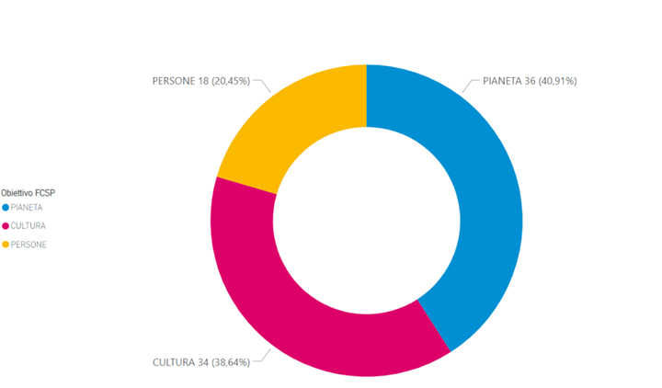

So far, the project has involved NGWE 88 municipalities/group of municipalities with as many projects, for a total of more than 4 million (4,335,284€) of final recipients (inhabitants of municipalities, cities or groups of municipalities that have joined NGWE): the territorial distribution of the agencies is rather unbalanced in favor of the Piedmont with 70 agencies in this single region (the province of Turin alone takes 42% of the total of the municipalities), 12 in Liguria and 6 in Valle d'Aosta. Compared to the internal operating divisions of Compagnia, however, the division of the agencies is more balanced: the departments -officially called "Goals"- Planet (dedicated to research, health, environment, innovation etc.) and Culture (dedicated to art, museums, cultural heritage, entertainment, etc.) have respectively 36 and 34 entities each, while People (dedicated to topics perhaps less significant in the balance of the offer of the PNRR, such as welfare, social, education, etc.) ranks in the queue with a total of 18 institutions. On the other hand, People includes definitely the most ambitious program among all those who have joined NGWE, it is a project of Carmagnola - an agricultural town near Turin- worth 600,000€ (the average value of the projects is around 18,000€) and provides for the coherent and organic recovery of three historic buildings and the creation of a new urban centre, imagined for about 30,000 users.

**Table 3- The distribution on the territory of North-West Italy of the municipalities involved in the three editions (concurrent) of Next Generation We. The colour of the spheres indicates to which of the three internal "objectives" of Compagnia the project of the organization (cyan= "Planet" - research, environment, health; magenta= "Culture"- art, entertainment, museums; yellow = "People" - social, education, inclusion). The dimensions of the spheres instead refer to the total cost of the project proposed by the agencies.**

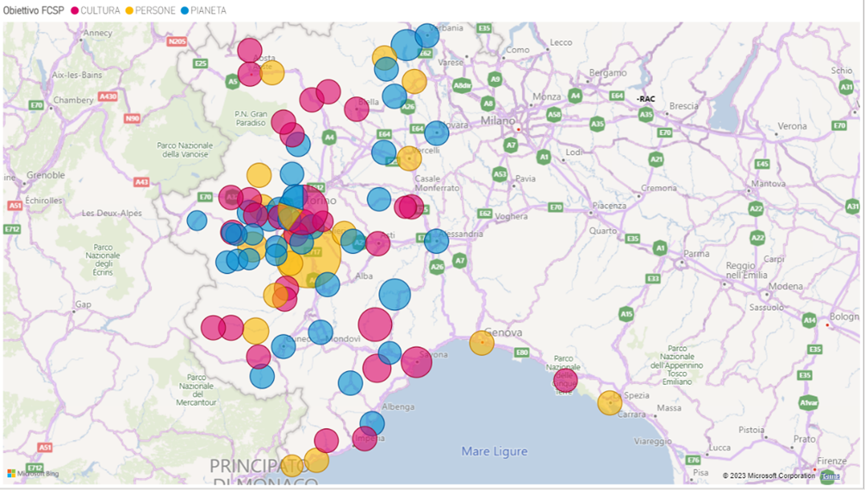

The call for the construction of collaborative networks and for co-design the proposed projects immediately seems to work with significant numbers, at least in comparison to the total of 88 municipalities/municipaltities teams that have participated so far in the project. In table number 4 we can see all the forms (and numbers) of partnerships contracted by the organizations during the first three editions of the project.

**Table 4 – NGWE’s networks of partnerships and cooperation between the municipalities involved in the projects and various different categories of potential associates, voluntaries, companies, public and third sectors entities, other municipalities, consultants, etc**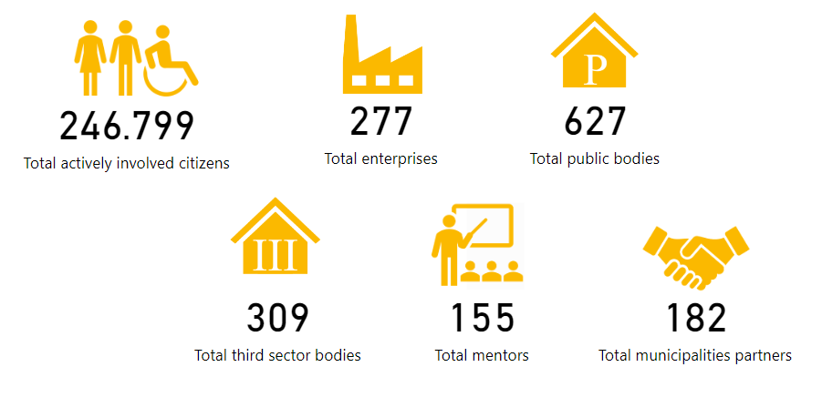

*Leverage effect, Leverage effects*

Initial case studies show that the leverage effect of participation in the NGWE call starts to generate a series of concrete and satisfactory positive results. In truth wherever an agency succeeds in winning a ban that is of the PNRR or a similar call, the return for those who have benefited not only equalizes the fund disbursed by the company for planning expenses, legal fees, training costs etc. but almost always generates a much higher revenue. It becomes so difficult to calculate how the lever mechanism can actually be measured. Some scholars have taken into consideration only the part of investments of the Compagnia addressed only to the so-called “costs of planning” (approximately 4,364,125€, that is little more than 2/3 of the total cost of the investment of Compagnia di San Paolo) excluding any other cost as a spurious with respect to the calculation (BONOMI, DE TOMMASO, GAZZETTI, LODI RIZZINI, MAINO 2022) and observing how many times the value multiplies in the total of the resources until now obtained through the various calls of the PNRR (or €32,929,709), the result achieved is an average of **7.5 times** the initial investment. If we consider the entire economic package of contributions invested by the Company (€5,835,500) and compare it with the total resources obtained so far through the PNRR calls (the aforementioned €32,929,709), we get a return of **5.6 times**. It get even more complicated, though. Compagnia’s analysts tried to narrow their focus to only entities that by May 2023 had finalized the application to the PNRR (37 bodies, 42% of the total: they saw an investment by the company equivalent to €2,734,500 and collected a total of resources from the PNRR equivalent to €28,454,685) or a call with similar characteristics (5 bodies, 5.7% of the total: they saw an investment by the Company equivalent to 392,500 € and collected a total of resources from the calls equivalent to €4,475,024) thus excluding participants who are still waiting for specific calls yet to come or who simply lost their way. In this case, the division of €32,929,709 out of €3,127,000 attests to the value of the leverage seems **10.5** **times** the initial investment. If you take as a reference only the 23 entities that participated and won the calls, getting the total already seen of €32.929.709 but having enjoyed an investment by FCSP amounted to only €1.581.000, the leverage jump to **20.8 times** the initial investment. Finally, if, referring to the first of these multiple assumptions for the elaboration of the leverage effect, we calculate it taking into account the minimum investment, or the resources donated by the Company exclusively and strictly for the planning of the candidate projects by the municipality (and therefore excluding funds for legal fees, 10% for the recruitment of professionals of managers with transversal skills, funds intended to encourage participatory design etc.) and referring only to the winners of the PNRR calls (planning costs = 1,186,100€, resources won by the calls 32,929,709€) the leverage apparently exerted by the action of the company reaches up to **27.7 times** the initial investment.

**Table 5 - The 15 nighest winning municipalities -identified by the name of their project- from the calls PNRR (in blue): note in orange comparison the initial figure allocated by FCSP to start the so-called leverage effect and, still, in green, only the part of such funding expressly dedicated to the design**

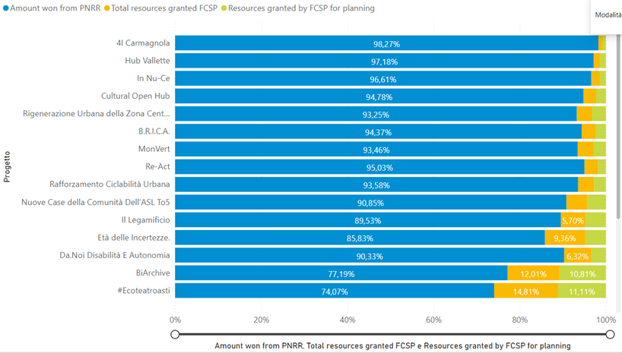

In the absence of a robust theory to be applied to an articulated case like that of the NGWE project, we can only assume as a result of the study on the leverage effect a range that goes -in the most limited case- from multiplication by **5,6 times** of the capital initially invested by the Compagnia to a multiplication by **27.7 times** in the most favorable case, which is however also the one with a richer conceptual background (identification of design costs only, separation of winning entities from those that have yet to compete).

This is a bet won by Fondazione Compagnia di San Paolo on at least three levels. The first, more concrete in terms of the economic return of the project, implies the more or less effective operation of the lever mechanism, and therefore, with a relatively small initial financial investment, the achievement of the objectives of the PNRR or similar calls is decisively favoured, bringing to the coffers of participating entities significantly multiplied resources. The second certifies the adoption of a planning approach that in addition to encouraging the mere transfer of resources to the entities involved in the Compagnia’s projects, it acts as a stimulus for the training of administrative staff and for the general empowerment of the same administrations; in this way, a logic of social innovation is put in place that pushes institutions to improve their management activities and to devise territorial agreements of codesign for achieving common objectives between municipalities and communities with similar needs and characteristics. The third level, finally, is the leap forward in terms of innovation of the philanthropic role of the Compagnia di San Paolo: which, involved in this particular type of design, in addition to simple disbursements in money, offers a direct or mediated commitment to capacity building and transfer of skills, alongside the State in remedying the lack of professionalism that have undermined the early design stages of the PNRR, and reinventing itself as a new form of subsidiary welfare that through specifically oriented interventions proves capable of making a difference where the need is stronger and more pressing.

**References**

Il PNRR e le difficoltà degli enti locali, in “Openpolis” Lunedì 3 ottobre 2022 = https://www.openpolis.it/il-pnrr-e-le-difficolta-degli-enti-locali/

Bandera, L (2022), Le competenze che servono al PNRR: in campo anche le Fondazioni, in Percorsi di secondo welfare, 18 febbraio 2022= <https://www.secondowelfare.it/governi-locali/le-competenze-che-servono-al-pnrr-in-campo-anche-le-fondazioni/>

Bandera, L. (2013a), Le Fondazioni di origine bancaria: sperimentazione e sostegno alle reti, in F. Maino e M. Ferrera (a cura di), Primo rapporto sul secondo welfare in Italia 2013, Torino, Centro di Ricerca e Documentazione Luigi Einaudi = <https://www.secondowelfare.it/wp-content/uploads/2013/11/1R2W_CAP4_BANDERA_Le_Fondazioni_di_origine_bancaria_sperimentazione_e_sostegno_alLe_reti-.pdf>

Bandera, L (2013b), Le Fondazioni di comunità: una nuova declinazione della filantropia, F. Maino e M. Ferrera (a cura di), Primo rapporto sul secondo welfare in Italia 2013, Torino, Centro di Ricerca e Documentazione Luigi Einaudi.

Bifulco, L., Dodaro, M., Mozzana, C. (2022), Welfare locale e innovazione sociale alla prova dell’emergenza, in “Polis, Ricerche e studi su societa e politica”, 1/2022, pp. 105-134, doi: 10.1424/103560.

Boesso, G., Cerbioni. F. (2017), Governance e filantropia strategico nelle Fondazioni: la via italiana tra determinismo e solidarismo, Paper presentato in occasione dell'X1 Colloquio Scientifico sull'impresa sociale, 26-27 maggio 2017, Dipartimento di Scienze per l‘Economia e l’Impresa, Università degli Studi di Firenze

Bonomi E., De Tommaso C. V., Gazzetti A., Lodi Rizzini C., Maino F. (2022). La sfida del PNRR per le amministrazioni locali. La leva del bando Next Generation We tra welfare filantropico e welfare di prossimità, SISP 2022, Roma 8-10 settembre 2022, Sessione 5.9 – Regulatory quality and policy effectiveness: The implementation of EU countries’ Recovery and Resilience Plan

Cibinel E. (2019), Dall‘innovazione al cambiamento: una nuova sfida per le Fondazioni di origine bancaria, in F. Maino e M. Ferrera (a cura di), Nuove Alleanze per un welfare che cambia. Quarto Rapporto sul secondo welfare in Italia 2019, Torino, Giappichelli, pp. 211-234

Contissa, F. (2022) La mancanza di risorse professionali qualificate rischia di frenare l’attuazione degli interventi del PNRR – Blog Martino & Partners 4 Novembre 2022 https://www.martinopartners.com/blog/la-mancanza-di-risorse-professionali-qualificate-rischia-di-frenare-lattuazione-degli-interventi-del-pnrr-pnrr/

Gazzetti, A. (2022), PNRR: il nuovo Next Generation WE a sostegno degli enti locali, in Percorsi di secondo welfare, 12 agosto 2022

Giacomino, G. (2023) Pnrr. Poche imprese e progettisti così arrancano i piccoli comuni. In “La Stampa” 1° Aprile 2023, pag. 42

Knott, J.H., McCarthy, D. (2007), Policy Venture Capital: Foundations, Government Partnerships, and Child Care Programs, in “Administration & Society”, 39, 3, pp. 319-353

Longo, F., Maino, F. (a cura di) (2021), Platform welfare. Nuove logiche per innovare i servizi locali. Egea, Milano.

Maino F. (2017), Secondo welfare e innovazione sociale in Europa: alla ricerca di un nesso, in F. Maino e M. Fenera (a cura di), Terzo Rapporto sul secondo welfare in Italia 2017, Torino, Centro di Ricerca e Documentazione Luigi Einaudi, pp. 19-42.

Maino F. (2021), Il secondo welfare e la crisi pandemica, tra pubblico-privato e nazionale- locale, in Maino F. (a cura di) (2021), Il ritorno dello Stato sociale? Mercato, Terzo Settore e comunità oltre la pandemia. Quinto Rapporto sul secondo welfare in ltalia 2021, Torino, Giappichelli, pp. 39-64.

Maino F., De Tommaso V. (2021), La survey sul welfare filantropico, in F. Maino (a cura di), Il ritorno dello Stato sociale? Mercato, Terzo Settore e comunità oltre la pandemia. Quinto Rapporto sul secondo welfare in ltalia 2021, Torino, Giappichelli, pp. 107-138.

Messia, F., Venturelli, C.) (2015), Il welfare di prossimità. Partecipazione attiva, inclusione sociale e comunità, Erickson, Trento

Mochi Sismondi C, (2022), I comuni alla sfida del PNRR, Forum PA 2023, 25 febbraio 2022 = https://www.forumpa.it/citta-territori/i-comuni-alla-sfida-del-pnrr/

Polizzi, E. (2021), L’innovazione sociale mimetica. La diffusione dei modelli filantropici di welfare, in “Autonomie locali e servizi sociali. Quadrimestrale di studi e ricerche sul welfare". 3/2021, pp. 477-492, d0lI 10.1447/102649.

Polverari, L. (2020), La capacità amministrativa: letteratura, criticità e un'agenda di ricerca a servizio del policymaking, in “Rivista giuridica del Mezzogiorno, Trimestrale della Svimez" 3-4/1020, pp. 743-762, doi: 10.1444/98225

Profumo, F. (2022), Relazione introduttiva del Congresso, XXV Congresso Nazionale delle Fondazioni di origine bancaria e delle Casse di Risparmio, Cagliari, 7-8 aprile 2022.

Salamon, L. M. (2014). Leverage for good: An introduction to the new frontiers of philanthropy and social investment. Oxford University Press.

Tucci, C. (2022) Pubblica amministrazione a corto di competenze, caccia a 14'000 esperti – Osservatorio PNRR 27 Ottobre 2022 https://www.ilsole24ore.com/art/pubblica-amministrazione-a-corto-competenze-caccia-14mila-esperti-AERPHoBC