Effectiveness is not Enough:

The Total Effect of the Tax Policy toward Charitable Giving – Boundaries, Take-up, and Effectiveness

Osnat Hazan, Ph.D.
The Institute for Law and Philanthropy, Buchmann Faculty of Law,
Tel Aviv University, ISRAEL
972-50-6238334
osnati@tauex.tau.ac.il

Abstract
Tax benefits for charitable giving are very common. Governments waive tax revenues aiming to encourage donors to increase their giving to nonprofits. Yet we know very little about the total effect of such policies. The effectiveness of tax benefits has been widely researched. However, while effectiveness deals with the potential upward impact of a tax benefit on donations, it is limited to benefit-eligible donations and is relevant only to donations for which the benefit is actually claimed.
Based on administrative data and complementary surveys, studying Israel in 2018 as a test case, I find that donors claim a tax benefit for 36% of their total donations; that 23% of total donations are ineligible for the benefit due to its boundaries (ceilings, floor, and qualified nonprofits); And that 41% of total donations are eligible for a benefit yet a benefit is not claimed for them. Almost 70% of unclaimed tax benefits apply to individuals’ donations below NIS 20,000 (about €5,000). This pattern significantly undermines the pluralistic agenda implicit in the tax policy, leaving the privilege of allocating public resources to fewer donors, mostly those who make large donations.
Thus, to reveal the total effect of the tax policy toward charitable giving, it is important to study not only the effectiveness of the tax benefit but also the scope and the patterns of ineligible donations and unclaimed tax benefits. Such a comprehensive approach proposed in this paper yields a detailed picture that reflects the actual realization of the tax policy.

Keywords: Tax benefit, Donations, Public policy, Philanthropy, Pluralism.

Introduction
Most countries worldwide and almost 90% of high-income countries offer tax benefits for charitable giving to Public Benefit Organizations (PBOs) (Pickering, Quick, and Kruse, 2014). Such benefits are delivered in different methods (deduction, credit, or matching) and are usually bounded by various conditions (OECD, 2020).
The tax benefit for charitable giving is also referred to as "tax incentive" since governments waive tax revenues aiming to incentivize donors to increase their charitable giving to PBOs. Thus, the tax benefit is tantamount to indirect governmental support for PBOs. It is sometimes regarded as an alternative to direct PBO funding (Brooks, 2004). Some find this scheme more effective for supporting public-benefit goals than tax collection and governmental allocation: It is more efficient in terms of administrative cost and it tends to expand total resources available to public causes, thereby amplifying social utility (Margalioth, 2017). Others emphasize the pluralistic benefit that this kind of indirect support brings about by enabling a large public to allocate public resources (Solnik, 2019).
The primary purpose of the tax benefit – creating an incentive – is also reflected in the most researched question regarding tax benefits for charitable giving, that of effectiveness. An effective tax policy should encourage private donors to give more due to the tax benefit, to an extent that exceeds the public cost of the benefit (the government’s waiver of tax revenues). There is ample empirical research on the question of effectiveness, beginning with early works (e.g., Clotfelter, 1985; Randolph, 1995; Steinberg, 1990); followed by later works, some complicate the analysis by differentiating among various target fields (Bradley, Holden, and McClelland, 2005; Brooks, 2007), while others provide a meta-analysis of past research (Peloza and Steel, 2005); to contemporary works, for example, the collection of chapters on tax effectiveness in the recent handbook edited by Peter and Lideikyte Huber (2021). Most of the studies explore tax deduction; very few study tax reforms in a credit method (e.g., Fack and Landais, 2010).
However, while effectiveness relates to the potential impact of a tax benefit on increasing total donations, it is limited to benefit-eligible donations and is relevant only to donations for which the benefit is actually claimed. Therefore, the measurement of effectiveness yields only partial information about the total effect of the tax policy. For example, a specific tax policy may be highly effective in terms of giving donors a strong incentive to increase their donations, but donors who claim the benefit (and thus are likely to be influenced by the policy) give only 10% of the total donations. In this case, an ostensibly effective policy actually has a very narrow effect.
Alongside the ample research on effectiveness, there are some accounts of the percentage of taxpayers who claim the tax benefit (e.g., Huber, Pittavino, and Peter, 2021). At face value, this approach answers the quest for measuring the take-up of the benefit. The question of take-up arises usually regarding social benefits that aim to enhance distributive justice by improving recipients’ conditions. Thus, to know whether a policy is meeting its goals, one has to monitor beneficiaries’ take-up and aspire to a high percentage of beneficiaries who exercise their rights. (For a review, see Currie, 2004). The case of a tax benefit for charitable giving, however, is different because it actually aims to improve the conditions of a third party – the PBOs. Although it is donors who can claim the tax benefit, the policy seeks not to improve their conditions but to induce them to donate more to PBOs. Thus, the realization of the purpose of the benefit – increasing total donations to PBOs – is contingent on the share of donations for which the benefit is actually received. Therefore, to estimate the take-up of the tax benefit for charitable giving, it may be valuable to estimate the extent of donations for which the benefit is claimed. Interestingly, the expression “tax benefit” immediately brings to mind the issue of take-up, which is easily ignored when one thinks of a “tax incentive”.
To explore the total effect of the tax policy, I therefore suggest a more comprehensive two-stage approach. First, mapping donations in view of the policy: a) drawing the boundaries of eligibility, estimating the percentage of donations that are left out of the tax policy due to these boundaries; b) assessing the relevance of the policy by calculating the share of the donations that are reported to the tax authority in order to claim the benefit (“reporting” is tantamount to claiming the tax benefit); and thereby c) revealing the extent of eligible donations for which donors do not claim the tax benefit. This creates a map with three zones: ineligible donations, unclaimed benefit-eligible donations, and reported donations (benefit take-up). Only then can we advance to the second stage: exploring the effectiveness of the policy and estimating the increase in donations due to the tax benefit against its public cost. These two stages do not add up to one single number, of course. Furthermore, they are not always independent. For example, donors may not take up the benefit due to a weak incentive. Nevertheless, a comprehensive approach such as this may reveal the total effect of a given policy. As specified below, our insights get deeper as the exploration differentiates donations (by source and size). In this paper, taking 2018 in Israel as a case study, I apply the first stage in detail and provide a preliminary analysis for the second stage.
In what follows, I describe the tax policies available, elaborate on the methods used in this study, provide descriptive statistics on the data in Israel and some comparative data, present the results of this study, and conclude by discussing the findings and offering some insights on their basis.

Tax benefit for charitable giving
The tax benefit for charitable giving is offered in various methods. According to a recent review by the OECD (OECD, 2020), 22 of 40 OECD member and participating countries offer a tax deduction for individuals’ donations (e.g., the U.S., Germany, and Japan). The deduction is given by subtracting the sum donated from the personal income-tax base before the tax liability is computed. Consequently, in countries that apply a progressive personal income tax, the benefit is regressive because it makes the "price" of giving lower for the wealthier. Twelve countries offer a tax credit (e.g., Canada, Sweden and France) – an amount subtracted from the tax liability (assuming the sum of the credit is smaller than the liability). This sum is usually a fixed percentage of the donation amount and is equal among all donors. Four countries offer a matching method, in which the recipient organization can claim a tax benefit and get a fixed share of the donation from the government. In some cases (e.g., the UK and Singapore), high-rate taxpayers can claim a complementary deduction. Last, four countries allow donors to designate a fixed percentage of their tax liabilities to entitled PBOs (e.g., Portugal and Hungary). Although this allocation method does not incentivize private giving because it actually allocates public money according to private preferences, it is included in the OECD review of tax incentives because it may cultivate a culture of private giving in countries where such a culture has not matured (Bullain, 2004). For corporate donations, the tax-deduction method is even more common among the surveyed countries than for individuals' donations.
Every country other than Singapore limits the benefit amount. The applied boundaries vary: a fixed ceiling of benefit or donation, a maximum share of taxable income or tax liability; or a combination of ceilings.
In Israel, according to Section 46(a) of the Income Tax Ordinance, an individual donor may claim a tax credit of 35% of a donation to a “public institution” (a qualified nonprofit). The credit is given for a yearly sum of donations: above a floor of NIS 200, below a ceiling of NIS 10 million, and up to 30% of taxable income. A corporate donation may be credited at the company tax rate (23%) (all limits as of 2023).

Method

Source of data
This study is based mostly on administrative data, some aggregate and some raw, some accessible to the public but most inaccessible and received specifically for this study. Complementary data were harvested from surveys and published reports alongside published peer-reviewed papers. A detailed account of the data sources and use follows.
Data from the Israeli Tax Authority (ITA) on claimed tax benefits – administrative data at the level of all individual and corporate donations that donors reported in order to claim the tax benefit for charitable giving. The data include donations given in the years 1999–2018. The variables used were: type of donor, amount of yearly donations, amount of tax credit, and taxable income (only partially). These data were analyzed in the Israel Central Bureau of Statistics (CBS) “research room” after being anonymized by CBS staff.
Data from the Israeli Corporations Authority (ICA) on large donations – since 2018, nonprofits in Israel must fill in an annual online report to the ICA on several aspects of their activity. The reportage includes details on donations above NIS 100K they received from a single entity during the year, the amount of the donation and its source (individual, corporate, nonprofit, charitable trust, etc., from Israel or RoW [Rest of the World]). In addition, I used information on qualified nonprofits in regard to the tax benefit for charitable giving (PBOs) originating in the ITA. All these data were used to compile the Yearbook of Nonprofits 2018 and permission to use them for this study was granted by the ICA.
Philanthropy of Israelis Survey 2012–2015 – the survey, conducted and published by CBS in cooperation with the “Committed to Give” initiative and the Institute for Law and Philanthropy at Tel Aviv University, yields a reliable estimate of the extent of philanthropy of Israelis by sources and ranges of donations. Nonprofits in Israel were surveyed by a paper questionnaire sent to them. They were asked to map their annual income from philanthropy of Israelis by source (households, companies, and bequests) and range of donations. The survey included a statistically representative sample of 408 nonprofits in all fields of activity, representing all nonprofits in Israel that had income exceeding NIS 500K (about 6,000 nonprofits) (CBS, 2017).
Donations to Israeli nonprofits: a comparative study – this study provides data on total private donations to Israeli nonprofits from Israel and RoW in 2018. It incorporations sundry administrative data and complementary formal data to yield a reliable comprehensive sum of donations to nonprofits in Israel (Hazan, 2021).
U.S. and Canadian tax-authority data – detailed administrative aggregate national-level data on donations are published by U.S. Internal Revenue Service and the Canadian Revenue Agency.

Procedure
The year of the case study is 2018. At the time of my research (mid-2021), this was the latest year for which reliable data on total donations in Israel were available. Furthermore, administrative data on reported donations to the ITA for the tax benefit are almost complete about three years after the donation year (although the tax benefit can be claimed six years after the donation is made).
The estimate of total private donations to nonprofits in 2018 comes from comparative research based on a broad and robust infrastructure of data sources (Hazan, 2021). The point of departure is NIS 7 billion in total donations.
The distribution of donations by sources is based on the Philanthropy of Israelis Survey. On average, individuals’ donations account for 72.2% and corporate donations account for 27.8% of total private donations. Unpublished data compiled by CBS (in the yearly nonprofits survey) support this division.
The distribution of donations into ranges is based on several sources. The primary division into five ranges is based on the Philanthropy of Israelis Survey, in which respondents specified the sum of donations they received from each source by each range (up to NIS 2,000; NIS 2K–20K; NIS 20K–100K; NIS 100K–500K; above NIS 500K). This division, however, is not sufficiently detailed for the current study, in which I aspired to take the credit floor and ceiling barriers into consideration. Thus, to further divide the small donations, I used a full record of online donations in 2018 from JGive, one of the largest online platforms in Israel through which small donations are donated to nonprofits. Small donations (up to NIS 2,000, about €500) were divided into two ranges according to the credit floor in 2018 (below and above floor: up to NIS 180 and NIS 180–2,000). To divide the large donations (above NIS 100K, about €25,000) further, I used the administrative data of the ICA, to which nonprofits report each and every donation above NIS 100K that they receive, disclosing the donors’ identity. Although the donors were anonymized in the data I analyzed, the ICA could verify the authenticity of the information on the donor’s identity (if it was a donation from an Israeli source) and created a variable indicating the type of donation source (individual, corporate, nonprofit, and from Israel or RoW). Basing myself on the distribution of large donations from Israeli sources as recorded in these administrative data, I divided large donations into five ranges (NIS 100K–500K, NIS 0.5M–1M, NIS 1M–5M, NIS 5M–9.2M; and above NIS 9.2M – above the credit ceiling in 2018).
Overall, throughout the analysis I kept the data distributed by two sources and nine ranges (18 cells). To simplify the presentation, below I parse the data by six ranges only (12 cells).
Estimating the share of donations given to qualified nonprofits. According to the Yearbook of Nonprofits 2018, 84% of total private donations in Israel were given to qualified nonprofits. Using the ICA raw data on large donations I computed the share of the sum of donations to qualified nonprofits separately in each cell (indicating source and range) among the ranges of large donations. (The differential shares were 84%–100%, with the exception of 34% of individuals’ donations above the ceiling for qualified nonprofits). The share of donations to qualified nonprofits in the smaller ranges (less than NIS 100K) was a plug number for the known overall share of donations to qualified nonprofits – 84% (the merged share in the smaller ranges was 83%).

Results

Descriptive statistics on reported donations and comparative data
Below are administrative data for Israel on the number of donors who claimed a tax benefit for their donations (Figure 1) and the sum of donations reported (Figure 2) in the years 1999–2018.

Figure 1. Number of donors who claimed a tax benefit for donations, by source and year
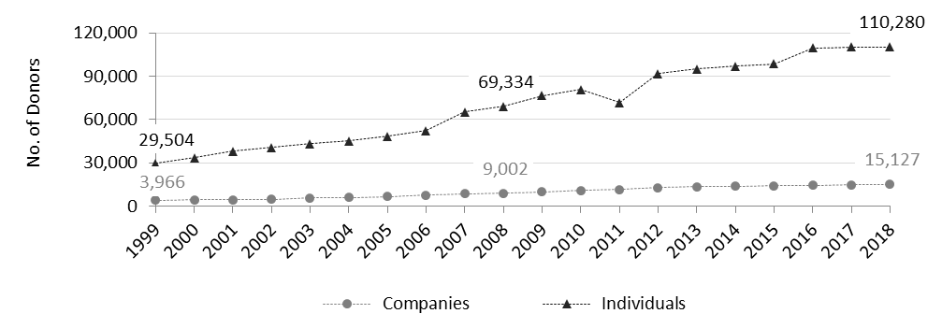

Figure 2. Sum of donations reported for a tax-benefit claim, by source and year
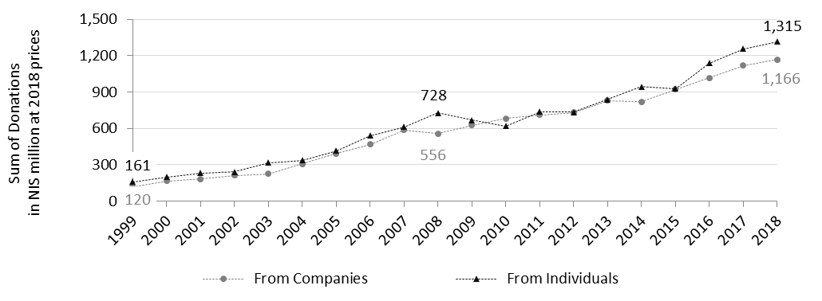
Although eight times as many individuals as companies reported donations, the sum of donations reported by individuals is almost equal to that of corporate donations in most years. In the test-case year, 2018, 15,127 companies reported NIS 1.2 billion in donations and 110,280 individuals reported NIS 1.3 billion.
Total donations increased almost 10 times over (at constant prices) between 1999 and 2018, whereas the number of donors (individuals and companies) quadrupled during that time. The increase in the number of individual donors (four times larger in 2018 than in 1999), of course, reflects population growth, manifested in an increase from 2.6 million taxpayers in 1999 to 4.3 million taxpayers in 2018. However, it also reflects a significant increase in the proportion of taxpayers who claimed the tax benefit for donations, from 1.1% in 1999 to 2.6% in 2018 (Figure 3, based on state revenue reports).

Figure 3. Number of individual donors who claimed a tax benefit for donations and their share among taxpayers, by year

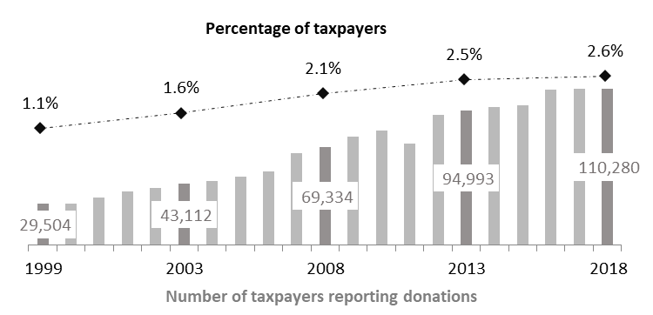

The proportion of taxpayers who reported donations in Israel is very small in comparison with other countries (Table 1). However, this kind of statistic is limited because despite being highly accurate (derived from administrative data) it tells us very little about the extent of take-up of the tax benefit. Instead of reviewing the percentage of taxpayers who report donations, a more interesting question would be: what is the percentage of donors who claim the tax benefit? This datum can be estimated very roughly from complementary data such as surveys. Although these estimations are not statistically reliable, they convey a sense of the magnitude of take-up in terms of donors. Again, Israel’s score is very low (Table 1).

Table 1. Share of donors and taxpayers who claimed a tax benefit, by country

Country | Year | Proportion of taxpayers claiming tax benefit | Proportion of donors claiming tax benefit | Source of data on taxpayers | Source of data on donors
Israel | 2018 | 2.6% | 8% | ITA | CBS
The U.S. | 2018 | 9.6% | 20% | IRS | Osili, Zarins, and Han, 2021
Canada | 2017 | 28.5% | — | CRA; Lasby and Barr, 2018
United Kingdom | 2016 | 11.0% | — | Almunia et al., 2020
Switzerland, Geneva | 2011 | 19.3% | 27% | Huber, Pittavino, and Peter, 2021 | Freitag et al.,2016, in Huber, Pittavino, and Peter, 2021;
Germany | 2009 | - | 61% |  | Sommerfeld, 2009, in: Adena, 2021

Even if the numbers were more accurate, we still would not know the extent of benefit take-up in terms of total donations—a variable that may yield a better way to assess the effect of the tax policy. To fill this lacuna, I move to the core analysis of this study.

Mapping the policy toward charitable giving in Israel
The point of departure is the total sum of domestic donations to nonprofits in Israel by individuals and companies in 2018: NIS 7 billion (to be exact, NIS 6,985 million) – NIS 5 billion from individuals (72%) and almost NIS 2 billion by companies. Out of total donations, NIS 1.6 billion in donations, was ineligible for the tax benefit. This chunk is comprised of NIS 593 million in donations below the credit floor (NIS 180) and NIS 1 billion in donations to unqualified nonprofits. Quite understandably, all the below-floor donations came from individuals. Notably, however, most donations to unqualified nonprofits also originated in individuals (only NIS 183 million out of NIS 1 billion was given by companies) (Table 2). It would seem that donations above the credit ceiling should also have been included among the ineligible donations. However, since donors report them when claiming a tax benefit (although they would receive only partial credit), they are included in the eligible donations. In 2018, donations in excess of the credit ceiling were estimated at NIS 150 million (2% of total donations).
Thus, the eligible donations (for partial or full credit) amounted to NIS 5.4 billion. Almost half of this total comprised individuals’ donations in sums smaller than NIS 20K and 25% originated in individuals’ donations smaller than NIS 2,000 (Table 2).

Table 2. Total donations, eligible and ineligible donations, NIS million, by source and range

Range | All donations |  | Ineligible donations |  | Eligible donations
 | Individual | Corporate | Individual | Corporate | Individual | Corporate
Total | 6,985 |  | 1,612 |  | 5.373
Total by source | 5,045 | 1,940 | 1,429 | 183 | 3,616 | 1,757
Up to NIS 180 | 593 | - | 593 | - | - | -
NIS 180–2.000 | 1,688 | 55 | 282 | 9 | 1,406 | 46
NIS 2K–20K | 1,190 | 166 | 199 | 28 | 991 | 138
NIS 20K–100K | 397 | 295 | 67 | 49 | 330 | 246
NIS 100K – NIS 1M | 514 | 576 | 69 | 40 | 445 | 536
Above NIS 1M | 663 | 847 | 219 | 56 | 444 | 791

Out of the NIS 5.4 billion in eligible donations, donors claimed a tax benefit for NIS 2.5 billion in donations, for an overall take-up rate of 46% of eligible donations. Corporate donors reported 66% of their total donations, and individual donors reported 36% of their total donations (Table 3). Apart from the difference between corporate and individual donors, it is salient that the take-up percentages are significantly higher for large donations than for small ones. Thus, while less than 10% of eligible donations in sums smaller than NIS 2,000 are reported (claiming a tax benefit), most donations above NIS 1 million are reported (96% of corporate donations and 83% of individual donations).
Unreported donations added up to NIS 2.9 billion, meaning that the tax benefit was not taken up for 54% of eligible donations. Looking at the absolute numbers, one’s attention is immediately drawn to individual donations below NIS 20K: the tax benefit was not claimed for NIS 2 billion in donations within this range (NIS 1.36 billion in donations below NIS 2,000 and NIS 0.7 billion in donations within the NIS 2K–20K range – together, more than 70% of unreported donations) (Table 3).

Table 3. Reported and unreported donations, NIS million, by source and range

Range | Percent of reported donations out of eligible donations |  | Reported donations  (benefit take-up) |  | Unreported donations (benefit non-take-up)
 | Individual | Corporate | Individual | Corporate | Individual | Corporate
Total | 46% |  | 2,481 |  | 2,892
Total by source | 36% | 66% | 1,315 | 1,166 | 2,301 | 591
Up to NIS 180 – ineligible | - | - | - | - | - | -
NIS 180–2.000 | 3% | 9% | 45 | 4 | 1,361 | 42
NIS 2K–20K | 29% | 36% | 290 | 49 | 701 | 89
NIS 20K–100K | 95% | 49% | 313 | 120 | 17 | 126
NIS 100K – NIS 1M | 54% | 63% | 242 | 336 | 203 | 200
Above NIS 1M | 95% | 83% | 424 | 658 | 20 | 133

Figure 4 summarizes the data and maps the actual outcome of tax policy toward charitable giving in Israel in 2018. The map departures from NIS 7 billion in total private donations from individuals and companies. 23% of this total donation is ineligible due to the policy boundaries (Figure 4, the lightest grey circular sectors). The rest is eligible for the tax benefit. The scope of eligible donations reflects the actual potential of the tax benefit – 77% of donations. The largest portion of donations – 41% of total donations – are eligible donations that donors do not report the ITA, resulting in zero take-up of the benefit. Most of these donations come from individuals (Figure 4, the dark grey circular sectors). This leaves us with 36% of total donations that were reported by donors who claimed the benefit and received partial or full tax credit (Figure 4, the black circular sectors).

Figure 4. The map of realized tax policy toward charitable giving in Israel

The scope of take-up reflects the relevance of the tax benefit. “Relevance” denotes the effect of the benefit only on donors who claim it and who may (or may not) increase their donation sums for this reason. Drawing the relevance zone allows us to move to the next stage, estimating the “effectiveness” of the tax benefit. The benefit is effective only if it induces an increase in total donations in a sum that exceeds its cost to the public. Thus, effectiveness is bounded by the extent of claimed donations.

Preliminary evidence of effectiveness in Israel
Evaluating effectiveness of the tax policy using the common method of exploring price elasticities is suitable mostly for countries that apply the deduction method. In countries that use the credit method, it is possible only when the percent of the credit is revised, triggering changes in the “price” of donating. In Israel, such a reform took place in 1985 – about 40 years ago – and the only changes since then relate to the levels of the credit floor and ceiling. Thus, evaluating the effectiveness of Israel’s tax policy requires alternative measures. While this endeavor is beyond the scope of the current paper, it is worth presenting here the aggregate data that indicate, roughly, to what extent the policy changes were effective.
In principle, effectiveness relates not only to the ability of the tax policy to increase donations. It is rather about the increase of donations above and beyond the benefits' cost (the waiver of tax revenues). Otherwise, the state would not encourage private donations but would fund them from public resources. Therefore, I explore the “net utility” of the tax policy, total donations less the tax credit given (hereinafter: “net sum of donations”).
Looking separately at the changes in the floor and in the ceiling, it is most evident that changes in the floor level influenced the number of individual donors (Figure 5). In 2011, the floor was raised to NIS 410 and then, in 2012 onward, it was dropped significantly, to NIS 180–190. The respective net sum of donations in the relevant range (below NIS 500) dropped in 2011, increased in 2012, and was quite steady thereafter (at constant prices). Furthermore, the numbers of donors followed the same patterns, indicating that it was the count of individual donors, and not their average donation, that changed. The changes in the floor, however, do not attest in the net sum of donations in the NIS 500–1,000 range.

Figure 5. Scope of individuals’ small donations in respect of the changes in tax-credit floor

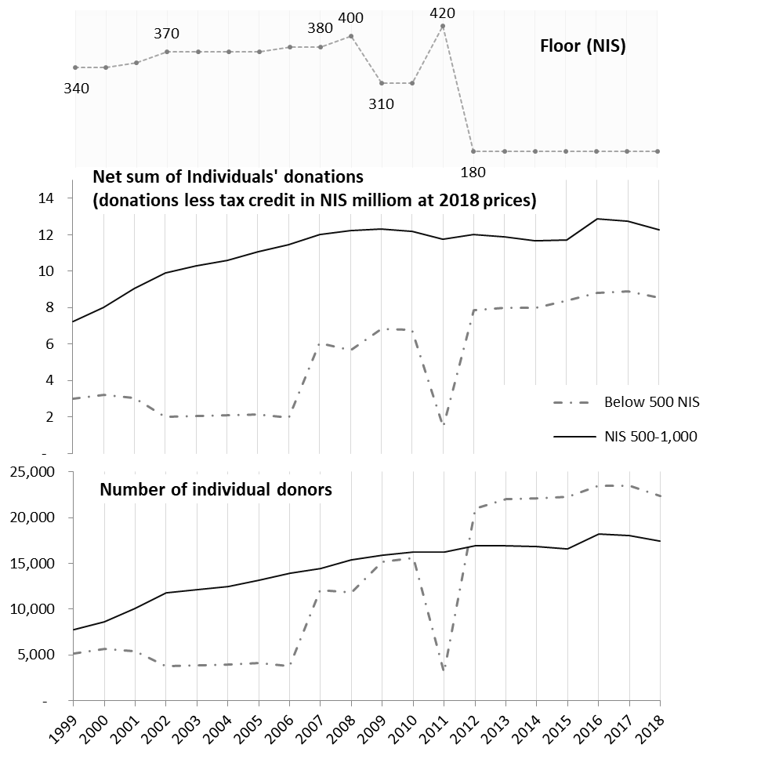
The changes in the credit ceiling, however, seem somewhat less effective. The ceiling was raised significantly four times (in 2000, 2007, 2009, and 2012). Overall, the net sum of the largest individual donations (above NIS 1 million) to which the credit ceiling may be relevant has grown over the years, although the patterns of increase do not appear to match the changes in the ceiling (Figure 6). For example, the ceiling was almost twice as high in 2009–2010 as before, yet the net sum of the largest donations dropped. Furthermore, unlike donors who made small donations, the number of large-scale donors showed no particular increase after the ceiling was raised– especially in comparison with the number of medium donors (see the slopes).

Figure 6. Scope of Individuals’ medium and large donations in respect of the changes in tax-credit ceiling

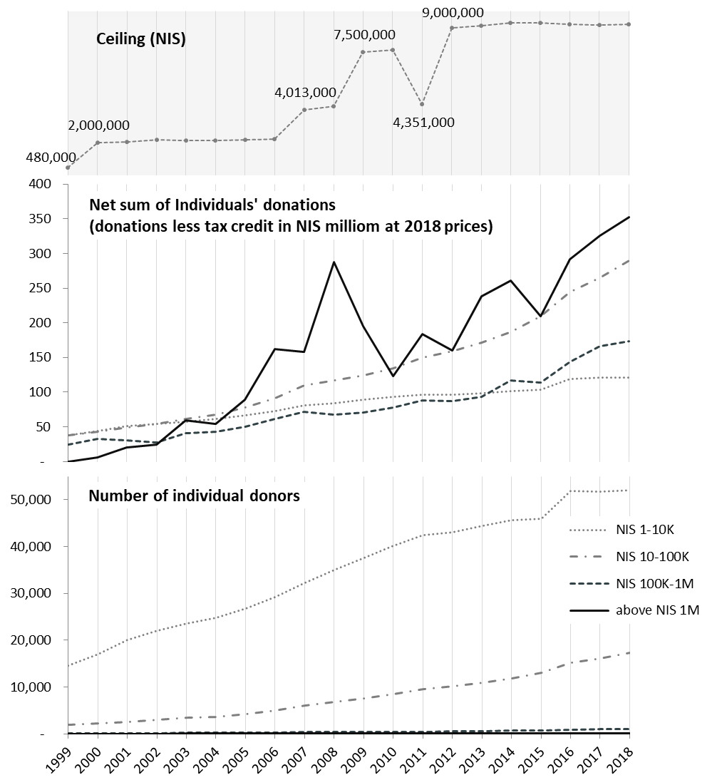

The net sum of the largest corporate donations also increased over the years (Figure 7). Although the upturn does not track the ceiling raises perfectly, it still follows the trend. As with individuals’ donations, the number of large-scale corporate donors did not grow to any particular degree. Last, it is worth noting that the tax-credit rate for companies has fallen over the years (along with the company tax rate), thus increasing the cost of donating to them but allowing greater net profit from which to donate.
All in all, other factors seem to play a much more important role than the credit ceiling. Examples are the process of wealth accumulation in Israel and establishing a culture of high net-worth giving, and the state of the economy (such as the 2008 financial crisis and its imprints in subsequent years). These findings are especially interesting in view of the common perception among philanthropists in Israel that the credit ceiling is a substantial barrier to high net-worth giving.

Figure 7. Scope of corporate medium and large donations in respect of the changes in tax-credit ceiling

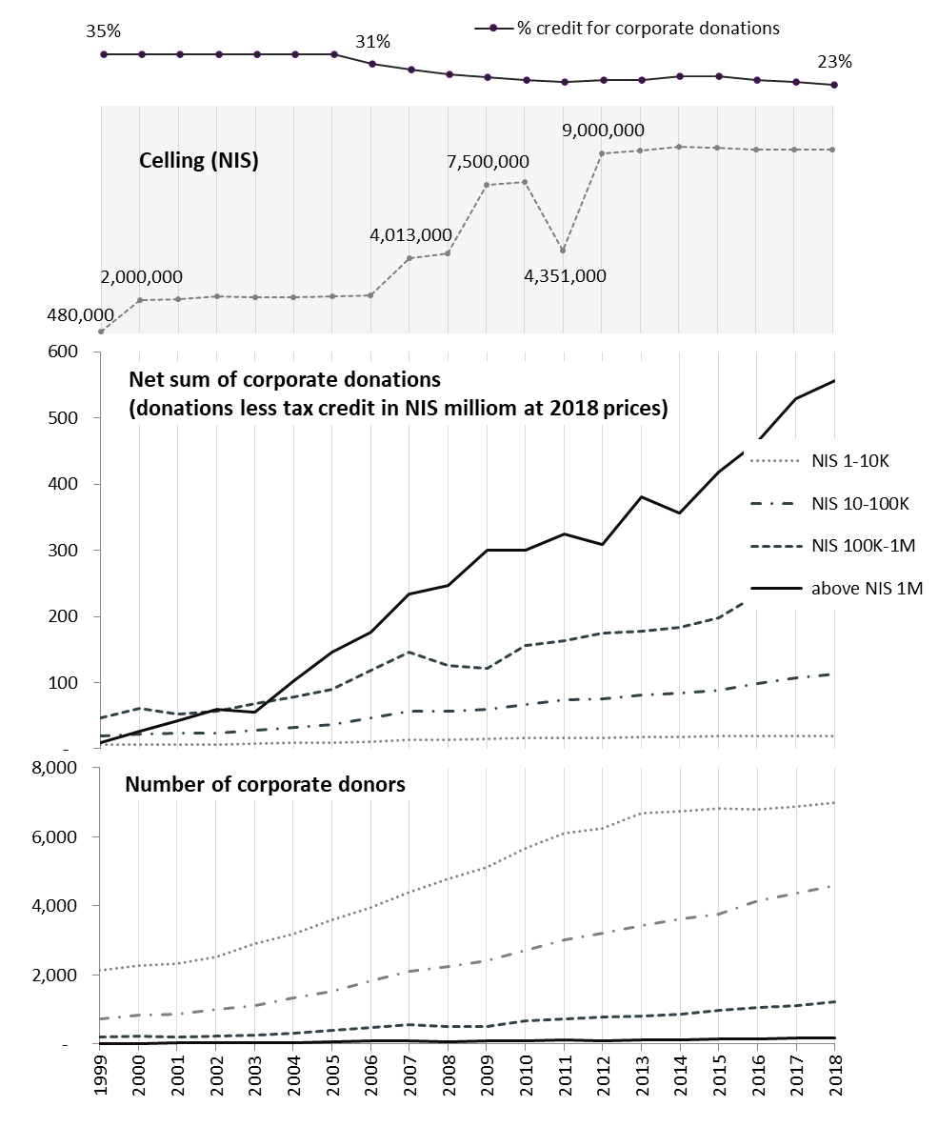

Estimating the tax-benefit cost under hypothetical full take-up conditions
The foregoing analysis presents the tax policy in terms of donations. It is also of interest, however, to assess the policy in terms of public cost or private benefit. I begin by presenting administrative data on the tax credit “given” (credit given is tax revenues actually waived and thus the public cost). In 2018, the waiver of tax revenue amounted to NIS 577 million: NIS 366 million in credits to individual donors and NIS 211 million to corporate donors (Table 4).
Basing myself on the actual tax credits given, I calculated the average percentage of the credit by source and range. Although the credit rate is constant for all donors (35% for individuals, 23% for companies), the actual credit may be lower due to the ceiling boundaries. First and foremost, the income ceiling is relevant to all ranges of donations, limiting the maximum sum of accreditable donations to 30% of yearly income. Thus, the income ceiling creates a subjective effective credit rate for each and every donor. Second, the credit for large donations is bounded by the credit ceiling (NIS 9.211 million in 2018). Overall, due to the ceiling boundaries, the average effective rates were 28% for individual donors (against a maximum of 35%) and 18% for corporate donors (against a maximum of 23%). As may be expected, the lowest average credit rate attested in the uppermost range of donations, which includes donations that exceed the credit ceilings (17% for individual donations, 16% for corporate donations).
Imputing the average percentage of tax credit to the unreported yet eligible donations by source and range, we can estimate the unclaimed credit that would have been given for unreported donations had donors claimed them. Overall, potentially, donors could receive additional credit amounting to NIS 907 million. 87% of “saved” or “lost” credit was due to individual donations, mostly for donations below NIS 20K (80% of unclaimed credit) (Table 4).

Table 4. Received tax credit and estimated unclaimed credit, NIS million, by source and range

Range | Effective credit rate |  | Received credit |  | Estimated unclaimed credit
 | Individual | Corporate | Individual | Corporate | Individual | Corporate
Total |  |  | 577 |  | 907
Total by source | 28% | 18% | 366 | 211 | 787 | 120
Up to NIS 180 – ineligible | - | - | - | - | - | -
NIS 180–2.000 | 35% | 22% | 16 | 1 | 475 | 9
NIS 2K–20K | 35% | 23% | 101 | 11 | 244 | 20
NIS 20K–100K | 34% | 22% | 107 | 26 | 6 | 28
NIS 100K – NIS 1M | 29% | 21% | 69 | 70 | 58 | 42
Above NIS 1M | 17% | 16% | 72 | 102 | 3 | 21

Discussion
The current research aimed to analyze the policy embedded in the tax benefit for charitable giving as actually implemented. Based on administrative data and complementary surveys and taking 2018 in Israel as a case study, the findings show that donors claim a tax benefit for 36% of their total donations, that 23% of total donations are not benefit-eligible due to boundaries: ceilings, floor, and qualified nonprofits (ineligible donations), and that 41% percent of total donations are eligible but no tax benefit is claimed for them (benefit non-take-up).
This research demonstrates why studying the effectiveness of the tax policy is not enough. Indeed, the common understanding of effectiveness as the increase in donations to PBOs less the public cost of the benefit (practically estimated by price elasticity) is needed in order to determine whether a particular benefit is better or worse than another and whether a given policy change benefits the public good as a whole. This, however, is not enough if we wish to assess the total effect of the policy as implemented. To that end, we need to adopt a comprehensive approach that begins with a preliminary stage of analysis. This stage includes calculating the extent of relevance of the policy, estimating the scope of eligibility, and analyzing the characteristics of the unclaimed donations.
The extent of the relevance of the policy is simply the share of reported donations from total donations, in this case, 36%. The benefit is expected to influence mostly those who claim it and thus is relevant as an incentive to their donations. This research reveals that although in Israel individuals donate 72% of total donations, they claim a benefit for only 26% of their donations whereas companies, which donate 28% of total donations, claim a benefit for 60% of their donations. Before even going into the reasons, be it due to benefit boundaries or to donors' non-take-up, one must be aware that in fact, the incentive is mostly relevant to corporate donors. It seems, however, that the public debate on the tax treatment of giving refers mostly to giving by individuals. Analyzing the extent and patterns of relevance is thus valuable both to assess the limits of the potential influence of the benefit and to check whether the policy hits the intended targets.
The extent of relevance is the perimeter for the next stage of examining effectiveness. Since effectiveness needs no further discussion, I move to discuss and elaborate on the rest of the preliminary stage. After subtracting the reported donations, we are left with "the rest" of donations that were not reported (64% of total donations in this case) whether due to ineligibility or non-take-up.
Estimating the scope of eligibility means evaluating the extent of ineligible donations, that is, donations that fail to qualify for the benefit due to the boundaries of the benefit. In such an inquiry, the policy may be found too harsh or too inclusive, thus missing its goals. The variety of policies reviewed by the OECD (2020) makes it clear that the various tax policies in different countries are as concerned with the boundaries of the benefit as with the benefit method. No two countries apply the same boundaries. In fact, the boundaries of the benefit appear to be an important tool for countries to navigate policy according to their values and preferences. However, only true data can produce a reflection “from the front lines” that would be a basis for reviewing whether the policy, in terms of its boundaries, actually meets its goals. For instance, Israel applies a credit floor. My findings, however, show that donations below the floor come from numerous donors and add up to a significant amount. From this perspective, the legislator should reconsider whether it is just to exclude a significant portion of donors from the benefits policy and deny them the benefit.
We move on to benefit non-take-up: the scope of eligible yet unclaimed donations. This figure is relatively easy to extract having data on claimed donations and once estimating the ineligible donations. It is important to consider the extent of unclaimed donations in view of that of claimed donations. As the former is greater than the latter, one must wonder why donors would waive their right to a benefit and, especially, what role the government plays in this waiver.
To answer these questions, we need to analyze the unclaimed benefit, for example, by source and size of donations. Obviously, such an analysis is more complicated and requires data that are rarely available. However, such an analysis may reveal a “density map", that is, the characteristics of donations for which most donors waive the benefit. For example, we know from the study reported above that in Israel almost 50% of unclaimed benefits pertain to individuals’ donations below NIS 2,000. Based on this knowledge, we can better tackle the puzzle of non-take-up. Within this range of donations, the profitability of claiming the benefit is modest in terms of the amount of money saved. Furthermore, the modest benefit stands against the considerable bureaucratic hassle involved (State Comptroller, 2021). Thus, the cost/benefit ratio of claiming the benefit is rather high. The cost/benefit ratio was found to be the main factor in explaining the non-take-up of social benefits, in comparison with the smaller role of lack of knowledge and presence of stigma (Currie, 2004). More generally, cost/benefit is becoming a major decision principle in various economical, public, environmental, and psychological contexts (Sunstein, 2014). Thus, although the findings (re the multitude of unclaimed benefit for small donations) support the common assumption, being based on real data, they matter: First, by focusing attention on a specific cohort of donors, the findings may allow more efficient action toward increasing benefit take-up; second, they support and legitimize every effort invested in making benefit take-up more accessible and simpler for all citizens. Such efforts are occasionally proposed even by the ITA’s professionals but are not easily adopted by the tax authority system or approved by the parliament. In general, the private sector proves to be faster and more efficient in finding solutions to poor benefit take-up (Currie, 2004). Indeed, in Israel there have been several initiatives, coming especially from nonprofits, to simplify and facilitate the process of reporting (and claiming the benefit) for individual donors. The current study justifies these efforts and validates the notion that there is a substantial “market” of unclaimed benefit to target. The findings also join earlier studies (Saeri et al., 2022) that encourage nonprofits, as the beneficiaries of the donations, to leverage their fundraising efforts by removing the obstacles to tax-benefit take-up that obstruct a specific (and now identified) cluster of donors in particular.
Broad take-up of the benefit for charitable giving has significant consequences and implications that are worth articulating explicitly. The first consequence relates to the scope of donations to the nonprofit sector. According to scholars (e.g., Brooks, 2007) and policymakers, the goal of the benefit is to increase private donations to civil society. However, even if the benefit offered is extraordinary in terms of its effectiveness, it will make scant impact as long as its take-up rate is low. Research that maps the extent and patterns of unreported eligible donations yields a reliable estimate of the extent of unclaimed benefit: the total sum of the tax credit/deduction that donors would receive if they claimed the benefit for unreported donations. According to the research reported here, if all eligible donations are claimed for a benefit and if all money received via the credit is donated to nonprofits (resulting in neutral effectiveness), donors in Israel could increase their donations to nonprofits by 13% (about NIS 1 billion) without withdrawing a single cent from their pockets! Assuming the tax benefit in Israel is effective, the government could encourage the private sector to increase its support for nonprofits by more than 13%. Just for the sake of proportion, in 2018, direct government transfers to nonprofits amounted to NIS 2.8 billion (excluding funding for universities, teaching hours in schools, and paying for outsourced social services). These are all substantial figures that are overlooked in the absence of data on the actualization of the policy.
The second consequence of the extent of take-up derives from the principle on which the tax benefit for charitable giving is based. The benefit is actually a manifestation of a pluralistic value: donors choose nonprofits to support in accordance with their preferences, values, and vision; By claiming the benefit, the donor actually makes the state participate in his or her donation because the state waives tax revenue and partially funds the donation; Therefore, the general meaning of the tax benefit for charitable giving is that the state allows donors to allocate public resources in keeping with their own preferences, thereby actualizing a pluralistic agenda. In democratic regimes, although the majority determines the composition of parliament and thus the governing policies, the importance of giving voice to multiplicity, to voices as plural as the public, is understood. The state’s support of a vibrant civil society is established on this notion and on the intention to address the “government failure” that causes deficient diversification of governmental services that target the “average citizen” (Hansmann, 1987). The tax benefit for charitable giving is an extension of this notion. However, if most donors do not claim the benefit, this pluralistic agenda is not realized. The current study reveals that only about 8% of Israeli donors claim the benefit and that most non-claimers are modest donors who, one assumes, belong to lower-income cohorts. Thus, according to this study, large numbers of individual donors in Israel, mostly in low-and-medium-income cohorts, waive their right to allocate public resources according to their values, thereby weakening pluralistic support of civil society.
One limitation of this study concerns the missing underlying mechanisms or motivations. While able to present patterns of non-take-up, I could only assume the reasons for it. Beyond cost/benefit considerations, however, there may be a cultural issue concerning the norm of claiming a tax benefit for charitable giving and the meaning ascribed this social institution (Lawrence and Suddaby, 2006). It may be the case that religious people who see charity as part of their religious practice (Khan, 2012) regard claiming a benefit as sullying the act of giving (even though they could use the benefit money to increase their giving). In fact, there are mixed findings about the relationship between religiosity and philanthropy (Bekkers and Wiepking, 2007), indicating that research into the deeper beliefs of donors toward philanthropic practices is needed as well as differentiating among religions. Also needed is future research to fine-tune the profile of the non-take-up donors and explore their perceptions and motivations.
Another limitation of this study is the lack of comparison. An evaluative comparison of the policy (in principle) appears in the Global Philanthropy Index. One of the sub-indexes in this publication is the tax-benefit policy. The world average score in this index is 3.52; Israel‘s score is 3.50. However, further research is needed to compare policy realization on the ground. There is no anchor with which to evaluate whether a 36% rate of reported donations in total donations in Israel is low, average, or high. Using administrative data and state wide surveys, I could extract the amount of reported donations as a percentage of total donations in the United States (IRS, Giving USA) and Canada (CRA, Lasby and Barr, 2018) – 67% in both. These, however, are only rough data that tell us nothing neither about the share of ineligible donations as against unclaimed benefits for eligible donations nor about the characteristics of donors who take up the benefit versus those who do not. To generate comparative data, international studies are needed.
A third limitation of this study is the lack of systematic data on donations by source and size. This study was based on a special survey done in 2017; it is not expected to be conducted again. Thus, there is no way to perform detailed and up-to-date follow-up research in Israel for the foreseeable future.
Despite these limitations, this study offers a new and comprehensive approach enabling us to review the tax policy toward charitable giving as it is actually implemented. I truly hope that researchers will apply this approach in additional countries. By going beyond specific cases, we may be able to characterize the effect of the tax benefits for giving and better understand its strengths and weaknesses. The impact of philanthropy on society is much discussed; a body of research such as that proposed would address itself to the impact of public (tax) policy on philanthropy.

References
Adena, M. (2021). Tax-price Elasticity of Charitable Donations – Evidence from the German Taxpayer Panel. In: The Routledge Handbook of Taxation and Philanthropy (pp. 219–235). Routledge.‏
Alepin, B. (2021). Treasury efficiency of the Canadian tax regime for private foundations and their founders. In: The Routledge Handbook of Taxation and Philanthropy (pp. 199–218). Routledge.‏
Almunia, M., Guceri, I., Lockwood, B., & Scharf, K. (2020). More giving or more givers? The effects of tax benefits on charitable donations in the UK. Journal of Public Economics, 183, 104-114.‏
Brooks, A.C. (2007). Income tax policy and charitable giving. Journal of Policy Analysis and Management, 26, 599–612.
Bekkers, R., & Wiepking, P. (2007). Generosity and philanthropy: A literature review. Available at SSRN 1015507.‏
Brooks, A. C. (2004). The effects of public policy on private charity. Administration & Society, 36(2), 166-185.‏
Bradley, R., Holden, S., & McClelland, R. (2005). A robust estimation of the effects of taxation on charitable contributions. Contemporary Economic Policy, 23(4), 545-554.‏
Bullain, N. (2004). Explaining Percentage Philanthropy: Legal Nature, Rationales, Impacts. International Journal of Not-for-Profit Law, 6(4).
Clotfelter, C. T. (1985). Federal tax policy and charitable giving. University of Chicago Press.‏
Currie, J. (2004). The take up of social benefits.‏ NBER Working Paper: 10488. Cambridge, MA.
Fack, G., & Landais, C. (2010). Are tax incentives for charitable giving efficient? Evidence from France. American Economic Journal: Economic Policy, 2(2), 117-141.‏
Hansmann, H. (1987). Economic theories of nonprofit organizations. The nonprofit sector: Research handbook, 27–42.
Hazan, O. (2021). Donations to Israeli nonprofits: Comparative research. The institute for law and philanthropy at Tel-Aviv university.
Huber, G. L., Pittavino, M., & Peter, H. (2021). Tax benefits for charitable giving: Evidence from the Swiss Canton of Geneva. In: The Routledge Handbook of Taxation and Philanthropy (pp. 253–267). Routledge.‏
Khan, A. A. (2012). Religious obligation or altruistic giving? Muslims and charitable donations. Sacred aid: Faith and humanitarianism, 90-114.‏
Lasby, D., & Barr, C. W. (2018). 30 Years of Giving in Canada: The Giving Behaviour of Canadians: Who Gives, How, and Why? Rideau Hall Foundation and Imagine Canada.‏
Lawrence, T. B., & Suddaby, R. (2006). institutions and institutional work. The Sage handbook of organization studies, 215-254.‏
Margalioth, Y. (2017). How Charitable Is the Charitable Contribution Deduction? Theoretical Inquiries in Law, 18(1), 37–60.
OECD (2020). Taxation and Philanthropy. OECD Tax Policy Studies, 27, OECD Publishing, Paris.
Osili, U., Zarins, S., & Han, X. (2021). The Giving Environment: Understanding Pre-Pandemic Trends in Charitable Giving.‏ Lilly Family School of Philanthropy at IUPUI.
Peloza, J., & Steel, P. (2005). The price elasticities of charitable contributions: A meta-analysis. Journal of Public Policy & Marketing, 24(2), 260-272.‏
Peter, H., & Lideikyte Huber, G. (2021). The Routledge Handbook of Taxation and Philanthropy (p. 738). Taylor & Francis.‏
Pickering, A., Quick, E., & Kruse, T. A. (2014). Rules to Give By: A Global Philanthropy Legal Environment Index.‏
Randolph, W. C. (1995). Dynamic income, progressive taxes, and the timing of charitable contributions. Journal of Political Economy, 103(4), 709-738.‏
Saeri, A. K., Slattery, P., Lee, J., Houlden, T., Farr, N., Gelber, R. L., ... & Zorker, M. (2022). What works to increase charitable donations? A meta-review with meta-meta-analysis. Voluntas: International Journal of Voluntary and Nonprofit Organizations, 1-17.‏
Solnik, E. (2019). Taxation in the service of pluralism: The mechanism of providing tax benefits for donations: the applicability of section 46 of the Income Tax Ordinance. PhD thesis. Faculty of Law, Tel Aviv University.
Steinberg, R. (1990). Taxes and giving: New findings. Voluntas: International Journal of Voluntary and nonprofit organizations, 1(2), 61-79.‏
Sunstein, C. R. (2014). The real world of cost-benefit analysis: thirty-six questions (and almost as many answers). Columbia Law Review, 167-211.‏
Urban-Brookings Tax Policy Center (2018), How did the Tax Cuts and Jobs Act affect benefits for charitable.

Official reports and open data sources
A background document prepared by the legal advisor to the Finance Committee dated May 6th 2021. (In Hebrew).
CRA: Canada Revenue Agency. T1 Final Statistics 2019 edition (for the 2017 tax year)
IRS: Internal Revenue Service. SOI Tax Stats – Individual Statistical Tables by Size of Adjusted Gross Income
The chief economist of the Ministry of Finance. The state revenue report for the years: 2004; 2006; 2011–2012; 2015–2016. (In Hebrew).
The Global Philanthropy Environment Index 2022. IU Lilly Family School of Philanthropy.
The state comptroller (2021). Benefits take up in the Israeli Tax Authority – expanded review. In Annual report 72a. (In Hebrew).
The Israeli Central Bureau of Statistics (2017). Philanthropy of Israelis survey 2012–2015.

This expression is common among scholars in the field of economics. However, in Hebrew, this tax policy is referred to as “tax benefit” only, both in the wording of the tax ordinance and in the common language. Thus, in this paper I will stick to "tax benefit".
Private foundations in Israel are not a primary source of private donations' statistics. Foundations operating in Israel are either registered as nonprofits, or are registered out of Israel, or are not associated at all. They do not receive a tax benefit for charitable giving. Accordingly, when a foundation gives a nonprofit financial support, its donation is either double-counted, or included in donations from RoW, or included in donations from individuals/companies.
Although this range was recorded in the Philanthropy of Israelis Survey, due to sampling errors the data were published in unified ranges. Therefore, I used the ICA data for this range as well.
One may differentiate between intensive and extensive elasticity, representing effectiveness in terms of the influence of the tax incentive on regular/repeat donors (intensive elasticity) vs. new donors (extensive elasticity) (Almunia et al., 2020). The take-up scope bounds only intensive effectiveness, whereas extensive effectiveness may either move donors from the unclaimed-donation sector to the take-up sector or bring in brand-new donors and allow the total donation pie to grow.
For example, a background document prepared by the legal advisor to the Finance Committee dated May, 2021 (in Hebrew).

