How did the pandemic crisis affect the financial, economic, and social performance of social enterprises?

Insights from Italian social cooperatives

Alessandro Montrone (University of Perugia), Elizabeth Searing (University of Texas at Dallas) and Simone Poledrini (University of Genoa)

**1. Abstract**

The Covid-19 crisis affected the world's economic and social system in many ways. Social enterprises (SEs) play a necessary role in delivering social value during such crises (Bacq and Lumpkin, 2020; Sarma et al., 2022; Weaver, 2020). However, there is still a lack of empirical evidence that analyzes the impact of the pandemic on the performance of SEs and how that performance differs from traditional, non-social companies. Therefore, the purpose of this contribution is to fill this gap.

This study compares two types of organizations in the same Italian context: social cooperatives and private limited companies. We present and compare their performance using ratio analysis in a three-dimensional perspective: economic, financial, and social, where the latter concerns the ability to create and distribute value-added to stakeholders (Riahi-Belkaoui, 1996), with particular emphasis on distributional fairness (Landis et al., 2014). In addition to policy recommendations, this study provides guidance on how to use existing accounting data to approximate social elements in business.

**2. Introduction**

In the last two decades, social enterprises (SEs) have been studied from several different perspectives, such as different business models (Defourny et al., 2021; Poledrini, and Borzaga, 2021), the legal typologies (Young, et al., 2016; Galera, and Borzaga, 2009; Fici, 2016), the theoretical aspects (Dart, 2004; Poledrini, 2015; Santos, 2012), the financial ones (Lall and Park, 2020; Périlleux, 2015; Searing et al., 2022), strategic (Haigh et al., 2015; Liu et al., 2012), and many others. However, the recent economic, financial and social crisis generated by the COVID-19 pandemic has opened a new avenue of research, allowing us to examine both how such SEs have performed under duress and how their impact on society is different from those of their non-SE organizational peers (Bacq and Lumpkin, 2020; Sarma et al., 2022). Therefore, this research aims to shed more light on this aspect and, in particular, to answer the following research question: *how did COVID 19 pandemic crisis affect the performance of SEs, especially in comparison to traditional, non-social companies*?

In order to answer our question, we extract data on two comparable corporate forms from the AIDA[1] database. First, we select the entire population of the most common SE legal form in Italy, that is social cooperatives (SCs). As a comparison group, we also extract the records for private limited companies (PLCs) from within the ATECO[2] sectors 87 (residential social assistance services) and 88 (non-residential social assistance). The choice of these ATECO codes made it possible to focus attention on the sectors of economic activity in which the form of SCs is widespread in Italy (Borzaga and Galera, 2016). All enterprises of both corporate types have between 5 and 250 employees, and we use a short panel of years (2018-2021) to capture pre-pandemic, pandemic and post-pandemic conditions.

Our findings are generally in line with our expectations, though with notable exceptions. First, though we expected a negative impact from the crisis and a strong post-pandemic recovery for both SCs and PLCs, we find that recovery happened to different degrees in the three dimensions considered. We also found that the two corporate forms to differ significantly in distributional fairness, with SCs maintaining their pre-pandemic pro-social distribution even at the cost of their financial and economic health in order to preserve their social mission. We also find a significant impact from government support programs, illustrating their efficacy as a policy tool during such crises.

**3. Literature Review**

The issue of social enterprise performance evaluation has been studied from two main points of view. The first perspective refers to the problems inherent in the accountability of social enterprises, which involves not only activities but also how SEs communicate about their activities (Connolly and Kelly, 2011; Bradford et al., 2018; Bagnoli and Toccafondi, 2011). The second perspective is more closely linked to the assessment of the economic, financial, and social actions carried out by social enterprises (Arena et al., 2015; Bagnoli and Megali, 2011). The two topics are linked and sometimes studied together, but they can also be addressed separately. This article focuses on the second stream trying to assess the performance of the organization.

The many articles belonging to this second line of research can be grouped into three main streams. The first is based on analyzing the financial statements values to assess the social impact generated by the SEs (Poledrini et al., 2022). The second evaluates the activities carried out and their consequent social implications beyond the financial statements data (Connolly and Kelly, 2011; Bagnoli and Toccafondi, 2011). Finally, the third modality can be defined as a hybrid methodology because it uses the abovementioned methods, such as in the case of the balanced scorecard (Somers, 2005).

The measurement of SEs performance cannot be limited only to the economic and financial dimension, but it must also consider the social one (Arena et al., Bengo, 2015; Bagnoli and Megali, 2011). We present a framework of common indicators as an accessible three-dimensional measure of organizational performance. The economic dimension is analyzed through ROA, ROI, and SFC; the financial dimension, using current ratio, warranty ratio, and the equity multiplier (Sostero et al., 2016). Finally, the analysis of the social dimension concerns the measurement of the ability to create and distribute value-added to stakeholders (Riahi-Belkaoui, 1996; Landis et al., 2014), which provides an accessible measure of a non-profit-maximizing goal that has meaning to both social cooperatives and private limited companies.

*3.1 Determining Purpose and Value in SCs and PLCs*

We start from the belief that the measurement of the performance of SCs and its comparison with that of PLCs cannot be limited to the traditional economic and financial dimensions, but it is necessary to add the social one, which is of great importance especially in terms of evaluating their role in the socio-economic context. This is often where measurements of social performance become mired - if measuring community impact, then the measure becomes highly contextual and difficult to compare across environments and organizations. Instead, we sought measures that used commonly available information in both SCs and PLCs and signified a non-profit-maximizing goal. Therefore, the measurement must be implemented with adequate ratios representing the different impact of SCs and of PLCs in terms of creation and dissemination of wealth and well-being on the economic and social context. Profit is not the primary purpose of the SCs, even if its usefulness for strengthening the capital structure through an adequate self-financing policy is not doubted. It should also be emphasized that, to the extent that the SCs do not distribute profits and do not raise significant initial capital, the accumulation of reserves represents for them a mandatory path for adequate capitalization.

Profit, on the other hand, remains a qualifying element of private limited companies, even if it is possible to discuss its "right" measure, its role in relation to other possible purposes, and its different destination (Coda, 1988). The problems of the measure and quality of profit have been widely debated in literature, revealing at least some reservations about it; consequently, it is not surprising that proposals should be made for approaches intended to replace profit as a measure of company performance (Egginton, 1984). Therefore, and even more with reference to the category of SCs operating in sectors with a strong social impact, it is necessary to use measures alternative to profit for an evaluation of performance.

If, then, the pursuit of corporate purposes must be framed in a triple dimension (financial, economic, and social), it is necessary to identify ratios that allow adequate measurement, representation and interpretation of the social dimension as well. These ratios can be identified in those based on an economic quantity of primary importance, namely the value added (Haller and Stolowy, 1998; Haller and Van Staden, 2014; Landis et al*.,* 2014; Montrone, 2000; Morley, 1978; Rees, 1990; Renshall *et al.,* 1979). In fact, the value added can be, on the one hand, defined as the greater wealth created by the company but, on the other hand, as a source of distribution of the same wealth among the subjects who have taken part, albeit in different roles, in the productive activity (Rispoli, 1983). Therefore, the value added can be very useful for judging the sociality of the company according to its ability to create enough new wealth to satisfy the expectations of different stakeholders (Haller and Van Staden, 2014).

Several configurations of value added can be obtained through the re-arrangement of the income statement, but we will refer to the distributable value added, which represents the real link between the process of creating new wealth and the process of its distribution (Haller, 1997; Montrone, 2000). This distributable value added represents the measure of the wealth that, once created, becomes available for distribution among the following categories of stakeholders:

* employees, who receive various forms of remuneration, both direct and indirect, immediate but also deferred;
* lenders, who are paid interest on the capital lent;
* public administration, which acquires a part of the wealth produced by the company through taxation;
* shareholders, remunerated through any distribution of profits;
* enterprise system, which, by means of self-financing, strengthens the financial solidity and economic-productive potential.

*3.2 The Measurement of the Financial, Economic, and Social Performance of SCs and PLCs*

Moreover, when determining which ratios to use in order to capture the financial, economic, and social perspectives, we recognize that each stakeholder group holds different expectations. For example, lenders tend to favor the aspect of solvency, referring to ratios of financial structure and, above all, trying to evaluate the company's ability to generate adequate cash-flow, an indispensable prerequisite for allowing the recovery of the money lent (Sostero *et al.* 2016). Shareholders of joint-stock companies favor the economic perspective, measurable in the current and future income capacity, using the traditional profitability ratios such as ROA, ROE and ROI (Teodori, 2000). In contrast, the geographic community of the company is primarily interested in the social impact on the territory, often measured in terms of jobs created. However, in all three cases, they are partial optics. Therefore, it is necessary to conduct an analysis that takes into account all three dimensions to avoid incomplete and even misleading assessments.

To measure the performance of comparable SCs in the triple dimension (economic-financial-social), and then compare it with that shown in the same time by companies of the same size and operating in the same sectors, but with the different legal form of limited liability company (PLCs), we chose to calculate and compare nine ratios.

The first three of these ratios aim at verifying the presence of financial balance, while the second three concern the evaluation of economic balance. Finally, the last set of three concern the issue of social impact on the reference community, focused on value added.

The three financial ratios aim to:

* outline the company's solvency conditions in the short term (*current ratio,* given by the ratio of current assets and short-term liabilities);
* indicate the existence of an adequate capital solidity with a significant contribution of equity in the financing of fixed assets (*warranty ratio*, given by the ratio between equity and fixed assets);
* express the correct setting of the financial structure in its composition between equity and debts (*equity multiplier,* given by the ratio between total assets and equity).

The three economic ratios are designed to:

* measure the overall economic performance of the company (*ROA*, given by the ratio between net income and total assets);
* focus, within the framework of the above-mentioned overall economic performance, the contribution of the core business (*ROI*, given by the ratio between EBITDA and total assets);
* verify the sustainability of the financing choices (*SFC*) in terms of economic impact, relating interest expense to sales revenues.

Finally, the three social ratios aim to:

* indicate changes in the productivity of the workforce (*Va/D*, value added per employee, given by the ratio between distributable value added and average number of employees);
* measure the company's ability to generate new wealth in relation to the capital employed in it (*Va/T*, return of assets in terms of value added, given by the ratio between distributable value added and total assets);
* capital intensity (*T/D*, ratio between total assets and average number of employees), capable of highlighting the "labour intensive" or "capital intensive" nature of the company.

Specifically, we selected the financial and the economic ratios in our recent contribution on the prediction of SCs crises (Poledrini et al., 2022). The existing Italian literature on the financial statements analysis considers these ratios as highly significant (Montrone, 2016; Sostero *et al.* 2016).

As regards the social ratios and the reasons for their choice, it should be considered that the value added per employee, in addition to being a valid indicator of changes in the efficiency and productivity of the workforce, is also useful in setting up a correct and sustainable policy to increase the remuneration of workers (Burchell *et al*., 1985; Riahi-Belkaoui, 1992). The return of assets in terms of value added can be considered as a measure of productivity of the overall capital invested in the business (Riahi-Belkaoui, 1992). It has a high social value, as well as economic, as it highlights to what extent the "enterprise system" increases the resources absorbed, highlighting its constructive (or harmful) role in the socio-economic context of reference. Finally, the measure of labour productivity is connected to the capital productivity through the ratio of capital intensity, useful to highlight the "labour intensive" or "capital intensive" approach of the company (Montrone, 2016).

**4. Methodology**

We carry out a comparative analysis using the same financial, economic and social performance ratios in two groups of companies. The first group includes companies established in the legal form of SC and the second one companies established in legal form of for-profit capital companies, restricting it only to limited liability companies (PLCs, in Italian “Società a Responsabilità Limitata – SRL”) to obtain an adequate benchmark in terms of companies’ complexity and size.

The analysis was limited to the sectors of economic activity in which the SCs mainly operate (Poledrini and Tortia, 2020): ATECO 87 (residential social assistance services) and 88 (non-residential social assistance). Comparing companies operating in the same sectors makes the analysis by benchmark more appropriate, even if we are dealing with two corporate types that are not homogeneous in their purposes. Due to this heterogeneity, we also carried out the analysis of the social dimension, by means of the value added based ratios.

The comparison between the results of the individual years was considered to be of primary interest due the well-known timing of the pandemic, beginning from March 2020 (start of the lock-down in Italy) and going on (albeit with different intensity) for the rest of the year. In other words, there is the possibility of measuring the negative impact of the pandemic on SCs and PLCs, taking as a benchmark their "pre-pandemic" situation (2018-2019) to capture pandemic (2020) and initial post-pandemic (2021) conditions.

The analysis is not on a sample basis as the extraction from the AIDA database was carried out on the entire population of the Italian SCs and PLCs. We acquired four years (2018-2021) of financial statement information and other significant parameters of companies, such as the number of employees. We did limit the data to those organizations of both types with more than 5 employees but less than 250 to enhance comparability and minimize outliers. The exclusion of companies from 0 to 5 employees (defined in Italy as “micro-companies”) and more than 250 is motivated both by the lack of many financial information in the database for the “micro”, and to make the group of companies more homogeneous in size since there are very few big social enterprises. Finally, if the organizations did not file for very year of the analysis, we removed them. After removing the data regarding some situations in which the lack of significant financial statements values in the database would have distorted the analysis, we considered 1,438 SCs and 1,007 PLCs belonging to the ATECO sectors 87 and 88.

As regards the diffusion of the two categories of companies throughout the territory, which could have an impact in terms of different performances, an analysis of the territorial distribution was deemed unnecessary as this does not vary significantly in terms of based on the legal typology between SCs and PLCs (Castelnovo *et al.,* 2020; Picciotti *et al*., 2014). In fact, among the SCs there are evident differences in terms of their performance if we consider the different national territorial contexts, but these do not differ much from what is the regional trend followed by the PLCs (Costa and Carini, 2016; Costa et al., 2012; Fusco and Migliaccio, 2018). Therefore, the comparison between the two groups of companies, included in the same ATECO sectors, the similar dimensions and the territorial distribution, is correct and significant in order to appreciate the financial, economic, and social performances of the two different legal forms.

**5. Descriptive Findings**

The extraction of the main data relating to size and economic results revealed the average values shown in the following table 1, respectively for the SCs and PLCs.

Table 1 - Average values of dimensional parameters and economic results - years 2018-2021



Figure 1 - Comparison between SCs and PLCs: revenues - years 2018-2021

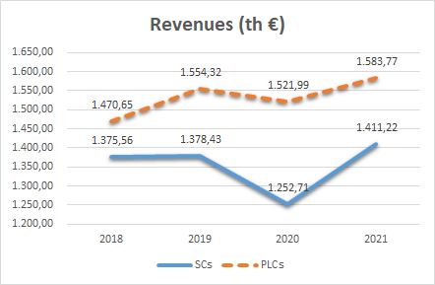

Figure 2 - Comparison between SCs and PLCs: total assets - years 2018-2021

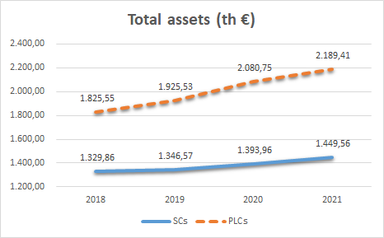

Figure 3 - Comparison between SCs and PLCs: employees - years 2018-2021

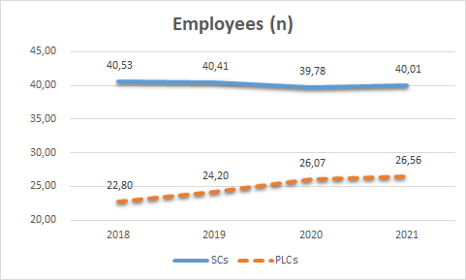

Figure 4 - Comparison between SCs and PLCs: net income - years 2018-2021

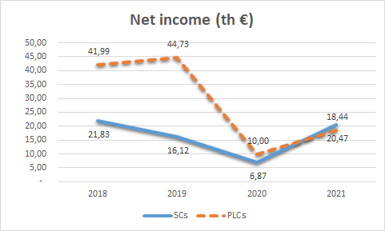

Figure 5 - Comparison between SCs and PLCs: value added - years 2018-2021

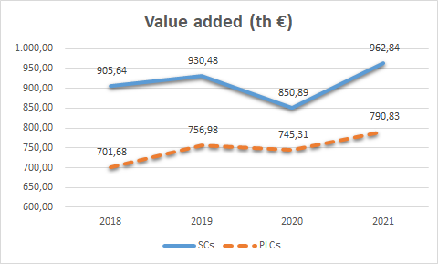

From the descriptive values shown in the tables and figures we can observe that the SCs are on average smaller in terms of revenues and, even moreso, in terms of investments. Further, SCs are less capital intensive than PLCs, but they are clearly more labour intensive. This is proof of the greater social role of SCs, as we are mindful of employment’s importance to the community.

The decline in revenues and economic results already makes the criticality of the year 2020 evident. We also see an increasingly lower measure of net income for SCs, especially in the pre-pandemic years, which indicates a lower priority on this measure. However, this lower level of net income seems to be more resilient since in the pandemic year 2020 the gap between SCs and PLCs is sharply reduced. Further, in the post-pandemic year 2021, the recovery is more robust in the SCs which return to the 2018 level. The more marked sociality and the positive impact on the socio-economic system emerge from the best average performance in terms of creating added value, always clearly higher in the period considered and with an average value in 2021 even higher than the pre-pandemic ones.

*5.1 Financial Ratio Analysis*

The following table 2 shows the average values found for the first group of ratios, those useful for assessing the financial balance, again comparing the two types of legal forms.

Table 2 - Average values of financial ratios - years 2018-2021



From the calculation of the average values of the financial ratios, it appears that the current ratio is positioned at more than satisfactory levels for both categories, but the performance of the SCs in terms of solvency conditions in the short term is through all the years much better. The warranty ratio also shows the existence of an adequate capital solidity with a significant contribution of equity in the financing of fixed assets in both categories, but highlights particularly favourable values in the SCs, plausibly due to the lower amount of investments in fixed assets. Finally, the equity multiplier expresses a difficult situation in the correct setting of the financial structure in its composition between equity and debts, which reaches progressively more worrying levels for the SCs, indicating an inadequate capitalization of these companies; however, in the year 2021 there is a clear improvement for SCs but not for PLCs, so much so that the two types of legal forms for the first time in the years considered are positioned almost on the same level.

Figure 6 - Comparison between SCs and PLCs: current ratio - years 2018-2021



Figure 7 - Comparison between SCs and PLCs: warranty ratio - years 2018-2021



Figure 8 - Comparison between SCs and PLCs: equity multiplier-years 2018-2021

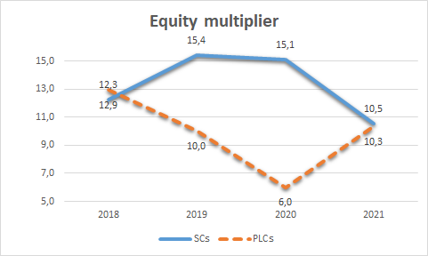

Therefore, with the exception of the aforementioned deterioration in terms of equity multiplier, the financial balance unexpectedly shows an improvement in 2020 and 2021 compared to the previous years, which may seem anomalous in consideration of the difficulties caused by the pandemic. However, it is necessary to take into account the emergency measures issued by the Italian government during the pandemic to support businesses, aimed at providing them with the financial resources necessary to overcome the most difficult period. However, these measures did not affect the deeper causes of the worsening of economic performance. In fact, observing the data shown in table 3, it is clear that 2020 is a difficult year in terms of profitability for both SCs and PLCs.

*5.2 Economic Ratio Analysis*

The following table 3 shows the average values found for the second group of ratios, those useful for assessing the economic performance, once again comparing the two types of legal forms.

Table 3 - Average values of economic ratios - years 2018-2021



ROA is clearly lower in the SCs than in the PLCs, though with less variability, even in the 2020 pandemic year. Specifically, in 2020, ROA enters the negative range for both categories, but the deterioration is more marked for the PLCs. Subsequently, the recovery occurs in 2021 for both, with values returning positive, without however reaching the same value of 2019.

The performance in terms of ROI is also not brilliant for the SCs, as there is a similar negative gap compared to PLCs; however, the two categories share a significant worsening in the year 2020, sharper in the PLCs, and a significant recovery in 2021, even if they remain slightly below the values of 2019.

Finally, the ratio between interest expense and sales revenues is substantially stable over time and positioned at similar values, demonstrating an adequate sustainability of the financing choices in terms of their economic impact, despite the clear prevalence of third-party financing with respect to equity capital shown by the equity multiplier.

Figure 9 - Comparison between SCs and PLCs: ROA - years 2018-2021

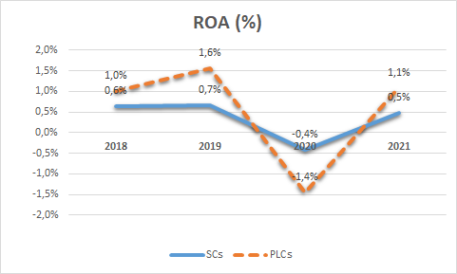

Figure 10 - Comparison between SCs and PLCs: ROI - years 2018-2021



Figure 11 - Comparison between SCs and PLCs: SFC - years 2018-2021



*5.3 Social Ratio Analysis*

Finally, we can examine social performance, starting from the value added per employee and comparing it with the more traditional (but less "social") labour productivity ratio represented by revenues per employee.

Table 4 - Average values of social ratios (labour) - years 2018-2021



Figure 12 - Comparison between SCs and PLCs: value added per employee - years 2018-2021

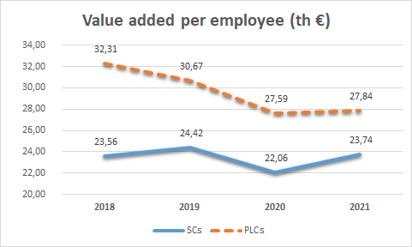

Figure 13 - Comparison between SCs and PLCs: revenues per employee - years 2018-2021

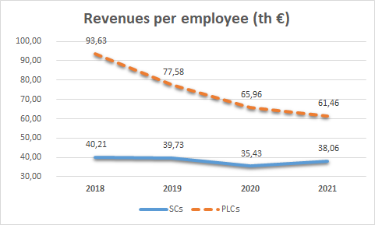

Here too we can observe a decidedly less brilliant performance for the SCs, whose average value added per employee is always lower than that obtained by the PLCs. However, it should not be forgotten that the SCs are clearly more labour intensive (see table 1) and create job opportunities for a number of employees that is on average almost double that of PLCs.

Moreover, in terms of revenues per employee, the disadvantage of the SCs appears even worse, but this ratio does not consider the social role of the SCs, making the comparison on this basis problematic since the numerator is revenues. The aforementioned results may not be completely comparable given that the role of the labour factor tends to configure differently in the two categories of companies.

In particular, in the SCs the percentage of part-time work is decidedly higher, a situation which, although correctly reflected in the calculation of the average number of employees reported in the financial statements, can affect in terms of lower productivity, compared to an exclusive or predominant use of full-time work.

On the other hand, in PLCs it is frequent that in the ATECO 87 and 88 sectors a part of the work is carried out by shareholders who do not appear among the employees and who are remunerated through the distribution of profits, a condition that underestimates the number of employees considered in the productivity ratios, so amplifying their measure. Nevertheless, the unfavourable gap for SCs is much sharper considering the "traditional" ratio, while it is more limited in the configuration of the labour productivity ratio based on value added.

In terms of the temporal evolution of both ratios, once more 2020 is characterized as a difficult year, but the SCs prove to be more resilient again, with a smaller decrease in both ratios. Finally, in 2021, the added value per employee clearly recovers in the SCs while it stagnates in the PLCs, but even more clear is the difference in the revenues per employee, where the PLCs continue in the worsening trend while the SCs show a partial recovery.

Finally, to complete the analysis of the social dimension, it is necessary to examine the results of the return of assets in terms of value added, also considering the different level of capital intensity.

Table 5 - Average values of social ratios (capital) - years 2018-2021



Figure 14 - Comparison between SCs and PLCs: assets per employee - years 2018-2021

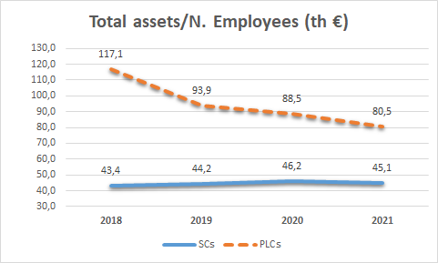

Figure 15 - Comparison between SCs and PLCs: value added on total assets - years 2018-2021

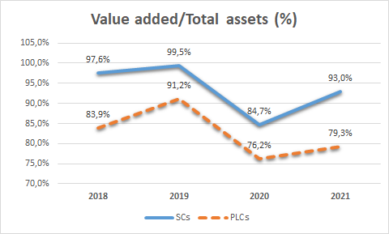

The average performance of the SCs is far superior that of the PLCs, although in both categories the difficulties of the year 2020 led to a significant deterioration. The recovery in 2021 is also sharper in the SCs, even if they remain below the pre-pandemic values. This confirms that SCs, far more than in terms of profitability, should be evaluated in terms of the ability to create and distribute value added.

At the same time, the data emerging from the capital intensity ratio (Total assets/N. employees) clearly denotes the SCs’ less capital intensive nature, resulting in 2018 in the endowment of means of production per employee about one third of that present on average in PLCs, a condition which, in turn, negatively affects in terms of lower labour productivity. However, observing the four-year trend, it can be seen that, compared with a substantial stability in the SCs, the value of capital intensity drops sharply in the PLCs, even in 2021 despite the average number of employees remaining just above 26.

**6. Econometric Findings**

Though the descriptive results are very informative, we also conducted more rigorous testing in order to better isolate the role of corporate form. This was done in two stages: two-sided t-tests of means between the two corporate forms and OLS regression with each of the nine indicators as the dependent variable.

The results for the tests for significant differences in means between PLCs and SCs is shown in table 6. The tests are two-sided without the assumption of equal variance (though the imposition of this assumption did not change the findings.)

Table 6 - Testing of Difference in Means

|  |  |  |  |  |  |  |
| --- | --- | --- | --- | --- | --- | --- |
|  | Mean(PLC)-Mean(SC) | SE Diff | Satterthwaite’s df | t | Pr(|T| > |t|) = 0 | Significance |
| CR | -1.0850 | 0.0919 | 9243.44 | -11.8095 | 0.000 | *** |
| WR | -3.3019 | 0.4331 | 9125.93 | -7.6236 | 0.000 | *** |
| EM | -3.5221 | 2.5760 | 6193.41 | -1.3673 | 0.172 |  |
| ROA | 0.0021 | 0.0046 | 5201.92 | 0.4617 | 0.644 |  |
| ROI | 0.2134 | 0.0047 | 5125.04 | 4.5047 | 0.000 | *** |
| SFC | 0.0030 | 0.0006 | 5744.35 | 5.3420 | 0.000 | *** |
| VAxE | 6.1578 | 0.6631 | 5171.21 | 9.2860 | 0.000 | *** |
| VAT | -0.1106 | 0.0146 | 8362.58 | -7.5659 | 0.000 | *** |
| TD | 50.2522 | 4.5207 | 4440.34 | 11.1160 | 0.000 | *** |

Beyond the confirmation of the importance of the differences between the two organization types generally, one of the most important takeaways is we are not able to reject the possibility that the difference in means in the equity multiplier is not zero. Since the gap in the equity multiplier appeared to have a worrying jump in liability exposure for SCs compared to PLCs, these findings ease the concern.

Table 7. Role of Corporate Form in Performance

|  |  |  |  |  |  |  |  |  |  |
| --- | --- | --- | --- | --- | --- | --- | --- | --- | --- |
|  | (1) | (2) | (3) | (4) | (5) | (6) | (7) | (8) | (9) |
| VAR | Current Ratio | Warranty Ratio | Equity Multiplier | ROA | ROI | SFC | Value Added xEmployee | VAT | TD |
|  |  |  |  |  |  |  |  |  |  |
| SocialCoop | 0.9140*** | 2.3201*** | 4.1760 | -0.0085 | -0.0291*** | -0.0029** | -5.4521*** | 0.1245*** | -42.7078*** |
|  | (0.173) | (0.796) | (4.909) | (0.006) | (0.006) | (0.001) | (0.926) | (0.034) | (6.193) |
| 2.Subsector | -0.6556 | -0.9340 | -0.6053 | -0.0113 | -0.0118 | 0.0009 | -0.2970 | 0.0987 | 17.0837 |
|  | (0.458) | (0.792) | (4.292) | (0.014) | (0.015) | (0.002) | (2.252) | (0.064) | (19.625) |
| 3.Subsector | -0.6414 | -0.0387 | -0.6927 | 0.0068 | 0.0119 | 0.0029 | 3.8150* | 0.0236 | -4.1223 |
|  | (0.418) | (1.202) | (4.175) | (0.012) | (0.013) | (0.003) | (2.285) | (0.061) | (15.223) |
| 4.Subsector | -1.3204*** | -0.5878 | 1.6203 | -0.0170* | -0.0150 | -0.0008 | -8.2087*** | 0.2846*** | -28.1847** |
|  | (0.377) | (1.152) | (5.251) | (0.009) | (0.010) | (0.001) | (1.656) | (0.057) | (14.025) |
| 5.Subsector | -0.6819 | 2.6424 | 2.4274 | -0.0065 | -0.0001 | 0.0011 | -3.7936** | -0.0317 | -14.7119 |
|  | (0.479) | (1.648) | (6.617) | (0.009) | (0.010) | (0.003) | (1.860) | (0.053) | (12.880) |
| 6.Subsector | -0.2765 | 0.2389 | -2.3523 | -0.0051 | -0.0029 | -0.0024* | -6.9616*** | 0.2058*** | -36.7256*** |
|  | (0.500) | (1.509) | (4.638) | (0.008) | (0.009) | (0.001) | (1.468) | (0.056) | (11.666) |
| 7.Subsector | -0.8046* | 1.7839 | 3.5354 | -0.0040 | 0.0004 | -0.0005 | -7.1440*** | 0.2815*** | -30.1862** |
|  | (0.424) | (1.197) | (7.786) | (0.008) | (0.009) | (0.002) | (1.757) | (0.063) | (12.913) |
| 8.Subsector | -1.3246** | -0.6754 | 19.2273 | 0.0154 | 0.0277 | 0.0043 | -8.0208*** | 0.2368 | -43.4454*** |
|  | (0.555) | (1.380) | (13.401) | (0.019) | (0.021) | (0.005) | (2.842) | (0.183) | (14.266) |
| 9.Subsector | -0.7525* | 0.9394 | 2.8630 | -0.0104 | -0.0105 | -0.0026* | -16.4249*** | 0.4099*** | -72.8488*** |
|  | (0.395) | (1.167) | (5.266) | (0.009) | (0.010) | (0.001) | (1.464) | (0.053) | (12.732) |
| 10.Subsector | -0.6497 | 1.6826 | 0.1691 | 0.0045 | 0.0076 | -0.0005 | -5.7103*** | 0.1136** | -23.2715* |
|  | (0.451) | (1.188) | (5.276) | (0.008) | (0.009) | (0.002) | (1.733) | (0.055) | (12.688) |
| year | 0.0922* | 0.2021 | -0.8108 | -0.0021 | -0.0037** | -0.0002 | -0.7863*** | -0.0286*** | -4.3411** |
|  | (0.051) | (0.194) | (1.177) | (0.002) | (0.002) | (0.000) | (0.276) | (0.004) | (1.742) |
| Roma | 0.2190 | 1.2151 | 3.0722 | 0.0043 | 0.0090 | -0.0018** | -0.8118 | -0.0421 | -13.3472** |
|  | (0.144) | (1.084) | (4.769) | (0.008) | (0.009) | (0.001) | (0.981) | (0.038) | (6.791) |
| Napoli | 1.0015* | 4.0925** | -5.8556 | 0.0238*** | 0.0286*** | 0.0003 | -3.4384 | -0.2139*** | -1.3330 |
|  | (0.589) | (1.834) | (4.636) | (0.009) | (0.009) | (0.001) | (2.557) | (0.045) | (8.472) |
| Milano | -0.3175* | -1.5637 | 9.8936 | -0.0167 | -0.0174 | 0.0004 | 9.9489*** | -0.1043** | 42.4800* |
|  | (0.164) | (1.813) | (7.138) | (0.015) | (0.016) | (0.001) | (3.802) | (0.046) | (23.182) |
| Genova | -0.0782 | 0.0083 | 10.9455 | -0.0141 | -0.0139 | -0.0038*** | 3.2247 | 0.2828** | 3.2660 |
|  | (0.271) | (1.834) | (12.066) | (0.011) | (0.012) | (0.001) | (3.154) | (0.112) | (22.406) |
| Catania | -0.2822 | 1.9574 | -3.0882 | -0.0020 | -0.0035 | -0.0005 | -7.3657*** | 0.0950 | -34.3359*** |
|  | (0.188) | (2.149) | (6.084) | (0.012) | (0.013) | (0.001) | (1.247) | (0.069) | (7.044) |
| Constant | -183.4458* | -405.8956 | 1,644.9776 | 4.1605 | 7.4800** | 0.4656 | 1,623.4707*** | 58.4834*** | 8,883.7904** |
|  | (102.298) | (392.407) | (2,376.290) | (3.143) | (3.271) | (0.336) | (557.737) | (7.834) | (3,522.408) |
|  |  |  |  |  |  |  |  |  |  |
| Observations | 9,780 | 9,780 | 9,780 | 9,780 | 9,780 | 9,780 | 9,780 | 9,780 | 9,780 |
| R-squared | 0.019 | 0.010 | 0.001 | 0.003 | 0.006 | 0.009 | 0.053 | 0.053 | 0.038 |
| Prob > F | 0.000 | 0.000 | 0.174 | 0.041 | 0.000 | 0.000 | 0.000 | 0.000 | 0.000 |

Robust standard errors in parentheses

*** p<0.01, ** p<0.05, * p<0.1

Now that we have confirmation of a difference between the two corporate forms for seven of nine of the indicators, we further press into the impact of each factor via OLS regression analysis. Since the creation of “kitchen sink” regression with all indicators would introduce issues with endogeneity in the financial variables, we instead use each of the nine indicators as a dependent variable. The primary independent variable is the corporate form, with subsector, location, and year included as control variables. As expected from the t-tests, the models for the Equity Multiplier and, to a lesser extent, ROA should be interpreted with caution due to the insignificant p-value for the regressions. Each regression clusters the errors on the level of the organization, and the base category for the subsector is ATECO code 870000.

As seen in Table 7, being a social cooperative has an impact on most of the indicators even with other factors taken into account. For example, being a SC compared to a PLC provides a boost to your Current Ratio, Warranty Ratio, and Value Added per dollar of Total Assets. There is a slight penalty to being a SC in terms of ROI and SFC, plus the larger numbers of employees means that the social indicators which ask about the value added per employee will be negatively impacted. However, all social indicators are strongly influenced by the subsectors, which suggests that capital intensiveness is likely tied to the subsector and business model. Organizations in Naples also fared particularly well on the financial and economic ratios, which warrants future research.

**7. Conclusions**

Considering the results of the comparative analysis on the SCs and PLCs data, it can be considered correct to apply an approach also focused on the social dimension; in fact, SCs play a decidedly more relevant role in terms of the creation of well-being for the widest audience of all stakeholders. Moreover, SCs having a higher value added also entails having a more positive role in terms of distributing this value. This means turning over greater wealth and well-being to more stakeholders, ranging from employees (where SCs are larger employers) to beneficiaries of social assistance and to the entire socio-economic system to which they belong.

We found that the monetary measure of the value added created and the relativized measure of the return rate of total assets in terms of value added show a clear superiority in the social dimension of the SC model. Though labour productivity is lower, this is influenced by the different configuration of labour in the two categories of companies, and it is largely counterbalanced by the ability shown by these companies to generate and enhance labour, thus responding to the social role they have to play.

In terms of policy, a SC deserves consensus, support and funding not so much if it is most profitable, but if it shows an overall positive impact on the socio-economic context through the production methods and quality of the services it provides. Moreover, data relating to the year 2020 show a higher level of resilience in SCs compared with PLCs and the results of the different ratios in 2021 demonstrate a more effective and stronger response of SCs in terms of recovery following the pandemic crisis with respect to the PLCs benchmark.

A limitation of this work consists in having considered only the data up to 2021 (the most recent year with wide availability of financial statements on the AIDA database); while it would have been interesting to verify what happened in 2022 to give a more complete picture of post-pandemic, this also represents an opportunity for future research. Another limitation lies in not having investigated the issues related to the distribution of value added among the various categories of stakeholders. We do not know which parties received what proportion of the value added, as this would likely require qualitative work. Even in this case, however, the limit could be a starting point for future research focusing on the different strategies in the distribution of the value added created.

**References**

Arena, M., Azzone, G., Bengo, I., 2015. Performance Measurement for Social Enterprises. VOLUNTAS: International Journal of Voluntary and Nonprofit Organizations 26, p. 649.

Bacq, S., Lumpkin G. T., 2020. Social Entrepreneurship and COVID‐19. Journal of Management Studies 58, p. 285.

Bagnoli, L., Megali, C., 2011. Measuring Performance in Social Enterprises. Nonprofit and Voluntary Sector Quarterly 40, p. 149.

Bagnoli, L., Toccafondi, S., 2011. Reporting Frameworks for Social Enterprises: A European Overview. *Working Paper CIRIEC* *9*.

Borzaga, C., Galera, G., 2016. Innovating the Provision of Welfare Services Through Collective Action: The Case of Italian Social Cooperatives. International Review of Sociology 26, p. 31.

Bradford, A., Luke, B., Furneaux, C., 2018. Social Enterprise Accountability: Directions, Dominance and Developments. Social Enterprise Journal 14, p. 156.

Burchell S., Clubb C., Hopwood, A.G., 1985. Accounting in its Social Context: Towards a History of Value Added in the United Kingdom. Accounting Organizations and Society 10, vol 4

Castelnovo P., Morretta, V., Vecchi, M., 2020. Regional Disparities and Industrial Structure: Territorial Capital and Productivity in Italian Firms. Regional Studies54, p. 1709.

Connolly, C., Kelly, M., 2011. Understanding Accountability in Social Enterprise Organisations: a Framework. Social Enterprise Journal 7, p. 224.

Coda, V., 1988. *L’orientamento strategico dell’impresa*, UTET, Torino.

Costa, E., Andreaus, M., Carini, C., Carpita, M., 2012. Exploring the Efficiency of Italian Social Cooperatives by Descriptive and Principal Component Analysis. Service Business 6, p. 117.

Costa, E., Carini, C., 2016. Northern and Southern Italian Social Cooperatives During the Economic Crisis: A Multiple Factor Analysis. Service Business 10, p. 369.

Dart, R., 2004. The Legitimacy of Social Enterprise. Nonprofit Management and Leadership 14, p. 411.

Defourny, J., Nyssens, M., Brolis, O., 2021. Testing Social Enterprise Models Across the World: Evidence From the “International Comparative Social Enterprise Models (ICSEM) Project.” Nonprofit and Voluntary Sector Quarterly 50, p. 420.

Egginton, D.A., 1984. In Defence of Profit Measurement: Some Limitations of Cash Flow and Value Added as Performance Measures for External Reporting. Accounting and Business Research 14, Spring.

Fici, A., 2016. Recognition and Legal Forms of Social Enterprise in Europe: A Critical Analysis from a Comparative Law Perspective. European Business Law Review 27, p. 639.

Fusco, F., Migliaccio, G., 2018. Crisis, Sectoral and Geographical Factors: Financial Dynamics of Italian Cooperatives. Euromed Journal of Business 13, p. 130.

Galera, G., Borzaga, C., 2009. Social enterprise: An International Overview of its Conceptual Evolution and Legal Implementation. Social Enterprise Journal 5, p. 210.

Haigh, N., Walker, J., Bacq, S., Kickul, J., 2015. Hybrid Organizations: Origins, Strategies, Impacts, and Implications. California Management Review 57, p. 5.

Haller, A., 1997. About the Decision-Usefulness of a Value Added Statement as Part of Financial Statements, Annual Congress of the European Accounting Association, Graz, 23-25 April.

Haller, A., Stolowy, H., 1998. “Value Added in Financial Accounting: A Comparative Study of Germany and France”*.* *Advances in international accounting: a research annual 11*, S. 23-51.

Haller, A. & Van Staden, C., 2014. “The Value Added Statement – an Appropriate Instrument for Integrated Reporting. Accounting, Auditing & Accountability 27, S. 1190-1216.

Lall, S. A., Park, J., 2020. How Social Ventures Grow: Understanding the Role of Philanthropic Grants in Scaling Social Entrepreneurship. Business and Society.

Landis C., Haller A., Van Staden, C., 2014. “The measure of value added as part of sustainability reporting- A comparative study*,”* European Accounting Association, 37th Annual Congress. Tallinn, Estland.

Liu, G., Takeda, S., Ko, W.W., 2012. Strategic Orientation and Social Enterprise Performance. Nonprofit and Voluntary Sector Quarterly, 43(3), p. 480.

Montrone, A. (2000), *Il valore aggiunto nella misurazione della performance economica e sociale dell’impresa*, FrancoAngeli, Milano.

Montrone, A., 2016. *L’analisi del valore e della performance nel ciclo di vita dell'impresa*, FrancoAngeli, Milano.

Morley, M., 1978. The Value Added Statement: A British innovation. The Chartered Accountant Magazine, May.

Périlleux, A., 2015. When Social Enterprises Engage in Finance: Agents of Change in Lending Relationships, a Belgian Typology. Strategic Change, 24, p. 285.

Picciotti, A., Bernardoni, A., Cossignani, M., Ferrucci, L., 2014. Social Cooperatives in Italy: Economic Antecedents and Regional Distribution. Annals of Public and Cooperative Economics 85, p. 213.

Poledrini, S., 2015. Unconditional Reciprocity and the Case of Italian Social Cooperatives. Nonprofit and Voluntary Sector Quarterly 44, p. 457.

Poledrini S., Borzaga C., 2021. Social Enterprises in Italy: a Pluralism of Different Business and Organizational Models, in “Social Enterprises Models in Europe” J. Defourny and M. Nyssens, Routlege, London.

Poledrini, S., Searing, E. A., Montrone, A., 2022. A Model for Directing and Modulating Public Interventions in Social Enterprises. Nonprofit Policy Forum Vol. 13, p. 307.

Poledrini, S., Tortia, E, 2020. Social enterprises: Evolution of the Organizational Model and Application to the Italian Case, Entrepreneurship Research Journal 10.

Rees, B., 1990. Financial Analysis, Prentice Hall, New York.

Renshall, M., Allan R., Nicholson, K., 1979. Added Value in External Financial Reporting, Institute of Chartered Accountants in England and Wales, London.

Riahi-Belkaoui, A., 1992. Value added reporting - Lessons for the United States, Quorum Books, Westport.

Riahi-Belkaoui, A., 1996. Performance results in Value Added Reporting, Quorum Books, Westport.

Rispoli, M., 1983. *Il Valore Aggiunto nel Controllo Della Strategia Aziendale*, Finanza Marketing e Produzione 1, n. 4, Dicembre.

Sarma, S. K., Kumar, K. K., Mishra, S. K., 2022. Strategic Response to COVID-19: How Do Social Enterprises Navigate Crisis Situations? Social Enterprise Journal, (ahead-of-print).

Santos, F. M., 2012. A Positive Theory of Social Entrepreneurship. Journal of Business Ethics 111, p. 335.

Searing, E.A.M., Poledrini, S., Young, D.R., Nyssens, M., 2022. The Hybrid Nature of Social Enterprises How Does It Affect Their Revenue Sources? Social Enterprise Journal 18, p. 321.

Somers, A. B., 2005. Shaping the Balanced Scorecard for Use in UK Social Enterprises. Social Enterprise Journal 1, p. 43.

Sostero U., Ferrarese P., Mancin M., Marcon C., 2016. *L'analisi economico-finanziaria di bilancio*, Seconda Edizione, Giuffrè, Milano.

Teodori C., 2000. *L'analisi di bilancio, Giappichelli*, Torino.

Weaver, R. L., 2020. The impact of COVID-19 on the Social Enterprise Sector. Journal of Social Entrepreneurship 14, p. 177.

Young, D. R., Searing, E. A. M., Brewer, C. V. (Eds.)., 2016. The social Enterprise Zoo: a Guide for Perplexed Scholars, Entrepreneurs, Philanthropists, Leaders, Investors, and Policymakers. Edward Elgar Publishing.

1. AIDA is a database created by Bureau Van Dijk (<http://bvcinfo.com>): it collects economic, financial and contact data of Italian companies.
2. ATECO is a type of classification adopted by the Italian National Institute of Statistics (ISTAT). It is used for national statistical revelations of an economic nature and represents the nomenclature of economic activities (NACE) created by Eurostat.