Sense of Community’s Impact on Philanthropic & Civic Behaviors
Richard M. Clerkin
Christopher R. Prentice
John F. Brennan
Department of Public and International Affairs
University of North Carolina Wilmington
Introduction
As Putnam (2020) demonstrates, social connectedness is important for improving individual satisfaction and creating a social infrastructure that facilitates community action to solve collective challenges. In this manuscript, we explore social connectedness through an individual’s of sense of community; the feeling that “members have of belonging, of significance to one another and to groups, and a shared faith that members’ needs will be met through their relationships” (Peterson et al. 2008). A strong sense of community, especially during times of societal upheaval, is critical to sustaining philanthropy and civic engagement. How and to what extent individual’s feel connected to their community influences their philanthropic behavior (Clerkin, et al. 2012). Additionally, a strong sense of community is associated with increased levels of civic engagement, driven by a need to contribute to their community (Speller, Lyons, and Twigger-Ross 2002). We explore how an individual’s sense of community influences: (1) their donative and volunteering behavior towards secular and religious nonprofits, and (2) their voting behavior in an upcoming election.
Donating, Volunteering, and Sense of Community
In a YouGov poll from summer 2022, over half of Americans (56%) reported donating in the past year, with 33% donating to human services organizations and 27% to religious organizations (Dumitru, 2022). Data from the U.S. Census Bureau indicate that over 23% of Americans over the age of 16 volunteered in 2021 (Schneider & Marshall, 2023). During the 2022 US mid-term congressional elections, over 52% of the US citizen voting age population took part in the elections (Press Release Number CB23-TPS.53, 2023). In this manuscript, we explore the extent to which an individual’s Sense of Community (SoC) is associated with whether they volunteered or donated in the past twelve months and whether they voted in the 2022 US midterm elections.
SoC is a multidimensional construct capturing various aspects of people–place bonding. Building from McMillan and Chavis’s (1986) work, these dimensions include an individual’s sense of membership in a community, ability to influence their community, reinforcement of needs from the community, and shared emotional connection to their community (Perkins, et al., 1990). In a meta-analysis of 106 empirical studies of SoC from 1980 to 2012, Talò, et al. (2014) demonstrate that there is a moderately strong relationship between SoC and community engagement, with effects dependent on social context (such as neighborhood and workplace) and individual demographics (such as age and nationality).
An individual’s SoC and connection to place, likely increase their sense of ownership in the community and make them more likely engage in philanthropic and civic activities. Therefore, we expect that the more connected people feel to their community, the more likely they are to donate their money or time to secular and religious (church, synagogue, mosque, or other place of worship) nonprofit organizations and more likely they are to vote in an upcoming election.
Data and Methods
Data for this study emanate from a recently completed nationally representative panel survey of US residents. Our data are collected as part of a larger panel study conducted by YouGov with survey questions asked pre-2022 US election and post-election. Our sense of community data are collected in both the pre- and post-election waves, the philanthropic data are collected in the pre-election wave, and voting behavior is collected in the post-election wave, allowing us also to explore the extent to which a person’s sense of community is associated with their actual voting behavior in the post-election survey.
Our panel includes 1,000 respondents who answered the pre-election survey and 852 respondents that answered both the pre- and post-election surveys. All respondents are assigned a survey weight intended to make the panel representative of the US population, both nationally and at the state level. We use data collected both from our survey module on sense of community and philanthropy as well as demographic, voting, and other data collected as part of the core-data questions. In our regression models, we control for the typical correlates of donating and volunteering, including gender, race, age, education, religiosity, income, and region of residence. We also ask respondents on the survey whether they think charities are more effective than government in delivering public services, and use this as a control variable in the regression models. Finally, given our interest in examining the impact of SoC on voting, we also control for party identification. We began by performing a confirmatory factor analysis of the individual SoC measures in Mplus to generate factor scores. When this approach failed to produce a positive definite covariance matrix, we performed an exploratory factor analysis to uncover dimensions in the SoC variables. We then analyzed the data using multivariate count and logistic regression techniques in Stata.
Results
Descriptive Statistics:
We examine eight dependent variables related to philanthropy and one dependent variable related to voting in this research. We asked respondents if, within the past year, they volunteered with a secular nonprofit, volunteered with a religious nonprofit, donated to a secular nonprofit, and if they donated to a religious nonprofit. From these four dichotomous variables we created three additional dichotomous variables, whether they engage in any volunteering if they selected yes for either secular or religious volunteering, whether they engage in any donating if they selected yes for making either a secular or religious donations, and whether they engaged in any philanthropy if either any volunteering or any donations are yes. We also created a count variable by summing the number of times the respondent said they volunteer/donated to secular/religious organizations, with total types of philanthropic engagement ranging from 0 to 4. In our final model, we examined the impact of sense of community on whether an individual voted in the 2022 US congressional mid-term election.
Descriptive statistics for some of our dependent variables do not match extant proportions of US donating and voting identified in other studies (Table 1). In particular, only 36% of our survey respondents reported donating in the past year, which diverges from findings in a nearly contemporaneous poll (roughly summer 2021 to summer 2022) where 56% of respondents reported donating in the past year (Dumitru, 2022). Overall, only 44% of our panel participants participated in any sort of volunteering or donating in the past 12 months, with an average of 0.73 types of philanthropic participation. These numbers are comparatively lower than other surveys of US philanthropic participation. Our findings might be influenced by how we structured the questions in the survey. In order to maximize the number of questions in the survey, the volunteering and donating question was phrased as check all that you did in the past 12 months rather than as a yes/no question for each type of philanthropic participation. Thus, some values coded as a no response may actually be missing values, thereby producing undercounts. In a future study, we will ask these philanthropic activity questions as yes/no questions to see if survey structure changes the results. It is also possible that the combined effects of the COVID-19 pandemic with social distancing guidelines and high rates of inflation applied downward pressure on in-person volunteering and monetary donations.
An even more surprising finding is that over 90% of our respondents reported voting in the 2022 US mid-term elections, compared to only 52% reported by the Census Bureau (Press Release Number CB23-TPS.53, 2023). This finding, however, emanates from self-reported data in the survey. YouGov is presently validating whether respondents actually voted in the 2022 mid-term elections, and will provide us with an updated file later that this summer that show accurate voting data. We expect that the percentage who actually voted will decrease and become closer to the US Census Bureau figure, at which time we will redo the regression analysis for Model 9. The percent who reported volunteering in our sample is relatively similar to the Census Bureau figures.
Table 1 about here
Sense of Community (SoC) Factor Analysis:
Our initial plan was to analyze the SoC data with a Confirmatory Factor Analysis (CFA) with three indictor variables loading on to four dimensions of SoC (sense of membership in a community, ability to influence their community, reinforcement of needs from the community, and shared emotional connection to their community) to see if these data match the SoC model. Four reverse coded indicator variables were recoded to match the rest of the indicator variables where higher values are associated with greater SoC. However, despite multiple attempts, the covariance matrix was not positive definite. Next, we performed an Exploratory Factor Analysis (EFA) on the SoC variables to see if that might produce data-driven factors.
Table 2 about here
In an EFA from one to four factors, the 2-factor model best fit the data. In Table 2, we report the factor loadings and highlight the factor the indicator loads on the most. Indicators, 1, 3, 4, 5, 7, 9, 10, and 12 most highly load on factor 1 and indicators 2, 6, 8, and 11 most highly load on factor 2. These factor loadings are not intuitive and raised red flags for a subset of our indicator variables. Each of the SoC dimensions has one indicator variable that is reverse coded – i.e., if respondents select that they agree with the statement, then it indicates a lack of SoC. All of the indicators loading most highly on factor one are positively worded questions, while the indicators loading on factor 2 were all recoded reverse worded questions. We interpret this factor loading pattern as potentially indicating a not insubstantial number of respondents failed to read each indicator statement closely and many may have chosen that they agreed with the statement as a function of inattention. Given that we do not know if the reverse coded items hang together because of nonrandom attention errors or if they are really indicating a unique underlying construct about feeling alienated from their community, we dropped these indicator variables when constructing our SoC variable and only kept the variables in factor 1.
We constructed the SoC variable as a count of the number of times the respondent agreed with one of the eight remaining statements. Therefore, our SoC variable ranges from 0 – 8, with an average respondent agreeing with 2.5 of the statements with a standard deviation (of the unweighted average) about 2.2 (see Table 1). With a median of 2, the SoC count is right skewed.
Philanthropy Regression Results:
Key Independent Variables: In examining the impact of SoC across our eight philanthropy models in Table 3, we find that SoC only increases the likelihood of engaging in secular volunteering (Model 4: or = 1.68, p < .01), which may also be driving the positive relationship between SoC and any volunteering (Model 3: or = 1.55, p < .01), and the count of types of philanthropic activities (Model 1: ß = 0.20, p < .01). We find no statistically significant relationship between a respondent’s SoC and the likelihood of engaging in religious volunteering or any type of donating.
Table 3 about here
In all three cases where we find a statistically significant relationship between SoC and our dependent variable, that relationship is non-linear. SoC-squared is negative in these models, indicating a diminishing return to increasing SoC and the likelihood of engaging in secular volunteering (Model 4: or = 0.93, p < .05), any volunteering (Model 3: or = 0.95, p < .05), and the count of types of philanthropic activities (Model 1: ß = -0.02, p < .05). Overall, since most secular volunteering takes place within someone’s geographic community, it makes sense that SoC will have the strongest impact on that type of philanthropy. Clerkin, et al. (2012), in their regional US study, found that while SoC was not related to whether a respondent made a secular or religious donation or the overall amounts of their secular and religious donations, increasing SoC was associated with a greater proportion of donations staying in the local community. We do not find any relationship between SoC and religious and secular donating. This finding is likely because it is much easier to make donations (e.g., to alma maters) outside of a respondent’s geographic community than it is to volunteer outside of the community.
Control Variables – Religious Importance: While SoC seems to be driving secular volunteering, religious importance is positively associated with religious volunteering (Model 5: or = 2.60, p < .01) and religious donating (Model 8: or = 2.63, p < .01). Religious importance also increases the likelihood of any volunteering (Model 3: or = 1.27, p < .05), any donating (Model 6: or = 1.46, p < .01), any philanthropy (Model 2: or = 1.56, p < .01), and the count of types of philanthropic activities (Model 1: ß = 0.23, p < .01). While a respondent’s connection to their geographic community (SoC) seems to be driving their engagement in secular volunteering, their connection to their religious community (religious importance) seems to be driving their engagement in sacred philanthropic activities.
Control Variables – Length of Residency: The common set of questions from the panel study contains information on whether the respondent has lived at their current address for five or more years. Somewhat surprisingly, length of residency is negatively associated with most of our philanthropic dependent variables. Respondents who have lived in their current residence for greater than five years are less likely to engage in secular volunteering (Model 4: or = 0.51, p < .05), any volunteering (Model 3: or = 0.53; p < .01), any donating (Model 6: or = 0.63, p < .05), any philanthropy (Model 2: or = 0.44, p < .01), and more likely to engage in fewer types of philanthropy (Model 1: : ß = -0.28, p < .01). This finding suggests that secular volunteering, in particular, might be a pathway for people who recently moved into a community to learn about their neighbors and build connections.
Control Variables – Attitude towards Charity: The more strongly a respondent believes that charity is better able to deliver services than government, the greater the likelihood they are to have made a donation in the past year. However, this belief does not have an effect on the likelihood of volunteering. The more a respondent believes that charity is better able to deliver services than government, the more likely they are to engage in making secular donations (Model 7: or = 2.05, p < .01), religious donations (Model 8: or = 1.73), p < .01), any donations (Model 6: or = 2.10, p < .01), engage in any philanthropy (Model 2: or = 1.73, p < .01), and engaging in more types of philanthropic activities (Model 1: : ß = 0.38, p < .01).
Control Variables – Party Identification: In general, respondents who identify with the Republican Party are more likely to engage in both secular and religious philanthropic activities than independents and more likely to engage in religious philanthropic activities than democrats. Independents have a lower likelihood of religious volunteering (Model 5: or = 0.37, p < .01), any volunteering (Model 3: or = 0.48, p < .05), any donating (Model 6: or = 0.49, p < .01), and a lower count of types of philanthropic activities (Model 1: : ß = -0.42, p < .01) than Republicans. Democrats have a lower likelihood of religious volunteering (Model 5: or = 0.51, p < .05), any volunteering (Model 3: or = 0.55, p < .05), religious donating (Model 8: or = 0.51, p < .05), and a lower count of types of philanthropic activities (Model 1: : ß = -0.28, p < .05) than Republicans.
Control Variables – Correlates of Philanthropy: Controlling for all else in our models, we do not observe statistically significant relationships between gender, marital status, and having children in the house with any of our eight philanthropy-related dependent variables. We find that being white reduces the likelihood of engaging in any philanthropic activity (Model 2: or = 0.57, p < .05) and that as age increases, so does the likelihood of making secular (Model 7: or = 1.02, p < .01) or any donations (Model 6: or = 1.02, p < .01), but the likelihood of religious (Model 5: or = 0.97, p < .01) or any volunteering (Model 3: or = 0.98, p < .05) decreases. We also find that respondents with higher levels of income are more likely to engage in most types of philanthropy (statistically significant in 7 of 8 models) than those with a high school education or less (statistically significant in 6 of 8 models) and that family income is positively associated with the likelihood of engaging in each type of philanthropic activity as well as the count of types of philanthropy a respondent engages in.
Voting Regression Results:
Key Independent Variable: While we are only able to make correlational statements in analyzing the impact of SoC on philanthropy since they were captured in the same survey wave, we are able to make causal statements when analyzing our voting model (Model 9). We captured the respondent’s SoC in both survey ways and whether they voted (self-reported for now) in the post-election survey wave. This allows us to look at the impact of both SoC in the pre-election wave on the likelihood of voting and whether a change in SoC is also associated with the likelihood of voting.
In examining the factors that influence voting (Table 4, Model 9), we find that SoC increases the likelihood of a respondent reporting that they voted in the 2022 US mid-term elections (or = 1.90, p < .05). Similar to findings in the philanthropy models, SoC also has a non-linear, decreasing returns relationship with the likelihood of voting; SoC-squared is negatively related to the likelihood of voting (or = -0.82, p < .05). SoC can increase the likelihood of voting, but each additional increase in SoC has a diminishing impact on this likelihood. Somewhat surprisingly, we find that respondents whose SoC increased between the pre- and post-election waves are less likely to have voted in the election (or = 0.82, p < .05).
Control Variables: We find several relationships between control variables and the likelihood of a respondent voting in the election. Respondents who have lived in their current residence for five or more years are more like to vote (Model 9: or = 2.84, p < .01) than those who have lived in their residence for less than five years. We also find that age, having a four-year or post graduate degree, having a child under 18 in the house, and having a higher family income all positively impact the likelihood of voting. Being an Independent (vs a Republican) and living in the Northeast (vs. living in the South) decreased the likelihood of voting in the election. We find no relationship between voting in the 2022 election and having volunteered or donated in the past year, attitudes towards charity and government, trust in the federal or state government, gender, and race.
Discussion
Above we detailed four statistically significant relationships between SoC and the likelihood of engaging in different types of philanthropic activities and voting. In order to determine whether SoC has substantive impacts on philanthropic and civic engagement, we performed a series of margins analyses in Stata to compute the predicted probabilities and counts, a much more meaningful statistic than an odds ratio. Specifically we explored the effects of SoC on the likelihood of secular volunteering, any volunteering, count of types of philanthropic activities, and voting in the 2022 elections. In each of these models, length of residency is also statistically significantly related to the dependent variable. We now turn to examining how these two connections to an individual’s community of place impacts their philanthropic activities and voting.
Secular Volunteering:
Figure 1 displays the curvilinear impact of sense of community on the likelihood of engaging in secular volunteering for our respondents. At zero SoC, we observe a 10% probability of a respondent volunteering. This probability increases to a high of 21% for respondents with an SoC score of four before decreasing to about 8% for respondents with an SoC score of 8. At lower levels of SoC, respondents might see value in volunteering to feel more connected and to improve their communities. At higher levels of SoC, people might already be satisfied with their community and see less value/return to volunteering improving their community and/or enhancing their connection to it.
Figure 1 about here
Our data also show a negative relationship between length of residency in a community and the likelihood of secular volunteering. Holding all else constant, residents who have lived in their current residence for less than five years have about a 21% probability of secular volunteering while those who have lived in their current residence for five or more years have only a 13% probability of secular volunteering. As seen in Figure 2, we observe the same diminishing return of SoC for both those respondents that have lived in their residence for fewer than five years and for five or more years. However, the 95% confidence intervals of the probability of secular volunteering overlap at each level for the two groups; thus, different levels of SoC do not have differing impacts on length of residency and the probability of secular volunteering.
Figure 2 about here
Any Volunteering:
We observe the same pattern with the probability of a respondent engaging in any volunteering as we did with the probability of engaging in secular volunteering. Figure 3 displays the curvilinear impact of increasing sense of community on the likelihood of engaging in any volunteering for our respondents. At zero SoC, there is roughly a 15% probability of a respondent volunteering. This probability increases to a high of 31% for respondents with SoC scores of four and five before decreasing to about 22% for respondents with an SoC score of 8.
Figure 3 about here
The same pattern also emerges when we examine how changes in SoC are associated with the probability of engaging in any volunteering based on length of residency. Our data show a negative relationship between length of residency in a community and the likelihood of secular volunteering. Holding all else at their mean, residents who have lived in their current residence for less than five years have about a 31% probability of any volunteering while those who have lived in their current residence for five or more years have only a 20% probability of any volunteering. As seen in Figure 4, we observe the same diminishing return to SoC for both those respondents that have lived in their residence for fewer than five years and for five or more years. However, once again, the 95% confidence intervals of the probability of any volunteering of two groups overlap at each level of SoC, indicating different levels of SoC do not have differing impacts on length of residency and the probability of any volunteering.
Figure 4 about here
Count of Types of Philanthropic Activities:
On average, our survey respondents engage in 0.73 of the four types of philanthropic activities captured in the survey (see Table 1). In Figure 5 we show how this philanthropic engagement changes relative to SoC. At no level of SoC, do we predict that an average respondent will engage in 1 or more types of philanthropic activity. The highest level of predicted count of types of philanthropic activities occurs at a score of 5 on the SoC scale, peaking at only 0.9 predicted types of activities.
Figure 5 about here
As with the probability of secular and any volunteering, the same pattern emerges when we examine how changes in SoC are associated with the count of types of philanthropic activities based on length of residency. On average, respondents with less than five years in their current residence engage in 0.91 types of philanthropic activities while respondents with five or more years in their current residence participate in 0.69 types of activities. The 95% confidence intervals of the predicted counts of activities overlap at each level of SoC; thus we do not observe differential impacts of increasing SoC on length of residency’s impact on philanthropic activity. However, we do observe that respondents with less than five years at their residence and with scores of three to seven SoC are predicted to engage in at least one type of philanthropic activity.
Figure 6 about here
Taken together, these findings indicate that at lower levels of SoC, community initiatives designed to increase engagement could help increase SoC and drive an increase in secular volunteering. Even small changes in SoC can increase the likelihood of volunteering. For example, an increase in SoC from 0 to 1 produces a 4 point, or 40%, increase in the likelihood of volunteering (from 10% to 14%). Further, larger changes in SoC can lead to even greater increases in the likelihood of volunteering – for example, increasing SoC from 0 to 4 doubles the probability of secular volunteering from 10% to 21%. Future studies might investigate whether the same relationships hold for informal volunteering. It is possible that once an individual feels a higher level of SoC, they are more likely to engage in informal volunteering rather than formal volunteering because they are already aware of the needs in their community and do not need to use formal volunteering through secular nonprofits to learn where and how they can contribute. Informal voluntarism could explain why SoC influences secular volunteering differentially for shorter or longer-term residents. Conversely, it is possible longer-term residency reflects an us versus them distinction between community and non-community members and that effect influences the differing levels of secular volunteering.
Voted in the 2022 Election:
The predicted probability of the respondent voting in the 2022 election follows the same pattern as with the probability of a respondent volunteering. Figure 7 displays the curvilinear impact of increasing sense of community on the likelihood of voting for our respondents. At zero SoC, there is roughly an 82% probability of a respondent voting. This probability increases to a high of 94% for respondents with an SoC score of five before decreasing to about 90% for respondents with an SoC score of 8.
Figure 7 about here
Length of residency has a different impact on the probability of voting than volunteering. As seen in Figure 8, respondents who have lived in their residence five or more years (93%) are more likely to vote than those that have lived in their residence for fewer than five years (85%). Additionally, unlike in any of our volunteering and count of philanthropic activities analyses, we find one value of SoC where the 95% confidence intervals do not overlap. At an SoC count of one, respondents with more than five years in their residence (92%) are more likely to vote than respondents with less than five years at their residence (82%). This finding could be driven by respondent interest in municipal elections on the ballot, with longer-term residents more aware of and interested in local governmental affairs.
Figure 8 about here
We asked respondents to answer SoC questions on the pre-election and post-election surveys, allowing us to examine the impact of any change in a respondent’s SoC on their likelihood to have voted in the election. The change in an individual’s SoC in the post-election survey from their expressed SoC in the pre-election survey is negatively associated with their likelihood to vote in the election. As seen in Figure 9, respondents whose SoC decreased by 7 were most likely (97%) to vote, while those with no change had a 90% probability of voting and those whose SoC increased by 6 were the least likely to vote (79%).
Figure 9 about here
We also find difference between length of residency at three points of changes in SoC where the 95% confidence intervals between respondents with less than five years and five or more years in the current residence does not overlap. In Figure 10, for respondents with five or more years in their current residence whose SoC decreased by one to those whose SoC increased by one we see a decrease in the likelihood of voting from 94% to 92%. This drop is even larger for those with less than five years at their residence over the same change in SoC from 88% to 84%. It appears that as people become less connected to their community may be voting in order to improve their community.
Figure 9 about here
Conclusion
In this manuscript we explore the relationship between connection to place and numerous philanthropic and civic engagement activities: donating, volunteering, and voting. We find that one of our measures of connection to place, SoC, is positively associated with secular volunteering, most likely driving its positive association with any volunteering and count of types of philanthropic activities. SoC is also positively associated with the probability of voting. Our other measure of connection to place, length of time at current residence is negatively associated with secular volunteering, but positively associated with voting, hinting at the idea that volunteering may be a way that new residents connect and learn about their community and voting is the way that they sustain that connection.
There are a number of limitations to our study that should be addressed in future research. First, the reverse coded items in our SoC measure loading together in our EFA indicate that in future iterations one should add attention checks to the survey to ensure that respondents are reading questions closely. The counterintuitive loadings may also indicate that more work needs to be done to develop a reliable SoC measure, and perhaps linking it more directly tied to philanthropic activities. Second, in addition to just collecting data on whether someone volunteered or donated, it would be helpful to have information on the intensity of volunteering, the amount donated, and whether volunteering and donating are taking place in the respondent’s community. Finally, given the disjuncture between the voting numbers among our sample and other estimates, we need to redo our voting analysis once we have verified voter information from YouGov. Related, if 90% of our sample actually voted in the 2022 US mid-term elections, when the turnout rate was 52%, then it raises questions about the representativeness of our sample and thus the generalizability of our results to the adult US population.
Despite these limitations, our findings provide some interesting insights for communities that are looking to increase their volunteering rates. In general, focusing on recruiting residents who have recently moved into the community to volunteer is more likely to yield an increase in secular volunteering than recruiting longer-term residents. Additionally, efforts to increase the connections that residents feel to their community should also lead to increases in secular volunteering in the community.

Tables and Figures
Table 1: Descriptive Statistics
Dependent Variable | Proportion | Observations
Categorical
Any Philanthropy | 44% | 1,000
Any Volunteering | 23% | 1,000
Secular Volunteering | 15% | 999
Religious Volunteering | 12% | 999
Any Donations | 36% | 1,000
Secular Donation | 35% | 999
Religious Donation | 20% | 999
Voted in 2022 Midterms | 90% | 794
Dependent Variable
Continuous | Mean | standard error | Range | Obs
Count of Types of Philanthropy | 0.73 | 0.039 | 0 - 4 | 999
Independent Variable | Proportion | Observations
Categorical
Male | 48% | 991
White | 70% | 1,000
Education Level |  | 1,000
High School or Less | 36%
Some College | 29%
4-Year Degree | 22%
Post-grad Degree | 12%
Party Identification |  | 918
Democrat | 38%
Independent | 34%
Republican | 28%
Married | 44% | 999
Child under 18 | 22% | 999
Importance of Religion |  | 1,000
Not at all | 23%
Not too much | 14%
Somewhat | 28%
Very Important | 35%
Family Income |  | 926
Less than $10,000 | 7%
$10,000 | 7%
$20,000 | 10%
$30,000 | 12%
$40,000 | 9%
$50,000 | 10%
$60,000 | 6%
$70,000 | 9%
$80,000 | 9%
$100,000 | 8%
$120,000 | 6%
$150,000 | 4%
$200,000 | 1%
$250,000 | 2%
$350,000 | 1%
$500,000 or more | 0.30%
Region |  | 1,000
Northeast | 18%
Midwest | 21%
South | 43%
West | 18%
Reside 5 or more years | 60% | 1,000
Charities more Effective than Government |  | 994
Strongly Disagree | 3%
Disagree | 8%
Neutral | 35%
Agree | 34%
Strongly Agree | 19%
Independent Variable
Continuous | Mean | standard error | Range | Obs
Age | 48 | 0.76 | 18 - 93 | 999
Sense of Community (pre-election survey) | 2.5 | 0.09 | 0 - 8 | 1,000
Post – Pre Sense of Community | 0.05 | -0.08 | -7 - 6 | 852

Table 2: Exploratory Factor Analysis
 | Factor 1 | Factor 2
SOC1 | 0.602* | 0.247
SOC2 | -0.382 | 0.901*
SOC3 | 0.492* | 0.341*
SOC4 | 0.768* | -0.002
SOC5 | 0.520* | 0.391*
SOC6 | 0.241 | 0.415*
SOC7 | 0.705* | -0.121
SOC8 | 0.027 | 0.730*
SOC9 | 0.481* | 0.235*
SOC10 | 0.652* | 0.009
SOC11 | 0.057 | 0.502*
SOC12 | 0.598* | -0.009

Table 3: Philanthropy Regression Results
IVs | Model 1  phil_total | Model 2  phil_any | Model 3  vol_any | Model 4  vol_sec | Model 5  vol_rel | Model 6  don_any | Model 7  don_sec | Model 8  don_rel
male | 0.03 | 0.97 | 1.18 | 1.18 | 1.40 | 0.84 | 0.86 | 1.03
 | (0.10) | (0.20) | (0.28) | (0.33) | (0.37) | (0.16) | (0.18) | (0.23)
age | 0.00 | 1.01 | 0.98** | 0.99 | 0.97*** | 1.02*** | 1.02*** | 1.01
 | (0.00) | (0.01) | (0.01) | (0.01) | (0.01) | (0.01) | (0.01) | (0.01)
white | -0.19 | 0.57** | 0.65 | 0.60 | 0.84 | 0.68 | 0.95 | 0.60*
 | (0.12) | (0.15) | (0.20) | (0.22) | (0.27) | (0.17) | (0.27) | (0.17)
somecol | 0.32** | 1.36 | 1.43 | 0.84 | 3.91*** | 1.43 | 1.08 | 2.25***
 | (0.14) | (0.37) | (0.49) | (0.33) | (1.45) | (0.35) | (0.31) | (0.65)
college | 0.53*** | 2.14*** | 1.55 | 0.85 | 4.22*** | 2.85*** | 2.56*** | 2.52***
 | (0.14) | (0.60) | (0.54) | (0.35) | (1.66) | (0.78) | (0.75) | (0.80)
pgrad | 0.44*** | 1.37 | 2.10* | 1.42 | 4.27*** | 1.45 | 1.58 | 1.74
 | (0.17) | (0.46) | (0.81) | (0.62) | (1.91) | (0.49) | (0.56) | (0.68)
ind | -0.42*** | 0.62* | 0.48** | 0.52 | 0.37*** | 0.49*** | 0.58* | 0.59*
 | (0.14) | (0.17) | (0.16) | (0.21) | (0.13) | (0.13) | (0.17) | (0.17)
dem | -0.28** | 0.80 | 0.55** | 0.50* | 0.51** | 0.67 | 0.95 | 0.51**
 | (0.12) | (0.19) | (0.15) | (0.18) | (0.17) | (0.17) | (0.27) | (0.14)
religimp | 0.23*** | 1.56*** | 1.27** | 0.86 | 2.60*** | 1.46*** | 0.99 | 2.63***
 | (0.05) | (0.16) | (0.14) | (0.10) | (0.44) | (0.14) | (0.09) | (0.37)
married | 0.13 | 1.21 | 1.32 | 0.97 | 1.50 | 1.19 | 1.09 | 1.40
 | (0.11) | (0.27) | (0.33) | (0.28) | (0.44) | (0.27) | (0.26) | (0.35)
child | -0.05 | 0.70 | 1.01 | 1.00 | 1.07 | 0.78 | 0.98 | 0.76
 | (0.12) | (0.18) | (0.30) | (0.36) | (0.34) | (0.21) | (0.26) | (0.23)
faminc | 0.08*** | 1.19*** | 1.10** | 1.11** | 1.06 | 1.21*** | 1.19*** | 1.10***
 | (0.01) | (0.04) | (0.04) | (0.05) | (0.04) | (0.04) | (0.04) | (0.04)
ne | -0.05 | 0.78 | 0.67 | 0.70 | 0.96 | 0.91 | 0.64 | 1.81*
 | (0.13) | (0.20) | (0.19) | (0.24) | (0.38) | (0.24) | (0.18) | (0.54)
mw | 0.18 | 1.14 | 1.06 | 1.14 | 1.14 | 1.19 | 1.26 | 1.51
 | (0.12) | (0.29) | (0.30) | (0.38) | (0.42) | (0.32) | (0.33) | (0.49)
we | -0.10 | 0.63 | 0.87 | 0.84 | 1.08 | 0.66 | 0.61* | 1.04
 | (0.14) | (0.21) | (0.32) | (0.36) | (0.38) | (0.18) | (0.17) | (0.34)
soc_tot8 | 0.20*** | 1.26 | 1.55*** | 1.68*** | 1.42* | 1.09 | 1.00 | 1.35*
 | (0.07) | (0.18) | (0.26) | (0.33) | (0.28) | (0.15) | (0.15) | (0.22)
soc8_sq | -0.02** | 0.98 | 0.95** | 0.93** | 0.98 | 1.00 | 1.00 | 0.98
 | (0.01) | (0.02) | (0.02) | (0.03) | (0.02) | (0.02) | (0.02) | (0.02)
res_dich | -0.28*** | 0.44*** | 0.53*** | 0.51** | 0.68 | 0.63** | 0.78 | 0.74
 | (0.10) | (0.10) | (0.13) | (0.14) | (0.19) | (0.14) | (0.17) | (0.19)
ch_avg | 0.38*** | 1.73** | 1.50 | 1.72 | 1.30 | 2.10*** | 2.05*** | 1.73***
 | (0.11) | (0.40) | (0.41) | (0.59) | (0.35) | (0.40) | (0.42) | (0.35)
Constant | -3.22*** | 0.01*** | 0.04** | 0.06* | 0.00*** | 0.00*** | 0.00*** | 0.00***
 | (0.54) | (0.01) | (0.05) | (0.09) | (0.00) | (0.00) | (0.00) | (0.00)
lnalpha | -12.05
 | (17.83)
Obs. | 834 | 835 | 835 | 834 | 834 | 835 | 834 | 834
Standard errors in parentheses
*** p<0.01, ** p<0.05, * p<0.1

Table 4: Voting Regression Results
VARIABLES | Model 9  vote22
male | 1.03
 | (0.34)
age | 1.06***
 | (0.01)
white | 1.23
 | (0.50)
somecol | 1.36
 | (0.53)
college | 3.08**
 | (1.60)
pgrad | 2.81*
 | (1.55)
ind | 0.30***
 | (0.12)
dem | 1.40
 | (0.66)
religimp | 0.91
 | (0.16)
married | 0.84
 | (0.38)
child | 2.54*
 | (1.22)
faminc | 1.17***
 | (0.06)
ne | 0.50*
 | (0.20)
mw | 0.72
 | (0.33)
we | 1.40
 | (0.67)
soc_tot8 | 1.90**
 | (0.55)
soc8_sq | 0.93**
 | (0.03)
soc8_pospredif | 0.82**
 | (0.08)
res_dich | 2.84***
 | (0.93)
ch_avg | 0.89
 | (0.31)
don_sec | 1.03
 | (0.50)
don_rel | 1.04
 | (0.42)
vol_sec | 1.59
 | (0.77)
vol_rel | 0.72
 | (0.36)
ftrust_d | 1.04
 | (0.63)
strust_d | 0.73
 | (0.38)
Constant | 0.14
 | (0.23)
Observations | 681
seEform in parentheses
*** p<0.01, ** p<0.05, * p<0.1

Figure 1: Secular Volunteering over Sense of Community
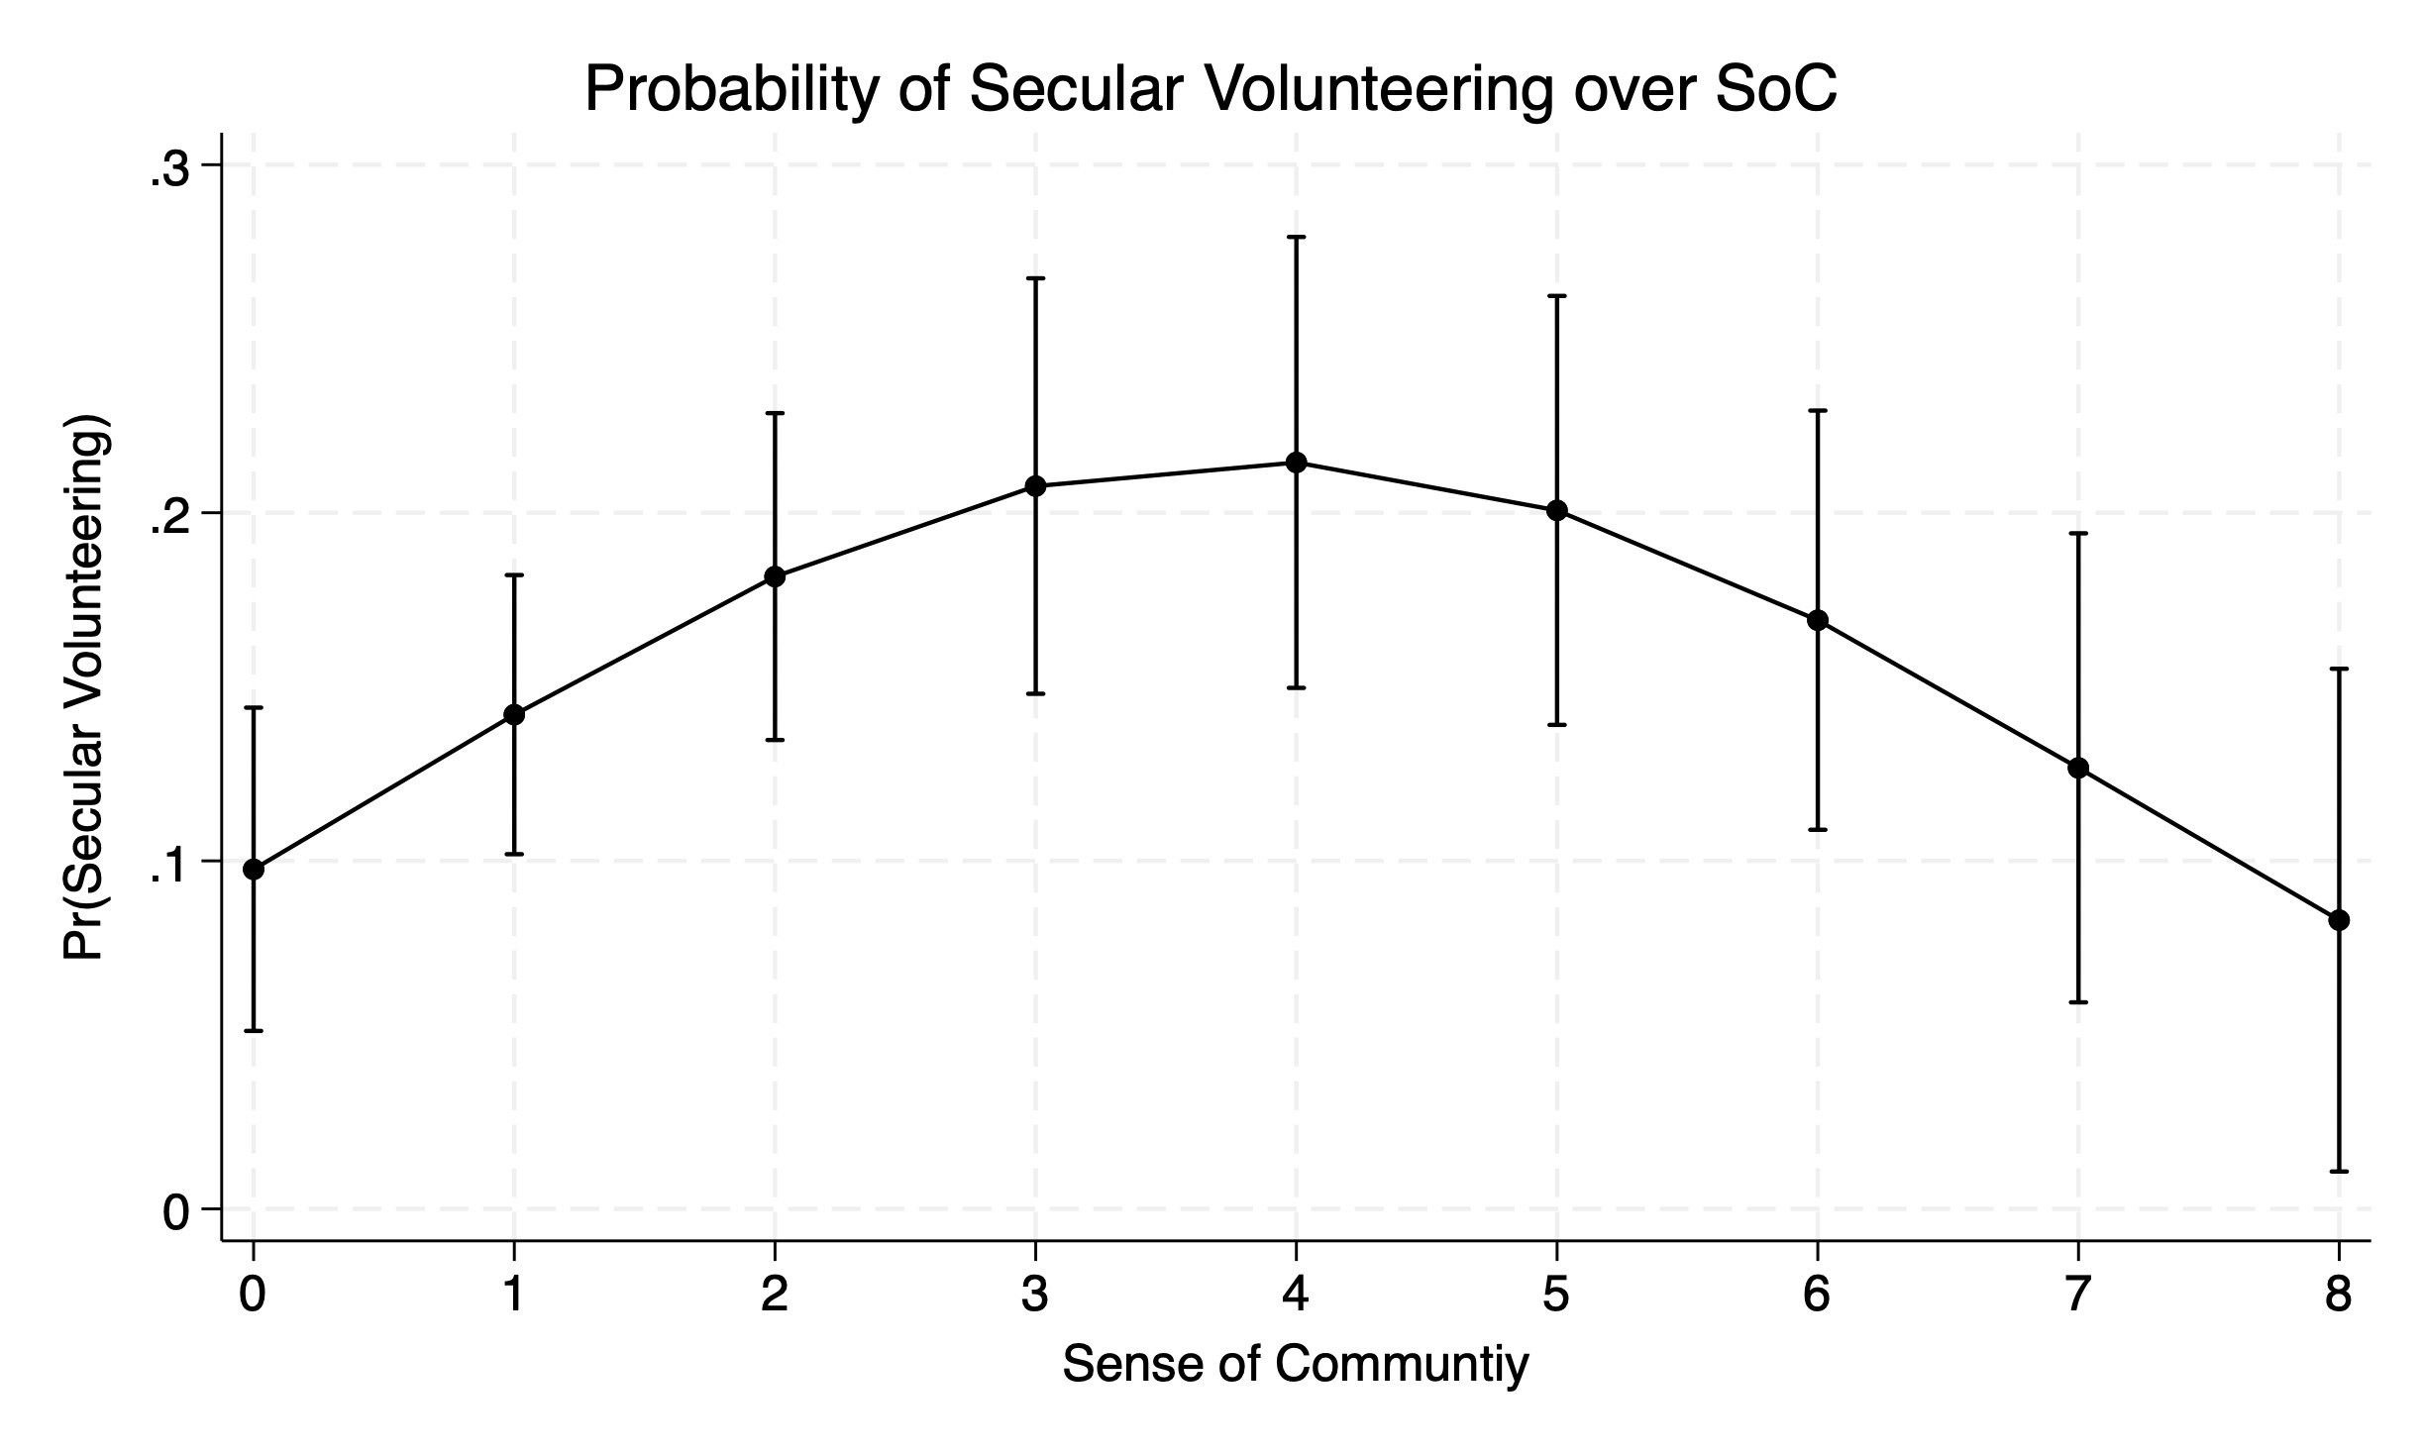
Figure 2: Secular Volunteering over Sense of Community by Length of Residency
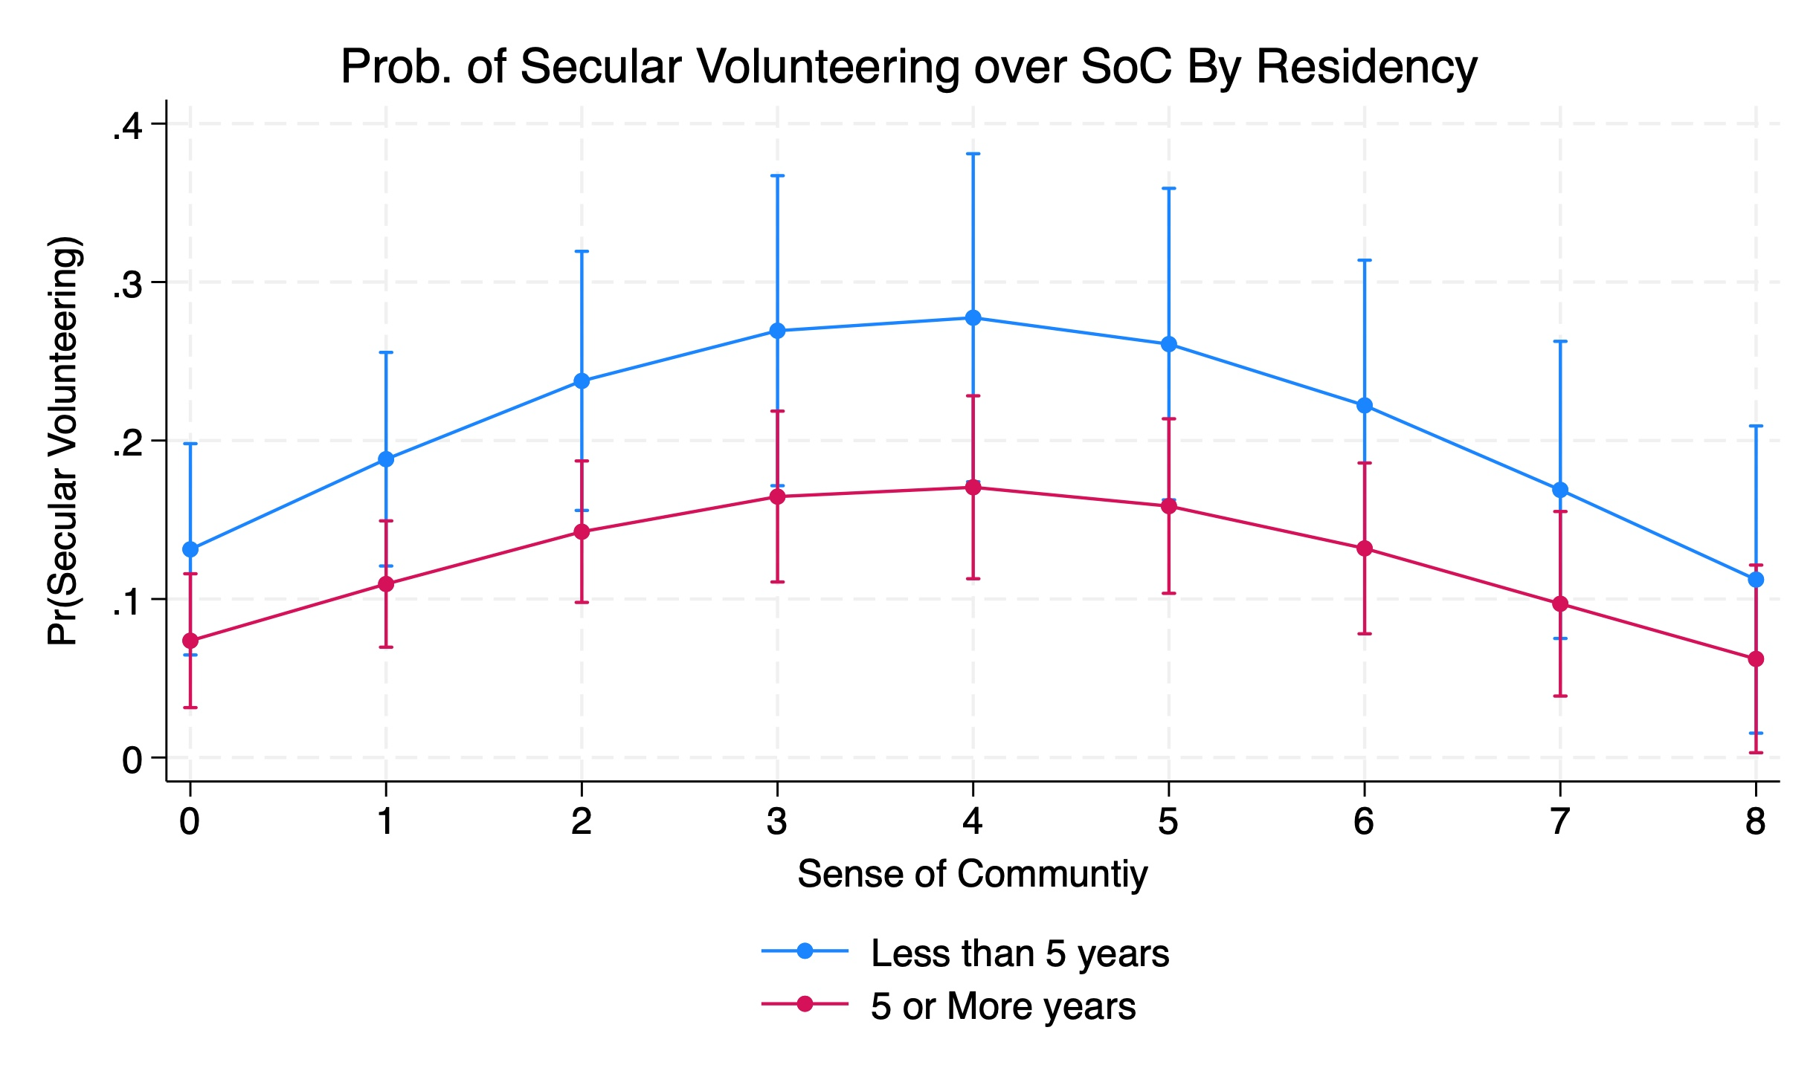
Figure 3: Any Volunteering over Sense of Community
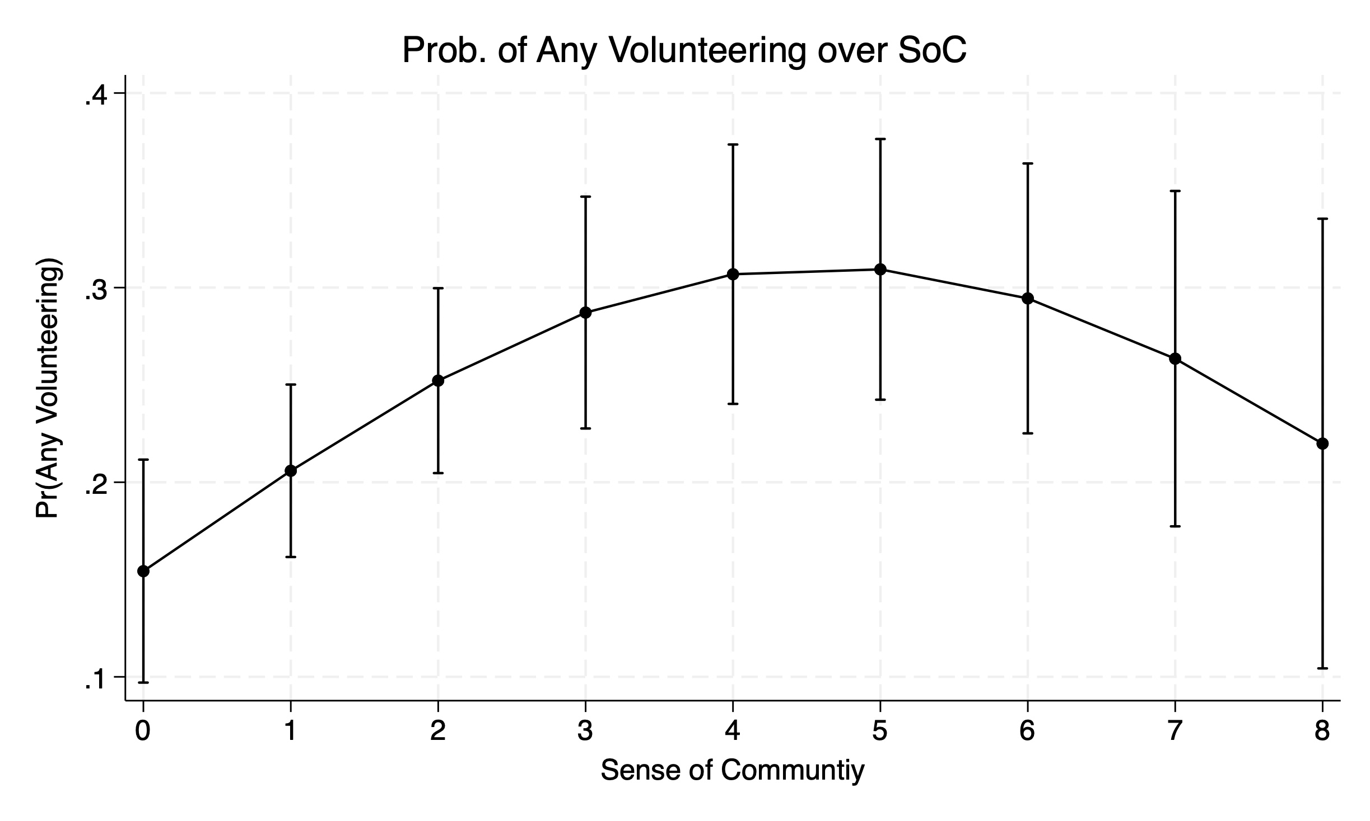
Figure 4: Any Volunteering over Sense of Community by Length of Residency
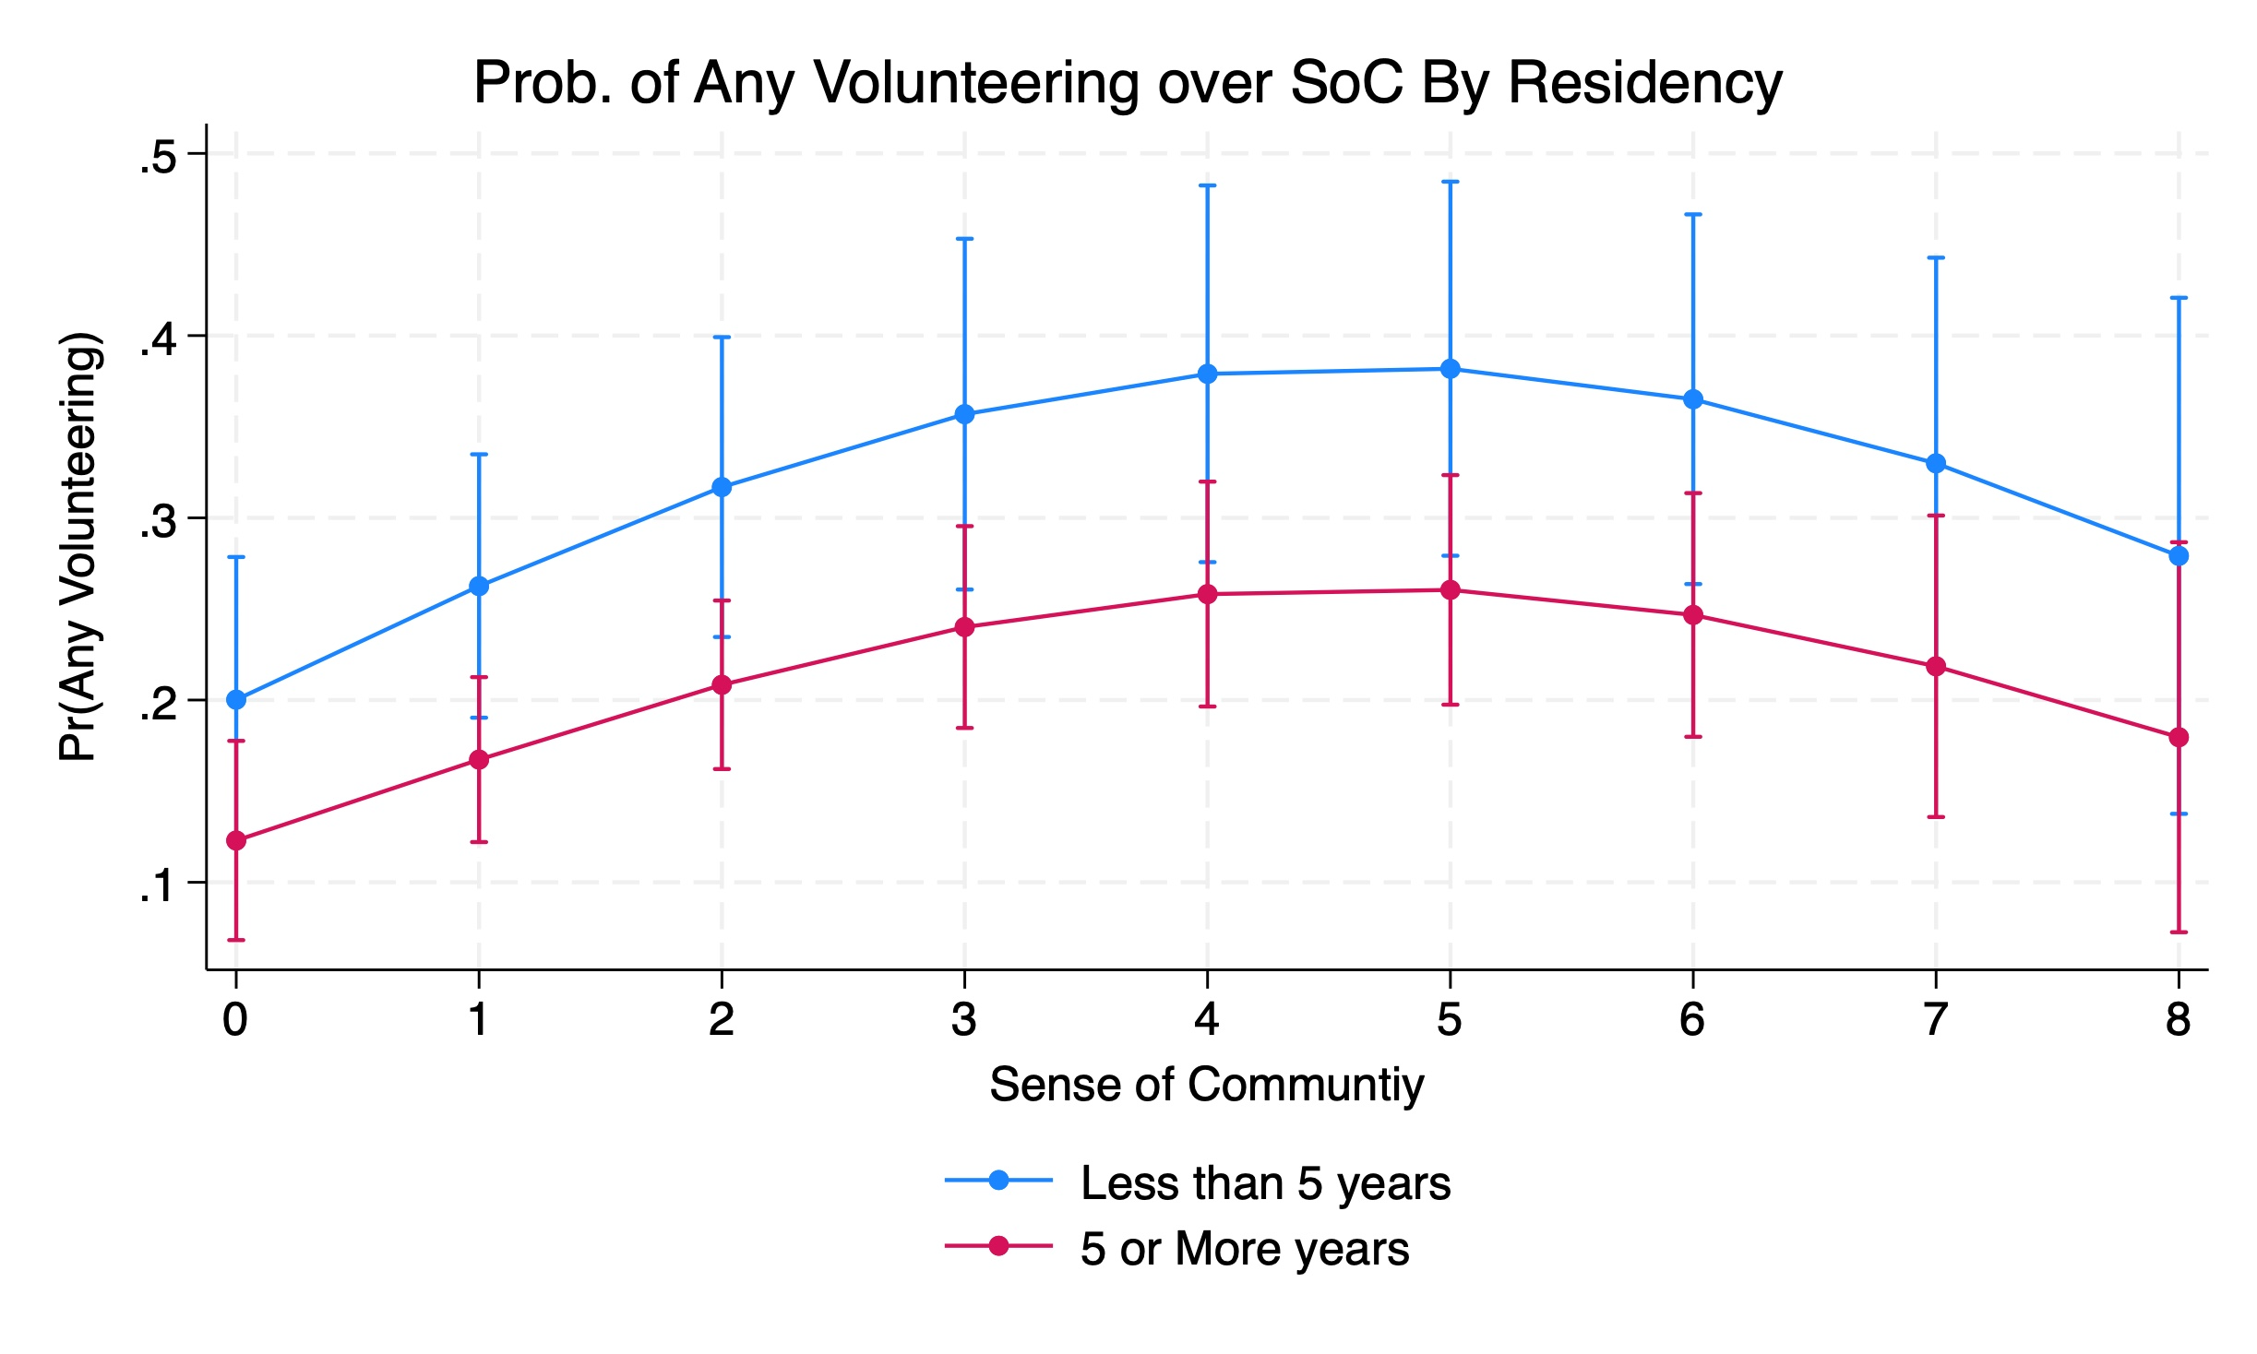
Figure 5: Count of Types of Philanthropic Activities over Sense of Community
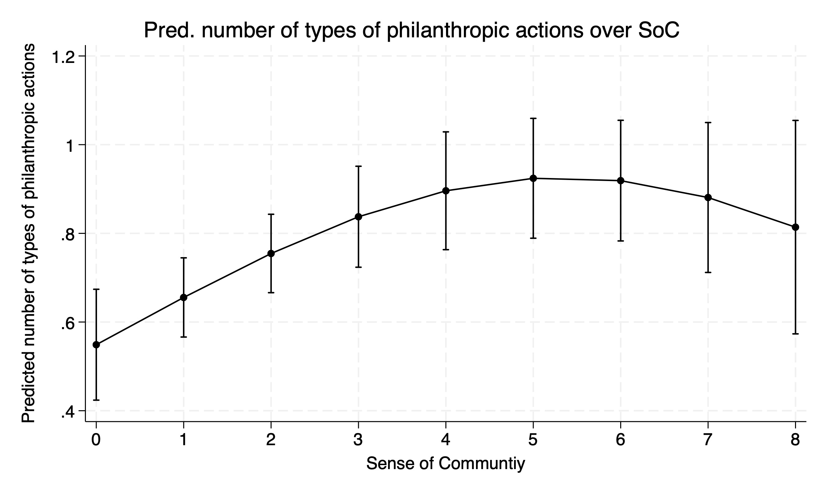
Figure 5: Count of Types of Philanthropic Activities over SoC by Length of Residency

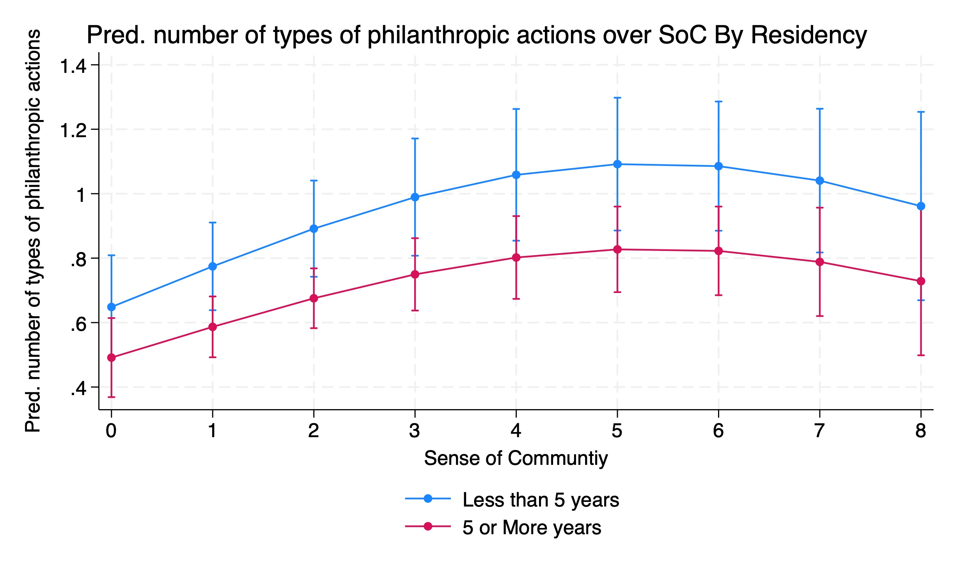
Figure 7: Voted in 2022 over Sense of Community
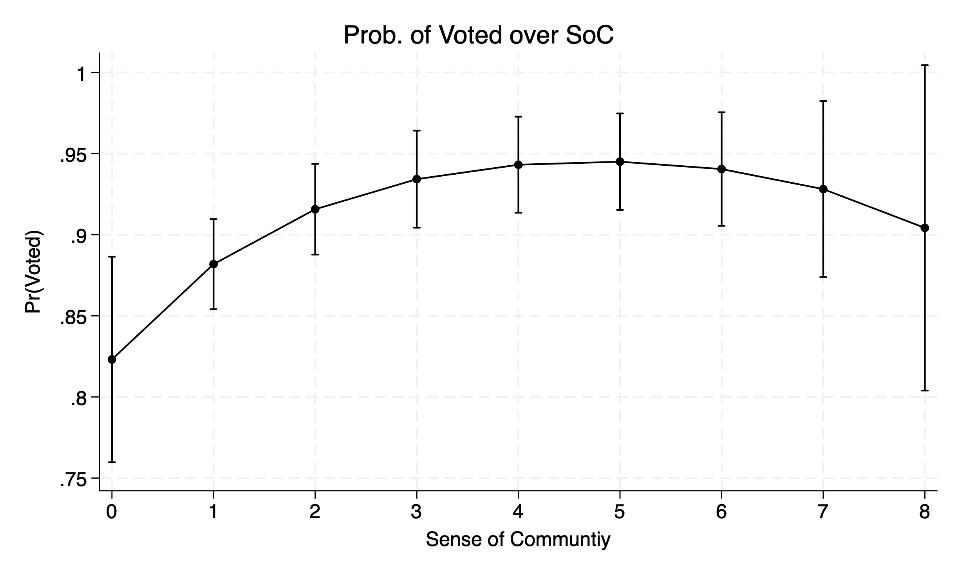
Figure 8: Voted in 2022 over Sense of Community by Length of Residency
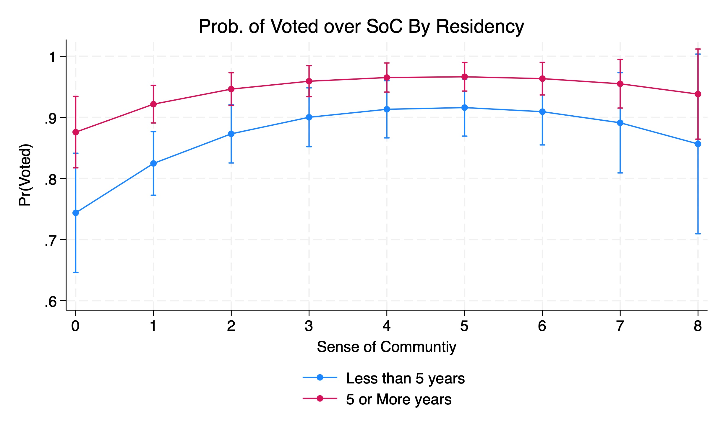

Figure 9: Voted in 2022 over Change in Sense of Community
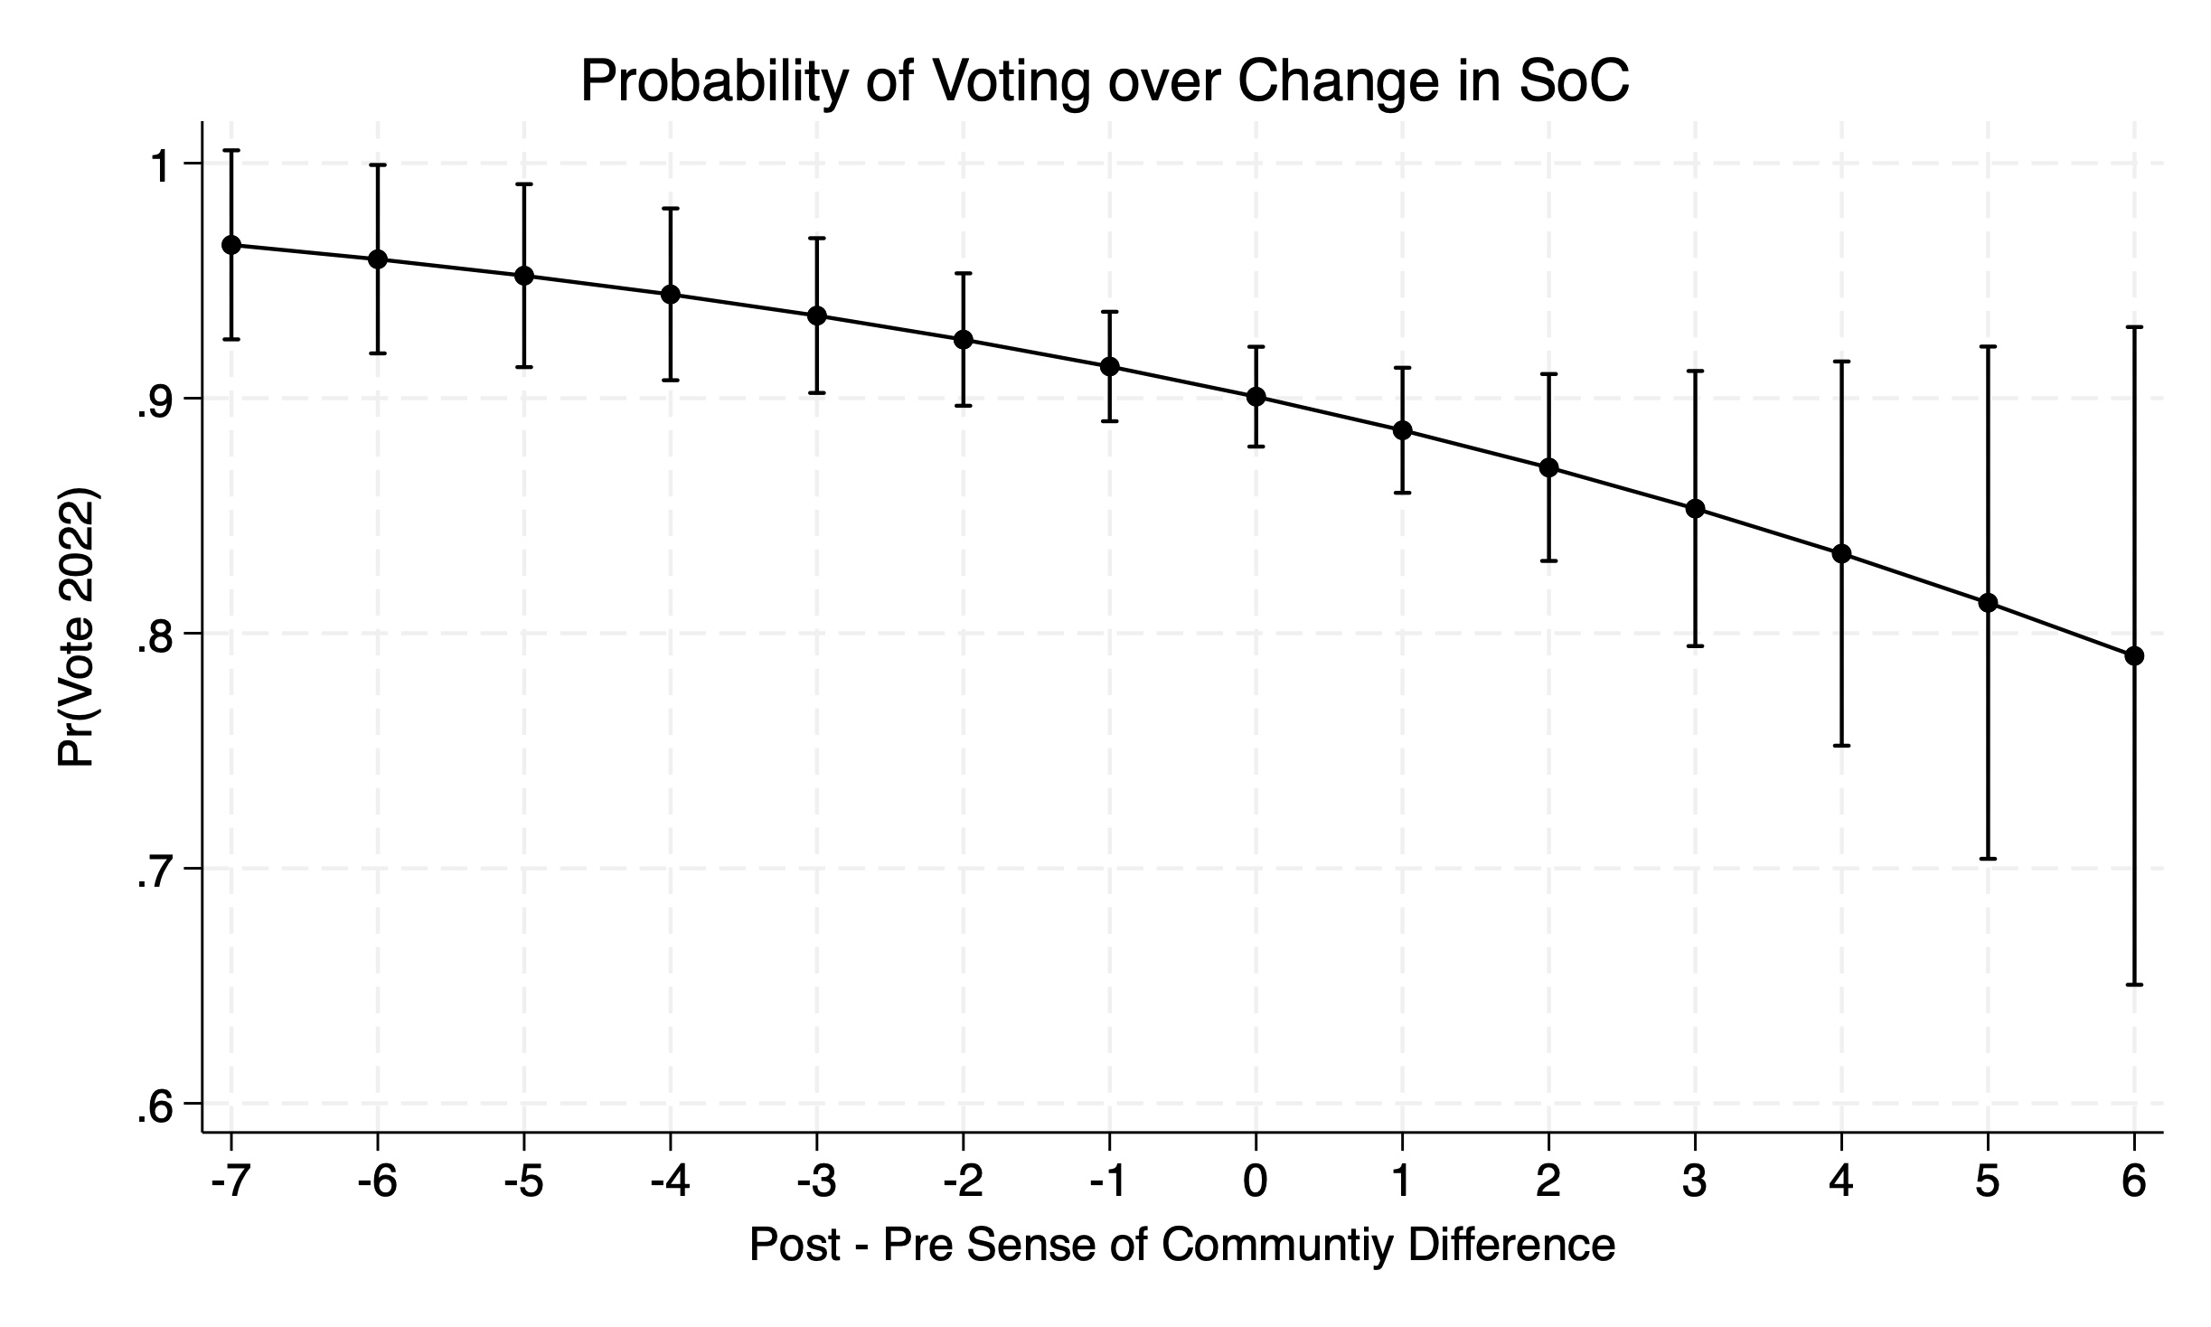
Figure 10: Voted in 2022 over Change in Sense of Community by Length of Residency
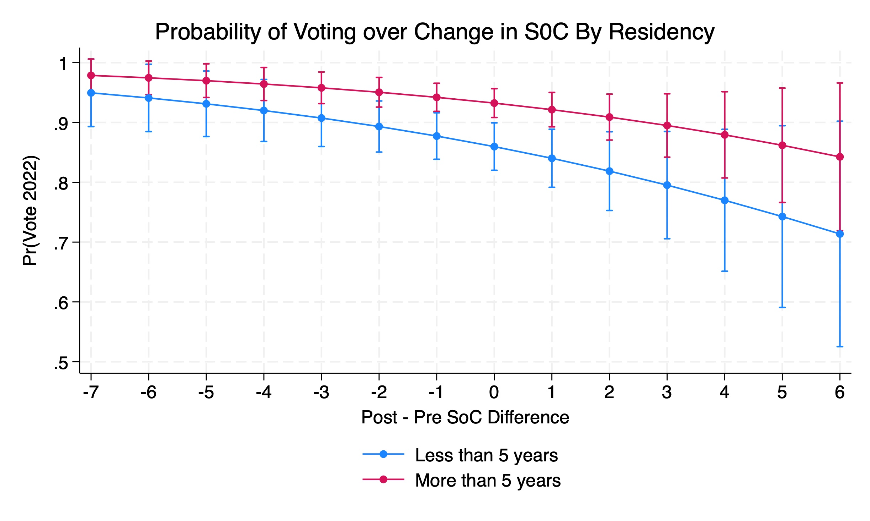

Works Cited
Clerkin, R. M., Paarlberg, L. E., Christensen, R. K., Nesbit, B., & Tschirhart, M (2013). Place, Time, and Philanthropy: Exploring Geographic Mobility and Philanthropic Engagement. Public Administration Review, 73 (1), 97-106.
Dumitru, O. (2022). Half of Americans say they have donated money to charity in the past year. Yougov.com, https://today.yougov.com/topics/society/articles-reports/2022/08/15/half-americans-donate-money-charity-past-year-poll (accessed June 15, 2023).
McMillan, D.W. and Chavis, D.M. (1986). Sense of Community: A Definition and Theory. American Journal of Community Psychology 14(1): 6–23.
Perkins, D.D., Florin, P., Rich, R.C., Wandersman, A., and Chavis, D.M. (1990). Participation and the Social and Physical Environment of Residential Blocks: Crime and Community Context. American Journal of Community Psychology 18(1): 83-115.
Peterson, N.A, Speer, P.W., Hughey, J., Armstead, T.L., Schneider, J.E., and Sheffer, M.A. (2008). Community Organizations and Sense of Community: Further Development in Theory and Measurement. Journal of Community Psychology 36(6): 798–813.
Press Release Number CB23-TPS.53. (2023). 2022 Voting and Registration Data Now Available. US Census Bureau. https://www.census.gov/newsroom/press-releases/2023/2022-voting-registration.html#:~:text=MAY%202%2C%202023%20%E2%80%93%20Voter%20turnout,citizen%20voting%2Dage%20population%20participating. (May 2, 2023) (accessed June 15, 2023).
Putnam, R. (2020). Bowling Alone: Revised and Updated: The Collapse and Revival of American Community. Simon & Schuster.
Schneider, E. and Marshall, T.J. (2023). At Height of Pandemic, More Than Half of People Age 16 and Over Helped Neighbors, 23% Formally Volunteered. Volunteering in America: New U.S. Census Bureau, AmeriCorps Research. January 25, 2023. https://www.census.gov/library/stories/2023/01/volunteering-and-civic-life-in-america.html (accessed June 15, 2023).
Speller, G. M., Lyons, E., and Twigger-Ross, C. (2002). A Community in Transition: The Relationship between Spatial Change and Identity Processes. Social Psychological Review 4(2): 39–58.
Talò, C., Mannarini, T., and Rochira, A. (2014). Sense of Community and Community Participation: A Meta-Analytic Review. Social Indicators Research 117(1): 1-28.

