How Households in India Give: 2020-21
Measuring Generosity
Shaivya Verma (Centre for Social Impact and Philanthropy, Ashoka University, India)

- Abstract

Giving is not a new phenomenon for Indians and it has been a part of their everyday lives for ages. Existing estimates of the total volume of giving in India range between INR 12-21.5 thousand crore. While existing studies are foundational, they do not present an overall overview of giving trends. To offer a more representative view of giving in India, the study is the first holistic attempt to understand household-giving patterns across geographies, socio-economic groups, demographics, and forms of giving. The study was conducted twice within a one-year period and is represented by a panel comprising ~81,000 households across different socio-economic categories in urban and rural India. The study examines three forms of donations: ‘cash’, ‘in-kind’ and ‘volunteering’ made to ‘religious organisations’, ‘non-religious organisations’, ‘family and friends’, ‘household staff’, and ‘beggars’. Characteristics such as gender and age influence giving to recipient groups. The most prominent form of donation was ‘cash’, followed by ‘in-kind’ donation, and ‘volunteering’. The largest market size is captured by ‘religious organisations’ and ‘beggars’. Among the households who did not donate cited ‘lack of resources’, and nobody had approached’ as important reasons for not donating

- Introduction

The nature and extent of giving varies by countries. Most of the scholarly works on philanthropy has historically focuses on wealthier, western populations. The extant literature depicts rich history of giving and charity in India but the numbers reported by different survey report contradictory levels of giving and volunteering (Cantegreil et al., 2013, Charities Aid Foundation (CAF), 2019, Sen et al., 2020, Sheth et al. 2015, Heist et al. 2022). Existing estimates of the total volume of giving in India range between INR 12 to 21.5 thousand crore. The ‘Everyday Giving in India Report 2019’ by Sattva valued the market for giving by Indian residents to be approximately INR 21.5 thousand crore. The report also estimated the worth of informal giving towards religious and spiritual causes to be INR 8.8 thousand crore. The ‘India Philanthropy Report 2021’ by Bain & Company and Dasra assessed the donation by family philanthropy to be INR 12 thousand crore in 2020. The ‘India Philanthropy Report 2022’ further predicts that family philanthropy is expected to grow at 13% per year until 2026.
According to IMF (2022), India is the third largest economy in the world in terms of purchasing power parity (PPP). Consequently, even though the private giving is on the rise, there is a dearth of literatures to understand the potential of individual donors (Viswanath and Dadrawala 2004, Sen et al. 2020). The World Giving Index (2021) report by Charities Aid Foundation reports that India is the 10th biggest riser in the overall giving index score in the past 5 years (2016-2020). The report also notes that India ranks 14th from 114 countries surveyed in terms of overall generosity. The rank is an improvement from the previous global rank of 124 in 2018.
Individual contributions are major source of charitable funding. In 2014, 72% of donations in the USA came from individuals (Giving USA 2015), 46% in Australia (McGregor-Lowndes et al. 2014), and 55% in New Zealand (Philanthropy New Zealand 2014). In India, the scenario of domestic funding has drastically changed from 2010 to 2018. The share of individual contributions grew from 26% to 60% of total private funding (India Philanthropy Report 2020). The report also notes that the philanthropic funding in India has grown from INR 12.5 thousand crore in 2010 to INR 55 thousand crore in 2018.
The few studies conducted so far on giving patterns in India have either focussed on rural (Heist et al. 2022) or urban areas (Sen et al. 2020), particularly to urban English-speaking Indians. Such studies are confined to certain parts of India or represent certain socio-economic groups. For instance, the ‘India Giving Report 2021’ reached out to approximately 2,000 urban respondents through an online survey. Sattva’s ‘Everyday Giving in India Report 2019’ was the first in-depth study to map giving in India; however, it estimated giving in rural India only through secondary research. This study will fill the gap and provides a more representative view of giving in India. I believe the study is first of a kind study that provides a nuanced understanding of household-giving patterns across geographies, socio-economic groups, demographics, and forms of giving. Given the lack of research, the study is important as it offers a comprehensive, national-level picture of the volume, value and composition of various forms of household giving in India. It also provides detailed information on the range of beneficiaries, their motivations, and the various forms and modes of giving.
In this context, the present study delves into a deeper question of to whom do households in India give and in what form? What motivates them to give and what are the deterrents to making donations? Accordingly, the specific objectives of the study are to understand the household incidence of different types of donations or charity, estimate the reported value of total giving by households, different recipients of donations being made by the households, age-group and gender patterns in making decision related to donation, patterns of contribution – ‘cash’, ‘in-kind’, or ‘volunteering’ services, and motivations and reasons for making or not making a contribution.
The paper is organized as follows. The next section provides background and reviews the literature of very few existing studies on giving. I then lay out the methodology and research design of the study and turn to the estimation results, analysis and discussion before listing down limitations. The last section concludes the chapter by recapping important findings, and policy implication.

- Literature Review

The literature on giving in India is sparse. Existing body of empirical literature on giving has mainly identified two forms of giving: monetary and volunteering. Due to definitional challenges, the findings on giving and volunteering have differed drastically in studies (Cnaan et al. 2011). Similarly, Kassam et al. (2016) concluded, “due to the challenge of capturing numbers on individual giving, it is widely debated how generous Indians are” (p. 96). The studies conducted so far do not fully capture the scope of giving such as the research on giving does not count the money people leave in the collection plate in Church or give to a homeless person (Cnaan et al. 2011) or to beggars. A similar problem exists while calculating the levels of donation. In the study by Center on Philanthropy Panel Study (COPPS) (2005) respondents were only asked if they had donated US$25 and above while ignoring donations done under US$25. Independent Sector (IS) (1999) survey did include money given under US$25 and included in-kind donations. The study listed 12 causes and asked households if they had donated sum of money or “cash equivalent of property” to the mentioned causes.
Similarly, the studies have differently defined the term volunteering services. There is no particular accepted definition of volunteering such as people often spare their time to religious organisations or for religious purposes as part of their religious duties which may not be counted as voluntary behaviour (Cantegreil et al. 2013, Heist et al. 2022). The lack of well-accepted and clear definition of volunteering causes challenges in accurately assessing the levels of volunteering (Musick and Wilson 2008). Cnaan (2011) notes that, “the term volunteer might be considered an all-encompassing term covering a wide range of activities that can go from handing water to runners in a race once a year to being a full-time volunteer worker.” The problem in defining a volunteer activity is that people define the same activity differently (Cnaan 2011).
Studies have shown that cash and individual contributions have played most important source of charitable funding (Sen et al. 2020). In 2014, about 46% and 55% donations come from individuals in Australia (McGregor-Lowndes et al. 2014) and New Zealand (Philanthropy New Zealand 2014) respectively. In the USA, 72% donations come from individuals (Giving USA 2015). However, India has seen changing trends in individual contribution over the years.
The World Giving Index (WGI) report by Charities Aid Foundation publishes report on how generous individuals in a country are. The report ranks countries around the world in terms of generosity. The sample is national represented by 1000 participants in each country. The 2019 report ranked India 82nd out of 126 countries (CAF 2019). As discussed above, the India rank in overall generosity have improved to 14th out of 114 countries in 2021. In the most recent report published in 2022 by CAF, ranks India 57th out of 119 countries surveyed. The study also reports the generosity in terms of helping strangers, giving money and volunteering. India ranks 82nd in terms of helping strangers, 61st in giving money to charity, and 18th in volunteering. About 57% reported to have helped someone they did not know, 31% responded to have helped by giving money and 33% gave volunteering time. Similarly, a study by Sheth et al. (2015) reports that in the year 2013, 28% Indians gave money to charity and 21% gave their time. The same report published in 2009, reported only 14% Indians have donated cash, and about 12% donated time. In terms of numbers, India saw and an increase of more than 100 million more Indians donating either in cash or in time in the period from 2009 to 2013. The report also finds that the media reporting of philanthropy has doubled in the five-year span (2009-2013).
Another study by Sen et al. (2020) on urban India reports the most common type was donation was made in cash and 61% of respondents reported to have donated in cash. The study also notes that 76% of survey participants donated in one form or the other. The data was collected from 1,925 urban settled income earners from three different cities of India: Kolkata (West Bengal), Cuttack (Odisha) and Bengaluru (Karnataka). The study does not represent pan-India. Another shortcoming of the study was that it excluded smaller everyday acts of giving and focussed primarily on the recollection of major donations (Heist et al. 2022). The study on urban India also excludes the timeframe and whether the giving was to charity (Heist et al. 2022). On the other hand, WGI was specific in asking about donation to a charity within last one month.
A more recent study by Heist et al. (2022) conducted in rural villages (n=3195) reports that people in rural areas are highly generous and engage in both formal and informal form of giving and volunteering. The paper uses large-scale door-to-door survey to understand the various forms of formal and informal prosocial behaviour. About 79% donated food, 83% donated money and/or 70% volunteered during one-year study period. The study also finds the significance of socio-economic indicators among the poor, except education, and lower social groups and minority religions compared to dominant social groups and religions exhibit higher prosocial behaviour.
The ‘India Giving Report 2021’ by Charities Aid Foundation (CAF) recorded that 82% respondents have contributed in some form in 2020. The findings also show the majority of people donated money to the poor followed by giving to religious institutions and to non-profit organisations. COVID-19 pandemic saw an increase in the overall individual giving. The study recorded 2,053 interviews online using YouGov’s online panel. The sample only represents urban population. It does not represent people living in rural parts of the country.
The discrepancies in definitions, methodology, sample have resulted in contradictory results. While WGI reports lower levels of giving in India, Sen et al. (2020) and India Giving Report 2021 reports higher levels of giving in India. The United Nations State of the World's Volunteerism Report (2018) reports that India provides 374 million of full-time equivalent volunteers. India ranks second indicating high levels of volunteerism. The report does not compare per capita statistics (Heist et al. 2022). Another study by Giving Tuesday (2021) showed, strongest levels of prosocial behaviour (money, time, goods, advocacy) in Kenya and India. The report also reported very high levels of advocacy and volunteering in these countries. The survey was conducted via an online survey of a sample size of 1,000 individuals in Brazil, Canada, India, Kenya, Mexico, United Kingdom, and the United States.
Similarly, studies conducted in the USA on giving and volunteering have differed in outcomes. The survey conducted by Independent Sector (IS) between 1988 and 1999 found that 7 in 10 American household in any year give to charity while 1 in 2 adults in America volunteered. In 1998, an adult American gave about 4 hours of volunteering time in a month. In 2007, the Census Bureau (U.S. Department of
Labor, 2008) reported 26.2% adults volunteering, which is a significantly lower estimates than COPPS (31%) and the IS (31%).
The concept of the forms of giving in India is different from the forms of giving as understood in the West (Cantegreil et al., 2013, Sen et al. 2020, Heist et al. 2022). In India, giving happens through various formal and informal channels and takes various forms (Cantegreil et al. 2013). To broaden the understanding of various forms of giving, the paper will discuss three types of prosocial behaviours or giving: cash, in-kind, and volunteering, especially in context of India.

  - Forms of Philanthropy

Cash Donations: Giving in cash plays a most important role among all the forms of giving. Cash donations can take various forms. Cash or financial donations are donations typically made in physical cash, by cheque, and via credit and debit card (both offline and online). ‘Cash’ transactions also include payments through digital wallets.
In-Kind Donations: The literature on in-kind giving is very limited although it does have a significant positive impact and are quite prevalent among Indians. These donations are made in a material form comprising both new and used articles such as food, clothes, furniture etc. Barth (2016) defines in-kind donations as, “any donation of goods and services for a charitable purpose” (p. 49). It can be geared towards a cause, individuals such as people in need or neighbours, or to an organisation (Heist et al. 2022). People in India regularly donate food to temples, neighbours and other community organisations (Heist et al. 2022).
Volunteering Services: Volunteering services can be understood as providing service without any charge to an individual, group of individuals or organisation/s. Volunteering can be both formal and informal. Formal volunteering activities are performed within an organizational setting, while informal volunteering involves activities outside of a formal organizational setting (Ajrouch Tesch-Roemer, 2017). Choi et al. (2007) defines informal volunteering as “helping friends, neighbors, or relatives who did not live with you and did not pay you for the help” (p. 106). United Nations report (2018) on volunteers finds that 70% of voluntary behaviours are in the form of informal volunteering. The literature on giving has associated formal volunteering with higher socio-economic status (Heist et al. 2022) while informal volunteering was found to be more prevalent in African Americans than among the more privileged in American society (Boddie 2004). Since time is a limited resource, formal volunteering presents higher opportunity cost to the poor (Taniguchi, 2006; Apinunmahakul et al., 2009; Wilson, 2012).

  - Selection of Variables

The paper seeks to measure the market landscape and the extent of participation of Indians in different forms of giving – cash, in-kind and volunteering but also dives into the preferred recipients of household donations. The recipients are classified into five types: religious organisations, non-religious organisations, household staff, extended family and friends, and beggars.
The concept of ‘giving’ is an integral part of many cultures and religions. While India’s religious landscape is complex, their cultures and beliefs influence larger social norms (Heist et al. 2022). For instance, dana is an important practice in Hindu, Buddhist, and Jain scriptures. In Buddhism, a person attains good rebirth by practicing giving or daan (Agarwal, 2010). the term caritas has been used in Christian theology, the Jewish use tzedakah to signify charity, and zakat is important according to the Quran. ‘Giving’ in India can be connected to the ethos of ‘Vasudhaiva Kutumbakam’ aka ‘the world is one family’. Kassam et al. (2016) notes that the concept of daan or the practise of cultivating generosity has become a part of Indian culture, across religions. Giving money to a hundi box in temples is a common tradition for Hindus and Buddhists (Agarwal, 2010). In addition to giving money, giving food is also common among Indians and across religions (Kassam et al., 2016).
While giving for religious purposes and to religious organisations is practiced commonly among Indians, giving to beggars is also a deep-rooted practice in Indian society. Beggars are common in all Indian towns and cities. Begging can be commonly observed on the streets, traffic signals, outside temples and other places of worship. In India, giving to beggars is considered a noble act (Singh 2023) and therefore many beggars are seen outside places of worship. Traditionally, monks have lived by seeking alms and individuals consider it as their tradition and duty to help someone in financial distress. It often times become difficult to ignore a child or a deformed person begging.
Besides giving to religious organisations and beggars, individuals also support various causes and donate in various forms to non-religious organisations, informally extend help to their household staff and to their extended family and friends. Study by Kassam et al. (2016) on the urban poor in India highlights the importance of helping relatives, and practice of giving food.
Further, the analysis will also examine various combination of factors explaining the motivations and incidences of giving.
Socio-Economic Status/Income Groups: Socio-economic status or income groups are important factor affecting the giving behaviour. The research on giving among lower-income households has mixed findings. Bennett (2011) reported that 51% poor in London donated money and the median monthly donation by lowest quartile of the income group is not drastically different than the national median. Similarly, Walker and Pharoah (2002) show the wealthy in the UK give between 1% to 2% while the poor donate between 3.5% and 4% of their incomes. Studies have found u-shaped, nonlinear relationship between the percentage of income donated and income (Heist et al. 2022), that is, lower income households give more percentage of income compared to middle income households (Andreoni 2006, Piff et al. 2010). Kassam et al. (2016) interviewed poor living in urban areas of India and notes that “the idea that philanthropy is a give-and-receive relationship” (p. 90).
On the other hand, studies have shown the donation tends to increase with the rise in income (Pharoah and Tanner 1997, Bekkers 2003, Lincoln et al. 2008, Sen 2020). The findings from People Research on India’s Consumer Economy (PRICE) (2021) survey shows one in every three Indian belongs to “middle class”. The insights also predict that by 2047, two out of three Indians will belong to “middle class”. With the rising number of households with more wealth, the spending has also escalated (Bhagwati and Woodrow, 2023).
However, the study by Sen (2020) shows that with the rise of income, the proportion of giving income declines. It further suggests that there is an increase in likelihood of giving with increase in income, but beyond a threshold, people are less likely to show that same level of generosity. The present study will explore the relationship between socio-economic level or income groups and generosity in India.
Urban-Rural landscape and Regions: Another important aspect is the place of origin of individual. People living in urban areas are better informed and have relatively stable sources of income compared to rural counterparts (Ho 2011). Sen (2020) in the study finds that people with urban background donate more than with people who migrated from rural areas. People in urban areas have a better opportunity and ease of access to donate (Sen 2020). Another reason given by Sen is that the individuals who migrated to the cities are economically less stable and hence the likelihood to donate is less. Additionally, Sen noted that the “urban individuals are also more likely to complement their cash giving with non-cash giving” (p. 280). Another study by Heist et al. (2022) on rural India shows higher participation rates than that was observed in the study on urban India by Sen et al. (2020).
Since studies have shown relationship between giving in rural and urban areas while no study has analysed the connection between giving and giving across regions in India. India is a vast country with big cities and many regions spread throughout the country. Some regions are more developed in terms of indicators such as literacy, health, and GDP. Reserve Bank of India (RBI) ranks Indian states in terms of GDP growth. The latest statistics 2019-20 shows the best performing states in terms of GDP are from the South. From the top 15 states, 5 states belong to south, followed by 4 states from north, and 3 states belong to each east and west India. Bhagwati and Woodrow (2023) notes that, “almost 29% of India’s disposable income comes from 63 biggest cities of the country which are now home to more than a quarter of its middle class.”
Age and Gender: Age and gender are yet other important factors affecting giving behaviour.
Studies have found a positive relationship between age and giving (Andreoni et al. 2003, Lee and Chang, 2007). As people age their involvement in community increases and thus more inclined to give back (Yao 2015). Some attribute the relationship between and giving to generosity in general (Yen 2002, Hrung 2004) while others attribute this to religious giving (Clotfelter 1997, Andreoni 2004). One theory suggests that the disposable income increases with age and hence older people are more generous. But Bekkers and Wiepking (2007) finds that even after controlling for income, the relationship between age and giving holds true. They explain that religious involvement gets higher with age and children while they begin to settle down leads to decline in family responsibilities. As a result, the older become empathetic towards others and their needs (Bekkers and Wiepking 2007). Thus, we expect to see a positive relationship between age and giving.
The role of gender in giving has conflicting findings. In contemporary times, females are also earning and take their decision of whether to give and how much to give (Andreoni and Payne 2003). Mesch et al. (2002) notes that females are considered to carry a stronger sense of empathy and are taught to show concern for others. However, other studies have suggested that women are more likely to contribute in the act of giving but men tend to give higher amounts (Belfield and Beney 2000, Rooney et al. 2001, Andreoni and Payne 2003). Also of importance is the role of gender in the decision of whom to give. Given the mixed finings, the study will analyse the relationship between gender and giving.

- Methodology

  - Sample

The study is based on a primary survey of households across 18 states in India. The survey reached out to ~81,000 households nationally representing different socio-economic categories. The current study used the Worldpanel Division of Kantar’s existing panel of households to collect data from empanelled respondents across socio-economic categories in urban and rural India.
The responses were collected in two phases. For the first phase, the responses were collected in April 2021 for the donations made in the period between October 2020 and March 2021. For the second phase, the responses were collected in October 2021 for the donations made in the period between April 2021 and September 2021. Overall, 1,40,000 responses related to household giving patterns were recorded in two phases in one-year period. The responses were collected both telephonically and in-person.
The panel used the National Consumer Classification System (NCCS) developed by the Market Research Society of India (MRSI). It provided a standardised household classification, representing a diverse socio-economic population that includes both urban and rural households. The NCCS is based on the education of the household’s chief wage earner and number of consumer durables owned by the household.

  - Key Terms Used

Households: The study defined households as a group of related persons co-inhabiting a house and sharing a kitchen.
Understanding ‘Giving’: ‘Giving’ or charitable contribution in the study is defined as the voluntary contribution/s made by households in the form of ‘cash’ or financial donations (physical cash, cheque, digital wallets credit/debit card - offline and online), ‘in-kind’ donations (any material such as food, clothes, furniture etc.) or ‘volunteering services’ (providing service without any charge) to an individual, group of individuals or organisation/s.
The study sought information across four major categories: recipient groups, urban–rural landscape, regions, and SECs (income groups).
Recipient Groups: The key recipients of donations were divided into the following groups: ‘religious organisations’, ‘non-religious organisations’, ‘household staff’, ‘extended family and friends’, and ‘beggars’.
Religious organisations here refer to institutions for religious worship including temples, mosques, gurudwaras, churches, and other similar institutions. Non-religious organisations encompass NGOs, agencies such as UNICEF, relief funds like PMCares, etc. For the purpose of this study, household staff were organised into separate categories like drivers, domestic workers, cooks, and others.
Urban–Rural Landscape and Regions: India’s geographical area was divided into two categories: 1) urban and rural India, and 2) four regions: north India, south India, east India, and west India. A more detailed note on constitution of zones is provided in Appendix A.
SECs/Income Groups: The sample for the study was derived using Marketing Research Society of India (MRSI) principles to cover respondents across Socio-economic Classification (SEC) on the basis of the education of chief wage earners and number of durables owned per household. For rural areas, agricultural land owned was also considered as a part of household durables for NCCS classification. The sample was representative of geographies and urban and rural consumers across socio-economic categories in India; it comprised a randomly selected panel of respondents by Worldpanel Division Kantar. A more detailed explanation of panel composition is provided in Appendix A of this report.
Based on the SEC classification GRID, this study used five broad income categories: SEC A, SEC B, SEC C, SEC D/E. On the scale, SEC A represents higher-income groups and SEC D/E represents lower-income groups.

  - Understanding Market Size

A key objective of the paper was to estimate the ‘market size’ for charitable giving in India. For the purpose of this study, ‘market size’ was broadly defined as a projected value, based on Worldpanel Division of Kantar panel survey results, that was indicative of the amount of ‘cash’ available in the country for individual household giving and philanthropy. The estimate was determined based on the donations made in ‘cash’ in one year that is, between October 2020 and September 2021.
A question on the amount of ‘cash’ donations made at a household level was posed to respondents in both phases of the study. Options were given to respondents in terms of amount ranges. The categories included were under INR 100, INR 101–300, INR 301–500, and so on. Based on the household incidence of ‘cash’ donations for each of these amount brackets, an estimation was drawn to arrive at an aggregate-level market size for each type of donation for both rounds of the study.
Further, a product of total households incidence (A) of each ‘cash’ amount range for a particular donation type and an average value (B) taken of that amount range has been used to arrive at the ‘cash’ amount donated (C) for that specific amount range within one type of donation.
A summation of ‘cash’ amount donated for each price range is then used to arrive at a total ‘cash’ amount donated for each type of donation (refer to Table 1), which cumulatively help us estimate the overall market size (refer to Table 1).
Table 1: Illustrative Example of Market Estimation Data

Q | You mentioned that you have made donations in CASH. Can you tell us what was the total amount of Donation/Charitable Contribution that you have made in CASH in the last 6 months
 |  | Mid-point
 | Under Rs 100 | 50
 | INR 101-300 | 200
 | INR 301-500 | 400
 | INR 501-1000 | 750
 | INR 1001-5000 | 2500
 | INR 5001-10000 | 7500
 | Over INR 10001 | 10001

Captured data for W2 for religious organizations
 | HHs’000  (A) | Mid-point  (B) | Donated Amount  (C = A*B)
Total Households'000 that made religious donations | 164594
Under Rs 100 | 40458 | 50 | 2,022,891
Rs. 101-300 | 48154 | 200 | 9,630,755
Rs. 301-500 | 33650 | 400 | 13,459,983
Rs. 501-1000 | 24313 | 750 | 18,234,592
Rs. 1001-5000 | 12137 | 2500 | 30,342,142
Rs. 5001-10000 | 1516 | 7500 | 11,368,170
Over Rs. 10001 | 900 | 10001 | 9,001,834
Total cash Amount | 94060368 |  | 94,060,368
Average | 571 |  | 571

Market estimate calculation basis responses from phase 1 and 2

Market Size Estimation
 |  | Phase 1 | Phase 2
Religious Organisations | Total Households (000) | 114803 | 164594
 | Total Cash Amount | 72,356,366 | 94,060,368
 | Average Cash amount | 630 | 571
Non-Religious Organisations | Total Households (000) | 6208 | 5833
 | Total Cash Amount | 6,191,473 | 4,684,327
 | Average Cash amount | 997 | 803
Household staff | Total Households (000) | 3592 | 3751
 | Total Cash Amount | 4,783,152 | 5,505,124
 | Average Cash amount | 1332 | 1467
Extended Family and Friends | Total Households (000) | 5092 | 7470
 | Total Cash Amount | 9,535,160 | 10,708,804
 | Average Cash amount | 1872 | 1434
Beggars | Total Households (000) | 90939 | 113926
 | Total Cash Amount | 13,293,975 | 16,070,377
 | Average Cash amount | 146 | 141
Overall (For Any type of Donations) | Total HHs doing any donations (000) | 202691 | 258363
 | Total Cash Amount (Crores) | 10,616 | 13,103
 | Average Cash amount | 524 | 507
Annual donation market size India | Total HHs who have donated | 267923
 | Total Cash Amount | 23,719

- Findings and Discussion

  - The Market Landscape of Household Giving in India

This section will discuss the estimates for in ‘cash’ giving only as ‘in-kind’ donations and volunteering services cannot be quantified. Donations in ‘cash’ includes giving by cash (currency notes), cheque, digital wallets (e.g., Paytm, GooglePay, Phone pe, Amazon Pay, etc.), credit/debit card (offline – through POS), and credit/debit card (online – through payment gateways).
The total market size of ‘cash’ donations in India was estimated to be INR 23.7 thousand crores for one year. ‘Religious organisations’ and ‘beggars’ were the preferred recipients of household giving. ‘Religious organisations’ constitute 70% of the market which translates to INR 16.6 thousand crore. This was
followed by ‘beggars’ at 12% (INR 2.9 thousand crore), ‘family and friends’ (INR 2 thousand crore) at 9%, ‘non-religious organisations’ (INR 1.1 thousand crore) at 5%, and ‘household staff’ at 4% (INR 1 thousand crore).
Corroborating earlier findings, rural India has emerged as more generous than urban India. Even though the average donation amount is lower in rural India (discussed in proceeding sections), it accounts for 67% of total share of households as compared 33% households who donated in urban India. In terms of the market share, 59% comes from rural India while 41% contributes from urban India.
About 30% share of the total households who donated are from south India, a well performing region in terms of GDP followed by north India at 29%, east India at 26% and west India at 23%. South India contributes to 30% of the estimated market share.
Income was predominant in explaining prosocial behaviour. With the increasing wealth in the Indian middle-class families, they are also focussing on bringing meaningful impact in the society. The share of households who donated most belong to the lower-income category while the highest share of market comes from middle-income category. Considering socio-economic variable 37% of the total households who donated belong to middle-income category (SEC B/C) and had the highest share of the market at 44%. Approximately, 52% of total households who donated are in the lower-income category (SEC D/E) whose contribution was 34% of the estimated market share. The results imply that the poorer households are more likely to take part in donation but in small token amounts.

Figure 1: Market Landscape (Oct’20-Sep’21)

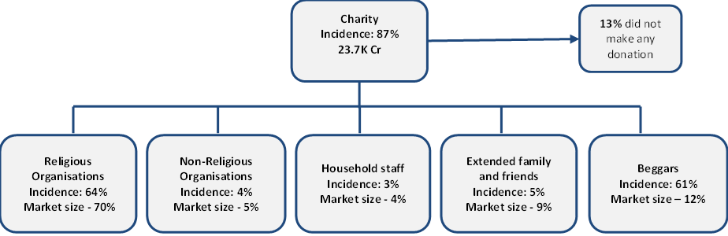

Figure 2: Estimated share of households and market size: Income groups, regions, urban–rural (Oct’20-Sep’21)

  - Understanding Patterns of ‘Giving’: Cash’, ‘In-kind’, and ‘Volunteering’

Overall, 87% households reported having made a donation in some form to one or more of the recipient categories. ‘Cash’ emerged as the most preferred form of giving across five recipient groups. Groceries were the main form of ‘in-kind’ donations. Out of the 87% of incidences, 93% donated in ‘cash’, 44% donated ‘in-kind’, and 1% reported to have ‘volunteered’.
In line with the findings of the market landscape, of the households who donated (87%), rural India observed a slightly higher incidence of donation at 88% compared to urban India at 83%. Among regions, eastern India (96%) and northern India (94%) reported higher incidence of donation. In other words, 9 out of 10 households were involved in giving in these regions. Findings across income categories varied between 83% and 89%. The below sections will discuss patterns across forms of donation: ‘cash’, ‘in-kind’ and ‘volunteering’.

Figure 3: Forms of donation across recipient groups (Oct’20–Sep’21). The percentages are calculated on the base of total incidences of household donation for each recipient groups.

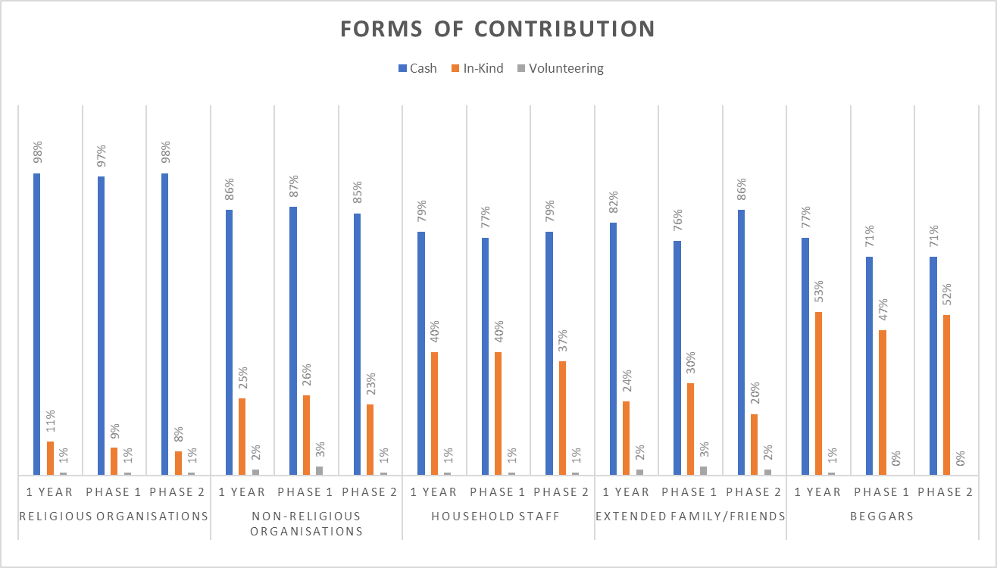

Patterns of ‘Cash’ Giving: Overall, the average donation amount for households saw a small decrease in phase 2, from INR 524 to INR 507. The trends show an increase in the average ‘cash’ donation to ‘household staff’ from INR 1,332 in phase 1 to INR 1,467 in phase 2. On the other hand, contributions to other recipient groups fell in phase 2 from phase 1. The highest difference could be observed towards the contribution to ‘family and friends’ which fell from INR 1872 in phase 1 to INR 1434 in phase 2.

Figure 4: Average ‘cash’ payment across recipient groups

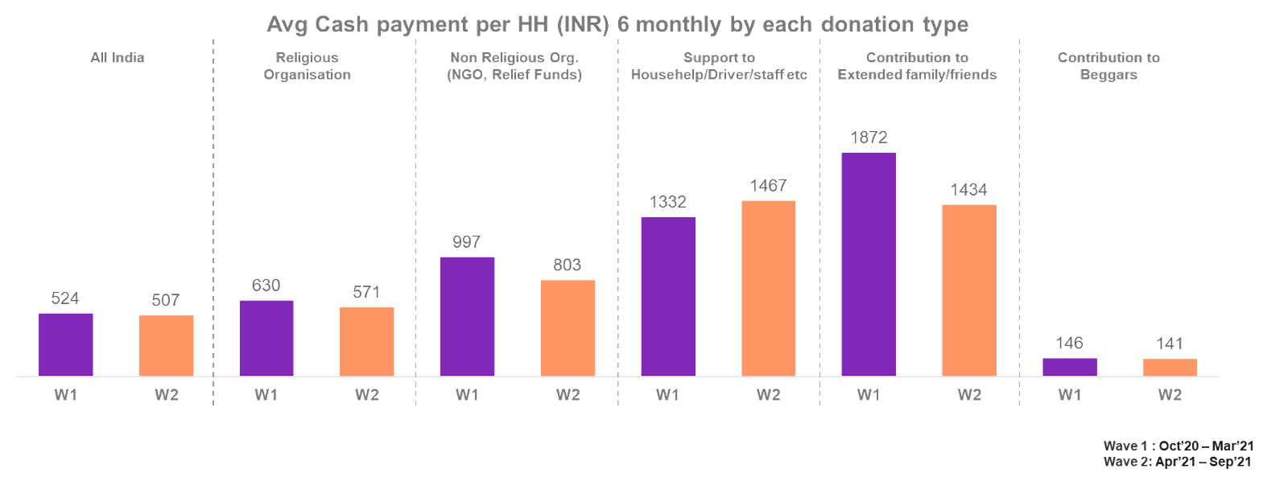

Figure 5: Trends in average ‘cash’ donation per household across urban-rural, regions and income categories

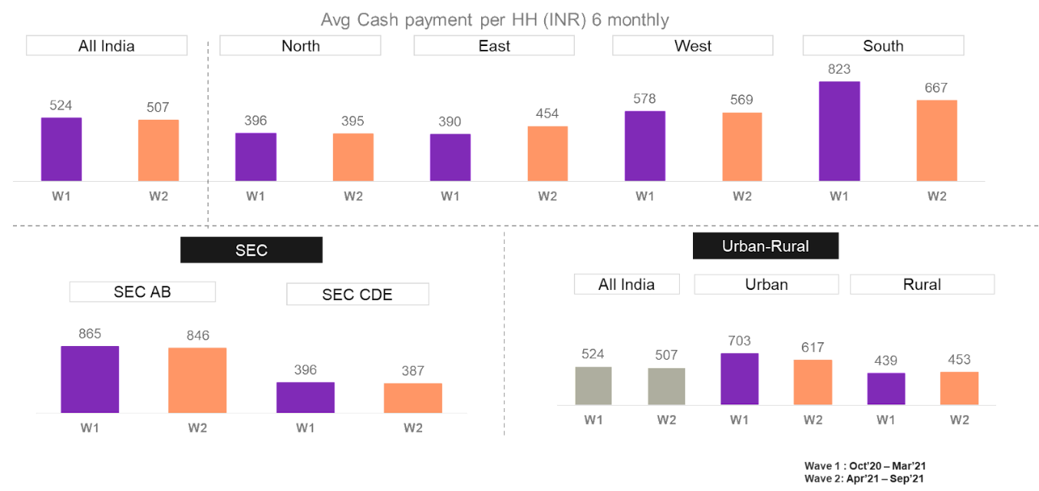

About 98% households who donated both in urban and rural India made contributions in the form of ‘cash’ to ‘religious organisations’. Supporting earlier findings, while the households in rural areas are more likely to give, the amount of average ‘cash’ donated was higher in urban households. The trends from phase 1 and phase 2 observed a decline in the average ‘cash’ amount donated by urban households while rural households saw an increase in the average ‘cash’ amount donated.

Figure 6: Incidence of ‘Cash’ donation by type of Recipients: All India, rural India, urban India. The percentages are calculated on the base of total incidences of household donation for each recipient groups.

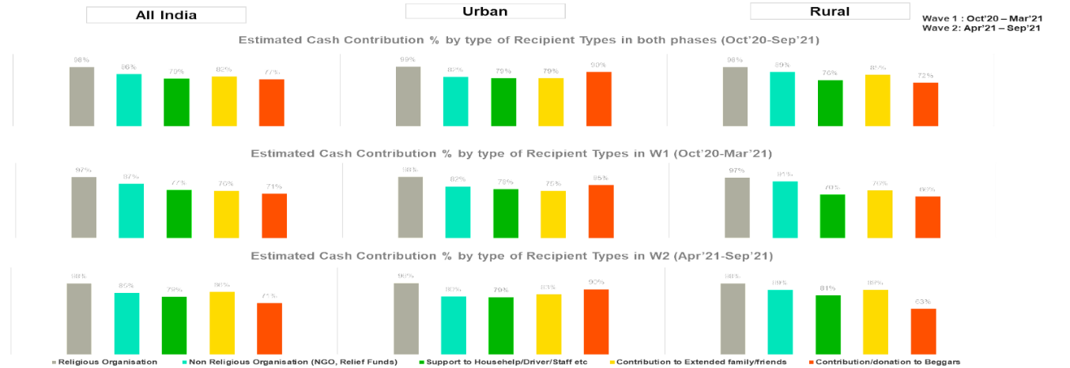

About 96% of the total incidence of household donations across regions were made to ‘religious organisations’ in ‘cash’ followed by ‘non-governmental organisations’. Incidences of donation and the average amount donated was highest in south India. West India donated the second highest average amount. South India donated on an average INR 823 per household in phase 1 and INR 667 in phase 2. The lowest averages of the amount donated were reported from north India at INR 395 in phase 2 and from east India at INR 390 for phase 1. The lowest average amount donated by households in form of ‘cash’ went to ‘beggars’ in all the regions except the south.

Figure 7: ‘Cash’ donations across regions. The percentages are calculated on the base of total incidences of household donation for each recipient groups.

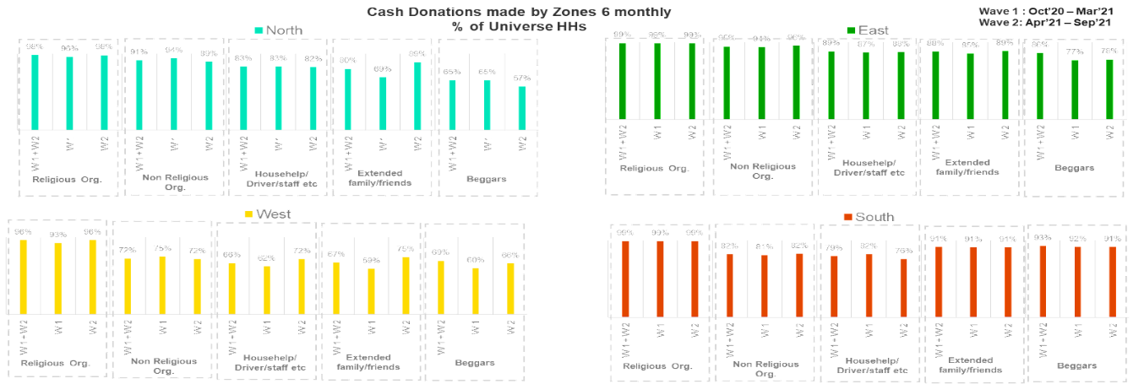

About 98% of total incidences of donation were made to ‘religious organisations’ and was made in ‘cash’. This was followed by donations made to ‘non-religious organisations’. A slight decrease in donation in phase 2 was observed by all income groups. The decrease was higher for higher-income categories than for the middle and lower-income categories. The average ‘cash’ contributions fell from INR 865 in phase 1 to INR 846 in phase 2 for SEC A/B. The results saw positive correlation between the income groups and average amounts donated. The highest income group households donated the highest average amounts with the amount of donation made decreasing with income. A higher proportion of the incidence of ‘cash’ donations to ‘beggars’ was reported among the higher income category (84% vs. 75% among low-income group).

Figure 8: ‘Cash’ donations across income groups. The percentages are calculated on the base of total incidences of household donation for each recipient groups.

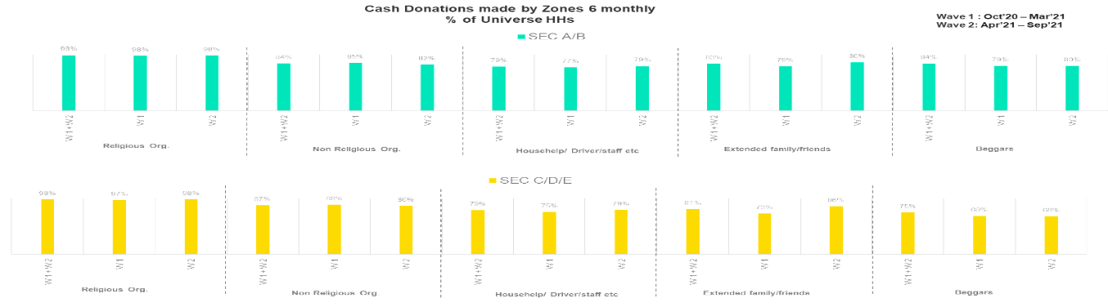

Respondents were asked to report on the frequency of their donations: ‘once in six months’, ‘once in three months’, and ‘once a month’. Giving to ‘beggars’ was more frequent than other recipient groups. Around 40% households who donated to ‘beggars’ donating more than ‘once a month’ on an average for a six-month period while for other recipient groups, most households made donations ‘once in six months’.
Currency notes were the most important medium of ‘cash’ donations made across recipient categories followed by payments made through digital wallets. The share of payments made via digital wallets are more than the payments made by cheque or debit/credit card for ‘non-religious organisations’, ‘family and friends’, and ‘household staff’. Credit and debit cards were marginally preferred over cheques to donate to ‘non-religious organisations’.

Figure 9: Mode of ‘cash’ contribution (Oct’20–Sep’21). The percentages are calculated on the base of ‘cash’ incidence of household donation for each recipient groups.

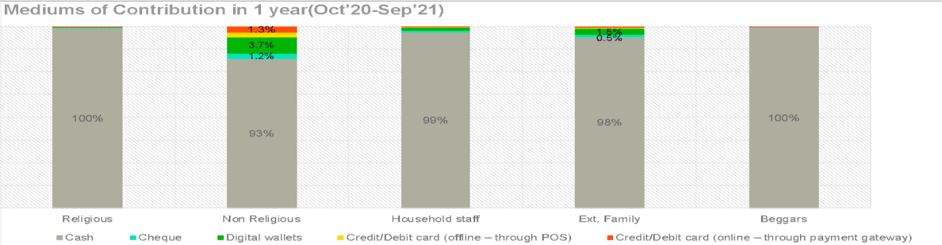

Patterns of ‘In-Kind’ Giving: In the study, ‘in-kind’ donations included groceries (dry rations, packaged food items, fruits and vegetables); clothing and blankets; food in the form of cooked meals; and household items (kitchenware, toys, and personal items); and construction, farming, and hardware equipment.
Groceries remain the main form of ‘in-kind’ donations to all recipient groups, followed by clothing and blankets, and food items such as cooked food and sweets. Out of the ‘in-kind’ donations made to ‘beggars’ and ‘religious organisations’, 87% and 85% respectively was in the form of groceries. While in phase 1 clothing was preferred over food when giving to ‘religious organisations’, in phase 2 the trend reversed. In phase 2, households preferred to give food over clothing to ‘religious organisations’.

Figure 10: ‘In-kind’ donations across recipient groups. The percentages are calculated on the base of ‘in-kind’ incidence of household donation for each recipient groups.

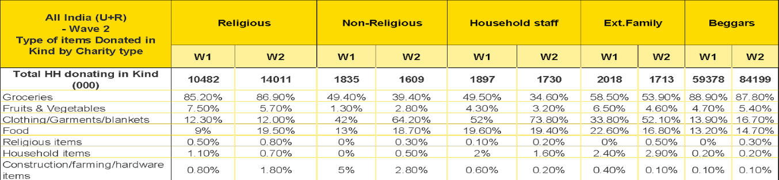

Households in urban areas who donated ‘in-kind’ gave more to ‘household staff’ and ‘non-government organisations’ while households rural India gave more ‘in-kind’ to ‘beggars’. About 43% of the household incidence of donation was made to ‘household staff’ in urban areas as compared to 40% incidence of donation at an all-India level. The ‘in-kind’ donation incidence was least to ‘religious organisations’ in both urban and rural areas.

Figure 11: ‘In-kind’ donations: All India, rural India, urban India. The percentages are calculated on the base of total incidences of household donation for each recipient groups.

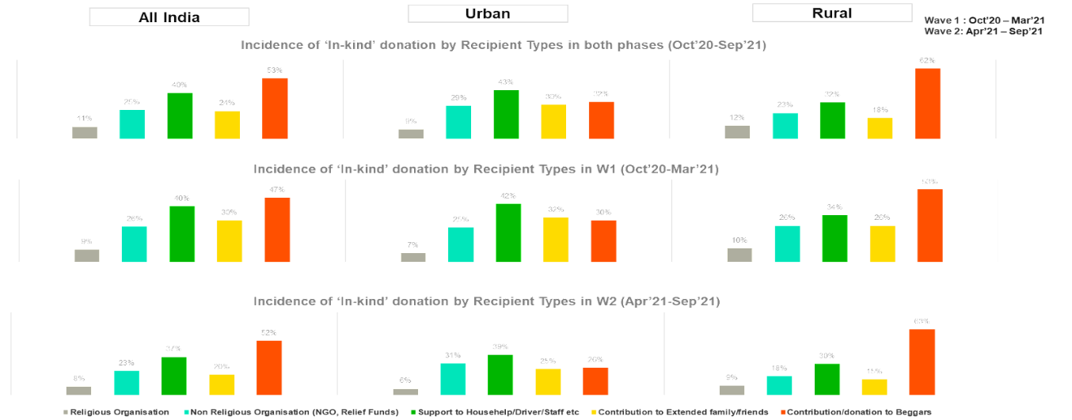

‘In-kind’ donations were more dominant in east and north India. The higher proportion of giving incidence was to ‘beggars’ in all the regions except for in the south, where the most incidence ‘in-kind’ donations were to ‘household staff’ and ‘non-religious organisations’.

Figure 12: ‘In-kind’ donations across regions. The percentages are calculated on the base of total incidences of household donation for each recipient groups.

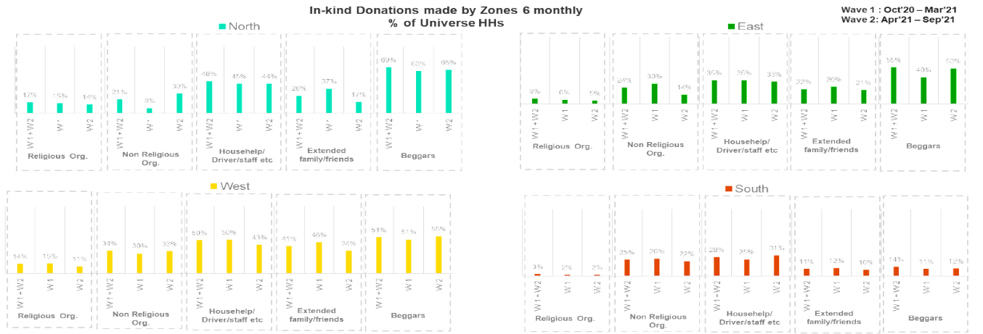

Similar to the previous findings on regions, the highest incidence of ‘in-kind’ donations was to ‘beggars’ across income groups. This was followed by ‘household staff’, ‘family and friends’ and ‘religious organisations’ respectively. Comparing socio-economic groups, incidence of donations is more for the households who belong to the upper-income groups than middle- and lower-income groups.

Figure 13: ‘In-kind’ donations across income groups. The percentages are calculated on the base of total incidences of household donation for each recipient groups.

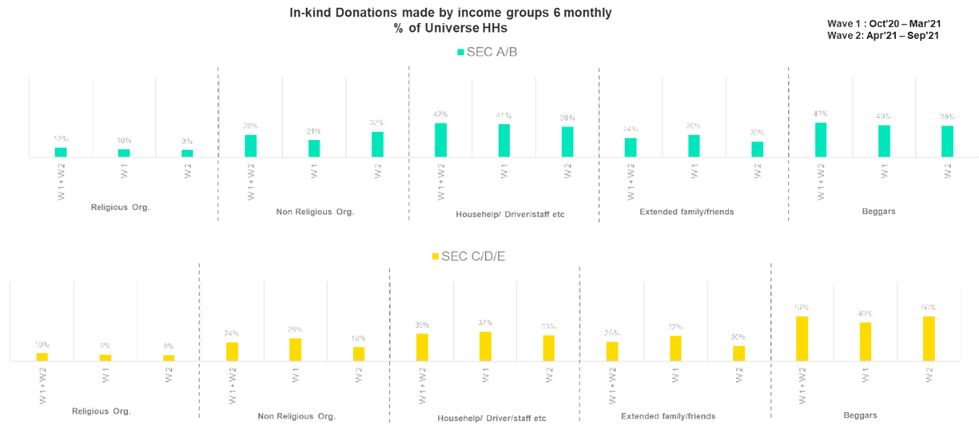

Respondents were also asked about the frequency of ‘in-kind’ donations, with the options of ‘once in six months’, ‘once in three months’, and ‘once a month’. Households tend to donate most frequently (more than ‘once a month’) to ‘beggars’ than to other recipient groups. For other recipient groups, most households donated ‘once in six months’.

Figure 14: Trends in frequency of giving ‘in-kind’ across recipient groups. The percentages are calculated on the base of ‘in-kind’ incidence of household donation for each recipient groups.

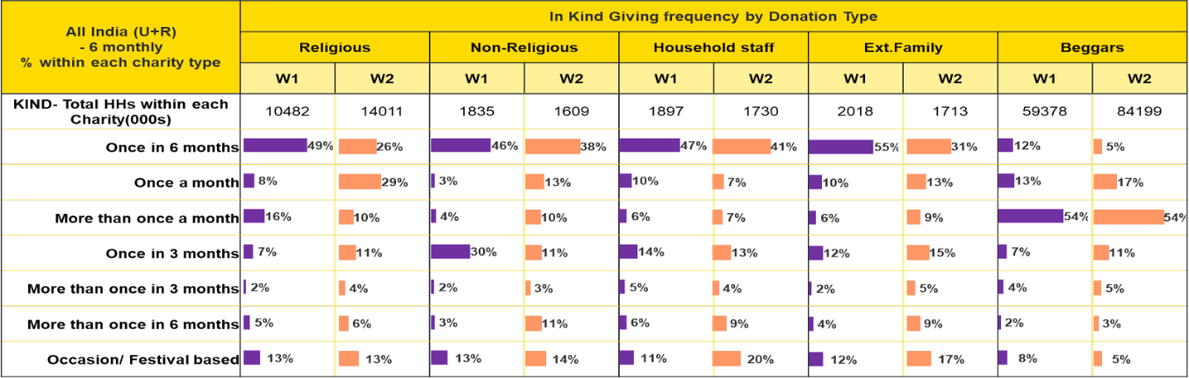
Patterns of ‘Volunteering’ Services: Opposite to the findings by Heist et al. (2022), the study does not reveal high incidence of ‘volunteering’. Only 1% reported to have volunteered during the study period. Among the households who volunteered, the highest incidence of ‘volunteering’ was towards ‘family and friends’ followed by ‘non-religious organisations’ (refer to figure 30). Most households volunteered under 5 hours in a 6-month period in both phases for with all the recipient groups except for ‘non-religious organisations’. About 52% reported ‘volunteering’ over 20 hours towards ‘non-religious organisations’ in phase 1 and 27% in phase 2.

Figure 15: Frequency of ‘volunteering services’ across recipient groups. The percentages are calculated on the base of ‘volunteering’ incidence of household donation for each recipient groups.

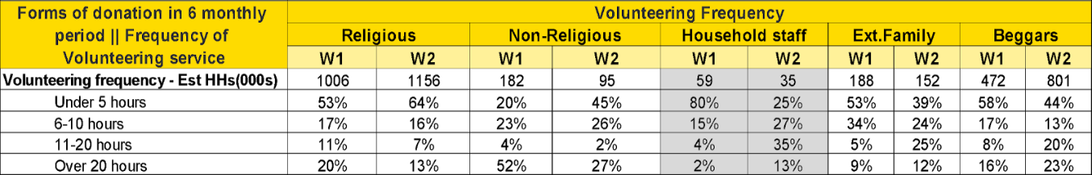
NOTE - Grey highlighted cells denote low unweighted base, hence please read with caution

The incidence of ‘volunteering services’ reported to be low in both urban and rural India. Among the households who donated in both urban and rural areas, 2% respondents reported ‘volunteering’ to ‘non-religious organisations’ and ‘family and friends’.

Figure 16: ‘Volunteering’ services: All India, rural India, urban India. The percentages are calculated on the base of total incidences of household donation for each recipient groups.

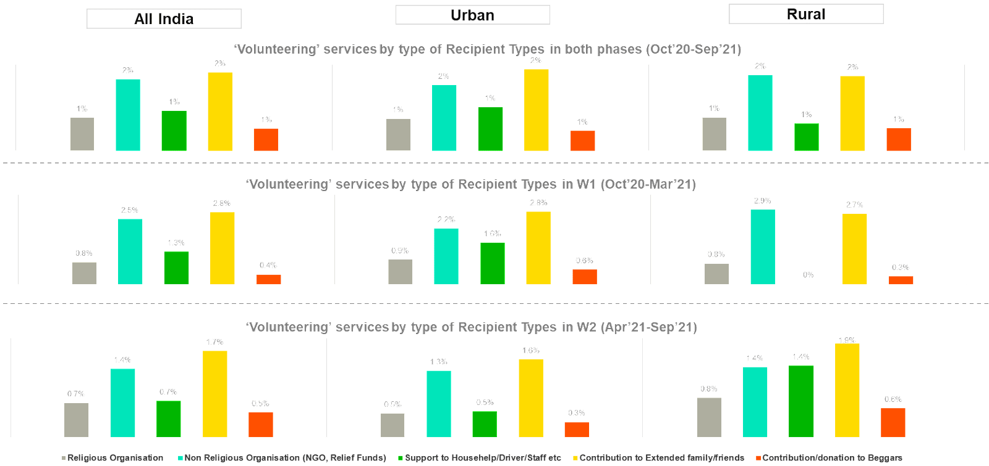

  - Who Decides and Who Gives?

Gender and age have an effect on where do households give. With rise in age, individuals are more likely to make decision of whom to give. Members of the households between the ages of 46-60 years, irrespective of gender, are the key decision-makers and payment makers for all the recipient groups except for ‘beggars’ where primary decision makers were men between the age-group of 25-45 years. Men were the key decision maker and also the final payment maker to ‘religious organisations’ and ‘family and friends’ while women emerged as key decision maker and final payment maker to ‘household staff’ and ‘beggars’. For giving to ‘non-religious organisations’ women and men between 46 and 60 years appeared to have involved almost equally in both decision making and making final payments.

Figure 17: Decision-making for giving at the household level (Oct’20–Sep’21). The percentages are calculated on the base of total incidences of household donation for each recipient groups.

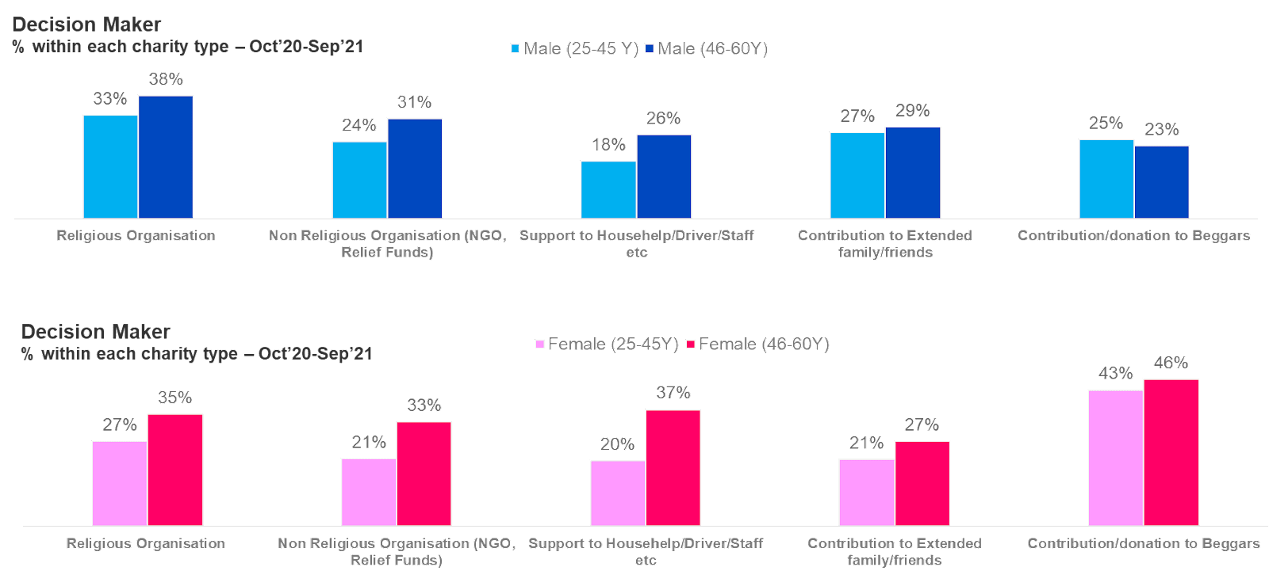

Figure 18: Final donation-maker at the household level (Oct’20–Sep’21). The percentages are calculated on the base of total incidences of household donation for each recipient groups.

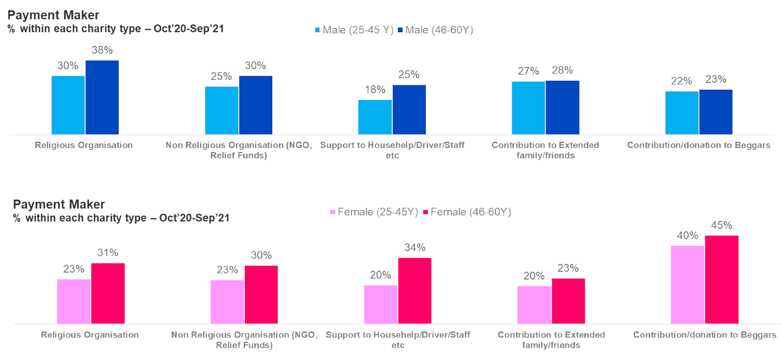

  - Motivations for Giving

A household motivation to give can be driven by various factors such as altruism and family tradition. Religious beliefs, desire to support someone in financial distress and family traditions appeared to be important driving factors for giving. The present study finds religious beliefs, supporting someone in financial distress and family traditions were the top three motivations for giving. Donations to ‘religious organisations’, ‘non-religious organisations’, and to ‘beggars’ were mainly driven by religious beliefs and family traditions while donations to ‘household staff’ and ‘family and friends’ were more cause-driven, for example, extending help during disaster or provide support to people in financial distress.

Figure 19: Motivations for giving at the household level in India (Oct’20–Sep’21). The percentages are calculated on the base of total incidences of household donation for each recipient groups.

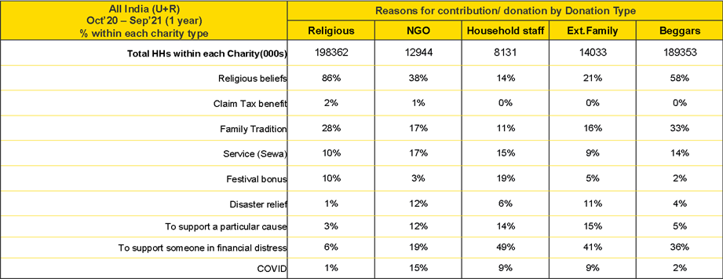

  - Deterrents to Making Donations

The second phase of the study also asked to report the reasons for not donating. About 17% households reported to have not donated in any form. Households who did not donate cited the ‘lack of resources’ followed by ‘nobody had approached’ and ‘previous negative experiences’ as the three most important reasons for not donating. The findings show different trends in terms of urban-rural landscape, regions and income categories.
Out of the households who did not donate in urban India cited ‘nobody had approached them for support’ as the most significant factor while households in rural India responded ‘lack of resources’ as the important deterrent. The most frequently cited reason for not donating in all the regions, except the west, was ‘lack of resources’ followed by ‘nobody had approached’ and ‘previous negative experience’. Among the higher-income category, most households mentioned that ‘nobody had approached’ them for donations. On the other hand, ‘lack of resources’ was reported as the chief reason for not donating among the middle- and lower-income households.

Figure 20: Reasons for not making donations (phase 2 of the study). The percentages are calculated on the base of total households who have not made any donation in phase 2.

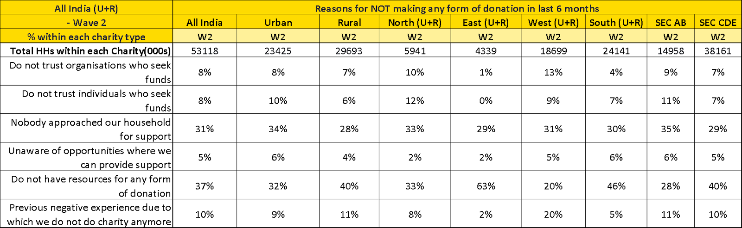

- Limitations

A key limitation of this estimate is that it is based on respondent recall of giving in the previous six months and may not be a representation of actual household giving. Other limitations are that this survey was conducted at the household level and does not take into account single-member homes, as well as acts of giving by individuals residing in hostels/paying guest accommodations and similar institutions. Since this market estimate has emerged from a sample survey, the estimate is also subject to statistical error. The present study intended to explore the extent and broad trends of household giving in India. Repeat giving patterns across the same household have not been analysed at this stage. Only a broad overview of giving across two phases has been presented.
While consumer panels are an effective way to access a diverse population to derive broad patterns and trends, they are necessarily limited in scope. They are currently not providing explanations behind the giving patterns emerging from the survey.

- Conclusion

The insights from the report point towards the potential for household giving within the overall scope of private philanthropy in India. The study estimates the market size of household giving in India as INR 23.7 thousand crore. The market size estimate could prove to be helpful for non-profits and volunteers seeking funds to help plan resource mobilisation and funding strategies. The most predominant form of giving was ‘cash’ at 93% of the total household giving. The survey revealed that ‘religious organisations’ captured the biggest market share of donations in India at 70%.
Higher- and middle-income groups reported that they did not any make donations because they were ‘not approached by anyone’. This suggests that there is potential for increasing household giving through effective outreach and communication. The study also revealed that religious beliefs were the primary motivation for giving followed by the desire to support someone in financial distress, along with family traditions.
Another important finding of the survey was information on gendered forms of giving. Women were the primary decision-makers in giving to ‘household staff’ and ‘beggars’, while men were the key decision-makers in giving to ‘family and friends’ and ‘religious organisations’.

Acknowledgements

Our deepest appreciation goes to all the households for participating in this research. We are grateful to CITI Bank for funding this study. We extend our deepest gratitude to Ingrid Srinath, Director, CSIP for her constant guidance and support. It was her firm belief in the need for this study that led to the initiation of a first-of-its-kind longitudinal study on household patterns of giving in India. The study would not have been complete without the rigorous review done by Senior Research Managers: Dr. Neha Nimble and Divya Chopra.
The report is an outcome of the sincere efforts of our execution partner Kantar World Panel who carried out data collection and preliminary analysis for this research on household giving in India. Special thanks to Seshadri Raha, Vinit Sharma and Priyanka Agha for their varied contributions towards the completion of this report.
References

A Closer Look at Informal Giving, Mutual Aid, and Community Care, Giving Tuesday, 2022. https://www.givingtuesday.org/informal-giving-community-care-and-mutual-aid/
Agarwal, S., 2010. Daan and Other Giving Traditions in India: The Forgotten Pot of Gold. New Delhi: AccountAid.
Ajrouch, K., Tesch-Roemer, C. 2017. Formal and Informal Volunteering in Later Life: Two Sides of the Same Coin?, Innovation in Aging Issue suppl_1, pp. 1395–1396.
Andreoni, J., Payne, A., 2003. Do Government Grants to Private Charities Crowd out Giving or Fund-Raising?, American Economic Review 93, pp. 792–812.
Andreoni, J., Philanthropy. University of Wisconsin. Feb. 2004, https://econweb.ucsd.edu/~jandreon/WorkingPapers/Philanthropy.pdf
Andreoni, J., 2006. Philanthropy, in “Handbook of the Economics of Giving, Altruism and Reciprocity (Vol. 2)” S. Kolm, J. Ythier, Editors. Elsevier, Amsterdam, pp. 1201–1269.
Apinunmahakul, A., Barham, V., Devlin, R., 2009. Charitable Giving, Volunteering, and the Paid Labor Market, Nonprofit and Voluntary Sector Quarterly 31, pp. 77–94.
Barth, S., 2016. In-kind Giving, in “Giving Australia 2016: Literature Review Summary Report” W. Scaife, M. McGregor-Lowndes, J. Barraket, W. Burns, Editors. QUT: The Australian Centre for Philanthropy and Nonprofit Studies, pp. 48–52.
Bekkers, R., 2003. Trust, Accreditation, and Philanthropy in the Netherlands, Nonprofit and Voluntary Sector Quarterly 32, pp. 596–615.
Bekkers, R., Wiepking, P. Generosity and Philanthropy. A Literature Review. University of Utrecht, Utrecht, ICS, 2007.
Belfield, C., Beney, A., 2000. What Determines Alumni Generosity? Evidence for the UK, Education Economics 8, pp. 65–80.
Bennett, R., 2011. Why Urban Poor Donate: A Study of Low-Income Charitable Giving in London, Nonprofit and Voluntary Sector Review 41, pp. 870–891.
Bhagwati A., Woodrow, R., 2023. Unleashing the Spirit of Generosity of India’s Middle Class, The Times of India, Feb. 2023 https://timesofindia.indiatimes.com/blogs/voices/unleashing-the-spirit-of-generosity-of-indias-middle-class/
Boddie, S. 2004. The Social Services of African‐American Congregations in the Welfare Reform Era, African American Research Perspectives 10, pp. 36–43.
CAF World Giving Index 2018: A Global View of Giving Trends, Charities Aid Foundation 2018, Octo. 2018. https://www.cafonline.org/docs/default-source/about-us-publications/caf_wgi2018_report_webnopw_2379a_261018.pdf?sfvrsn=c28e9140_4
CAF World Giving Index 2019: Ten Years of Giving Trends, Charities Aid Foundation 2019, Oct. 2019. https://www.cafonline.org/docs/default-source/about-us-publications/caf_wgi_10th_edition_report_2712a_web_101019.pdf
CAF World Giving Index 2021: A Global Pandemic Special Report, Charities Aid Foundation 2021, Jun. 2021. https://www.cafonline.org/docs/default-source/about-us-research/cafworldgivingindex2021_report_web2_100621.pdf
CAF World Giving Index 2022: A Global View of Giving Trends, Charities Aid Foundation 2022, 2022. https://www.cafonline.org/docs/default-source/about-us-research/caf_world_giving_index_2022_210922-final.pdf
Cantegreil, M., Chanana, D., Kattumuri, R., 2013. Revealing Indian Philanthropy. London: Alliance Publishing Trust.
Center on Philanthropy Panel Study, Key findings: Center on Philanthropy Panel Study, Indiana University–Purdue University, Indianapolis, 2005.
Choi, N., Burr, J., Mutchler, J., Caro, F., 2007. Formal and Informal Volunteer Activity and Spousal Caregiving among Older Adults. Research on Aging 29, pp. 99–124.
Clotfelter, C. T., 1997. The Economics of Giving. Giving Better, Giving Smarter, in Working papers of the National Commission on Philanthropy and Civic Renewal, pp. 31–55.
Cnaan, R., Jones, K., Dickin, A., Salomon, M., 1996. Estimating Giving and Volunteering: New Ways to Measure the Phenomena, Nonprofit and Voluntary Sector Quarterly 40, pp. 497–525.
Everyday Giving in India Report: Harnessing the Potential of a Billion Givers for Social Impact, Sattva, Apr. 2019. https://www.sattva.co.in/publication/research-everyday-giving-in-india-report/
Giving USA, Giving USA Annual Report, 2015. http://www.givinginstitute.org/?page=GUSAAnnualReport
Heist, H., Scott, M., Cnaan, R., Moodithaya, M., Bennett, M., 2022. The Philanthropic Poor: Prosocial Behavior in Rural India, Nonprofit and Voluntary Sector Quarterly 51, pp. 1349-1376.
Ho, M., 2011. Being and Becoming Donors: How Children and Young People Engage with Charities. Ph.D. Dissertation, The University of Edinburgh. https://www.era.lib.ed.ac.uk/handle/1842/5968.
Hrung, W., 2004. After-life Consumption and Charitable Giving, American Journal of Economics and Sociology 63, pp. 731–745.
Independent Sector, Giving and Volunteering in the United States: Methodology and How to Interpret Survey Data, 1999. http://www.independentsector.org/GandV/s_meth.htm
India Philanthropy Report 2020: Investing in India’s most Vulnerable to Advance the 2030 Agenda to Action, Bain & Company and Dasra, 2020. https://www.bain.com/globalassets/noindex/2020/bain_report_india_philanthropy_2020.pdf
India Philanthropy Report 2022: Building Philanthropic Infrastructure to Accelerate Giving in India, Bain & Company and Dasra, 2022. https://www.dasra.org/assets/uploads/resources/Dasra-Bain%20India%20Philanthropy%20Report%202022.pdf
Kassam, M., Handy, F., Jansons, E., 2016. Philanthropy in India: Promise to Practice. Los Angeles: Sage.
Lee, Y., Chang, C., 2008. Intrinsic or Extrinsic? Determinants affecting Donation Behaviors, International Journal of Educational Advancement 8, pp. 13–24.
Lincoln, R., Morrissey, C., Mundey, P., 2008. Religious Giving: A Comprehensive Review of the Literature, in “Report for the John Templeton Foundation Generosity Planning Project”.
McGregor-Lowndes, M., Flack, T., Scaife, W., Wiepking, P., Crittall, M., 2014. “Giving and Volunteering in Australia 2014: Environmental scan/literature review,” The Australian Centre for Philanthropy and Nonprofit Studies (ACPNS). QUT, Australia. http://eprints.qut.edu.au/79593/1/Giving-and-Volunteering-in-Australia-2014-Environmental-Scan-and-Literature-Review-2.pdf
Mesch, D., Rooney, P., Chin, W., Steinberg, K., 2002. Race and Gender Differences in Philanthropy: Indiana as a Test Case, New Directions for Philanthropic Fundraising 37, pp. 65–77.
Musick, M., Wilson, J., 2008. Volunteering: A social profile. Indiana University Press, Bloomington.
Philanthropy New Zealand, Giving New Zealand: Philanthropic Funding 2014, 2014. http://www.philanthropy.org.nz/sites/all/files/Giving%20New%20Zealand%202014.pdf
People Research on India’s Consumer Economy (PRICE), Household level view of India’s Consumer Economy & India’s Citizen Environment, 2021. https://www.ice360.in/app/uploads/2021/03/ICE-360-Proposal_v6.pdf
Pharoah, C., Tanner, S., 1997. Trends in Charity Giving, Fiscal Studies 18, pp. 427–443.
Philanthropy New Zealand, 2014. Giving New Zealand: Philanthropic Funding, 2014. http://www.philanthropy.org.nz/sites/all/files/Giving%20New%20Zealand%202014.pdf
Piff, P., Kraus, M., Cote, S., Cheng, B., Keltner, D., 2010. Having Less, Giving More: The Influence of Social Class on Prosocial Behavior, Journal of Personality and Prosocial Behavior 99, pp. 771–784.
Reserve Bank of India – Publications, 2021. https://www.rbi.org.in/Scripts/PublicationsView.aspx?id=20677
Rooney, P., Steinberg, K., Schervish, P., 2001. A Methodological Comparison of Giving Surveys: Indiana as a Test Case, Nonprofit and Voluntary Sector Quarterly 30, pp. 551–568.
Sen, A., Chatterjee, R., Nayak, N., Mahakud, J., 2020. Determinants of Individual Giving Behavior in Urban India, Voluntas 31, pp. 271–285.
Sheth, A., Ayilavarapu, D., Bhagwati, A. India Philanthropy Report 2015, Mar. 2015. https://www.bain.com/insights/india-philanthropy-report-2015
Sheth, A., Ayilavarapu, D., Pandit, R., Sinha, M., India Philanthropy Report 2021, Mar. 2021. https://www.bain.com/insights/india-philanthropy-report-2021/#https://www.dasra.org/assets/uploads/resources/Bain_Dasra_India_Philanthropy_Report.pdf
Singh, R., 2023. Why Begging Remains a Permanent Fixture in the Country, The Tribune, Jun. 2023. https://www.tribuneindia.com/news/comment/why-begging-remains-a-permanent-fixture-in-the-country-337725
Taniguchi, H., 2006. Men's and Women's Volunteering: Gender Differences in the Effects of Employment and Family Characteristics, Nonprofit and Voluntary Sector Quarterly 35, pp. 83–101.
United Nations Volunteers, The Thread that Binds: Volunteerism and Community Resilience, United Nations, 2018. http://unv-swvr2018.org/
U.S. Department of Labor 2008a. Volunteering in the United States, 2007. Washington, DC: Author. http://www.bls.gov/news.release/volun.nr0.htm
Walker, C., Pharoah, C., 2002. A Lot to Give: Trends in Charitable Giving for the 21st Century. Hodder and Stoughton, Hachette.
Wilson, J., 2012. Volunteerism Research: A Review Essay, Nonprofit and Voluntary Sector Quarterly 41, pp. 176–212. https://doi.org/10.1177/0899764011434558
Yao, Kimberly, 2015. Who Gives? The Determinants of Charitable Giving, Volunteering, and Their Relationship, Wharton Research Scholars, 126, 2015. https://repository.upenn.edu/wharton_research_scholars/126
Yen, S., 2002. An Econometric Analysis of Household Donations in the USA, Applied Economics Letters 13, pp. 837–841.

Appendix A.

Methodology for Panel Creation and Survey

The ‘How India Gives’ study was executed using the Worldpanel Division of Kantar Panel’s composition, data collection, and quality assurance standards and methods. Data for the study was collected as part of a monthly FMCG-purchase data collection survey conducted at the household level by the Worldpanel Division of Kantar.
The survey was conducted twice to document recall over a six-month period, during phase 1 of the pandemic in April 2021 (covering responses from October 2020 to March 2021) and phase 2, October 2021 (covering responses from April to September 2021). These surveys were conducted telephonically (77% in phase 1) and in person (97% in phase 2).
The methodology for panel construction and data collection has been briefly summarised in a phased manner below:

Phase 1: Panel Construction and the Mapping and Listing of Households

In Phase 1 of the methodology, panel construction and the mapping and listing of households were conducted as per the Worldpanel Division of Kantar World Panel’s standard methods. Findings from the latest baseline survey of the Worldpanel Division of Kantar were used to gauge the demographic profile. This was then taken into account for panel creation and revisions.

The panel set-up involved two distinct stages:

Stage I: Baseline Survey: A baseline survey, that is, a large-scale household survey using random sampling, was executed to gauge the demographic profile and factors influencing consumer behaviour and decision-making.
The key respondent at the household level was also a key decision-maker in FMCG purchases. The respondent could be either male or female. A household was broadly defined as a group of related persons living together and taking their meals from a common kitchen. Single-member homes and institutions such as hostels were not included in the sample. Household staff and guests were also not added to the definition of a household.

Stage II: Random Selection of Households and Panel Creation: The final panel comprised an 80:20 ratio of urban and rural households, respectively, which was projected to the Indian census data. It covered 18 states, 135 urban towns, and 705 villages. The panel comprised ~80,000 households and was demographically representative of 94.5% of India. The variables taken into consideration for panel sampling and projections were:

- Affluence levels, that is, Socio-economic Classification (SEC)
- Age of respondent (up to 34 years, 35–44 years, and 45+years)
- Geographical spread (urban, rural, town and village classes, state)

Using systematic random sampling, households were selected for recruitment as panellists and were formally onboarded as part of the Worldpanel Division of Kantar panel. The existing Worldpanel Division of Kantar panel was updated using the same specifications as per the mentioned variables to replace any defunct respondent households.
The Worldpanel Division of Kantar panel utilised the Census 2011 data for projections of the sample to the population, which is a growing universe (growth was calculated based on the decadal growth from Census 2011 versus 2001). While projecting, sample households were given different weightages depending on the variables mentioned earlier. The projections also took into account the homogeneity and heterogeneity of households of sample groups.

Table A.1 provides an overview of states covered in each region.

North | East | West | South
Delhi | West Bengal | Maharashtra | Tamil Nadu
Uttar Pradesh | Odisha | Gujarat | Karnataka
Rajasthan | Bihar | Madhya Pradesh | Kerala
Haryana and Punjab | Jharkhand | Chhattisgarh | Andhra Pradesh
 | Guwahati |  | Telangana

Table A.1: States covered in the survey

For towns and villages, the sampling was done based on size; the broad categorisation of towns and villages surveyed were done as per average population size. From a socio-economic perspective, the SEC classification was calculated based on the standard New Consumer Classification System (NCCS). Based on the education of the chief wage earner and the number of durables owned by the household, the specific SEC category of the respondent group was defined. Table A.1 provides an overview of the SEC classification grid.

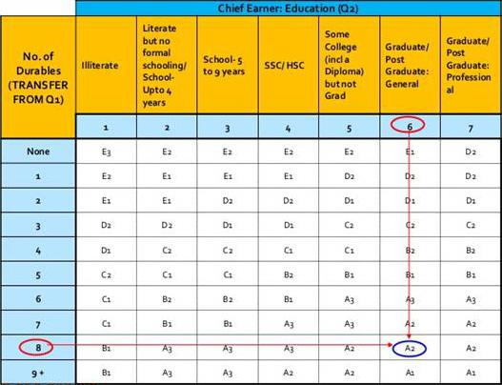
Image SEQ Image \* ARABIC 1: Socio-economic class classification grid
Source: New Consumer Classification System (NCCS), https://mruc.net/assets/frontend/new-consumer-classification-system.html

Based on the SEC classification GRID, broad SEC categories included SEC A1, A2/A3, SEC B, SEC C, and SEC D/E for this study. As per the classification, SEC A1 represented households with graduates or post graduate professionals as chief wage -earners and those that had over 9 consumer durables per household. This category was the most affluent in the SEC classification, while the SEC D/E households had chief wage earners who either lacked any formal education or had higher education but limited access to consumer durables (less than 4) at the household level, indicating a weaker economic background in comparison to SEC A households.

Phase II: Data Collection and Cleaning

The survey was conducted using Computer-Assisted Personal Interviews (CAPI) formats. Field surveyors were trained by Worldpanel Division of Kantar to conduct the ten-minute surveys with panel members after conducting regular monthly FMCG purchase data collection. The step-wise process for data collection, cleaning, and release has been illustrated in the image below.

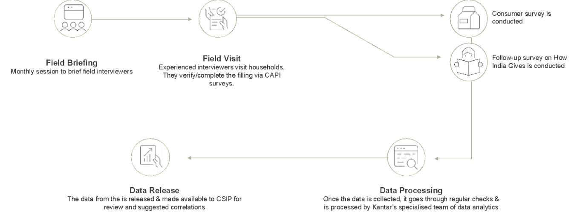
Image 1.2: Stepwise illustration of data collection and cleaning.

Family philanthropy includes contributions given either in a personal capacity or through self-identified ‘family foundations’ (Sjeth et al. 2021).
The study covers 18 states across urban and rural areas. Punjab and Haryana, and Andhra Pradesh and Telangana are reported together respectively. The study covered only Guwahati in Assam as representing the North-East and excludes J&K and Goa. A more detailed note on the geographical coverage is provided in Appendix A.
INR 23.7 thousand crores = USD 2.8.9 billion, Euro 2.64 billion
INR 16.6 thousand crore = USD 2.03, Euro 1.85; INR 2.9 thousand crore = USD 0.35, Euro 0.32; INR 2 thousand crore = USD 0.24, Euro 0.22; INR 1.1 thousand crore = USD 0.13, Euro 0.12; INR 1 thousand crore = USD 0.12, Euro 0.11.
Due to extremely low base, section on ‘volunteering services’ will not discuss regional and income-group wise findings.
Grey highlighted cells denote low unweighted base, hence please read with caution.
Durables owned included 11 items owned or accessible to respondents: these were electricity connection, ceiling fan, LPG stove, two-wheeler, colour TV, refrigerator, personal computer/laptop, washing machine, car/jeep/van, agricultural land (only in rural areas), and air conditioner

